Name: Matthew Towles
HOMEWORK #2 – Week 2

This homework is worth 10% of your course grade.

Read each problem carefully. Failure to follow the instructions for a problem will result in a zero score for that problem.

Submit the completed Homework via Assignment in LEO.

1. Construct a truth table for the Boolean equation:
M = A’B C’ + A’B C + A B’C + A B C

A | B | C | M
0 | 0 | 0 | 0
0 | 0 | 1 | 0
0 | 1 | 0 | 1
0 | 1 | 1 | 1
1 | 0 | 0 | 0
1 | 0 | 1 | 1
1 | 1 | 0 | 0
1 | 1 | 1 | 1

2. Draw a simple NOT, AND, OR circuit in sum of products (SOP) form that represents the equation above.

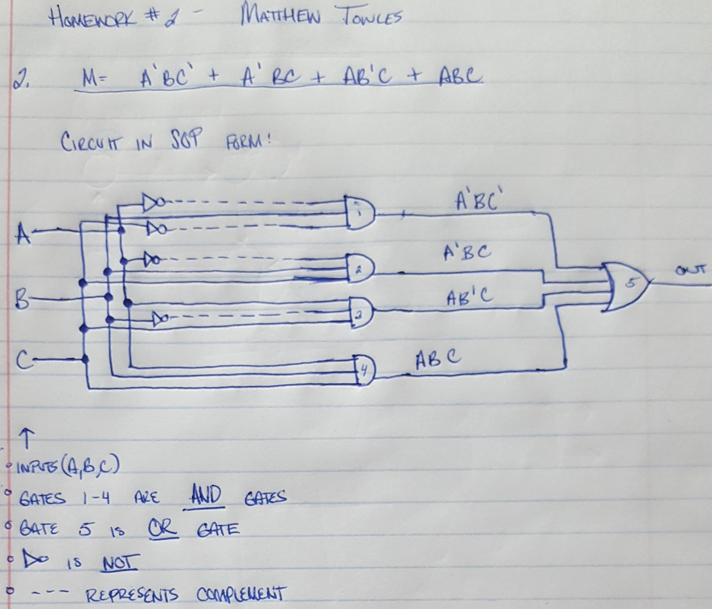
3. The truth table for a Boolean expression is shown below. Write the Boolean expression on SOP form

x | y | z | F
0 | 0 | 0 | 1
0 | 0 | 1 | 0
0 | 1 | 0 | 0
0 | 1 | 1 | 1
1 | 0 | 0 | 1
1 | 0 | 1 | 1
1 | 1 | 0 | 0
1 | 1 | 1 | 1

Answer: F = x’y’z’ + x’yz + xy’z’ + xy’z + xyz

4. Find the truth table that describes the following circuit:

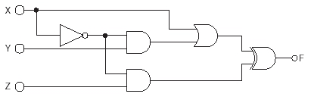

F = (x + (x’y)) XOR (x’z):

x | y | z | x + x’y | x’z | F
0 | 0 | 0 | 0 | 0 | 0
0 | 0 | 1 | 0 | 1 | 1
0 | 1 | 0 | 1 | 0 | 1
0 | 1 | 1 | 1 | 1 | 0
1 | 0 | 0 | 1 | 0 | 1
1 | 0 | 1 | 1 | 0 | 1
1 | 1 | 0 | 1 | 0 | 1
1 | 1 | 1 | 1 | 0 | 1

5. Describe the function of a decoder circuit;

identify the types and quantity of gates needed to implement a 3-to-8 decoder;

either create (or give the location in the text) of a logic diagram of a decoder circuit

A decoder circuit processes bits as input and gives output signal based on the input. Let n be in the set of positive integers. If there are n inputs that the decoder can take, then it will give 2^{n} outputs. Only one of those outputs will be 1 – which will correspond to the number represented by the bits given as input. So, if a decoder has 4 inputs, it will have 16 outputs. Only one of those outputs can be a 1, the other 15 will be 0s.

To implement a 3-to-8 decoder, 8 AND gates and 3 NOT gates will be required. One NOT gate per input. One AND gate per output.

A decoder circuit can be found in the module figure 2.7. Another one can be found in the text in section 3.5 figure 3.14.

