**Matt Allen**

**DS 700**

**Assignment 3**

|  |  |  |  |  |  |  |  |
| --- | --- | --- | --- | --- | --- | --- | --- |
| **Exercise 1: Forecasting Chicken Wing Demand** | | | | |  |  |  |
| **a. Forecast the demand for week 7 using a five-period moving average** | | | | | | |  |
| Week | 1 | 2 | 3 | 4 | 5 | 6 | F7 |
| Demand | 650 | 521 | 563 | 735 | 514 | 596 | 585.8 |
|  |  |  |  |  |  |  |  |
| **b. Forecast the demand for week 7 using a three-period weighted moving average.** | | | | | | | |
| W1 | 0.5 |  |  |  |  |  | F7 |
| W2 | 0.3 |  |  |  |  |  | 599.2 |
| W3 | 0.2 |  |  |  |  |  |  |
|  |  |  |  |  |  |  |  |
| **c. Forecast the demand for week 7 using exponential smoothing.** | | | | | | |  |
| alpha | 0.1 |  |  |  |  |  | F7 |
| F6 | 600 |  |  |  |  |  | 599.6 |
| A6 | 596 |  |  |  |  |  |  |
|  |  |  |  |  |  |  |  |
| F7 = F6 + Alpha * (A6 - F6) | | |  |  |  |  |  |

**d. What assumptions are made in each of the forecasts?**

In exercise a, I made the assumption that the average of the past five months is a good predictor of the chicken wing demand in the following month. In exercise b, I weighted the most current past periods the most with the assumption the future will be similar to near past. In exercise c, I assumed no trend or seasonality.

|  |  |  |  |  |  |  |  |  |
| --- | --- | --- | --- | --- | --- | --- | --- | --- |
| **Exercise 2: Forecasting tire demand** | | |  | |  | |  | |
|  | | | | | | | | |
| **Exercise 2: Forecasting tire demand** | | | |  | |  | |
| **a. Develop a spreadsheet using the first seven days of demand to determine the best exponential smoothing model for values of α = 0.2,**  **α = 0.3, and α = 0.4. Select the model with the smallest absolute deviation for seven periods.** | | | | | | | |
|  | | | | | | | |
|  | | | | | | | |
|  |  |  | |  | |  | |
| Total Months |  | Level smoothing parameter (alpha) | |  | | SumAbsDev | |
| 7 |  | 0.2 | |  | | 100.377088 | |
|  |  |  | |  | |  | |
| Day | Demand | Level Estimate | | Forecast | | AbsError | |
| 0 |  | 198 | |  | |  | |
| 1 | 200 | 198.4 | | 198 | | 2 | |
| 2 | 209 | 200.52 | | 198.4 | | 10.6 | |
| 3 | 215 | 203.416 | | 200.52 | | 14.48 | |
| 4 | 180 | 208.0992 | | 203.416 | | 23.416 | |
| 5 | 190 | 211.71904 | | 208.0992 | | 18.0992 | |
| 6 | 195 | 215.062848 | | 211.719 | | 16.71904 | |
| 7 | 200 | 218.0754176 | | 215.0628 | | 15.062848 | |

I chose alpha = 0.2. It had the smallest sum of absolute deviations. See spreadsheet.

|  |  |  |  |  |  |  |  |
| --- | --- | --- | --- | --- | --- | --- | --- |
| **Exercise 2: Forecasting tire demand** | | | |  | |  |  |
| **b. Develop another spreadsheet using the holdout sample for the second seven days to compare the best exponential smoothing model found in part a with a three-period moving average model. Compare the predictions on the basis of the total absolute deviation for the seven periods.** | | | | | | | |
|  | | | | | | | |
| Total Months |  |  | SumAbsDev | |
| 7 |  |  | 44 | |
|  |  |  |  | |
| Day | Demand | Forecast | AbsError | |
| 5 | 190 |  |  | |
| 6 | 195 |  |  | |
| 7 | 200 |  |  | |
| 8 | 208 | 195 | 13 | |
| 9 | 186 | 201 | 15 | |
| 10 | 193 | 198 | 5 | |
| 11 | 197 | 195.6666667 | 1.333333333 | |
| 12 | 188 | 192 | 4 | |
| 13 | 191 | 192.6666667 | 1.666666667 | |
| 14 | 196 | 192 | 4 | |

Based on the Sum of Absolute Deviations, the second model in (b) is a better predictor of tire demand

**c. What principles does this problem illustrate?**

This problem is an example of comparing models based on some statistic. Here the statistic is absolute deviation. I chose the model that minimized this statistic. The absolute deviation is the statistic I tried to minimize.

**Exercise 3: Predicting household income with logistic regression**

**I created a new variable called FamilyIncomeGreaterThanOrEqualTo150000. This variable is set to 1 if the existing variable FamilyIncome is greater than or equal to 150000 otherwise the value is 0.**

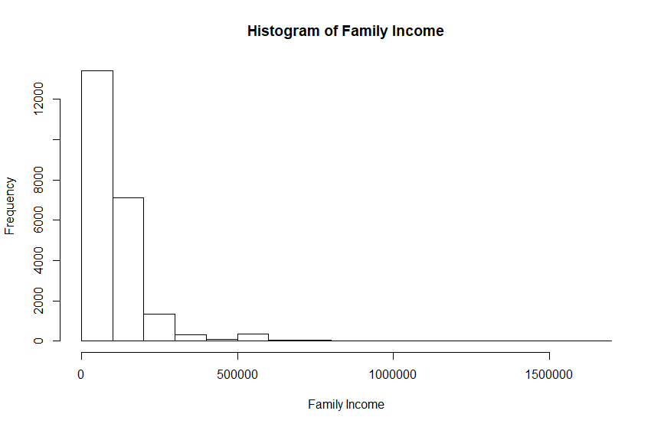

For my model, I am using the variables HouseCosts, and FoodStamp. I would expect a positive relationship between HouseCosts and Family income greater than or equal to 150000, and a negative relationship for FoodStamp.