DS 740 Final Project Executive Summary by Matt Allen
The data set that was used for the final project is the NYC Open Data. In particular, the datasets related to NYC’s Citi Bike system was used. There are two main data sources. One that documents Citi Bike stations and one that has 30 million Citi Bike trips 2013-present. Due to the large size of the data, the current study was limited to Citi Bike trip data from June 2016. The data was used to see if a model could be created to predict gender based on Citi Bike trips. Two methods used in the analysis were linear discriminant analysis, and logistic regression. The purpose of creating a model to predict gender is for Citi Bike to understand their customers better. Are there differences in how women and men use the Citi Bike system?
Before starting to clean the data, a summary of the data was created. The columns in the dataset were trip duration in seconds, start time, stop time, start station name, end station name, user type to indicate subscriber, birth year and gender. One thing that stood out in the data was that males had about 3 bike trips for every 1 bike trip made by females. It is clear that males use the Citi Bike system significantly more than females.
After doing a basic summary of the data, cleaning of the dataset was performed. Any rows that had missing values were just removed from the dataset. The data is so large that imputation methods were not needed. From the summary of the data, it was seen that the max bike trip was over 36,000 minutes. It was guessed that such trips correspond to missing or stolen bikes. Further, the Citi Bike system is intended for short commuter trips, so the data was limited to trips of less than a half an hour. The birth year column had a minimum birth year of 1885. This seems very unlikely. A minimum birth year of 1916 was established. All records with birth year less than 1916 were removed. This limits the population to riders under the age of 100, which seems reasonable.
The next step was to add three derived columns. A column called age was created by subtracting birth year from the year of the Citi Bike trip, which in this study is the year 2016. The start date column was used to create a column called start hour, which indicates the hour of the day when the trip was started. Another column for trip duration in minutes was derived by dividing the trip duration column in seconds by sixty to get the trip duration in minutes.
Again, it was clear that males were overly represented in the data set, so a technique was needed to even out gender representation in the data set. A down sampling method was used. It randomly selected males and females and created a new data set that had the genders equally represented.
It was also decided to limit the columns used to predict gender to trip duration in minutes, age, and start hour. Histograms of the three predictor columns were created. Trip duration in minutes showed some right skewness, but it did not seem too extreme to need a transformation.
With the data set in place, the two techniques of Logistic Regression and Linear Discriminant Analysis were used to create models that predict gender of Citi Bike riders based on trip duration in minutes, age, and start hour. First logistic regression was performed on the entire data set. All predictors were found to be significant at a level of 5%. The logistic regression model was checked to see if multicollinearity existed between predictors. There was no evidence of multicollinearity found. Ten-fold cross validation was then performed on the full model. The model was found to have a true positive rate of 58% and a true negative rate of 42%. Next a ROC curve was created to examine the trade-off between true positive and true negative rates. See the ROC curve in Figure 1. It was found that the area under the curve for ROC was 0.57, where .5 indicates random chance. The logistic model was not much better than randomly guessing a rider’s gender.

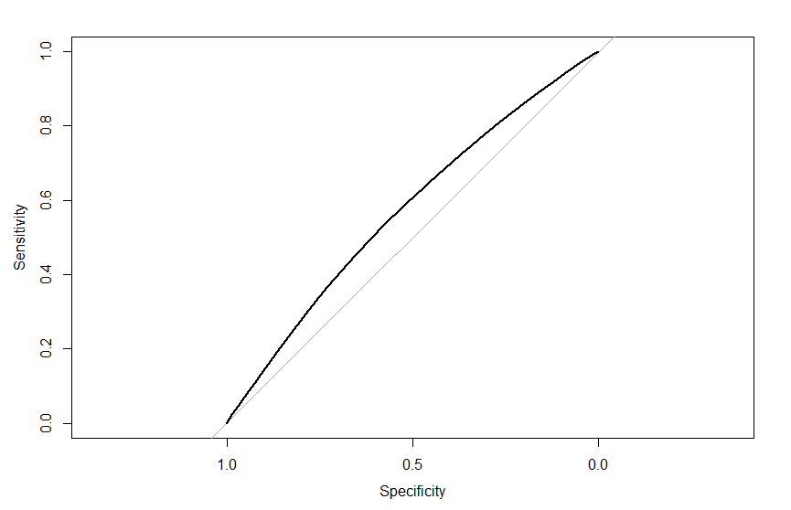
Figure 1. ROC curve for Logistic Regression

The next technique used was linear discriminant analysis. Two models were used with ten-fold cross validation: one with just the predictor trip duration in minutes and the other was the full model. The model with just trip duration in minutes was found to have an overall error rate of 50%. The full model was found to have an error rate of 44%. The technique of linear discriminant analysis also failed to create a model with much predictive power.
The models created in this study were not found to have much predictive power. However, it was clear that males use the Citi Bike system much more frequently than women. This is an important finding. Further research should be done to find out why women are not using the system as much as men. Citi Bike could look for ways to encourage more females to use the Citi Bike system. The next question to be investigated would be: What are the barriers to using Citi Bike for women?

