# **Programming with Python**

# Module 01:



Python Programming Language – Official Website

"Python is a programming language that lets you work more quickly and integrate your systems more effectively. You can learn to use Python and see almost immediate gains in productivity and lower maintenance costs.

* Python runs on Windows, Linux/Unix, Mac OS X, and has been ported to the Java and .NET virtual machines.
* Python is free to use, even for commercial products, because of its OSI-approved open source license.
* There are two main versions of Python: *"New to Python or choosing between Python 2 and Python 3? Read Python 2 or Python 3."* -- Python Programming Language – Official Website <http://wiki.python.org/moin/Python2orPython3>
* Our book uses version 3.x, but Mac already has 2.x installed. I recommend uninstalling and using 3.x (<https://docs.python.org/3/using/mac.html>)
* Check out this YouTube Video: <http://www.youtube.com/watch?v=1HZ38RzykuE>

## SNAGHTML540fb2b**Console Applications**



Once you have installed Python, you can create a program that runs as a Console application (think “Command Prompt”). The Windows program IPConfig.exe is an example of a console application.

To start, in Windows, you open a console window using Start Menu ➤ Run (windows key + r) and type in the following command “CMD”.

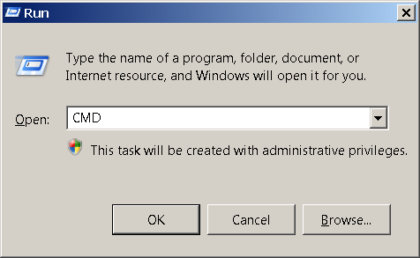

You will then be presented with a Command Prompt window like this…

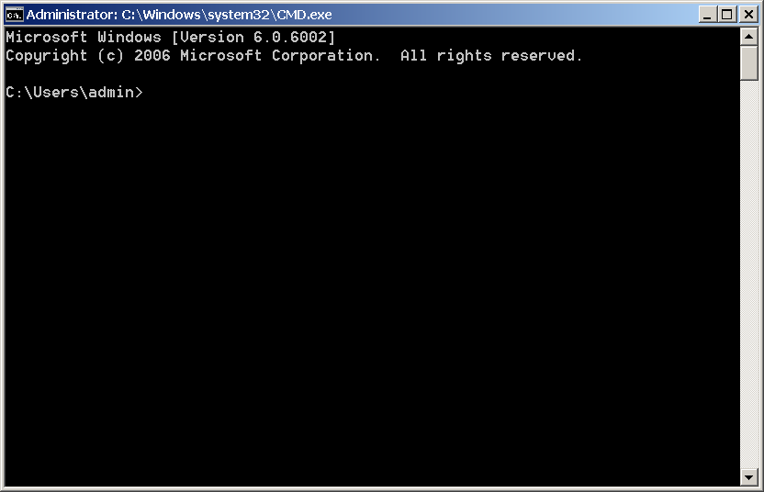

Now, type in the command “IPConfig.exe” and hit the Enter key to see the IPConfig program run.

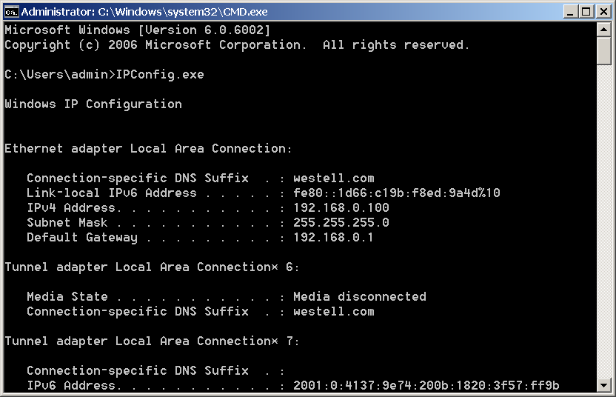

IPConfig.exe is a Console application. These applications are not fancy, but they do allow you to accomplish useful tasks on a computer with the minimal fuss as to making your application look nice!

## **Programming Basics**



In a very general way, programs break down into two distinct categories:

* ***Data:*** the information you want to work with, such as a person’s name and phone number.
* ***Operations:*** are the things you want to do with the data, such as printing out the data or adding two numbers together.

Of course, a program may also have other things as well, like *comments*, *namespaces*, or *directives*, but the data and operations are the core of the program. As for the other things, here is a list of commonly used items.

* ***Comments:*** provide additional information to humans.
* ***Namespaces:*** provide an easy way to organize your code into named groups.
* ***Directives:*** provide additional information to the computer, but are not directly part of the program.
* ***Statements:*** the commands you add to a Python code file.
* A *statement* is one instruction to the computer.
* Each of these statements will be made up of one or more keywords or symbols (sometimes called *tokens*).
* Since these can be more than one token per statement, you also need a way to indicate to the computer that you are done with a statement. In Python you do so with a *carriage return*.
* In Python you optionally use a semicolon(;) at the end of the statement. (*But this is considered wrong by many of the python faithful!)*

x = 4 # This is one statement,

y = 5 # this is another,

z= x + y # and another as well

## **Comments**



In the previous code, we used comments to identify the purpose of a statement. Commenting code is useful for notes like these, but also for when you want to see if disabling a particular set of statements solves a problem. Any code that follows a comment will not be processed. So, if you *comment out* a section of code, and the problem disappears, then you know that the error is related to that set of statements.

A comment only affects code on one line unless you use a block comment.

**#** This is a standard, *inline*, Python comment.

Block, *multi-line*, comments are not officially available in Python, but look like this in other C style languages.

**/\***

C Style languages use a slash-star and star-slash pair for a block comment.

Note to self: Both these statements are commented out for testing

int x = 5;

int y = 10;

**\*/**

Block, *multi-line*, comments can be made in Python using 3 single quotes like this:

**'''**

**Both these statements are commented out for testing**

**int x = 5;**

**int y = 10;**

**'''**

**Case-Sensitivity**



Python is a case-sensitive language, so you must be careful as you type.

x = 4 # This places the value of four into a variable called x

X = 13 # But, this places the value of four into a variable called X !

print(X) # displays the value 13 to the user

PRINT(X) # this command is not understood by Python

**Functions**



Programmers have found that it a good practice to organize your code into groups. Statements are often grouped into *functions (*also known as *methods* or *sub-procedures)*. After you create a function, you can run its group of statements by *calling* the method.

def DemoMethod():

print("This is a statement in DemoMethod")

print("This is another statement in DemoMethod")

#End DemoMethod

## **The Main() Method**



Most applications run a “Main()” method as soon as a program is started. Often this method is hidden or implied, as it is in Python.

Within the Main() method, any code you type in will be processed one line after the other. If you call another method from the Main() method, it will jump to that method, run the statements inside of the called method, and return to the Main() method when it is done. The example below outlines the order in which your statements will be processed.

def DemoMethod(): # 3) jumps to here and run both statements…

print("This is a statement in DemoMethod")

print("This is another statement in DemoMethod")

#End DemoMethod

# 1) Start of Main

print("This is a statement in the invisible Main method")

DemoMethod() # 2) call the method DemoMethod()...

# 4) jumps back to here…

print("This is another statement in the invisible Main method")

# 5) End Main (the program ends! )

## **The print() Function**



The print() function was created in Python to print out information to the command window. If you remember, IPConfig.exe wrote out its data to the command window for a human user to read. If you want to send output you would use the method to do so.

### The input() Function



The input() function gets data from the program’s user. It is also used to “pause” the program in the first chapter of the book, but we will see more practical uses for it later.

**Note:** In Python 2.x you use the **raw_input()** function instead of the input() function to avoid and error!

The way it is used in the first chapter is to stop the CMD (command) window from closing once the script finishes. You can see this behavior if you open a Python script from Windows Explorer.

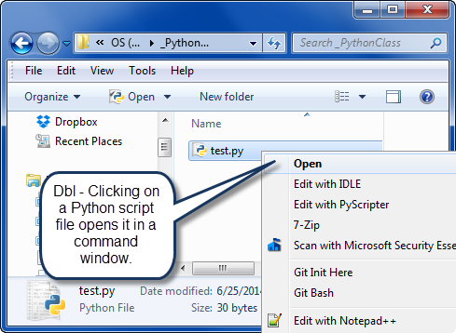

When the script finish it programming statements it will close the Command window immediately. Using the input() function will pause the script until the user presses the Enter key.

## Let’s review chapter 1 in you book now…



**LAB 1-1: Create a Console Application**

1. Create a new script using IDLE that prints out the text, “This is a test!” Do not use the **input**() function yet.
2. Run the script using Window Explorer. Note how the command window closes immediately after the script finishes.
3. Add the **input**() function to pause the script until the user presses the **Enter** key

