Matthew Felicano

Instructor**:** Randal Root

IT FDN 100 A

11 July 2016

*'''----------------------------------------------------------------  
Dev:MFeliciano  
Assignment03 :  
1. Create a new program that asks the user for the name of  
a household item, and then asks for its estimated value.  
Store, both pieces of data in a text file called, HomeInventory.txt  
----------------------------------------------------------------'''  
  
# Begin by opening and appending a file*objHI = open(**"C:\\Users\\feliciam\\Documents\\_PythonClass\\HomeInventory.txt"**, **"a"**)  
*# Here we are giving the users some information on how to use the program.*print(**"Enter household items below."**)  
*# Next create a loop that allows user to keep entering items and values until they are finished.***while** (**True**):  
 *# First prompt the user for the name of household item.* strI1 = input(**"Enter item: "**)  
 *# Next prompt user for the value of item.* strV1 = input(**"Enter estimated value: "**)  
 *# Now we write answer to file and create a new line for more input.* objHI.write(**"Item: "** + strI1 + **" "** + **"Value: $"** + strV1 + **"\n"**)  
 *# Finally give user an opportunity to continue entering items or exit the program.* **if** input(**"Hit 'Enter' to continue or type 'exit' to quit this program. "**): **break**

1. Creation steps
   1. Open PyCharm
   2. Create header – This tells you or future programmers what the code is doing and who wrote it.

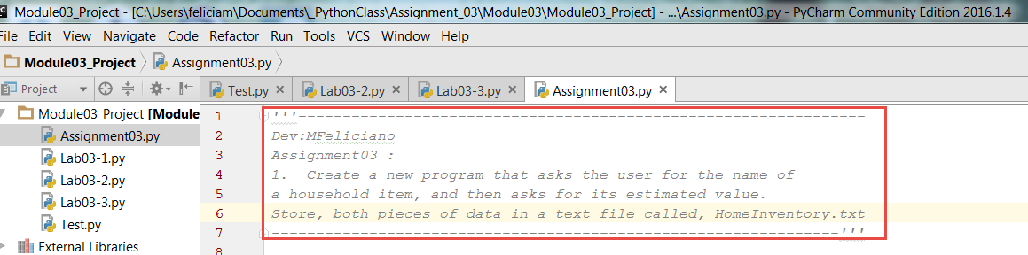

Remember a header is always best practice no matter what type of code you are writing. It helps future programers, and yourself, to understand what the code is attempting to accomplish. Don’t forget to document any changes, the date they were made, and who made them. If someone inherits your code they will have a general idea of what it is doing.

1. Write the code to open and append a file

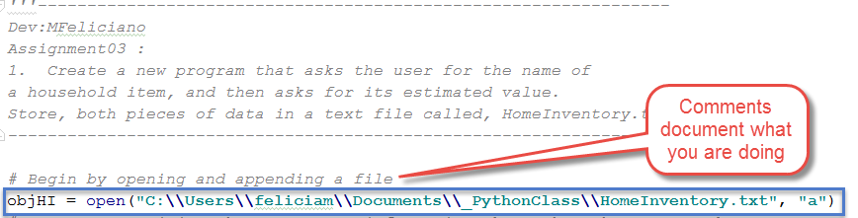

Here we are defining an object and telling Python to open it and append the contents. We have given Python the locaion of the file. Note – by using ‘append’ Python will create the file if it does not exist in the file tree.

1. In this section we are giving our end user information on how to use the program.

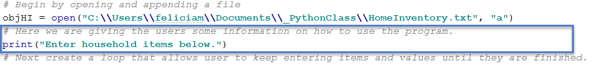

We accomplish this by using the print function and adding some text. In this case it was just a simple instruction to get the user started.

1. Next we create a loop that allows the user to enter as many items as they wish and stop when they type ‘Exit’

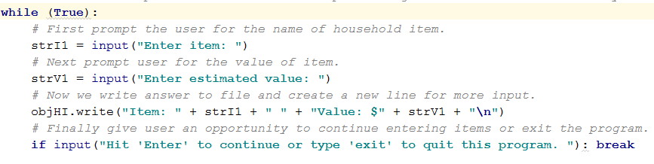

* The first prompt asks the user to enter and item and stores it as a string.
* The second prompt asks for the value of the item and stores it as a string.
* The next step is to write the data to the file we use the write function for this demonstrated in the line objHI.write(**"Item: "** + strI1 + **" "** + **"Value: $"** + strV1 + **"\n"**)
  + The “\n” in the code tells the program to start a new line

1. Finally we give our user the option to keep entering items or exit the program



This allows the user to hit ‘Enter’ to keep adding items and values. When they are finished they just need to type ‘Exit’

1. The file contents will look something like this.

