Matthew Feliciano

Instructor**:** Randal Root

IT FDN 100 A

18 July 2016

1. Creation steps
   1. Open PyCharm
   2. Open new Python file
   3. Create header – This tells you or future programmers what the code is doing and who wrote it.

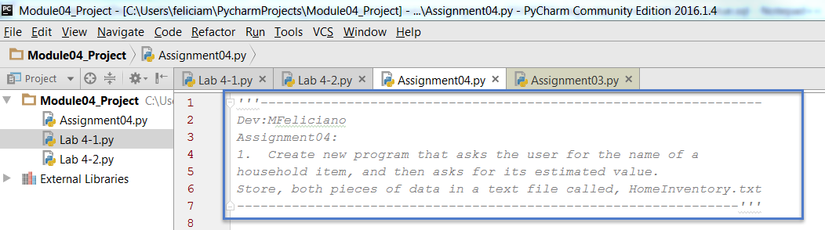

Headers are always a best practice no matter what type of code you are writing. It helps future programers, and yourself, to understand what the code is attempting to accomplish. Don’t forget to document any changes, the date they were made, and who made them. If someone inherits your code they will have a general idea of what it is doing.

1. Next we need to assign values to our variables

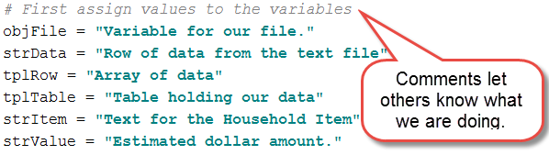

Here we are defining variables to be used later in our program.

1. Open the HomeInventory.txt file

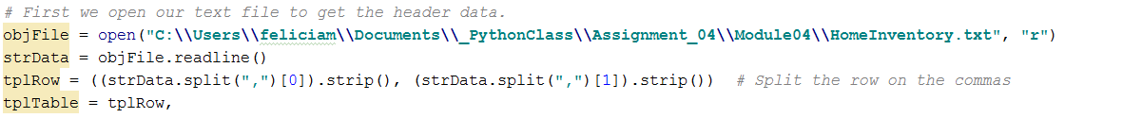

Here we are opening the file and striping out our header data

1. Now we are going to pull the rest of the rows currently in the table and store everything in our Tuple and close the file

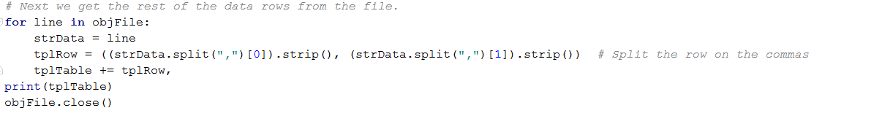

1. Here we are adding some instructions for the user.



1. Next we create a WHILE loop to gather the user input.

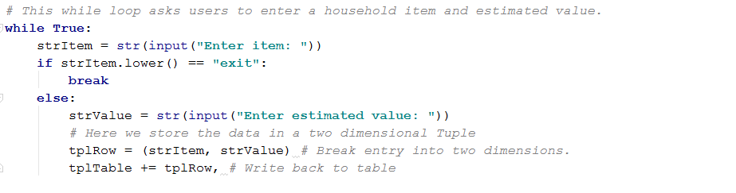

This loop is asking the user to enter an item (strItem) and its estimated value (strValue). This step gives the user an option to exit when they are finished.



1. This next section takes user input and either saves the file and exits the program or exits without saving.

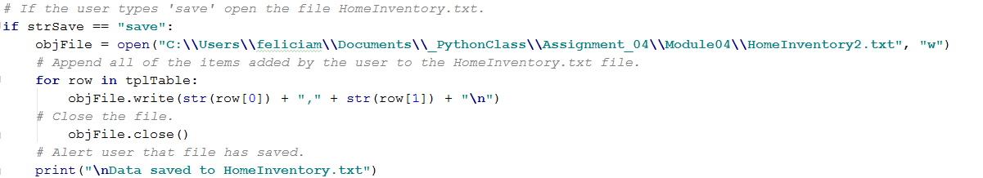

When the user types ‘save’ the program will:

* Open the HomeInventory.txt file
* Write back the data from the Tuple
* Close the file
* Let the user know that the data has been saved to HomeInventory.txt

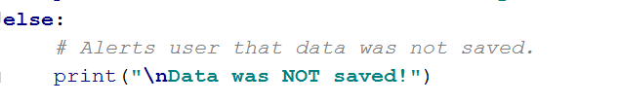

If the user hits ‘Enter’ instead the program exits and tells the user that the data was not saved.

1. The file contents will look something like this.

