Matthew Feliciano

Instructor**:** Randal Root

IT FDN 100 A

08 August 2016

1. Creation steps
   1. Open PyCharm
   2. Open new Python file
   3. Create header – This tells you or future programmers what the code is doing and who wrote it. (Note we are now using a standardized template)
   4. Since this is an update to previously created code we leave the original create data and update the ChangeLog

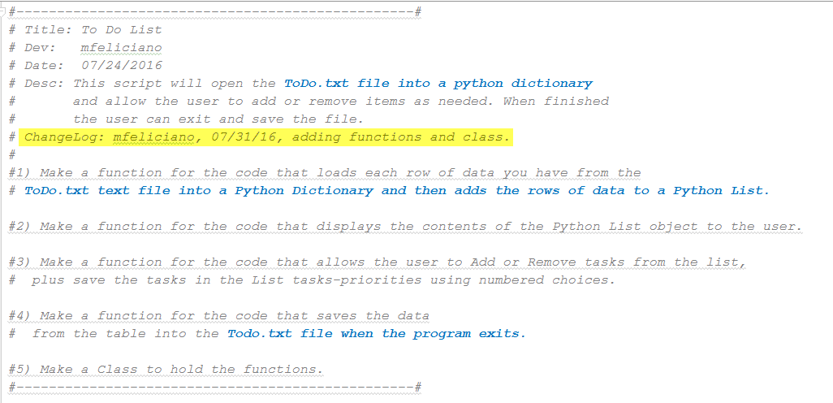

1. Next we need to assign values to our variables



Here we are defining variables to be used later in our program.

1. The Processing section of the template lets us know what the program is doing.
   1. In this update to the program we are adding functions that we can reuse
      1. Open the ToDo.txt file

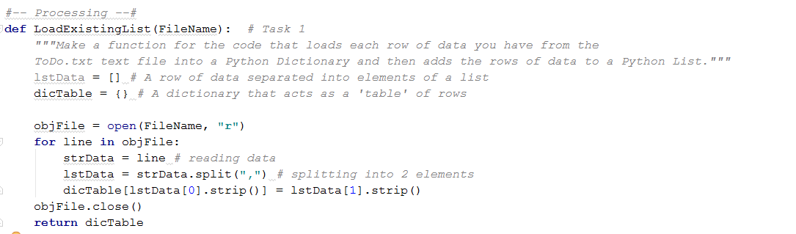

* + 1. Now we display what is currently in the file to the user.

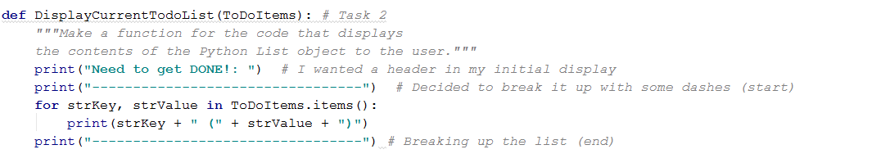

* + 1. Here we are giving our user options to select to update the file.

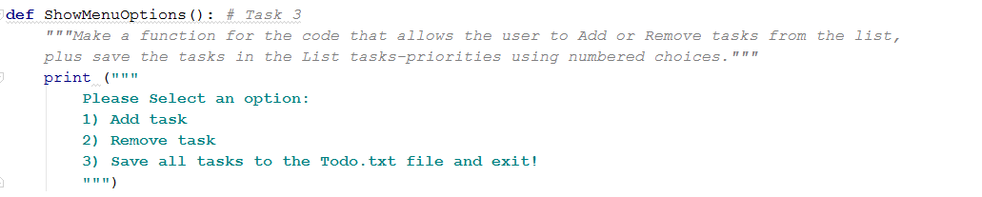

* 1. This next section tells the program what actions to take depending on the user’s selection.



1. Now that we are using functions we can move everything to the Input/Output (I/O) of the program.

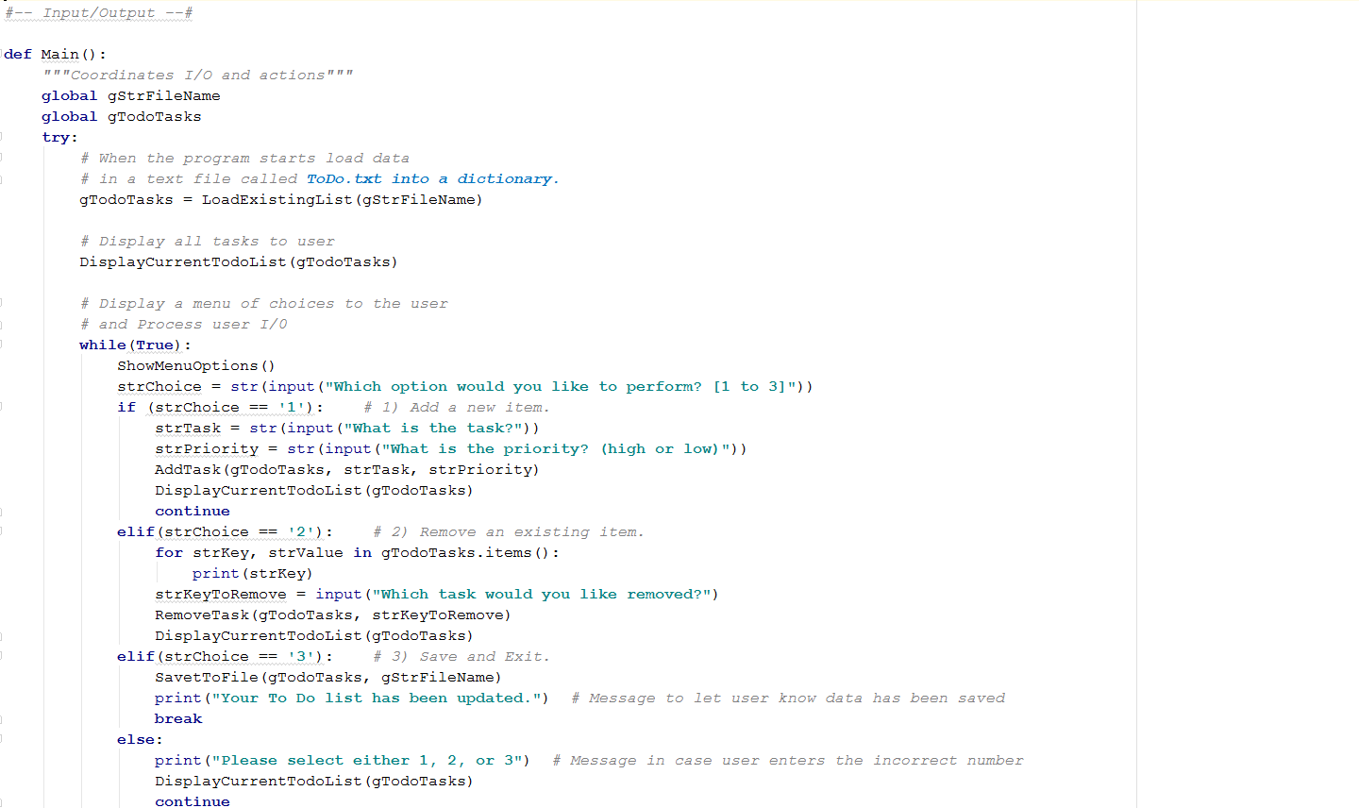

1. When the user selects option #3 the program will:

* Open the ToDo.txt file
* Write back the data from our Dictionary
* Close the file
* Print a message to the user saying the data was saved

1. The file contents will look something like this.

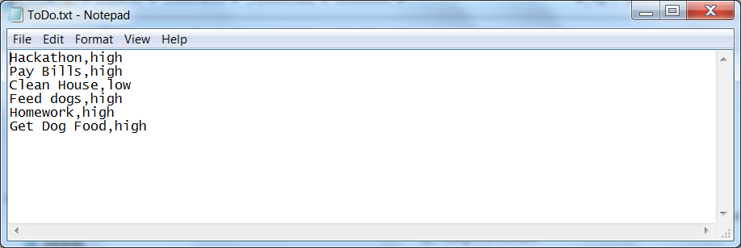

1. Python code
2. *#-------------------------------------------------#  
   # Title: To Do List  
   # Dev: mfeliciano  
   # Date: 07/24/2016  
   # Desc: This script will open the* ***ToDo.txt file into a python dictionary****# and allow the user to add or remove items as needed. When finished  
   # the user can exit and save the file.  
   # ChangeLog: (Who, When, What)  
   # None at this time  
   #-------------------------------------------------#  
     
   #-- Data  
   # First assign values to the variables  
   # objFile = "Variable for the file."  
   # strData = "Row of data from the text file"  
   # lstData = A row of data in a list  
   # dicTable = A dictionary to match 'Tasks/Priorities'  
   # strMenu = A menu of user options  
   # strOption = Option user selected  
     
   #--- User Input/Output to file  
   # Use a menu to get user input  
   # send output to a file  
     
   #--- Processing  
   # 1) When the program starts, load the each rows of data you have  
   # in* ***ToDo.txt text file into a python Dictionary.****# 2) Display all* ***todo items****# 3) Display menu to user  
     
   # 4) Add item to list  
     
   # 5) Remove item from list  
     
   # 6) Save tasks to* ***ToDo.txt file****#---------------------------------------*objFileName = **"C:\\Users\\feliciam\\Documents\\_PythonClass\\Module05\\ToDo.txt"**strData = **""**dicTable = {}  
     
   *# 1)*objFile = open(objFileName, **"r"**)  
   **for** line **in** objFile:  
    strData = line *# reading data* lstData = strData.split(**","**) *# splitting data into 2 elements* dicTable[lstData[0].strip()] = lstData[1].strip() *# loading into Dictionary*objFile.close()  
     
   *# 2)*print(**"Need to get DONE!: "**) *# I wanted a header in my initial display*print(**"------------------"**) *# Decided to break it up with some dashes***for** strKey, strValue **in** dicTable.items():  
    print(strKey + **" ("** + strValue +**") "**)  
     
   *# 3)***while**(**True**):  
    print(**"""  
    Please Select an option  
    1) Add task  
    2) Remove task  
    3) Save all tasks to the Todo.txt file and exit!  
    """**)  
    strOption = str(input(**"Which option would you like to perform? [1 to 3]"**))  
     
   *# 4)* **if** (strOption == **'1'**): *# Add task option selected* strTask = str(input(**"What is the task?"**))  
    strPriority = str(input(**"What is the priority? 'high or low'"**))  
    dicTable[strTask] = strPriority  
    **continue***# 5)* **elif** (strOption == **'2'**): *# Remove a task option selected* **for** strKey, strValue **in** dicTable.items():  
    print(strKey)  
    strKeyToRemove = input(**"Which task can be removed?"**)  
    **if** (strKeyToRemove **in** dicTable):  
    **del** dicTable[strKeyToRemove]  
    **else**:  
    print(**"Task not found."**)  
    **continue***# 6)* **elif** (strOption == **'3'**): *# Exit and save option selected* objFile = open(objFileName, **"w"**)  
    **for** strKey, strValue **in** dicTable.items():  
    objFile.write(strKey + **","** + strValue + **"\n"**)  
    objFile.close()  
    print(**"Your To Do list has been updated."**) *# Message to let user know data has been saved* **break**