Matthew Felicano
Instructor: Randal Root
IT FDN 100 A
4 July 2016

Create a new program that asks the user to input 2 numbers then prints out the sum, difference, product, and quotient.
'''-------------------------------------------------------
Dev:MFeliciano
LAB 2-1: Working with variables
1)Create a script using IDLE that add two numbers
together and then print the answers to the screen.
-------------------------------------------------------'''

#User input first value
strNumber1 = input('Enter the first number: ')
#User input second value
strNumber2 = input('Enter the second number: ')
#Convert to float and sum
fltSum = float(strNumber1) + float(strNumber2)
#Print result
print('The sum of', strNumber1, 'and', strNumber2, 'is: ', fltSum)
'''---------------------------------------------------------------------------
Dev:MFeliciano
1) Create a new program that asks the user to input 2 numbers then prints out
the sum, difference, product, and quotient.
---------------------------------------------------------------------------'''

#User input first value
strN1 = input('Enter the first number: ')

#User input second value
strN2 = input('Enter the second number: ')

#Convert to float and sum
fltSum = float(strN1) + float(strN2)

#Convert to float and subtract
fltDif = float(strN1) - float(strN2)

#Convert to float and multiply
fltPrd = float(strN1) * float(strN2)

#Convert to float and divide
fltQuo = float(strN1) / float(strN2)

#Print results
print('The sum of', strN1, 'and', strN2, 'is:', fltSum);
print('The difference between', strN1, 'and', strN2, 'is:', fltDif)
print('The product of', strN1, 'and', strN2, 'is:', fltPrd)
print('The quotient of', strN1, 'and', strN2, 'is:', fltQuo)

- Creation steps
  - Open IDLE
  - Create header – This tells you or future programmers what the code is doing and who wrote it.
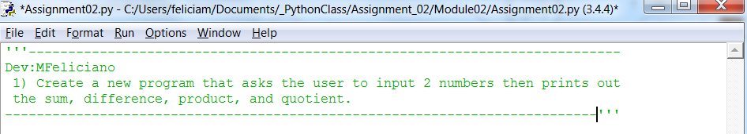
Creating a header is always best practice no matter what type of code you are writing. This helps future programers, and yourself, to understand what the code is attempting to accomplish. This is also a good place to document any changes, the date they were made, and who made them. Often times your code will be inherited by someone else or you will inherit code written by another programer.
- Write the code for user input of variables
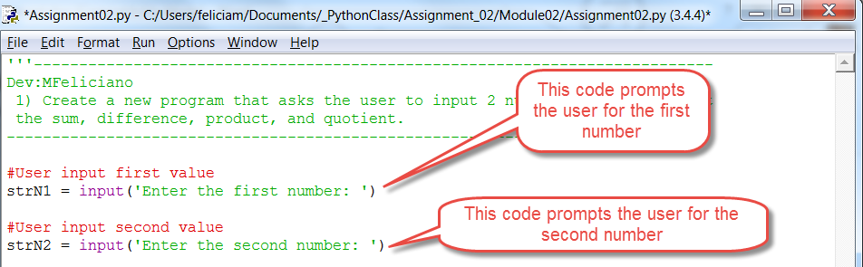
The input functions pause the program to allow the user to add values for the variables. Using ‘strN1’ and ‘strN2’ identifies the inputs as string values to programers who may read the code in the future. Making them as short as possible reduces the number of key strokes to write the program.
Notice there are comments in the code. This also let’s others know what your code is attempting to do. This is helpful if someone, including yourself, needs to debug your code.
- Write code to calculate the sum, difference, product, and quotient,
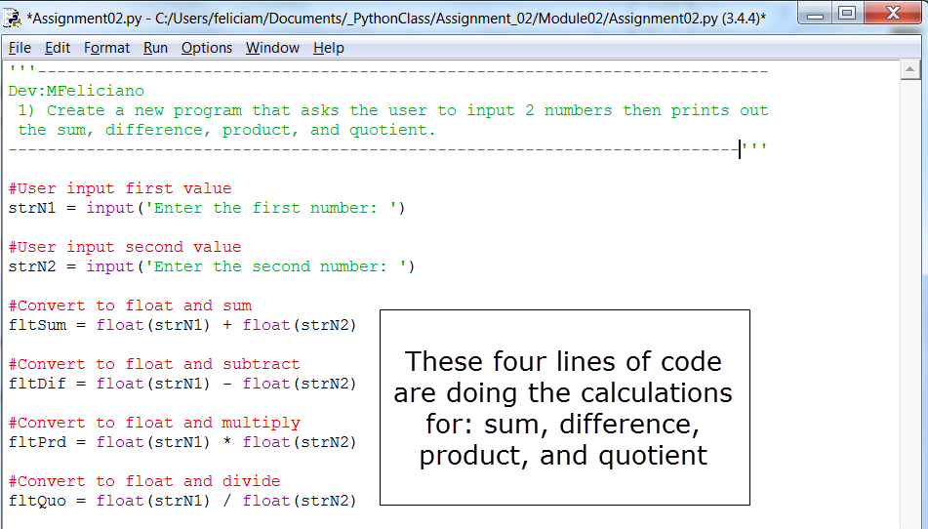
In this section we are converting our strings to floats and performaing the calculations on the values that the user inputs.

- Finally we are going to print the results of the user input to the screen
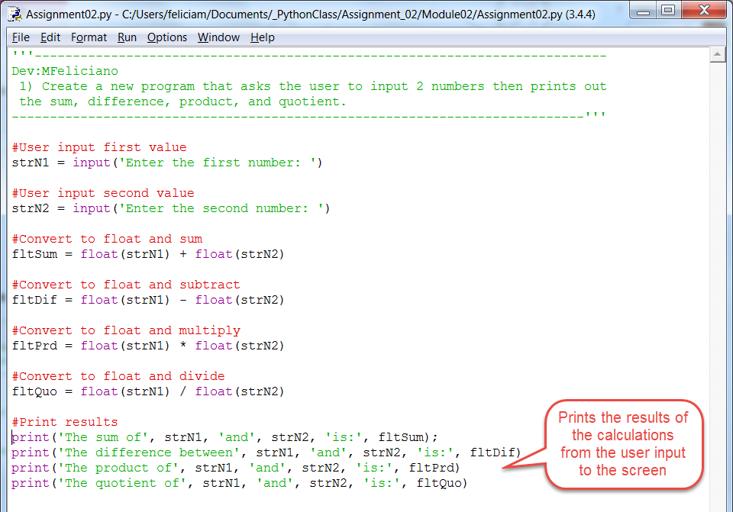
Each print function will reslut in a differnet output that is taken from users input and the previous calculations done above.
- The results will look something like this.
