Intro to Programming (Python)

Assignment 02:

Overview
In this activity you will learn about built-in functions and operators, and how you use them. You will also learn how to create your own demonstration scripts and document your knowledge. Your later documents will be reviewed by your peers, so practice making you document and code look professional.

This assignment will include the following:
- Watch the Module Videos:
- Review the following web pages:
- Watch the following videos:
- Apply your knowledge
- Document your knowledge
- Submit your work.

Step 1: Watch the Module Videos:
- Mod02-1-Module 02 Overview
- Mod02-2-What is Data?
- Mod02-3-Declaring Constants and Variables
- Mod02-4-Assigning Values
- Mod02-5-Choosing Data Types
- Mod02-6-Escape Characters
- Mod02-7-Line Continuation Character
- Mod02-8-Overloaded Methods
- Mod02-9-Concatenation
- Mod02-10-Operational Constructs
- Mod02-11-Lab 2-1 Starter
- Mod02-12-Lab 2-1 Answer
- Mod02-13-Value vs. Reference Types
- Mod02-14-Chapter 02 Review
- Mod02-15-Assignment 02 Starter
You can find these on my YouTube channel:
https://www.youtube.com/playlist?list=PLfycUyp06LG_Ui56yzznsHhfEosKZSahX

Step 2: Review the following web pages:
- http://www.learnpython.org/en/Variables_and_Types
- http://www.learnpython.org/en/Basic_Operators

Step 3: Watch the following videos:
- Variables - http://www.youtube.com/watch?v=667ZeuZ0Q8M

Step 4: Apply your knowledge
Now that you have reviewed the websites and videos, try to do the following tasks.
1) Create a new program that asks the user to input 2 numbers then prints out the sum, difference, product, and quotient.

Step 5: Document your knowledge
You have practiced simple python script that uses variables. You have also see how many other taught others to do the same. Now, create a simple document to outline the steps you took in performing this assignment. Make sure the document is in a Microsoft Word document (.doc or .docx).

NOTE: Make sure you put it in proper, college level, formatting! It does not have to be perfect, but if you turn in a simple blob of text, you will not get credit for it! Here is a link that may help you understand what I am looking for. At a minimum look at the pictures.

http://jerz.setonhill.edu/writing/academic1/mla-style-papers/

You have been warned!

Step 6: Submit your work.
Now upload the .doc or docx file to the class assignment page.

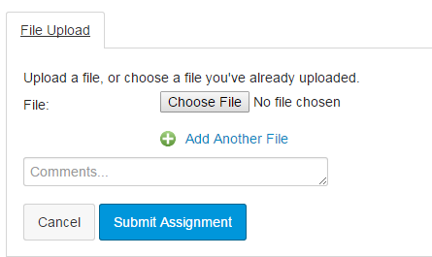

You are done!

