Intro to Programming (Python)

Assignment 03:

Overview
In this activity you will learn about typical programming statements and constructs. You will also learn about how to download, install, and use an Integrated Development Environment (IDE). Once again you will create your own scripts and document your knowledge. Your later documents will be reviewed by your peers, so practice making you document and code look professional.

This assignment will include the following:
- Watch the Module Videos:
- Review the following web pages:
- Watch the following videos:
- Apply your knowledge
- Document your knowledge
- Submit your work.

Step 1: Watch the Module Videos:
- Module03-1-Overview https://youtu.be/hqIk26JUYrs
- Module03-2-Using an Integrated Development Environment https://youtu.be/yUvGPA2TuXQ
- Module03-3-Pseudo Code https://youtu.be/VlAhNRmCacY
- Module03-4-Conditional Statements https://youtu.be/tjWQJZ5IiKg
- Module03-5-Lab 03-1 Starter https://youtu.be/oJq5kMcK9OQ
- Module03-6-Lab 03-1 Answer https://youtu.be/GVrGMcm3kGI
- Module03-7-Comparison Operators https://youtu.be/xsNI281xjhI
- Module03-7-Boolean Values https://youtu.be/s8nRRxIX-IU
- Module03-9-Loops https://youtu.be/kH6DKoZCZdU
- Module03-10-Program Arguments https://youtu.be/raozrHRP0yk
- Module03-11-Lab 03-2 Starter http://youtu.be/h2bwfL1pZ1g
- Module03-12-Lab 03-2 Answer http://youtu.be/h_W6BXU18N0
- Module03-13-Writing Data to a File https://youtu.be/hJyTCpB7yZI
- Module03-14-Lab03-3 Starter https://youtu.be/LdTV04rKSAQ
- Module03-15-Lab03-3 Answer https://youtu.be/7vIy_y3EDxM
- Module03-16-Chapter 03 Review http://youtu.be/4n6WLU4Xhbo
- Module03-17-Assignment 03 Starter http://youtu.be/sO1aS5hZtdM

Step 2: Review the following web pages:
- http://www.tutorialspoint.com/python/python_if_else.htm
- http://www.tutorialspoint.com/python/python_while_loop.htm
- http://www.tutorialspoint.com/python/python_files_io.htm

Step 3: Watch the following videos:
- Working with Files - http://videolecture.blogspot.com/2011/04/python-programming-tutorial-41-working.html

Step 4: Apply your knowledge
Now that you have reviewed the websites and videos, try to do the following task.

- Create a new program that asks the user for the name of a household item, and then asks for its estimated value. Store, both pieces of data in a text file called, HomeInventory.txt

Step 5: Document your knowledge
You have practiced simple python script that uses variables and writes data to a file. You have also seen how many other taught others to do the same. Now, create a simple document to outline the steps you took in performing this assignment. Make sure the document is in a Microsoft Word document (.doc or .docx).

NOTE: Make sure you put it in proper, college level, formatting! It does not have to be perfect, but if you turn in a simple blob of text, you will not get credit for it! Here is a link that may help you understand what I am looking for. At a minimum look at the pictures.

http://jerz.setonhill.edu/writing/academic1/mla-style-papers/

Step 6: Submit your work.
Now upload the .doc or docx file to the class assignment page.

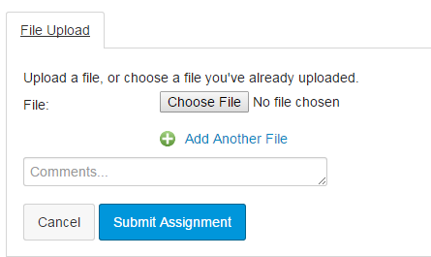

You are done!

