Intro to Programming (Python)

Assignment 04:

Overview
In this activity you will learn to work with for loops and tuples. Once again you will create your own scripts and document your knowledge. Your documents will be reviewed by your peers, so make your document and code look professional.

This assignment will include the following:
- Watch the Module Videos:
- Review the following web pages:
- Watch the following videos:
- Apply your knowledge
- Document your knowledge
- Submit your work.
- Post your document
- Perform a Peer Review

Step 1: Watch the Module Videos:
https://www.youtube.com/playlist?list=PLfycUyp06LG-pBmX3NqLG8ehmUhseoCNu

Step 2: Review the following web pages:
http://www.tutorialspoint.com/python/python_tuples.htm
http://en.wikibooks.org/wiki/Python_Programming/Tuples

Step 3: Watch the support videos:
http://www.youtube.com/watch?v=R8mOaSIHT8U&feature=related

Step 4: Apply your knowledge
Now that you have reviewed the websites and videos, try to do the following task.

- Create new program that asks the user for the name of a household item, and then asks for its estimated value. (This project is similar to the last one!)
- Ask the user for new entries and stores them in the 2 dimensional Tuple.
- Ask the user, when the program exits, if they would like to save/add the data to a text file called, HomeInventory.txt.

Step 5: Document your knowledge
Create a simple document to outline the steps you took in performing this assignment. Make sure the document is in a Microsoft Word document (.doc or .docx).

NOTE: Make sure you put it in proper, college level, formatting!

Step 6: Submit your work
Now upload the .doc or docx file to the class assignment page.

Step 7: Post your document
In this module you need to post your document in the discussion forum so that others may review it. Just add your word document to the “Assignment 04 Documents for Review” discussion forum as shown in here:

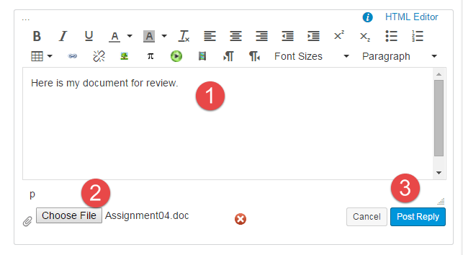

Step 8: Perform a Peer Review
You will be randonly assigned a review parter by Canvas after the assignment due date. Please read the assignment turned in by this student and comment on the discussion forum.

- One thing that you liked about their paper
- One thing that could make the paper better

You are done!

