Intro to Programming (Python)

Assignment 05:

Overview
In this activity you will learn to work with for Lists and Dictionaries. Once again you will create your own scripts and document your knowledge. Your documents will be reviewed by your peers, so make your document and code look professional.

This assignment will include the following:
- Watch the Module Videos.
- Review the following web pages.
- Watch the following videos.
- Apply your knowledge.
- Document your knowledge.
- Submit your work.
- Post your document.
- Perform a Peer Review.

Step 1: Watch the Module Videos:
https://www.youtube.com/playlist?list=PLfycUyp06LG9I4194n8OvgCbmEXQt3a8z

Step 2: Review the following web pages:
http://en.wikibooks.org/wiki/Non-Programmer's_Tutorial_for_Python_2.6/Lists

http://www.bogotobogo.com/python/python_dictionaries_tuples.php

http://www.afterhoursprogramming.com/tutorial/Python/Reading-Files/

(Remember these additional links are to give you a different opinion / viewpoint of the material we are covering. You only need to review the web pages to see what is out there as a resource. You do not need to read them thoroughly. The idea is to expose you to many different ways of looking at these topics and provide you will links to sites you can use in the future.)

Step 3: Watch the support videos:
Reading from a text file.
https://youtu.be/m0o0CkYsDzI

Step 4: Apply your knowledge
Now that you have reviewed the websites and videos, try to do the following task. (This project is similar to the last one!) This time, you will Create new script that manages a "ToDo list." The ToDo file will contain two columns of data (Task, Priority) which you will store in a Python Dictionary. Each Dictionary will represent one row of data. Which will then be added to a Python List to create a table of data.

- Create a text file called Todo.txt using the following data:

Clean House,low
Pay Bills,high

- When the program starts, load the each rows of data you have in the ToDo.txt text file into a python Dictionary.

Tip: You can use a for loop to read a single line of text from the file and then place the data into a new dictionary object.

- After you get a row of data add it to a Python List object (now the data will be managed as a table or two dimensional array).
Pro
- Display the contents of the List to the user.

- Allow the user to Add or Remove tasks from the list, plus Save the tasks in the List tasks-priorities using numbered choices. Something like this would work:

print ("Choose 1 to Add task")
print ("Choose 2 to Remove task")
print ("Choose 3 to Save all tasks to the Todo.txt file and exit!")

- Save the data from the table into the Todo.txt file when the program exits.

Step 5: Document your knowledge
Create a simple document to outline the steps you took in performing this assignment. Make sure the document is in a Microsoft Word document (.doc or .docx).

NOTE: Make sure you put it in proper, college level, formatting!

Step 6: Submit your work
Now upload the .doc or docx file to the class assignment page.

Step 7: Post your document
In this module you need to post your document in the discussion forum so that others may review it. Just add your word document to the “Assignment 05 Documents for Review” discussion forum as shown in here:

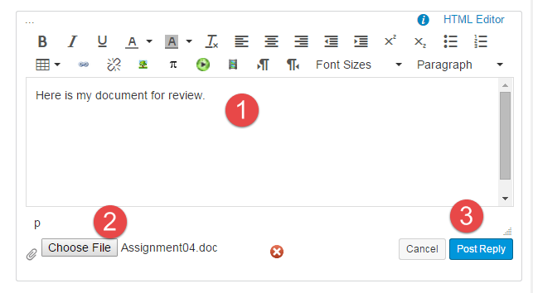

Step 8: Perform a Peer Review
You will be randonly assigned a review parter by Canvas after the assignment due date. Please read the assignment turned in by this student and comment on the discussion forum.

- One thing that you liked about their paper
- One thing that could make the paper better

You are done!

