Intro to Programming (Python)

Assignment 06:

Overview
In this activity you will learn to work with functions. Once again you will create your own scripts and document your knowledge. Your documents will be reviewed by your peers, so make your document and code look professional.

This assignment will include the following:
- Watch the Module Videos.
- Review the following web pages.
- Watch the following videos.
- Apply your knowledge.
- Document your knowledge.
- Submit your work.
- Post your document.
- Perform a Peer Review.

Step 1: Watch the Module Videos:
Module 06 Playlist:
https://www.youtube.com/playlist?list=PLfycUyp06LG-7xrsqU6kCTOXr2TLDPgD2

Step 2: Review the following web pages:
http://www.tutorialspoint.com/python/python_functions.htm

http://www.learnpython.org/en/Functions

(Remember these additional links are to give you a different opinion / viewpoint of the material we are covering. You only need to review the web pages to see what is out there as a resource. You do not need to read them thoroughly. The idea is to expose you to many different ways of looking at these topics and provide you will link to sites you can use in the future.)

Step 3: Watch the support videos:
Creating Functions: https://youtu.be/qO4ZN5uZSVg

Step 4: Apply your knowledge
Now that you have reviewed the websites and videos, try to do the following task. (This project is VERY similar to the last one!). This time you will place the code you created for working with your ToDo.txt file into Functions and a Class. (If you had problems with the last one, remember my review video is available!)

- Make a function for the code that loads each row of data you have from the ToDo.txt text file into a Python Dictionary and then adds the rows of data to a Python List.

- Make a function for the code that displays the contents of the Python List object to the user.

- Make a function for the code that allows the user to Add or Remove tasks from the list, plus save the tasks in the List tasks-priorities using numbered choices.

- Make a function for the code that saves the data from the table into the Todo.txt file when the program exits.

- Make a Class to hold the functions.

Step 5: Document your knowledge
Create a simple document to outline the steps you took in performing this assignment. Make sure the document is in a Microsoft Word document (.doc or .docx).

NOTE: Make sure you put it in proper, college level, formatting!

Step 6: Submit your work
Now upload the .doc or docx file to the class assignment page.

Step 7: Post your document
In this module you need to post your document in the discussion forum so that others may review it. Just add your word document to the “Assignment 06 Documents for Review” discussion forum as shown in here:

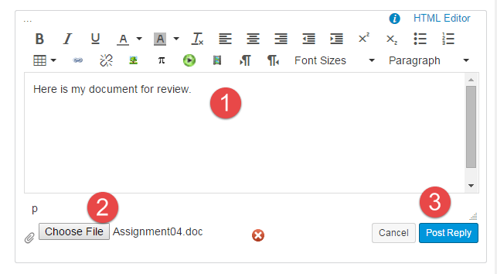

Step 8: Perform a Peer Review
You will be randonly assigned a review parter by Canvas after the assignment due date. Please read the assignment turned in by this student and comment on the discussion forum.

- One thing that you liked about their paper
- One thing that could make the paper better

You are done!

