Software Requirements Specification
For
TrackMe
Version 1.0 approved
Prepared by Matthew Finn
4/11/2016

Table of Contents
Table of Contents ii
Revision History iii
1. Introduction 1
1.1 Purpose 1
1.2 Document Conventions 1
1.3 Intended Audience 1
1.4 Product Scope 1
1.5 References 2
2. Overall Description 2
2.1 Product Perspective 2
2.2 Product Functions 2
2.3 User Classes and Characteristics 4
2.4 Operating Environment 5
2.5 Design and Implementation Constraints 6
2.6 User Documentation 6
2.7 Assumptions and Dependencies 6
2.8 State of the art 7
3. External Interface Requirements 9
3.1 Sample User Interfaces 9
3.2 Hardware Interfaces 12
3.3 Software Interfaces 12
3.4 Communications Interfaces 13
4. System Features 13
4.1 User Registration 13
4.2 User Profile 14
4.3 GPS Settings 14
4.4 TrackMe (Request to be tracked) 15
4.5 Fall Detection 16
4.6 Messaging 17
4.7 Contacts 18
4.8 Help 19
4.9 Social Media Account Integration 19
4.10 DB Management Web Service 20
4.11 Real Time Data Analytics 21
5. Other Nonfunctional Requirements 22
5.1 Performance Requirements 22
5.2 Safety Requirements 22
5.3 Security Requirements 22
5.4 Software Quality Attributes 22
6. Project Milestones 23

Revision History
Date | Description | Version
23/10/16 | Draft | 0.1
2/11/16 | Draft II | 0.2
4/11/16 | Version 1.0 Approved | 1.0

Introduction

Purpose
The purpose of this Software Requirements Specification (SRS) document is to provide a comprehensive description of the intended features & functionality of the TrackMe application. This document will cover software, hardware, preliminary design of the application’s User Interface (UI) and any other relevant technical dependencies.

Document Conventions
This document is intended as a set of requirements but also contains some technical information along with description of some requirements.
This document contains vocabulary that readers may not be unaccustomed to.
Term | Definition
TrackMe DB | The MySQL database hosted on a Linux server that stores all TrackMe user data
P2P | Peer to peer communication between 2 devices.

Intended Audience
This document is intended for individuals involved in the development or supervision of the TrackMe application. This would include any individuals working on the development of the project, the project supervisor (Dr. Des Chambers) and any members of the NUI Galway IT faculty or other organisations that may be involved in the final year project process.

Product Scope
The goal of this project is to design and develop an application that utilises the unique capabilities of smartphone devices. The application in this case will be used to aid personal security for vulnerable adults and children. The application could use various mechanisms to help with this including active periodic check-ins from the device itself, remote monitoring of device location, and detecting lack of movement or movement outside certain boundaries depending on the requirements of individuals being monitored. The application will be enhanced with backend server and management capabilities.

References
[1] | Android Developers . 2016. | Android Developers . [ONLINE] Available at: https://developer.android.com/guide/topics/manifest/uses-sdk-element.html.

[2] Fluid UI. 2016. Fluid UI - Free web and mobile app prototyping. [ONLINE] Available at: https://www.fluidui.com.

[3] BSafe - Personal Safety App - Android Apps on Google Play. 2016. BSafe - Personal Safety App - Android Apps on Google Play. [ONLINE] Available at: https://play.google.com/store/apps/details?id=com.bipper.app.bsafe&hl=en.

[4] EmergenSee - Personal Safety - Android Apps on Google Play. 2016. EmergenSee - Personal Safety - Android Apps on Google Play. [ONLINE] Available at: https://play.google.com/store/apps/details?id=com.emergensee&hl=en.

Overall Description

Product Perspective
The TrackMe application is designed for use on android mobile devices. The mobile application will be the main focus of the project but there will also be a server-side web application that will manage the administration of the database (DB) containing user profile information. The project comprises of both the android mobile client-side application and the server side functionalities that are included in detail in this document.

Product Functions
The list below gives an outline of the main features of the TrackMe application. There are 2 categories of features discussed in the outline below: Core features and additional features. The core features discussed are features that are essential to the operation of the application whereas the additional features are new functionalities that will be added to the application if time permits as the project progresses.

Core Features

- User Registration

- The ability for users to register an account for the TrackMe application.

- User Profile

- The ability to configure profile details and choose from various default profile types.

- Location Settings

- The ability to track a users location through either GPS or GSM.

- TrackMe (Request To Be Tracked)

- The ability to send a request to another user asking them to track your location.

- Fall Detection

- The ability to enable fall detection

- Messaging Settings

- The ability for the application to be able to send messages through various possible platforms in case of emergency.

- Contacts

- The abilty to have a list of contacts within the TrackMe application

- Help Menu

- The ability to access guidelines for configuring the application.

- Push Notifications

- The ability to show push notifications on the Android OS home screen.

Additional Features

- Social Media Account Integration

- The ability for a user to link various social media platforms with their TrackMe account and post updates to these social media accounts

- DB Management Web Service

  - Development of a web service to administer the DB where information of all users of the application is stored.

- Real Time Data Analytics

- The ability to read and analyse real time user location data.

User Classes and Characteristics
All user classes are equally important to satisfy in the development of this product.
The 3 main user classes that this application is to be aimed at are as follows:

- Teenager->Adult (Aged 16+)
- This type of user decides when they want to use the application.

- All configuration access is granted to this type of user so they can choose exactly how they’d like to use the application.

- They have a higher than average (average meaning average across population) technical expertise with the use of smartphones.

- Young Teen (Aged 12 - 16)
- Don’t have configuration access to application GPS tracking configuration once it is configured by their parent/guardian.

- Technically proficient with smartphones but not at the same level of expertise as the “Teenager->Adult” user class.

- Elderly Person (Of Retirement Age +)
- Level of technical expertise is assumed to be lower than average

- All configuration access granted to this type of user, can change emergency contact details and which features of the application and enabled (Fall Detection, GPS Tracking)

Operating Environment
The main component of the TrackMe project is the application that will be limited to the Android OS.
The application will be a self-contained unit and will not rely on any other Android-related software components.
The application will be built with “Minimum SDK Version 15” and “Target SDK Version 24”.
The table below that the application will be compatible with android platform version 4.0.3 up to version 7.0. [1]
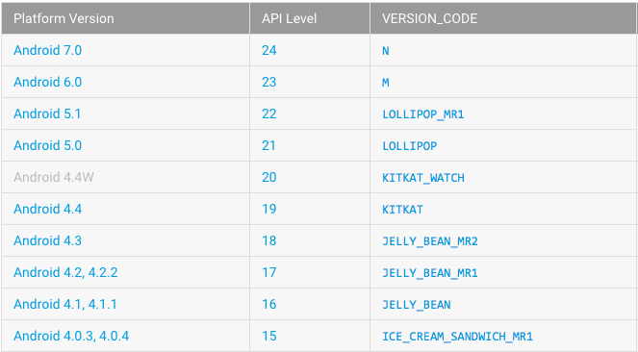

The application will frequently interact with a Linux server hosted by the IT department in NUI Galway. The TrackMe DB will be stored on the server using MySQL.

Design and Implementation Constraints
Limited screen size & resolution will be a major design consideration as the application will be designed with mobile devices, particularly smartphones, in mind.
The creation of a user interface that is both effective and easy to navigate will be a challenge.
Another consideration is the effect of using mobile data & location services on battery consumption. The application should be designed to be as efficient as possible whilst using mobile data and location services.
Phone storage is also a constraint that should be considered as storage space on mobile devices is often highly limited.
Other constraints such as limited memory and processing power should be considered throughout the development of this application.

User Documentation
There will be a “Help” section in the proposed application. Explains all aspects of configuring the application for each user profile type.

Assumptions and Dependencies
Hardware
Some of the features of the application rely on hardware components present in Android handsets.
Features that use these hardware components will be entirely reliant on the ability to access these functionalities such as:

- GPS tracking will be reliant on the handset’s location sensors.
- Fall detection will be reliant on the handsets accelerometer and the ability for it to be used when the phone screen is turned off.

External
- The applications feature is dependent on the ability to access the SMS message-sending feature of the handset.
- The ability to link social media accounts to the user profile is dependent on the user permissions defined and if they allow access to social media applications such as Facebook, Twitter, Viber, Whatsapp.

State of the art
Similar Applications

In my research of application that provide similar functionality to the proposed features of TrackMe I have found both bSafe and emergensee. Both applications are android based personal security applications and share many features with TrackMe.

BSafe features [3]
- Social Personal Safety Network
- Location Sharing
- Location Tracking (Similar to TrackMe feature of TrackMe application)
- Location Check-In
- Check-In Timer
- Fake Call Triggers
- Guardian Alert Button

Emergensee features [4]
- Live streaming of video & audio
- GPS location data
- Preset timer for check-in
- Text & email distress notifications
- Incident recording capability
- 24/7 monitoring
- Real-time precautionary escort
- Pre-set safety contacts

Proposed Technologies used in TrackMe Application

Location Tracking
- Implemented could be achieved using GPS location sensors on phone when location services are activated.
- Implemented could be achieved using phone network provider when GPS is turned inactive.

Fall Detection
- Implementation could be achieved using hardware based accelerometer and gyroscope sensors and software based sensors such as linear accelerometer and rotation vector sensor

Sending P2P Requests
- Implementation of request sending could be achieved using the Session Initiation Protocol API.

Storage
- On device storage could be implemented using SQLite databases as android development provides full support for their usage.
- The external database implementation of the main TrackMe DB will be implemented using a MySQL database on a Linux server.

External Interface Requirements

Sample User Interfaces
Below are sample user interface mockups of the main features of the application. [2]

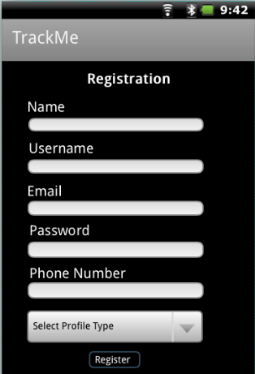
User Registration

- Appears once upon initial download of the application.

- Prompts user to enter their account details.

- Notifies user if information provided is invalid.

Home Screen
- Users can access all of the applications features from this menu such as:

  - TrackMe (Request to be tracked)
  - Their profile information
  - GPS Settings Menu
  - Messaging Settings menu
  - Fall Detection Settings
  - Their Contacts
  - Notification Settings Menu
  - Help menu where they can get help using the application
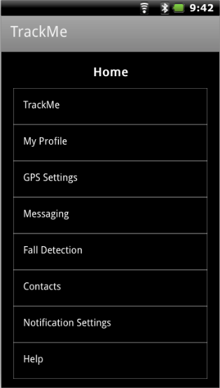

TrackMe Configuration
- Users can request to be tracked by another user of the application in this menu. It allows user to:
  - Enable their phone to be tracked
  - “Track Now” allows users to track other users they’ve been requested to track.
  - Choose the contact they wish to request to track them.
  - Configure how often location updates are sent.
  - Send the request to the contact they’ve chosen.

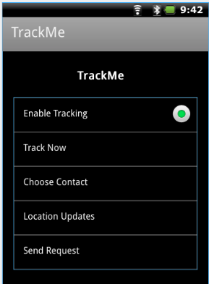

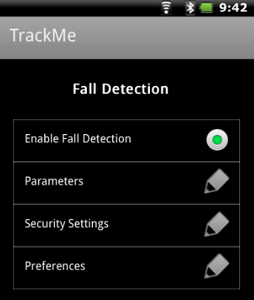
Fall Detection

- Users can configure fall detection from this menu:

  - Enable Fall Detection

  - Set Fall Detection Parameters

  - Enable Security Settings

  - Configure Preferences

GPS Settings

- Users can configure their GPS settings from this menu:
  - Enable Mobile data usage

  - Enable GSM data usage

  - Set location update preferences

  - Update location co-ordinate boundaries.

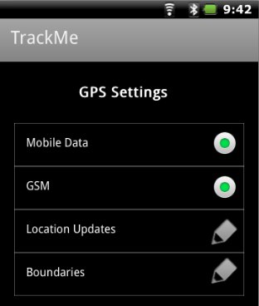

Messaging

- Users can configure all messaging accounts & preferences in this menu such as:

  - SMS settings

  - Facebook Settings

  - Viber Settings

  - Whatsapp Settings

  - Preferences i.e. Messaging application of choice, message content

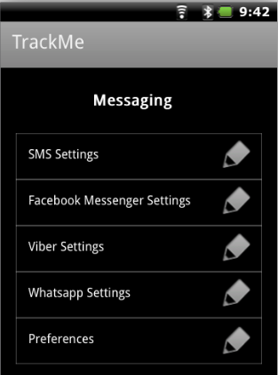

Hardware Interfaces
TrackMe is an Android-based application and will be designed to run solely on Android devices.
All data surrounding location updates will be pushed to and pulled from the main TrackMe server. TCP/IP and HTTP protocols are intended on being used to handle transfer of this information.
There is also a possibility of using direct P2P communication between android devices but the feasibility of this is yet to be determined.
TrackMe is being implemented to run on Android version 4.0.3 (Ice-Cream Sandwich) and any later versions of Android OS.
Messages will be sent through Mobile Data, Wi-Fi or SMS depending on the preferences and configuration of the user account.

Software Interfaces
Development of the TrackMe application will be carried out using the Java Development Kit (JDK) and the Android Software Development Kit (SDK).

Data Transfer
Outgoing data will be in the form of location co-ordinate updates.
Incoming data will be in the form of user location data received from the TrackMe server when tracking another users location.

Communication
The application will rely on pulling and pushing data to and from the TrackMe server.
- Examples of items that can be pushed to server:
  - New user account created
  - Location Update
  - Changes to user account details
- Examples of items that can be pulled from server:
  - Location updates of user being tracked.

Communications Interfaces
The application will have a HTTP web-based server. This server will store all of the data for each user account. A user’s android device will push updates to this server as often as specified in their configuration. A user will also be able to sync the most up to date data from this server when tracking another users location.

System Features
Core Features

User Registration
4.1.1 Description
Upon initial installation of the application and opening it for the first time the user will be shown the user registration screen.
The interface prompts the user for details:
- Name
- Username
- Email
- Password
- Password Confirmation
- Phone Number
- Account Type
Once the user presses the Register button a new user is created on the TrackMe DB server.
4.1.2 Stimulus/Response Sequences
  - Launch TrackMe application for the first time.
  - Enter all registration details.
  - User details pushed to TrackMe server.
  - Application transitions to home menu.
4.1.3 Requirements
- Valid email address format.
- Password confirmation must match password.
- User information must be transferred and stored securely.

User Profile
4.2.1 Description
The user profile interface allows users to view and edit their information.
If a user updates any of the details of their profile their information is pushed to the TrackMe server.
4.2.2 Stimulus/Response Sequences
- User selects My Profile from the Home screen
- User can select edit button on any field.
- User updates the field(s) selected.
- Updated user details are pushed to TrackMe server
4.2.3 Requirements
- User information must be transferred and stored securely.

GPS Settings
4.3.1 Description
The GPS Settings screen allows the user to set preferences regarding their location tracking and what is used to obtain their location.

4.3.2 Stimulus/Response Sequences
- User selects GPS Settings from Home Screen
- User can update various GPS Settings:
    - Enable/Disable Mobile Data
    - Enable/Disable GSM
    - Configure Location Updates
    - Configure boundaries (Identify what constitutes irregular activity
- Updated user details are pushed to TrackMe server.
4.3.3 Requirements
- User information must be transferred and stored securely.

- Location sensors on Android device must be functional in order to obtain accurate updates for GPS settings

TrackMe (Request to be tracked)
4.4.1 Description
The TrackMe interface allows users to send a request to another user to track their location updates. It also enables users to track a user they’ve been requested to track.
4.4.2 Stimulus/Response Sequences
- User selects TrackMe from Home screen
- User enables tracking
- User can configure TrackMe configuration such as:
  - Choose contact to track them
  - Configure frequency of location updates
- Send Request to be tracked
4.4.3 Requirements
- Request to be tracked must be sent securely through a reliable communication channel.
- Location sensors on Android device must be functional in order to obtain accurate location updates.

Fall Detection

4.5.1 Description
The Fall Detection Menu allows a user to define parameters and security settings for the fall detection feature of the TrackMe application.

4.5.2 Stimulus/Response Sequences
- User selects Fall Detection from Home Screen.
- User can configure fall detection parameters such as
  - Enable/Disable fall detection
  - Define parameters that identify irregular activity
  - Configure security preferences such as notification settings upon irregular activity.
4.5.3 Requirements
- Accelerometer must be functional in order to detect a fall.

- Location sensors on Android device must be functional in order to obtain accurate location updates upon sensing irregular activity

Messaging
4.6.1 Description
The messaging screen allows users to link social media accounts and set their messaging preferences.
4.6.2 Stimulus/Response Sequences
- User selects messaging from the home screen
- User can configure settings for the following forms of messaging
  - SMS
  - Facebook
  - Viber
  - Whatsapp
- User can configure messaging preferences such as primary messaging method and warning message sent upon detection of irregular activity.
- Updated configurations are pushed to TrackMe DB

4.6.3 Requirements
- Active internet connection required to link social media accounts.
- Integration of social media accounts available.
- User data is encrypted & sent securely to the TrackMe DB.

Contacts
4.7.1 Description
The contacts interface allows users to add contacts to their profile.

4.7.2 Stimulus/Response Sequences
- User presses contacts on home screen.
- User adds new contact.
- User edits details of existing contact.
- User syncs phone contacts and new contacts appear.
- Updates to contacts synced to TrackMe DB.

4.7.3 Requirements
- Access granted to phone contacts.

Help
4.8.1 Description
The help menu gives user information about how to use the application and configure parameters for application features such as GPS settings and fall detection.
4.8.2 Stimulus/Response Sequences
- User chooses Help from home screen.
- User can read about application configuration for various features such as:
- GPS Settings
- Fall Detection
- Messaging
- Profile Types
4.8.3 Requirements
- Tutorials on each of the applications features available to user.

Additional Features

Social Media Account Integration
4.9.1 Description
The social media integration feature will give users the ability to link various social media platforms to their TrackMe account.

4.9.2 Stimulus/Response Sequences
- User accesses social media menu from home screen.
- User chooses social media account to link to their TrackMe account i.e. Facebook, Twitter etc.
- Updated user data is securely pushed to the TrackMe DB.
- User can update social media account status & check-in at a location through their TrackMe application.
4.9.3 Requirements
- User allows TrackMe application to access social media account.

DB Management Web Service
4.10.1 Description
The database manage web service feature will give administrators of the application the ability to manage the main TrackMe DB on the Linux server through a web service.
4.10.2 Stimulus/Response Sequences
- Administrators of the TrackMe application log into database web portal.
- Admin can add or remove users from the system
- Admin can edit user details.
- Updates are saved to TrackMe DB
4.10.3 Requirements
- Login security is high so user data is safe.

Real Time Data Analytics
4.11.1 Description
This feature will involve performing data analytics on real time user location data in order to help improve identification of irregular activity by dynamically updating more frequently visited locations.
4.11.2 Stimulus/Response Sequences
- While the application is tracking user location and pushing data to the TrackMe DB data analysis will be carried out on the data collected
b. Analysis may include:
- Analysis of most visited location among demographics
- Better identification of irregular activity
4.11.3 Requirements
- Ensure proper usage of user data.
- Ensure safety of user data.

Other Nonfunctional Requirements

Performance Requirements
The TrackMe application will be using sensors on handsets that can often be very intensive in their battery usage i.e. location sensors for GPS and the accelerometer. More efficient ways to use these sensors will need to be considered when using these hardware features.

Safety Requirements
As this application is designed with the safety of its’ users in mind it is fundamental that the application is thoroughly tested and can reliably identify situation in which in needs to send an alert. It is also necessary to avoid as many false positives as possible as this will undermine the reliability and reputation of the application.

Security Requirements
Security is of utmost importance to this application as it is dealing with data regarding user location. It is fundamental that this data is only seen by its’ intended audience as any breach of this would undermine the applications’ reputation.
It is also necessary to have a high level of security when dealing with other user details such as phone number, email and other social media account details as these are not details that would ever be intended for public domain.

Software Quality Attributes
The code for the TrackMe application must have a high level of testability. This would help ensure that the product is of a high quality. Ideally the codebase should be highly extensible making implementation of updates to the application easier thus allowing further development of the application to be manageable. Another less important attribute would be the portability of the application between platforms such as iOS and Windows.

Project Milestones
Milestone | Date | Comment
SRS Document | 4/11/16 | Due date from software requirements specification document.
Functional Beta Demo | Early February | A version of the application with some core functionality available to be demoed.
Full functioning application demo | Late March | A full version of the application with all core features and possibly some additional features implemented.
Project Bench Demonstration | April 17 | A demonstration of the application to be reviewed as part of my final year project.
Final Project Report | April 17 | A report on the project development process.
Project Vive Voce | April 17 | An assessment of the project via interview.

