Matthew Flavin

CS 478

Assignment 5

4/30/21

1. The two Python scripts ‘client.py’ and ‘server.py’ create a connection via sockets, allowing the client to send a .png image to the server, and the server will classify it as either rock, scissors, or paper. The model used is a TensorFlow sequential mode trained with images of hands forming rock, paper, and scissors on a white background. The connection is created via sockets using Python standard libraries. The scripts are dependent on having TensorFlow, NumPy and Keras libraries installed.
2. In order to use this set of scripts, two .bat files have been provided. The user only needs to open the .bat files to use the program.
   1. Open server.bat
   2. Open client.bat
   3. Ensure .png files are in the same directory as the .py files. Three have been provided: scissors1.png, rock1.png, paper1.png.
   4. To use an image on the model hosted by the server, simply type the name of one of the images, for example: client paper1.png
   5. The server will return the classification of the image.
   6. To quit, type ‘quit’.
   7. For extra instructions, type ‘help’.

**SCREENSHOTS OF EXAMPLES ON NEXT PAGE**

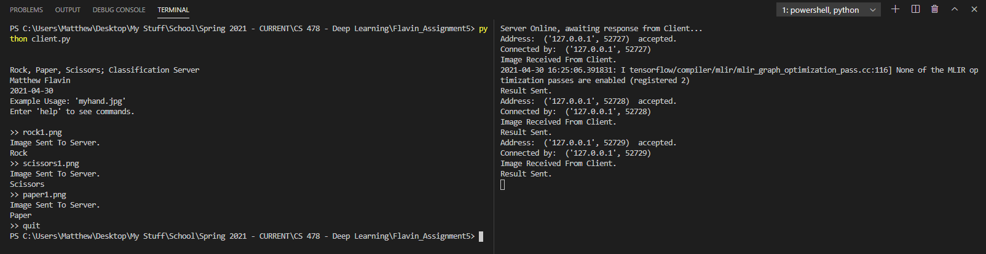

Client and Server Example 1

Showing use of the model on three images.

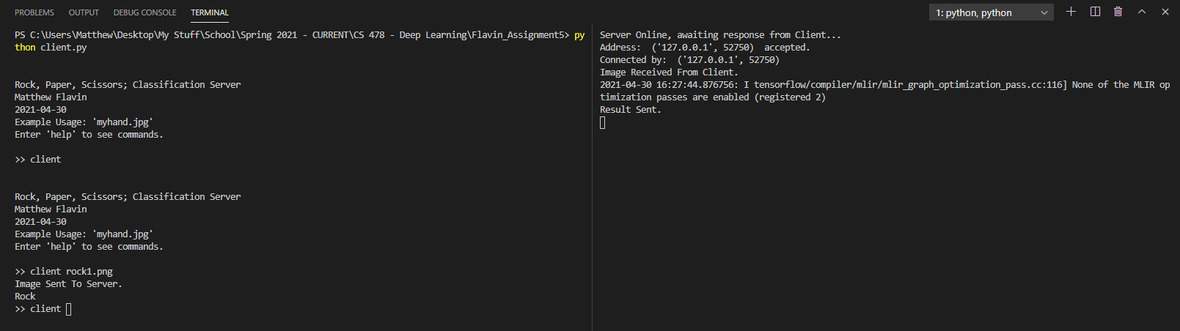

Client and Server Example 2

Usage of the default ‘client’ command