Mini Prediction Machines

System Components

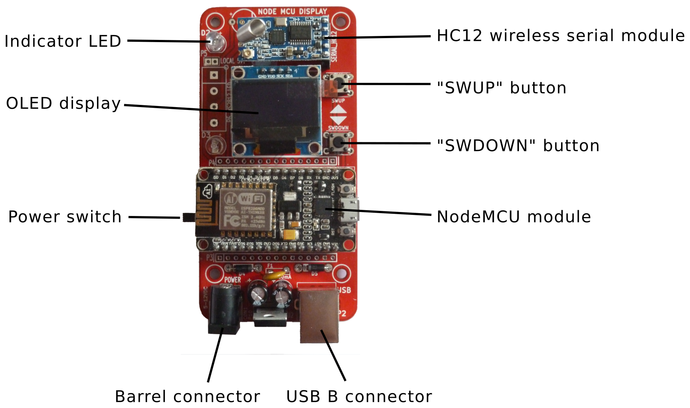

Configuration
In order to work, the Mini Prediction Machine must connect to the Internet via a WiFi network. The MPM must be told which WiFi network to connect to, and provided with a passphrase for that network if needed.
This is accomplished by the MPM acting as a WiFi access point (AP) first, allowing you to connect to it and use a web browser to configure the device. It will then shut off access point mode, and try to connect to the WiFi network you specified.
- Connect a powered USB cable to the MPM with the USB B connector
- If necessary, move the power switch on the side of the MPM to the ON position. The MPM should display Mini Prediction Machine ID: XXYYZZ on the OLED display (where XXYYZZ is a unique ID for that specific unit, e.g. 05FD3C)
- Press the SWUP button . You should see the indicator LED blink rapidly for a second and then settle into a mostly-on pattern. The MPM will create a WiFi network named MiniPredictionMachine_XXYYZZ. Note: it may make a minute for your phone/computer’s WiFi network list to update before you can see the new network.
- Connect to the MPM using WiFi on your phone or computer. The password is sunshine.
- Open your web browser and visit the page http://192.168.4.1/ You should see a list of available WiFi networks. Select a network which you can use to connect to the Internet, and enter the passphrase if required
- Set the Time Server value to time.google.com if it is not already set
- Enter the longitude and latitude of the weather station
- Click the Save & use WiFi button. You should see a message in your web browser saying: “Settings Saved Trying to connect ESP to network. If connection fails, reconnect to AP to try again.”
- When the MPM connects to the WiFi network, it will display this message: “Connected to WiFi, waiting for weather data”, which will be replaced by weather data when the MPM receives a broadcast from the weather station. This happens once per minute.

Messages
Sometimes the Internet-based systems may with to display a textual message on the MPM OLED display. Messages are valid for some period of time, after which they will automatically be replaced by the latest weather data from the weather station.
The user may toggle the display between the current message and the latest weather data by pressing the SWDOWN button.

Indicator LED flash codes
- Blinking three times per second – the MPM is trying to connect a a WiFi network
- Blinking once every two seconds – the MPM is connected to a WiFi networks
- Very rapid blinking for one second – the MPM is entering access point mode
- Inverted blinking (mostly on) – the MPM is in access point mode (button SWUP was pressed)

