The Decoupling of the “AI” Label from Substance in U.S. Securities Filings, 2001–2025
Matthew Greer-Gentis · Harvard Kennedy School Draft working paper · 2026-07-09 · Draft. Please do not cite without the author’s permission.
This is an AI-assisted draft. The research design, the measurement choices, and the interpretation are the author’s; a coding assistant built the pipeline and scaffolded this text. Every figure and number is reproducible from the public repository at https://github.com/matthewgg22/ai-disclosure-measurement (see the reproducibility appendix). All results are market-level and aggregate. Nothing here identifies or characterizes an individual issuer.

Abstract
In U.S. 10-K filings, the phrase “artificial intelligence” appeared in 0.8% of filers in 2001 and 50.7% in 2025. Over the same period, marketing vocabulary (“AI-powered”, “AI-driven”) reached 14.6% of filers, while the more costly vocabulary of building AI (large language model, training compute, fine-tuning) stayed near 1.8%. Software (SIC-73) fell from a roughly 57% (2018) peak share of AI mentions to 27% (2025) as the label appeared across more sectors. Measuring capability with audited R&D, the R&D-intensity premium of AI-labeled filers over the market fell across 2018–2024, from +0.036 to +0.009, as the AI-labeled pool grew from 37 firms (2015) to about 2,400 (2024). The 2015 benchmark is a small sample (n = 37) and is reported with that caveat. A placebo using the same marketing construction on control buzzwords finds the “AI-powered” form in 12.9% of filers in 2025, roughly seventy times the rate for blockchain, cloud, or quantum, which locates the effect in AI rather than in buzzwords generally. Together these measurements describe a label whose correlation with real capability weakened as it spread, consistent with a lemons dynamic (Akerlof, 1970). The results are market-level statistics from public data and make no claim about any individual issuer.
Keywords: securities disclosure, AI washing, textual analysis, EDGAR, information content.

1. Introduction
A word in a securities filing is supposed to carry information. When a company writes that it uses “artificial intelligence,” a reader infers something about what the company does. This paper asks a narrow empirical question. Over the last quarter century, has the “AI” label in U.S. 10-K filings continued to correlate with a firm’s actual capability, or has it drifted toward cheap talk?
The question matters for disclosure policy. Disclosure works only when the vocabulary of disclosure stays tied to substance. When a term becomes free to use, so that writing “AI” costs nothing and signals little, it stops helping investors tell firms apart and starts helping weaker firms pool with stronger ones. Regulators have recently called this pattern “AI washing” and have brought cases against advisers who overstated their use of the technology (SEC, 2024). Those cases are issuer-specific and are not the subject of this paper. This paper supplies the market-level backdrop against which such cases sit: how far, and in which direction, the language of AI in filings has moved relative to its substance.
The contribution is a set of aggregate measurements over the full 10-K corpus: four that describe the label’s spread and its relation to substance, and a placebo that checks whether the pattern is specific to AI. Each is reproducible from public data with a single command, and each is reported with its own limitation. The unit of analysis is the filing corpus and named sectors, never an individual company.

2. Data
All measurements use public sources. Filing-level text counts come from the SEC’s EDGAR full-text search (FTS), which indexes filings from 2001 onward. Because FTS caps its reported total at 10,000 results, it cannot serve as a denominator once a term becomes common. For the count of distinct 10-K filers per year the paper uses the EDGAR full-index master file, which is the complete filing-level population. Audited financials, namely research and development expense and revenue, come from the SEC’s XBRL frames API, which returns a whole-market cross-section for a given concept and year.
Phrases are matched as quoted strings so that phrase search does not pick up token false positives such as electrical “transformers” or sales “agents.” All counts are cached locally and are regenerated by the accompanying pipeline. Because EDGAR accrues new filings over time, absolute counts drift. The stable objects are the shares and ratios reported below.

3. Results

3.1 Prevalence (Figure 1)
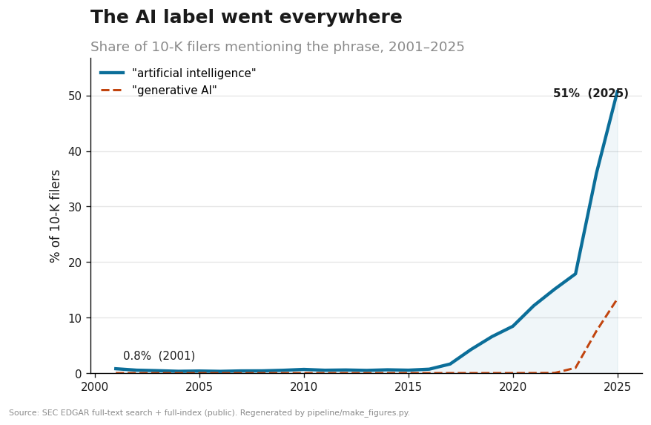
Figure 1. Share of 10-K filers mentioning AI terms, 2001-2025.
The share of 10-K filers using the phrase “artificial intelligence” rose from 0.79% in 2001 to 50.69% in 2025. The rise is uneven. It is flat through roughly 2016, then steepens after 2017 and again after 2022. A second phrase, “generative AI,” is essentially absent through 2022 and then appears in 13.37% of filers by 2025, which indicates that the vocabulary itself turns over as new terms enter and older ones saturate. By 2025 a majority of public-company annual reports invoke the label.

3.2 Marketing versus substance (Figure 2)
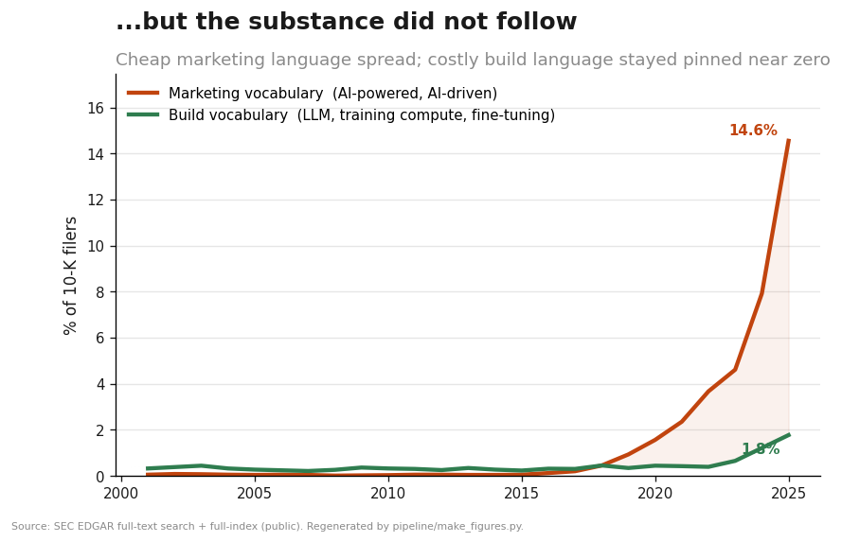
Figure 2. Marketing versus build vocabulary, share of 10-K filers.
Adoption of the word is not adoption of the thing. Splitting AI vocabulary into a marketing register (“AI-powered”, “AI-driven”, “AI-native”) and a build register (large language model, foundation model, training compute, fine-tuning, retrieval-augmented generation), the two diverge. By 2025 marketing vocabulary reaches 14.55% of filers, while build vocabulary, the language a firm uses when it is actually training or deploying models, stays at 1.77%. In 2001 both were near zero, at 0.05% and 0.32%. The widening gap between the cheaper register and the costlier one is the population-level signature of a label spreading faster than the practice behind it.
Two cautions apply. First, the bucket values are summed shares of their member phrases and are therefore upper bounds, since a single filing can use several phrases. The object to interpret is the divergence between the two registers, not the level of either. Second, a population ratio cannot classify an individual filing. That a marketing phrase is common and a build phrase is rare says nothing about whether any particular company is doing real work. This is an ecological-inference boundary, and the paper does not cross it.

3.3 Sector diffusion (Figure 3)
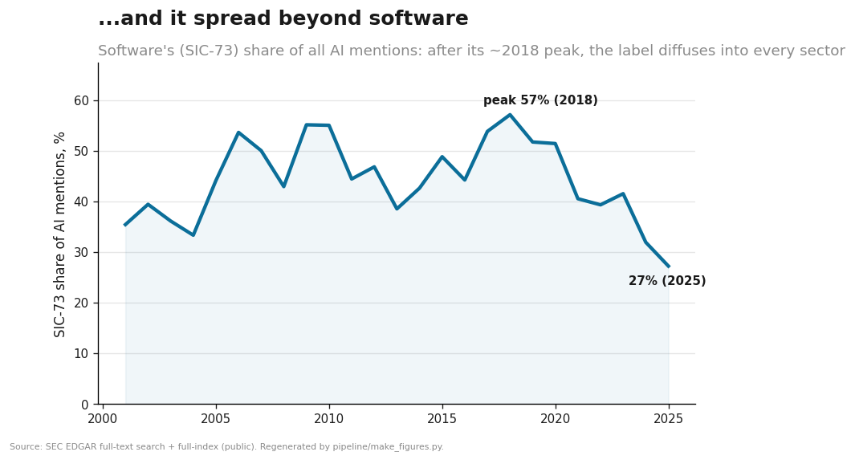
Figure 3. Software (SIC-73) share of AI mentions.
If the label tracked capability, its sectoral home would be stable. Software (2-digit SIC 73) accounted for a peak of roughly 57% of all AI mentions in 2018. By 2025 that share had fallen to 27% as the label appeared across more sectors. The early-2000s values are noisy, because there were few AI-mentioning filers then and the denominators are small, so the defensible reading is the post-2018 decline from the peak rather than a smooth twenty-five-year slide. The direction is consistent with a label that has moved out of the industry producing the technology and into industries that consume it or merely invoke it. This is the weakest of the four series and is offered as support, not as a primary result.

3.4 Informativeness (Figure 4)
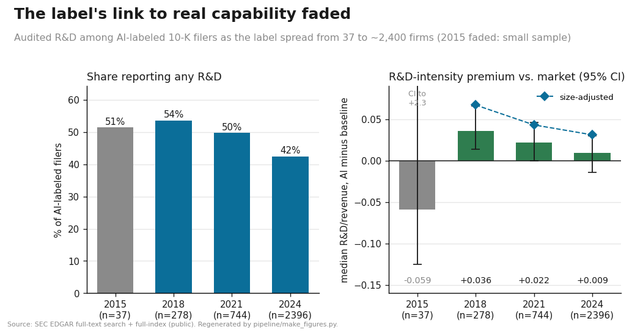
Figure 4. Share reporting R&D, and the R&D-intensity premium with 95% CIs and the size-adjusted overlay.
The sharpest test asks whether AI-labeled firms still resemble firms that do research. Using audited R&D, which is difficult to fabricate and is not reported by the financial holding companies that pad the pool, two quantities fall as the label spreads. First, the share of AI-labeled filers reporting any R&D declines from 51.4% (2015) to 42.4% (2024). Second, the median R&D-intensity (R&D over revenue) premium of AI-labeled firms over the all-filer baseline falls from +0.036 (2018) to +0.022 (2021) to +0.009 (2024). Over the same window the AI-labeled pool grows from 37 firms (2015) to 278 (2018), 744 (2021), and 2,396 (2024).
95% bootstrap confidence intervals (2,000 resamples, resampling each group with replacement) sharpen the reading. The 2018 premium is +0.036 with a CI of [0.014, 0.066], which excludes zero. By 2024 it is +0.009 with a CI of [−0.014, 0.030], which includes zero. The 2021 value (+0.022, CI [−0.0, 0.046]) is marginal. In words, AI-labeled firms carried an R&D-intensity premium distinguishable from zero in 2018, and by 2024 they no longer do. The 2015 benchmark rests on only 37 firms, and its CI runs to +2.3 (a handful of tiny-revenue firms with very large R&D ratios), so it is uninformative and is treated as a small sample. This before-and-after pattern is consistent with a lemons dynamic (Akerlof, 1970): as a costless label spreads, the average quality of the firms carrying it converges toward the market, and the label’s power to separate stronger firms from the rest weakens.
A composition confound deserves a direct check. As the pool grows it fills with larger and less R&D-intensive firms, so part of the premium’s decline could reflect a change in the composition of AI-labeled firms rather than a change in what the label signals. To test this, the premium is recomputed within total-assets terciles (cut on the baseline) and averaged across terciles, which compares AI firms only to non-AI firms of similar size and holds the size mix fixed. The size-adjusted premium is higher than the raw premium in every year (0.067 in 2018, 0.043 in 2021, 0.031 in 2024), which means the raw figure understated the label’s association with R&D because large low-R&D firms diluted it, and it still declines over the window. So composition does not explain the fall. The size-adjusted estimates are noisier, however: their 95% bootstrap CIs (2018 [−0.003, 0.130], 2021 [−0.015, 0.121], 2024 [−0.012, 0.158]) are wide and mostly include zero, because averaging tercile medians uses smaller per-cell samples. The size-adjusted decline is therefore directionally supportive but not sharply identified, and 2015 has too few AI firms with reported assets to stratify.

3.5 Is the decoupling specific to AI? (Figure 5)
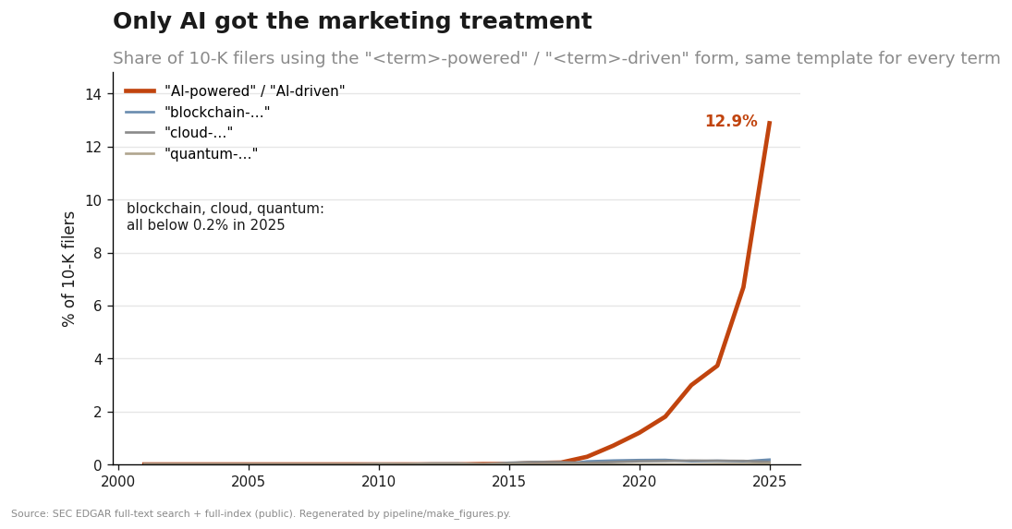
Figure 5. Marketing-form prevalence, AI versus control buzzwords.
A natural objection is that every buzzword inflates, so the marketing-versus-substance gap in Section 3.2 may say nothing special about AI. Figure 5 tests this with a placebo. It applies the same marketing construction, “-powered” and “-driven”, to AI and to three control buzzwords (blockchain, cloud computing, quantum computing), and measures the share of 10-K filers using each. In 2025 the AI form reached 12.9% of filers, against 0.18% for blockchain, 0.09% for cloud, and 0.03% for quantum. Bare mentions of the four terms differ by roughly a factor of three; the marketing form differs by roughly a factor of seventy. Using an identical template for every term, only AI produced a large marketing vocabulary. The near-absence of “-powered” language for the controls is itself the result, and it locates the decoupling specifically in AI rather than in buzzwords generally.

4. Interpretation
Read together, these measurements describe one movement. A label that once appeared almost only in software firms, in a small number of filings, has become a majority phenomenon that appears across sectors. Its marketing register has run ahead of its build register, and its correlation with audited research capability has weakened. On average, the “AI” label carries less information about what a firm can do than it once did.
The scope of that statement should be stated plainly. It concerns the average informativeness of a word across a large corpus. It does not identify which firms overstate, it does not measure investor harm, and it does not establish causation. Claims of those kinds require issuer-level evidence and belong to separate work; they lie outside the scope of this paper and outside the data it uses. The value of a market-level result is that it is general. It describes the condition under which issuer-level “AI washing” becomes both easy to do and hard to detect: easy because the label is free, hard because the label no longer separates.
The result also has a precedent. Cooper, Dimitrov, and Rau (2001) found that dot-com era name changes earned abnormal returns unrelated to any change in business. The pattern here is the filing-level, textual analogue a generation later, in which a fashionable label is adopted faster than the capability it names.

5. Limitations
The measurement is phrase-based and inherits the limits of dictionary methods in textual analysis (Loughran and McDonald, 2011). Phrase lists are not exhaustive, and language evolves; the paper reports no sensitivity to alternative phrase sets. EDGAR full-text search caps its totals, which is why the denominator comes from the master index. The marketing and build buckets are summed upper bounds, so their levels overstate and only the divergence is interpreted. Sector shares in the early 2000s rest on small samples. The informativeness test uses four benchmark years and audited R&D, which not all firms report, and the 2015 point in particular is a small sample; it is also subject to the composition confound noted in Section 3.4. The informativeness premium (Section 3.4) is reported with 95% bootstrap confidence intervals, since it is a statistic of a firm-level sample. The prevalence, lexicon, sector, and placebo figures (Sections 3.1, 3.2, 3.3, 3.5) are near-complete counts of filings rather than samples, so they carry no sampling error and no interval is reported for them; their uncertainty is in the phrase definitions, not in sampling. Because EDGAR accrues filings continuously, absolute counts drift even as the reported shapes hold.

6. Conclusion
Between 2001 and 2025 the “AI” label in U.S. securities filings went from a rare, software-specific term to a majority phenomenon spanning sectors, while the costlier vocabulary of building AI stayed flat and the label’s correlation with audited research capability fell. On average, the label’s information content weakened as it spread. For disclosure policy the implication is not that any particular claim is false, but that the word itself does less of the work that disclosure relies on it to do. Restoring that work is a measurement problem before it is an enforcement one, and the measurements here are offered as a public, reproducible baseline.

7. Reproducibility appendix
Every figure and number regenerates from committed aggregate data in the accompanying repository:
- Repository: https://github.com/matthewgg22/ai-disclosure-measurement
- Figure, data script, and exact number map: docs/RESULTS.md
- Construction detail (denominators, phrase lists, identification): docs/METHODOLOGY.md
- Regenerate the figures (no network): pip install matplotlib && python pipeline/make_figures.py
Figures 1 to 4 correspond to docs/figures/f1_adoption, f2_marketing_vs_substance, f3_sector_diffusion, and f4_informativeness.

References
To be finalized and formatted by the author. The works below are real and load-bearing but should be verified against the author’s citation style.
- Akerlof, G. A. (1970). The Market for “Lemons”: Quality Uncertainty and the Market Mechanism. Quarterly Journal of Economics, 84(3), 488–500.
- Cooper, M. J., Dimitrov, O., & Rau, P. R. (2001). A Rose.com by Any Other Name. Journal of Finance, 56(6), 2371–2388.
- Loughran, T., & McDonald, B. (2011). When Is a Liability Not a Liability? Textual Analysis, Dictionaries, and 10-Ks. Journal of Finance, 66(1), 35–65.
- U.S. Securities and Exchange Commission (2024). SEC Charges Two Investment Advisers for Making False and Misleading Statements About Their Use of Artificial Intelligence. Press release 2024-36.

