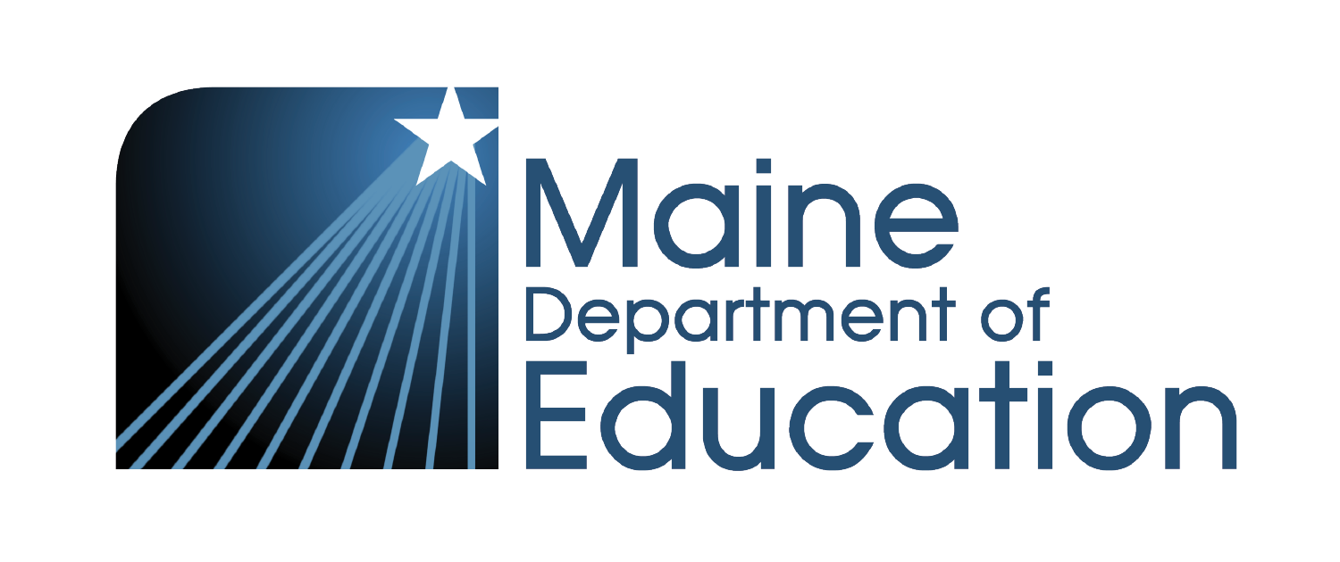
MAINE DEPARTMENT OF EDUCATION
Updates from the Communications Team
Launching the Communications Portal, The Commons — a new blogging space for department teams, and an updated Brand Guide. Live August 3.

SAVE THE DATE
Monday, August 3 · 10 a.m.
Portal launch walkthrough — calendar invite coming soon.

Hi team,
We're rolling out three updates for you: the new Communications Portal, The Commons (a new blogging space for department teams), and an updated Brand Guide. Together, they make it easier to find what you need, reduce questions, and connect our team's work. Let's start with the portal.
The Communications Portal is your one-stop shop for anything and everything comms at the Maine Department of Education. It brings together the tools, templates, brand resources, and workflows your team uses every day, all in one place, so the answers you need are easier to find.
We're going live at our walkthrough on Monday, August 3, and wanted to give you a preview of what's inside before then.
What's inside
Nine sections pulling together the tools our team already uses, plus a few new ones:
Analytics Dashboard  Live analytics for maine.gov/doe — page views, downloads, and traffic trends. | Interactive Brand Guide  Colors, typography, voice, language — always current.
Templates & Assets Library  Official presentation, letterhead, logos, and design templates. | Publications  Mailchimp campaign performance — open rates and clicks.
Events Tracker  Submit calendar events and check the DOE PD calendar. | YouTube Tracker  Submit and track your video uploads to the DOE channel.
EnGiNE  Quick access to Maine's professional learning platform. | Process & Procedure  Standard procedures for working with the Comms Team.
Workflow
Direct link to the Dynamics content-request queue.
Plus, a website mini-portal for staff working with maine.gov/doe pages — file management, page explorer, and a moderation queue for pending approvals.
ONE PLACE FOR EVERYTHING COMMS
Portal, Teams, and the Handbook
The portal is your destination for comms. It's designed to reduce questions, maximize efficiency, and keep the resources you need always easy to find.
Microsoft Teams: The portal is linked in Teams, so you can jump over without breaking your workflow. But when you're looking for anything comms — that's what the portal is for.
The Handbook: Procedure-specific items like email signature formatting and PD certificate guidance stay in the Handbook as the source of truth. The portal has interactive versions of the same items, so you can find them from either place.

ALSO LAUNCHING
The Commons — a new blogging space for the Maine DOE
The Commons is a new blogging space where department teams can publish stories, longer-form resources, and original topic-based content that doesn't quite fit in a newsroom article. It's designed to help your team share your work directly with the audiences you care about.
What the blog IS for:
• Longer resources and how-tos your team wants to share with a specific target audience
• Original topic-based articles written by the Maine DOE content experts
• Small-scale announcements that are specific to a target audience and not relevant to the larger Newsroom audience.
What the blog is NOT for:
• Priority notices (still sent out through MailChimp)
• Event marketing (Maine DOE Events should be posted on the calendar and also the newsroom)
• Announcements relevant to a larger audience or anything time-sensitive that needs a broad reach quickly
How posts get published:
1. Author drafts the post
2. Submits to their supervisor for approval
3. Approved posts move to the webmaster for publishing
4. The portal's moderation queue shows what's pending review
As always, our brand guidelines, our audience, and our professional standards apply.

ALSO UPDATED
Our Brand Guide
The interactive Brand Guide inside the portal reflects our latest brand — colors, typography, voice and tone, and language guidelines. It's the same content as the PDF in the Handbook, but easier to reference and search.
We'll walk through what's updated during the launch on August 3.

What to do now

1 | Mark your calendar: Monday, August 3 at 10 a.m.

2 | Watch for the calendar invite — it's coming soon with the meeting link

3 | Bring your questions — we'll walk through everything and get you set up
The Communications Portal is your one-stop shop for anything and everything comms — built to reduce questions, maximize efficiency, and keep the resources you need always easy to find. See you on August 3.
Warmly,
The Communications Team
Chloe Teboe · Communications Director
Rachel Paling · Communications Coordinator
Matt Leavitt · Website & Technology Coordinator
Maine Department of Education · Website & Technology · Communications

