ECEN3730-Board 4 Report

Matthew Gorbold McCardle

The goal of this project is to build an instrumentation droid to measure the limitations of power sources. In this process I got my first chance to design and build a 4-layer board.

Figure 1: The schematic design for Board 4.

Figure 2: Slammer circuit schematic.

I chose to challenge myself by building the graduate level version of this final project. I built an Arduino attached to my slammer circuit. The slammer circuit will measure the Thevenin voltage and Thevenin resistance of any power source connected. The voltage drops measured by the voltage regulator module in the MOSFET will be used to calculate the Thevenin resistance of the VRM.

Figure 3: The board design for board 4, the top (left) contains the slammer circuit and power connections, and the bottom (right) is an Arduino.

The original size and structure of a standard Arduino board was maintained on the back, however the new additions in the slammer circuit, smart LEDs, buzzer, and three power connectors are on the front. The dimensions of the main body of the board are 2660 x 1950 mm.

Unfortunately, due to the long delivery times and tight deadlines, I was unable to get my correct board order placed before the 2-week order period at the end of the semester. So I had to borrow an extra board to solder and test from a TA in the class. My design contained an error in the pouring the copper layers, resulting in me having a copper layer on the top layer. I corrected the issue in Figure 3.

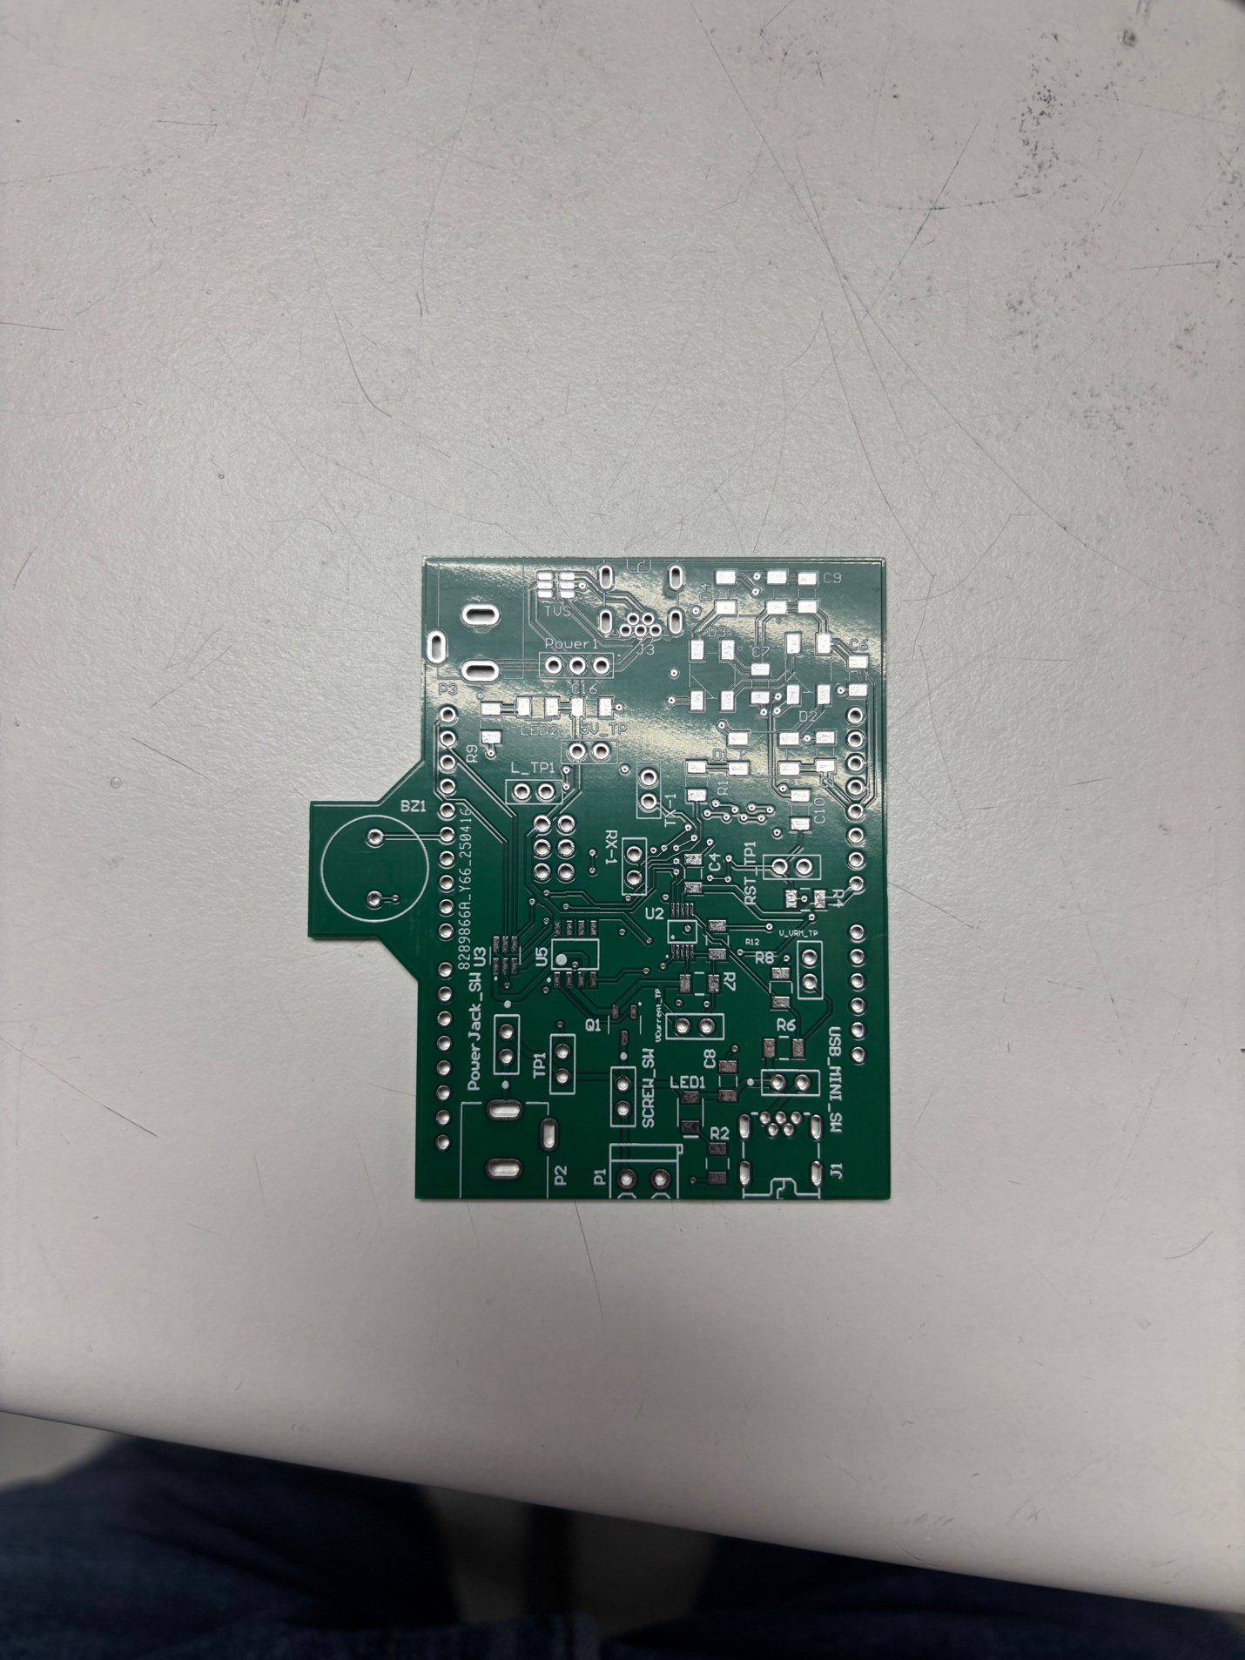

Figure 4: My board design with false copper layer pours.

Figure 5: Bootloading the Arduino firmware from a commercial arduino onto my board.

To verify the Arduino firmware worked, I uploaded code to turn on the smart LEDs amd the buzzer. The buzzer was verified by Jithendra, the smart LEDs and indicator LEDs work as shown in Figure 6.

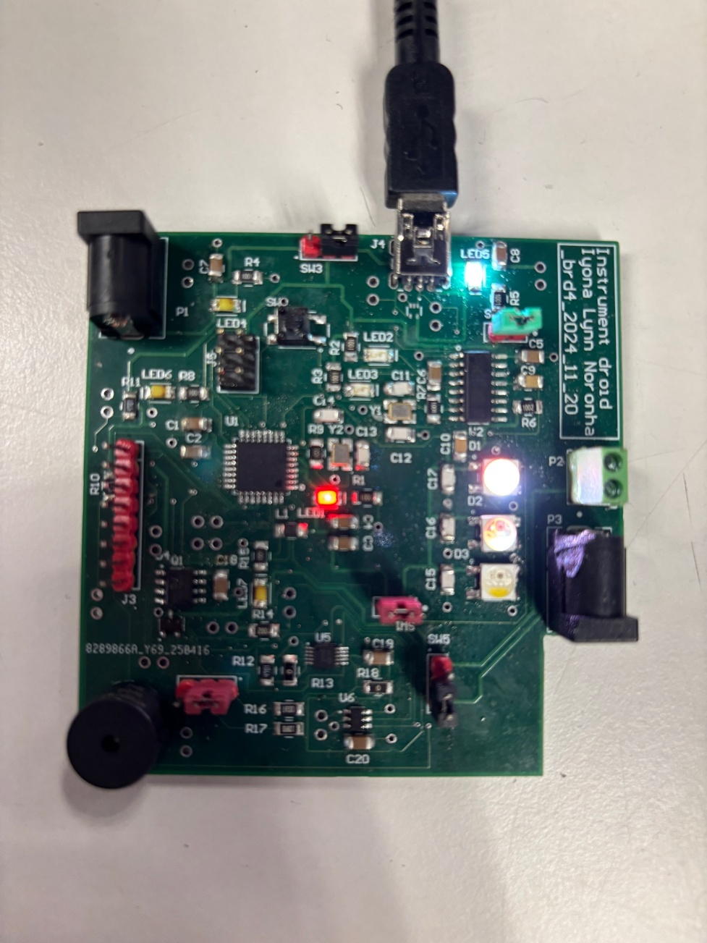

Figure 6: Assembled board using a TA’s board.

Once the firmware was verified by uploading code, I tested the digital to analog converter (DAC) output to ensure that it produced a signal as expected when an external test power source was connected. I chose to analyse an external 5V, 2A power jack connected power source connected to the board because it is a source I regularly use to power Arduinos.

Figure 7: The DAC output with external power source connected.

The DAC behaves as expected, it produces a ramping up square wave voltage.

Figure 8: The opamp output with external power source connected.

The opamp produces a similar wave output to the DAC, with a ramping up square wave output.

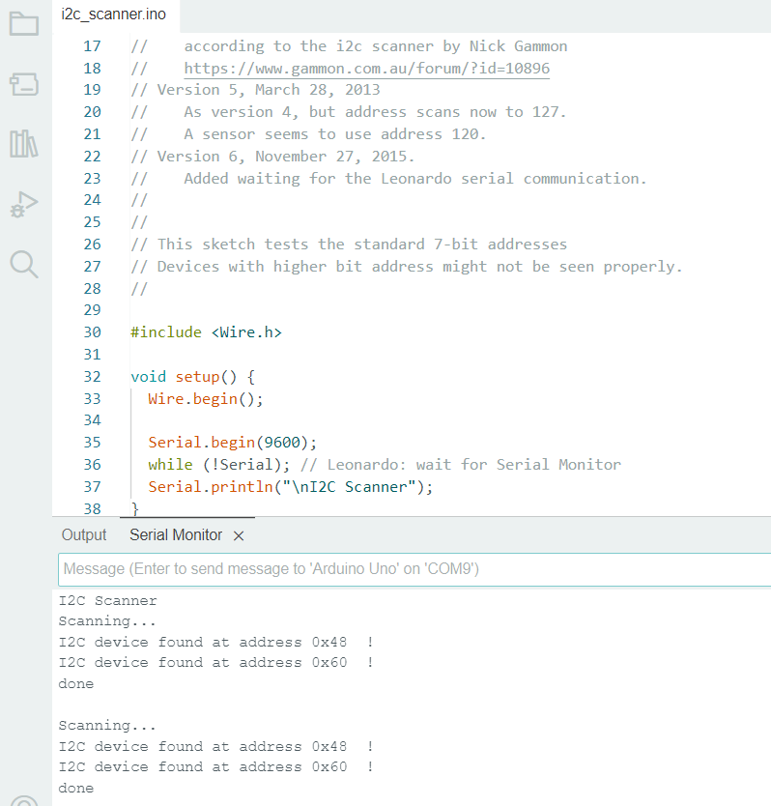

Figure 9: The I2C scanner output checking for all valid I2C connections.

After scanning for sources using I2C communication, there are two recognized sources as expected. The DAC being 0x60 and ADC 0x48.

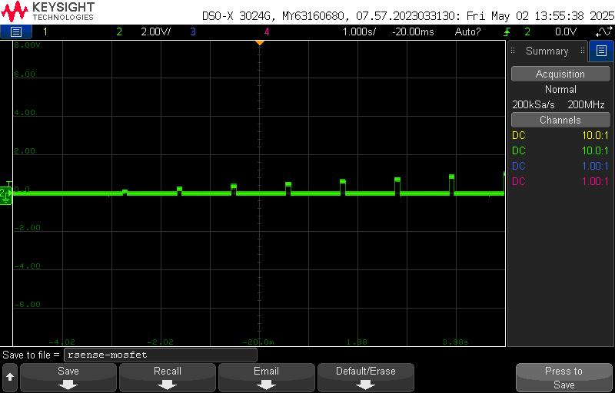

Figure 10: The MOSFET output at the R_sense resistor.

The MOSFET outputs a vertically shrunk version of the opamp and DAC output

Figure 11: The ADC output voltage probed at the VRM output.

The ADC behaves as expected, producing a constant 1.53 V voltage source, with small peaks up to 1.77V when the DAC output load is turned on.

Given that each component works as expected, the outputs can be measured to find both the Thevenin voltage and the Thevenin resistance can be calculated from the external power source. The Thevenin voltage when the load is applied is 1.77V.

This Thevenin resistance is high for high precision measurements and if being relied on as a source would require a voltage regulating module to reduce impacts on designs.

In this project I pushed myself to design and manufacture the graduate level version of this assignment. I wanted to challenge myself to try a harder design on a 4-layer board and push myself to independently make both the Arduino and slammer circuit together on one board. This challenge turned out to be too much to do solely by myself. In the design check-off phase the TAs found an error with my copper polygon pours which they were split on knowing if my design iteration would work or not. I was told to use Lyona’s design to conduct the project on due to tight deadlines and the complexity of the board. If I found out late in the testing process my design didn’t work, I may not be able to switch over to a working board before the end of the semester. I chose to take the TAs advice and solder all components onto Lyona’s working board, so I could be assured that I could take correct measurements. Attempting the graduate level version ultimately didn’t work as intended, however from talking to TAs frequently, I learned more than I would have otherwise. I am glad I tried the graduate level design because I learned more about copper pours, 4-layer board and managing space on two sides than I would have otherwise. The space constraint I gave myself taught me to think harder about my layout and produce a better design than I would have made otherwise. However, the design I made ended up taking way more time than I anticipated in both the design process and the manufacturing process.

I experienced significant struggles when debugging the board components because of the size of the board. When I boot loaded the board, I found that I could not properly upload code to the ATMEGA, I needed to resolder some components to ensure the crystals were properly connected.

I learned a new method to solder small components which worked very well. I used solder paste with flux and used the heat gun to set the solder onto the component pads first. Then I used the heat gun and a pair of tweezers to push the component down onto the pads without soldering each pad individually. This saved me a huge amount of time and effort of soldering each pin individually. One weakness of this method is the amount of solder at times was insufficient to connect the components properly. I needed to go back and add more for the DAC and the ATMEGA.

If I were to attempt this board design again, I would choose to attempt the graduate level design again, however I would check in with TAs more frequently to ask questions for the board layout. I would also start the board layout earlier than I did due to the complexity. I would choose to change the size of the board to allow all components to be on one side. I am confident I could fit the design in a 3900 x 3900 mil board shape. This choice gave me the most issues when routing all components, when I was creating minimal cross-unders and short trace connections.

Overall, I thoroughly enjoy this project and getting pushed hard to get better at debugging PCBs and get better at designing complex 4-layer boards. I learned a huge amount from this project about managing multiple layers, pouring copper polygons and space constraints. I enjoyed getting hands on experience in this course and applied learning of the theory I have learned in previous semesters; I am confident I will use this knowledge next year and hopefully during my future career too. Thank you, Professor Swettlen and all the TAs, for teaching me so much and helping us throughout the class!