Brd3- Arduino Report

Matthew Gorbold McCardle

The goal of this project is to create my own Arduino that is better than a commercial Arduino.

Figure 1: Altium Schematic of my Arduino Design.

For the schematic, I emphasized readability and organization. The netlabel naming convention helped me keep track of connectivity. For direct one-to-one connections I used the convention [Origin]-[Destination] and for branch connections I named the branch.

Figure 2: Board Layout for my Arduino.

Figure 3: Physical board Layout for my Arduino.

For my layout I prioritized signal integrity, I routed each component to have as few cross-under sections while keeping the length of connections short. I challenged myself to keep the board roughly the same size as a standard commercial Arduino, in which I was successful. The board layout worked well during testing due to the spacing of the components. I could easily tell which components were connected by looking at the board. The labelling was clear, so I had no doubts about which component went in each place. The indicator LEDs (LED1 and LED2) were helpful for knowing when the ATMEGA was receiving and transmitting data with the CH340.

To reduce possible risk factors, I spaced components evenly apart to aid myself in soldering. When I soldered the board, I chose to complete the most complex parts first, starting with the TVS, U1, U2. I learned that it was easiest to solder these components if I put solder on the pads first, then use the heat gun and flux to attach the components. In the future I will use this technique for soldering all complex components.

For the first test to compare my design to the commercial design, I measured the difference between the switching noise on the quiet low side on both the D13 pin and the Slammer circuit.

To Prove my board works as an Arduino Uno, I uploaded the starter “Blink” code to it and the LED I attached to D13 blinked as intended.

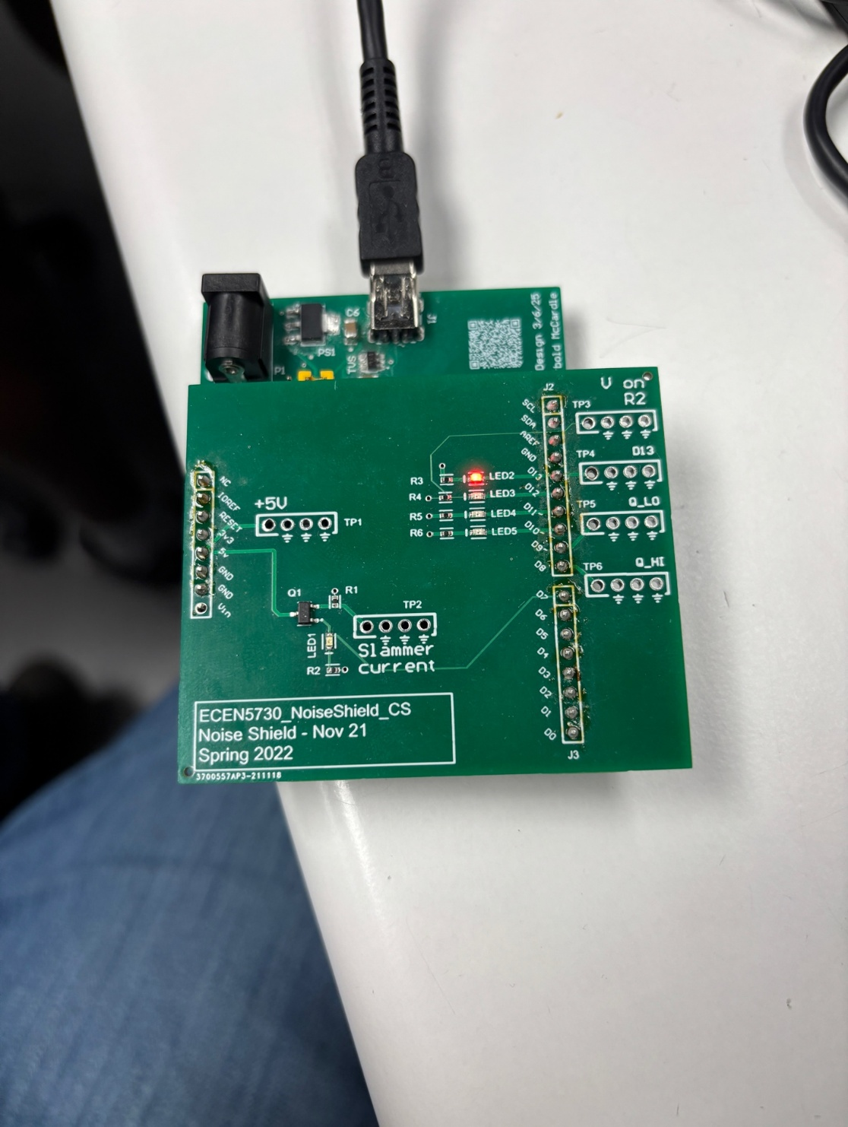

Figure 4,5: Blink LED test for my Arduino using shield.

Experiment 2 part 1: Measuring the difference between the amplitude of noise on my board and the commercial board on the D13 and Quiet Low pins.

My board:

D13 Switching Noise Quiet Low Rise/Fall

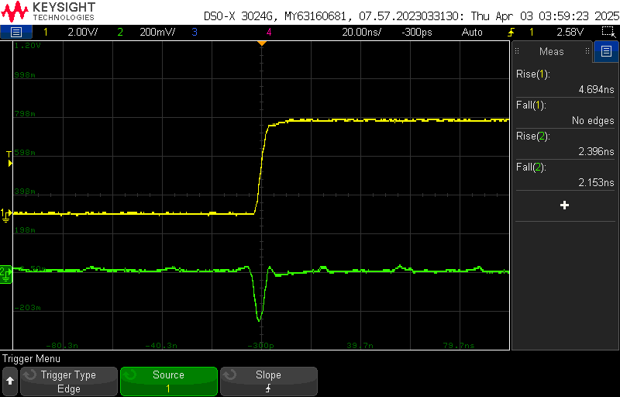

Commercial Board:

D13 Switching Noise Quiet Low Rise/Fall

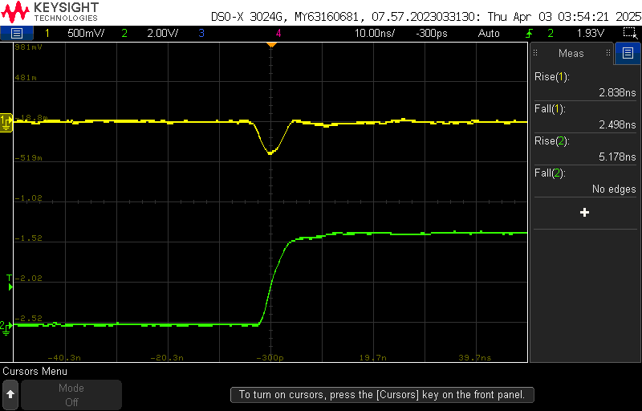

|  |  |  |  |  |
| --- | --- | --- | --- | --- |
|  | D13 pin | | Quiet Low Pin | |
|  | Rise time (ns) | Fall time (ns) | Rise time (ns) | Fall time (ns) |
| Commercial | 5.178 | 6.262 | 2.838 | 5.362 |
| My design | 4.694 | 5.308 | 2.396 | 7.688 |
| % difference for my design | -9.35 | -15.24 | -15.57 | 43.38 |

Overall, we see that my design reduces the rise and fall time by 12.3% for the D13 pin and increases the noise by 13.91% for the Quiet Low pin.

Slammer

My board:

Slammer Switching Noise Quiet Low Fall/Rise

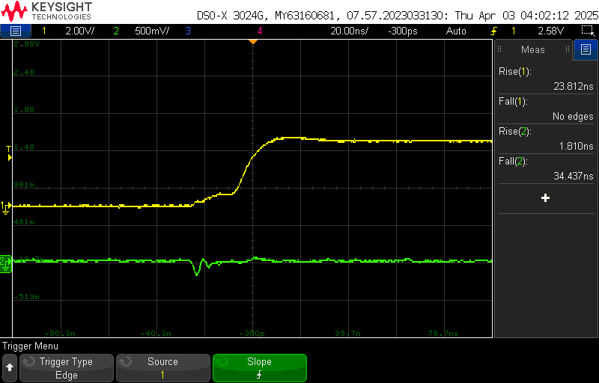

Commercial Board:

Slammer Switching Noise Quiet Low Fall/Rise

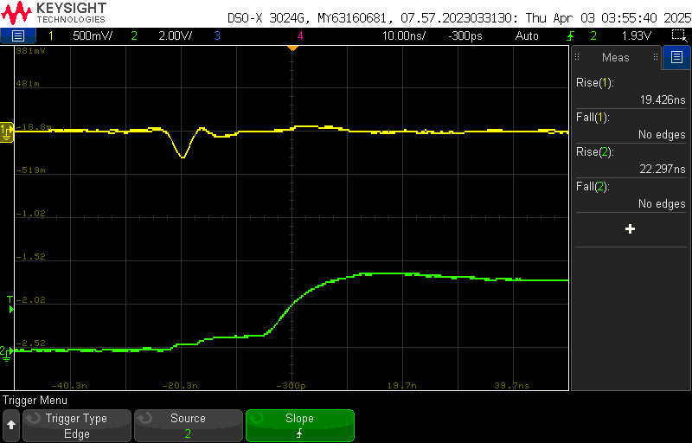

|  |  |  |  |  |
| --- | --- | --- | --- | --- |
|  | Slammer | | Quiet Low Pin | |
|  | Rise time (ns) | Fall time (ns) | Rise time (ns) | Fall time (ns) |
| Commercial | 22.297 | 8.182 | 19.426 | 8.500 |
| My design | 23.812 | 9.917 | 1.810 | 10.625 |
| % difference for my design | 6.79 | 21.20 | -90.67 | 25.00 |

My circuit increases the rise/fall times for the slammer by 14% and decreases the Quiet Low pin rise/fall time by 32.84%. Given the results the data is producing, the rise/fall times alone are not the best indicator in measuring the switching noise for the Arduino’s pins.

Exp 3:

The source of the noise on the power rail in the current draw from the slammer, measured from the Quiet High, Slammer and Power Pins. The noise is being measured when the microcontroller is the aggressor source of noise. This time the peak-to-peak voltage of the signal will be measured, this should give a better indicator of noise.

My Board:

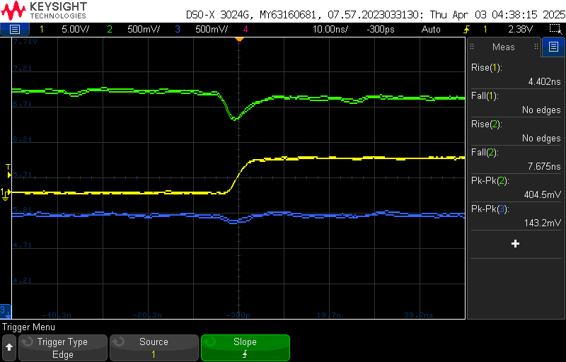

Commercial Board:

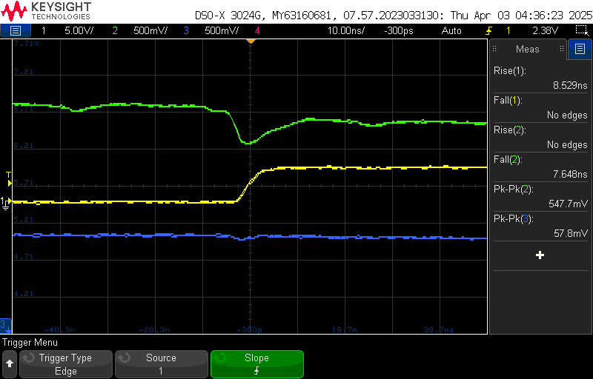

|  |  |  |  |  |
| --- | --- | --- | --- | --- |
|  | Peak-to-Peak Rising (mV) | | Peak-to-Peak Falling (mV) | |
|  | Quiet High (green) | Power (blue) | Quiet High (green) | Power (blue) |
| Commercial | 547.7 | 57.8 | 575.4 | 123.1 |
| My design | 404.5 | 143.2 | 484.9 | 159.6 |
| % difference for my design | -26.15 | 147.75 | -15.73 | 29.65 |

The table above shows that my design decreases peak-to-peak switching noise on the Quiet High pins but increases noise on the Power lines. My board design decreases the peak-to-peak switching noise on the Quiet Low pins by 20.94% while increasing the power line switching noise by 88.70%.

Exp 4:

The source of the noise on the power rail in the current draw from the slammer, measured from the Quiet High, Slammer and Power Pins. The noise is being measured when the board is the aggressor source of noise.

My Board:

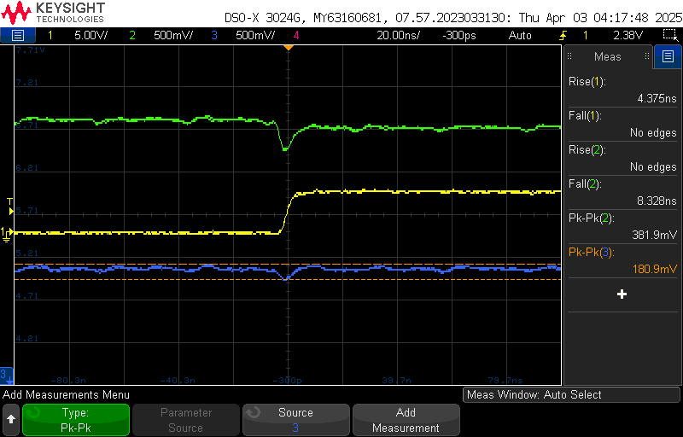

Commercial Board:

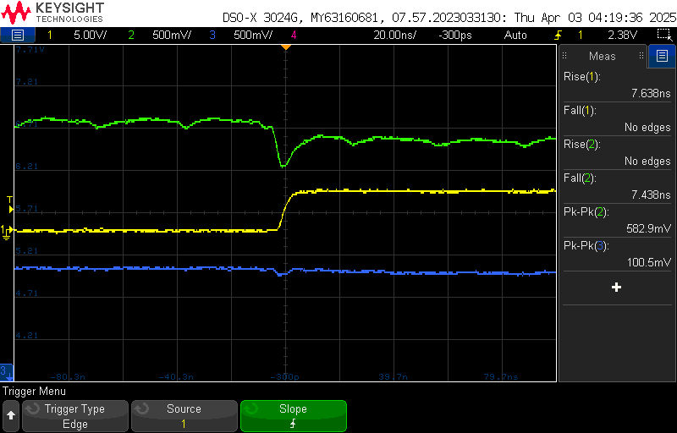

|  |  |  |  |  |
| --- | --- | --- | --- | --- |
|  | Peak-to-Peak Rising (mV) | | Peak-to-Peak Falling (mV) | |
|  | Quiet High (green) | Power (blue) | Quiet High (green) | Power (blue) |
| Commercial | 582.9 | 100.5 | 582.9 | 160.8 |
| My design | 381.9 | 180.9 | 522.6 | 180.9 |
| % difference for my design | -34.48 | 80.00 | -10.35 | 12.50 |

My board produces 22.42% less noise than the commercial board for the Quiet High pins, while increasing the noise by 46.25% for the power line. The cause of this increase in noise in the power line is due to an error by me in placing the decoupling capacitors C12 and C13, these capacitors should be before the pins on the ATMEGA instead of after. If this error were resolved, I would be confident the power line noise would be properly filtered by the decoupling capacitors and there would be a different outcome.

Exp 5:

Measuring the field emissions noise from the bottom of the board with the slammer shield pin connected.

My Board:

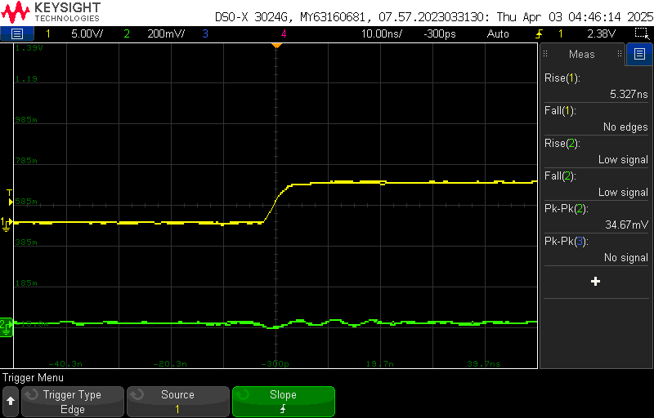

Commercial Board:

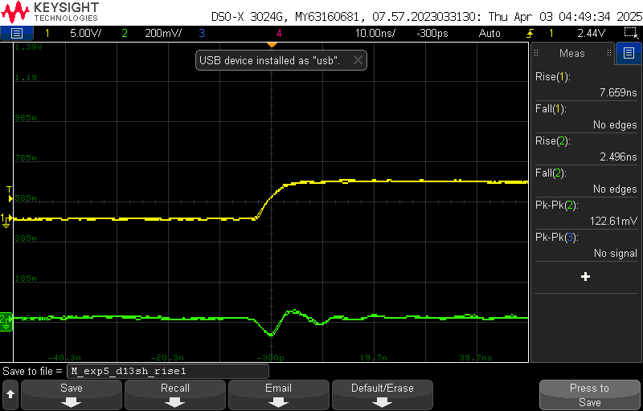

|  |  |  |
| --- | --- | --- |
|  | Peak-to-Peak Rising (mV) | Peak-to-Peak Falling (mV) |
|  | Quiet High (green) | Quiet High (green) |
| Commercial | 122.61 | 170.35 |
| My design | 34.67 | 61.81 |
| % difference for my design | -71.74 | -63.73 |

For the field emissions it is clear my board produces far less peak to peak noise than the commercial board, with an average 67.74% less emissions on my board.

In future designs I would remove the L_SW because when testing the ATMEGA, there is no value in testing it with or without the inductor. To further reduce noise, I would move both C12 and C13 to the other side of the ATMEGA. During testing, I found this error to be crucial in measuring the power line noise. This error drastically increased the noise on my design in the power line. Having them placed after the pins means their filtering effect is limited in comparison to having them before. In the future I will be sure not to make the same mistake again.

I had no software issues when boot loading the board, however I would consider adding a 6-pin port for ICSP pins for convenience boot loading rather than having to correct directly to communication pins. I also would add an indicator LED for the +5V line. If someone was unfamiliar with the board, they could be unsure if the board is on or off.

When measuring the peak-to-peak noise of my design and comparing it to the commercial board I reduced switching noise on the Quiet High pin by 21.68%. I believe in a future design I can offset the increased noise from the power lines by fixing the locations of decoupling capacitors and more efficiently filtering noise.