Credits -
Goods Exchange is for items that the Wholesaler will repair or replace.
This includes:
- Manfrotto
- Hahnel
- Rode
If this item is on QA Hold Release it before you start return Order.

Start a new Purchase Order
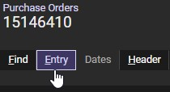

- Choose Correct Supplier
- Choose X Goods Exchange - Pronto will create new PO Number
- Choose Correct Warehouse (Set this a default)
- Enter through to end of page
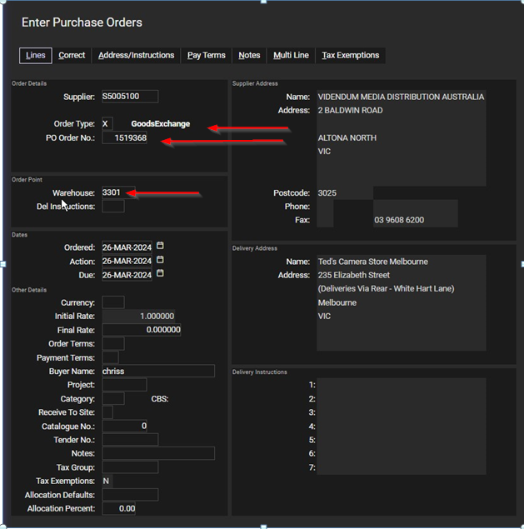
Pronto will ask for original Purchase Order the item was supplied on
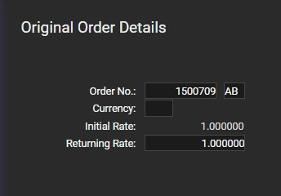
Click on “Part Return…
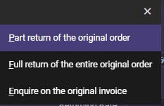
Choose item to be Returned and Select Reason Code 2
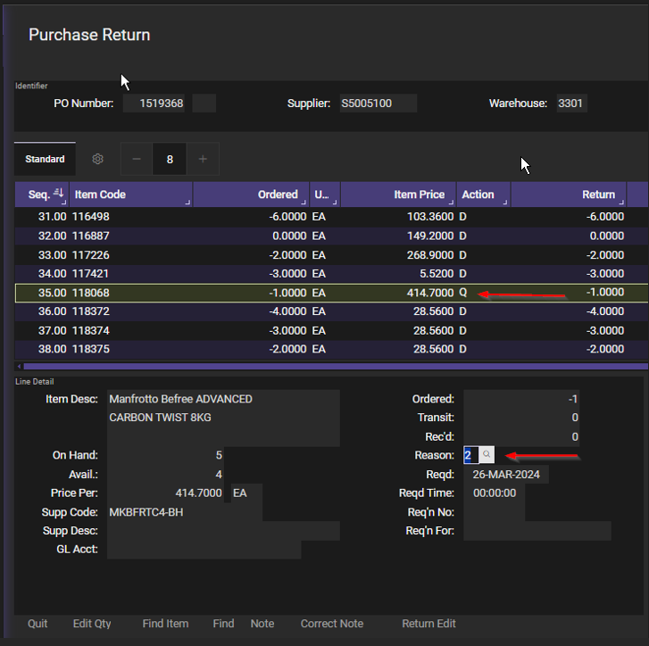
Click on Quit
Add a note line to show Fault and another line with Invoice Number
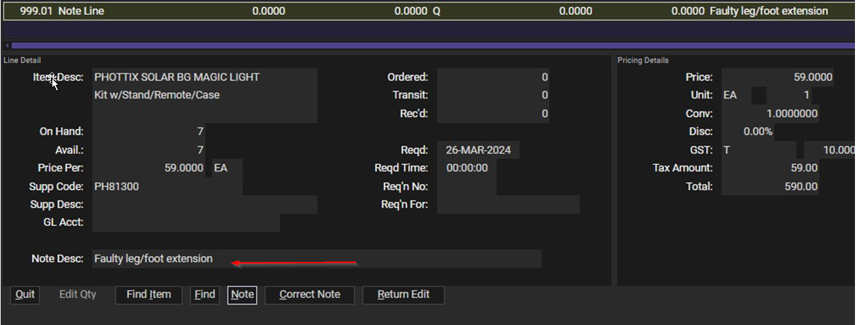

Complete Order with Status as X
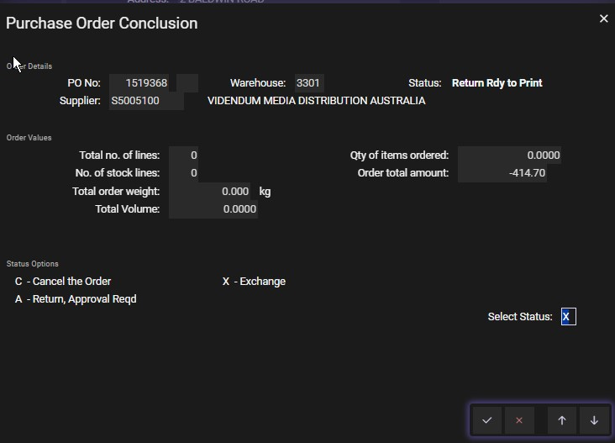

Click on spool order, Press F5 and choose “Other” and Select your printer.
Scan the Return Document and save it to your Credits Folder on the desktop.
Send the original with the Goods being returned.
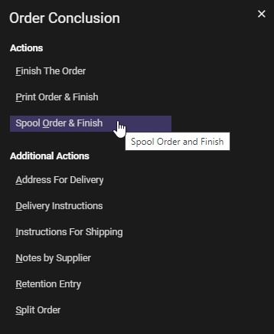
The Purchase Return will now progress to “Completed Exchange” and Pronto will create a new order so you can receive the Goods back into the store.
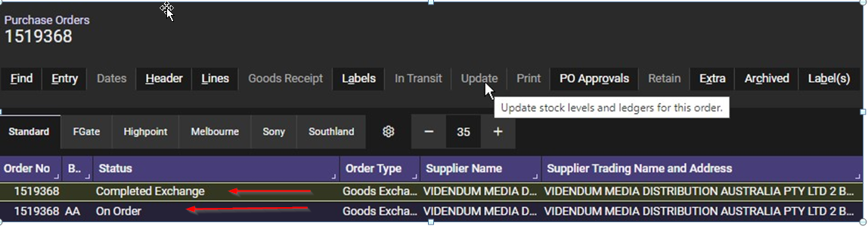

When the item is returned to your Store, receive it into Stock as with a normal Purchase Order.
