TikTok Shop Indonesia
Nursing & Feeding Category Analysis
Brand Spotlight: Hegen Indonesia
Data Source  FastMoss | Analysis Date  March 2026 | Country  Indonesia

Executive Summary
This report analyses the Nursing & Feeding category on TikTok Shop Indonesia, using data from FastMoss covering 300 shops, 300 top products, 284 most promoted products, and 300 affiliate creators. The analysis benchmarks Hegen Indonesia — a Singapore-origin premium feeding bottle brand — against category incumbents to identify performance gaps and strategic growth opportunities.

Category Leader GMV (7d)  Rp977.7 jt  Sakumini Official Store | Hegen Indonesia GMV (7d)  Rp67.2 jt  Rank ~265 / 300 shops | Hegen GMV Trend (MoM)  -59.9%  Declining — needs action

Key findings at a glance:
- Baby Bottles & Accessories is the dominant subcategory with 2.27 million units sold — directly Hegen's market.
- The category is highly concentrated: top 3 shops control the majority of weekly GMV, all Indonesian brands.
- Micro-creators (10K–100K followers) drive the most total units sold across the affiliate ecosystem.
- Live commerce accounts for a material share of top-creator GMV — a channel Hegen is not currently using.
- Hegen's best product has only 9 cumulative affiliates vs. the top competitor product's 7,466 — a 830x gap.

1. Category Overview

1.1 Market Structure
The Nursing & Feeding category on TikTok Shop Indonesia is a concentrated market. Among the top 300 shops tracked, the top two players — Sakumini Official Store (Rp977.7 jt 7-day GMV) and Dr.Isla (Rp947.4 jt) — generate nearly double the revenue of the third-ranked shop. This concentration suggests that brand and affiliate scale are significant moats.
Hegen Indonesia sits at the bottom of the top-15 ranking with Rp67.2 jt in 7-day GMV, reflecting an 8.7x gap to the category leader. Both Hegen and category leaders are classified as Brand shops, but local Indonesian brands dominate due to more aggressive affiliate strategies and lower price points.

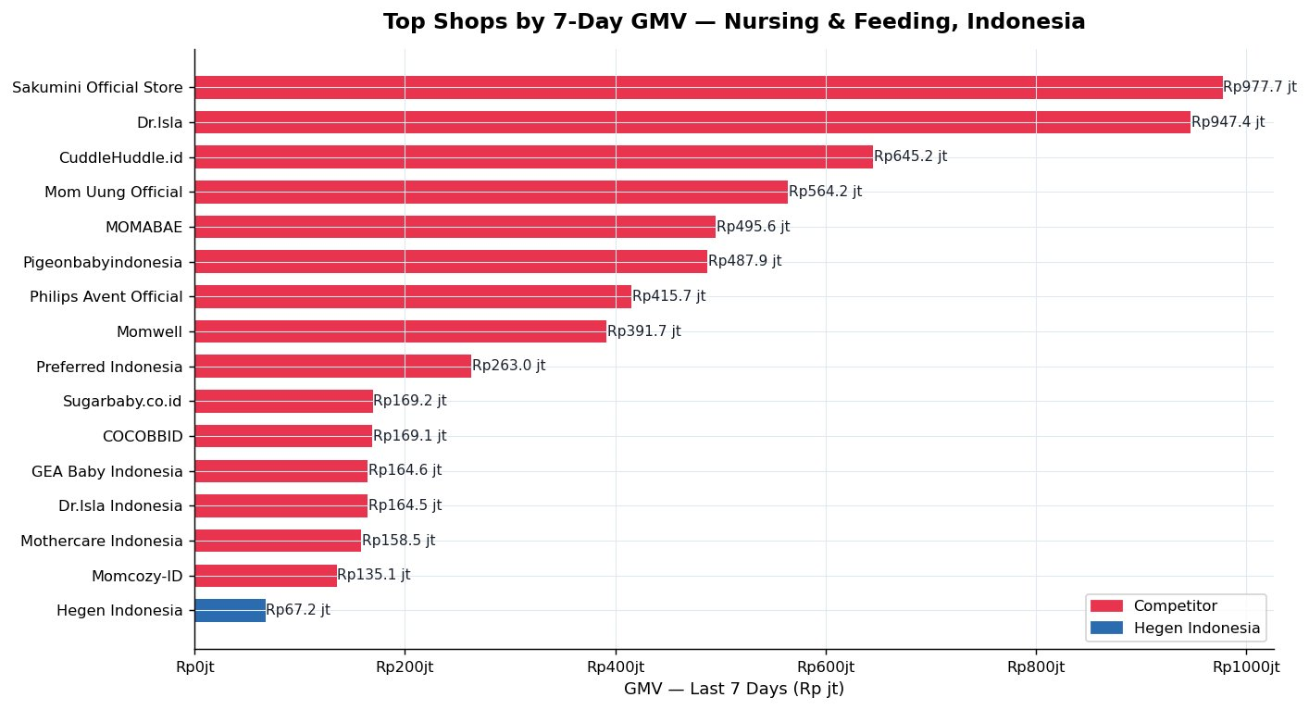
Figure 1: Top shops by 7-day GMV — Nursing & Feeding, Indonesia. Hegen (blue) vs competitors (red).

1.2 Growth Trends
Month-on-month GMV growth varies widely across the category. Several small shops show extraordinary MoM figures (e.g., Glodok123 at +316,229,900% and RayyanzaShopID at +428,999,900%) — these are data anomalies caused by near-zero prior-month baselines and should be excluded from trend analysis. Excluding outliers, meaningful growers include KOI.STORE (+29.7%) and Momwell (+65.4%).
Hegen's GMV MoM of -59.9% and units MoM of -62.5% represent a significant and accelerating decline. The bubble chart below shows that Hegen (small blue dot, bottom-left) has both low absolute GMV and negative growth, while maintaining a relatively small influencer network — the likely causal factor.

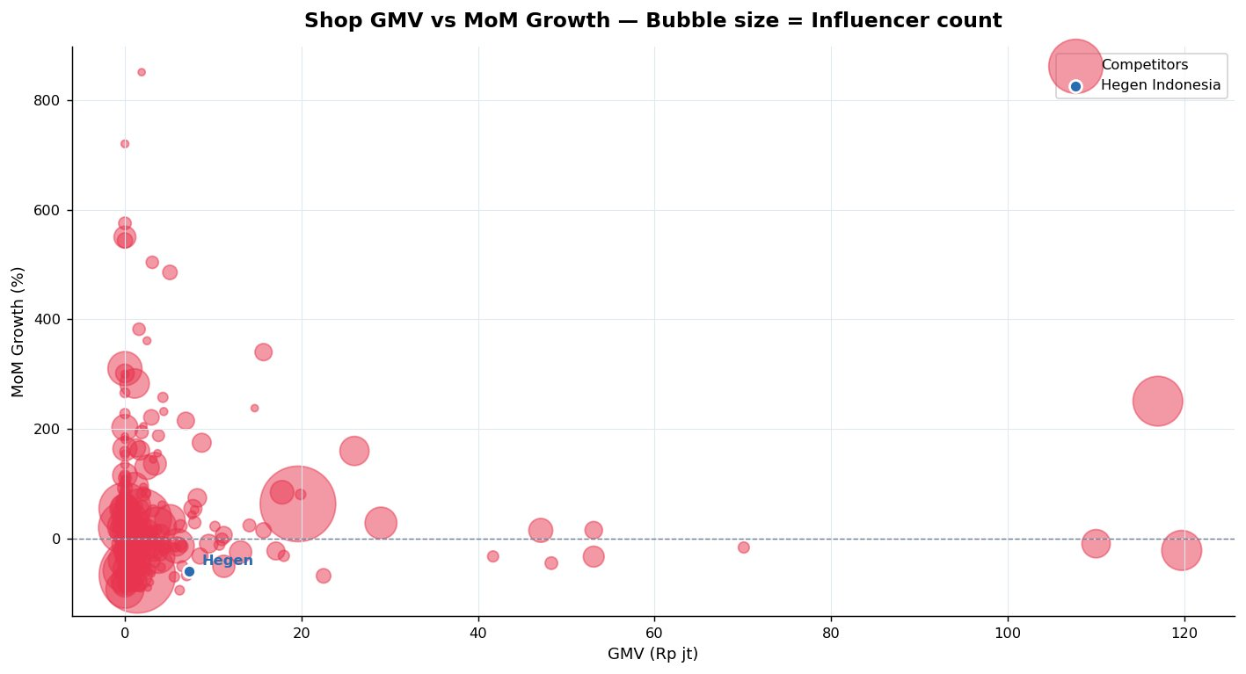
Figure 2: Shop GMV vs MoM growth. Bubble size = influencer count. Hegen is the small blue dot at bottom-left.

1.3 Subcategory Breakdown
Baby Bottles & Accessories dominates with 2,270k total units sold — nearly double the second subcategory (Formula & Milk Storage at 1,169k). This is directly Hegen's subcategory, confirming that the demand exists. The challenge is not category headroom but Hegen's ability to capture a meaningful share of it.
Other significant subcategories include Dummies (927.9k units), Baby Utensils (648.8k), and Baby Bottle Cleaners (589.6k) — categories that could represent cross-sell opportunities for brands with an established bottle presence.

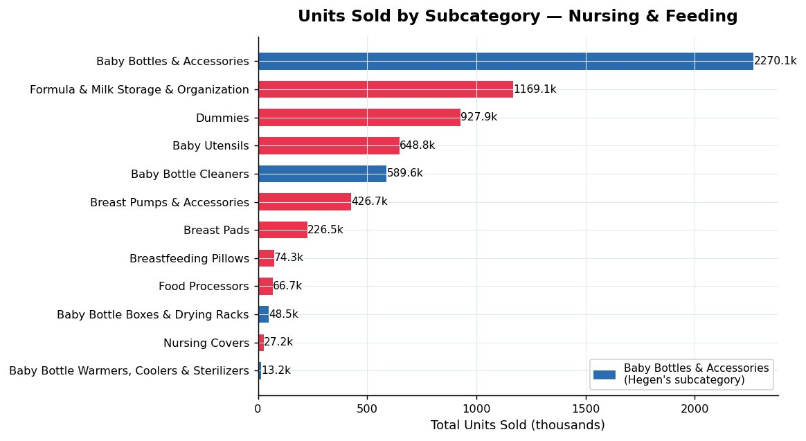
Figure 3: Total units sold by subcategory. Baby Bottles & Accessories (blue) is Hegen's core segment.

2. Product & Commission Analysis

2.1 Commission Rate Landscape
Commission rates across the 284 most promoted products range from 1% to 15%, with a category median of 7%. The distribution is bimodal: a cluster at 4–6% and a larger cluster at 10%+. Products offering 10% commission attract the most affiliates, as they directly translate to higher creator earnings per sale.
Hegen's current commission rate of 5% sits below the category median (7%) and well below the highest-affiliate bracket (10%). This is likely a significant contributor to Hegen's affiliate underperformance — creators have a direct economic incentive to promote higher-commission products over Hegen.

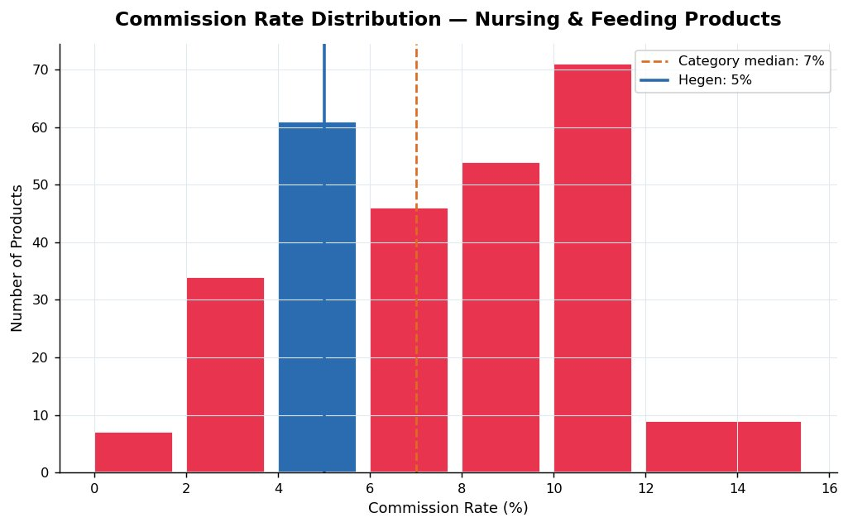
Figure 4: Commission rate distribution. Hegen (5%, blue bar) is below the category median of 7% (dashed orange line).

2.2 Affiliate Coverage — Top Products
The most-promoted product by affiliate count is a Sakumini feeding bottle with 7,466 cumulative affiliates. The top 5 products all exceed 2,000 affiliates. These products benefit from a flywheel effect: more affiliates generate more content, which drives more visibility, which attracts more affiliates.
Hegen's best-performing product (Hegen Ocean Odyssey Feeding Bottle PPSU) has only 9 cumulative affiliates — representing a 830x gap to the category leader. Even accounting for Hegen's premium positioning, this gap is structural and actionable through commission rate and creator outreach improvements.

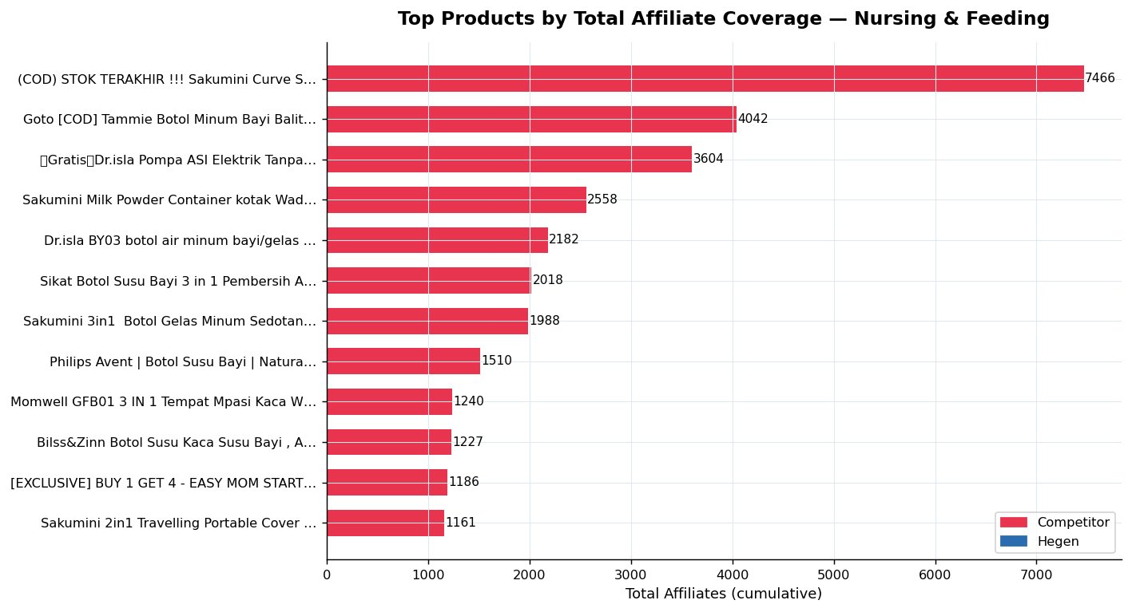
Figure 5: Top products by total affiliate coverage. Hegen's best product (9 affiliates) is not visible on this scale.

2.3 Price vs. Volume — Baby Bottles
Within the Baby Bottles & Accessories subcategory, the highest-volume products cluster in the Rp0–50,000 price range. This confirms the premium pricing challenge for Hegen, whose bottles retail at Rp371,070 — a price point where consumer volume is structurally lower. However, several products in the Rp40,000–50,000 range still achieve 175,000–325,000 total units, suggesting that the right creator and affiliate strategy can overcome moderate price barriers.
Note: The x-axis uses Rp ribu (thousands) scale. Hegen's price point falls near the Rp370 ribu mark, off the right edge of the highest-density cluster — this visual confirms the positioning gap relative to mass-market competitors.

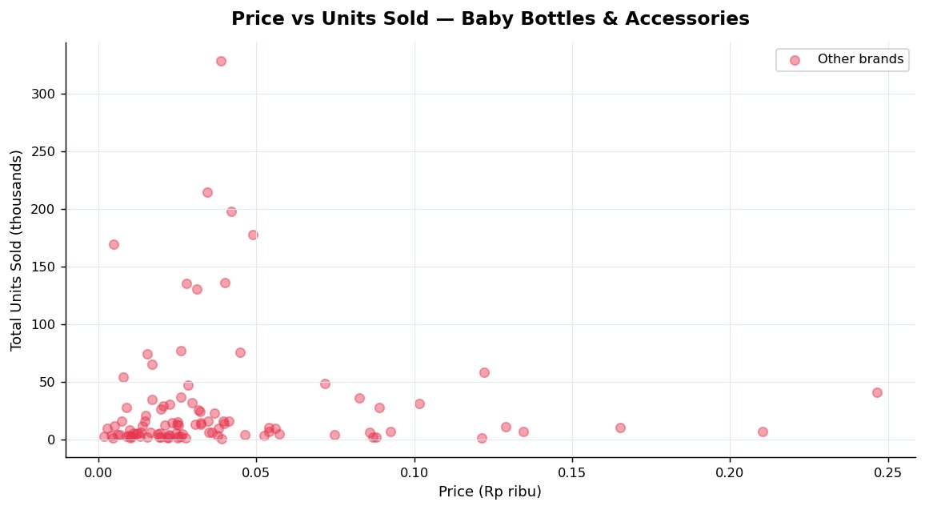
Figure 6: Price vs units sold — Baby Bottles & Accessories. High-volume products cluster at the lower price range.

3. Creator Intelligence

3.1 Creator Tier Analysis
Across the 300 affiliate creators tracked in the Nursing & Feeding category, micro-creators (10K–100K followers) generate the highest total units sold in the past 28 days at 1,945k — significantly ahead of mid-tier (1,268k), nano (707k), and mega creators (736k). This is the single most important finding for Hegen's affiliate recruitment strategy.
Engagement rate follows the opposite pattern: mega-creators lead at 2.87%, followed by macro (2.27%) and mid-tier (1.56%). Micro-creators at 1.20% engagement still drive the most absolute volume due to sheer numbers. For a brand like Hegen targeting premium-aware parents, a combination of mid-tier creators (trust and reach) and micro-creators (volume) represents the optimal mix.

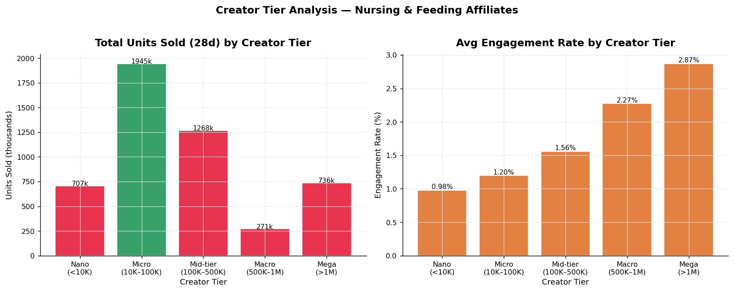
Figure 7: Creator tier analysis. Left: total units sold by tier (micro dominates). Right: avg engagement rate by tier.

3.2 Video vs. Live Commerce
Among the top 12 sales-driving creators in Nursing & Feeding, video commerce and live commerce play different roles. Mom Uung Official (the top creator by total GMV) derives the majority of her GMV from live streams. Dr.Isla Indonesia similarly relies heavily on live commerce. By contrast, creators like Cerita Uji, Karen Kurniawan, and Mama Zarrah are purely video-driven.
This bifurcation has an important implication: a comprehensive creator strategy should include both video-specialist affiliates (for always-on content) and live commerce specialists (for high-GMV sessions). Hegen currently has no visible live commerce presence in this category.

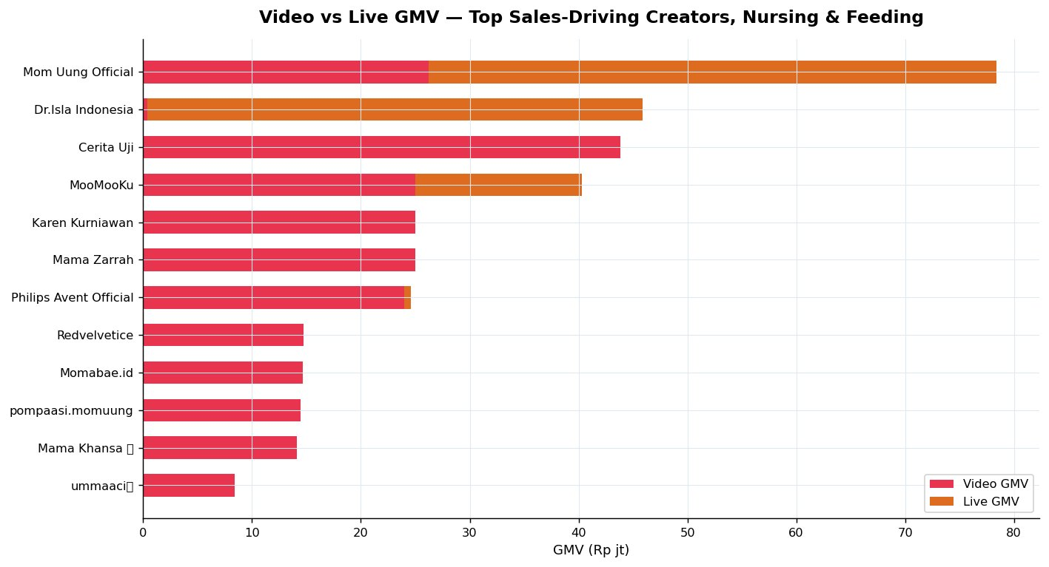
Figure 8: Video vs Live GMV breakdown for top sales-driving creators. Orange = live, red = video.

3.3 Creator Efficiency — GMV per Follower
Creator efficiency (GMV generated per follower) reveals a counterintuitive finding: the most efficient creator, PT Youkebei Shop, generates Rp18,790 GMV per follower — far exceeding larger creators like Mom Uung Official. This suggests that niche, highly-targeted creators with smaller but more commercially active audiences can outperform mega-creators on a per-follower basis.
For Hegen, this means the priority should not be signing the most famous baby creator, but finding creators whose audiences over-index on premium baby product purchasers. Creators like ummaaci and oceanedes, who rank highly on this efficiency metric, represent the type of profile Hegen should prioritise.

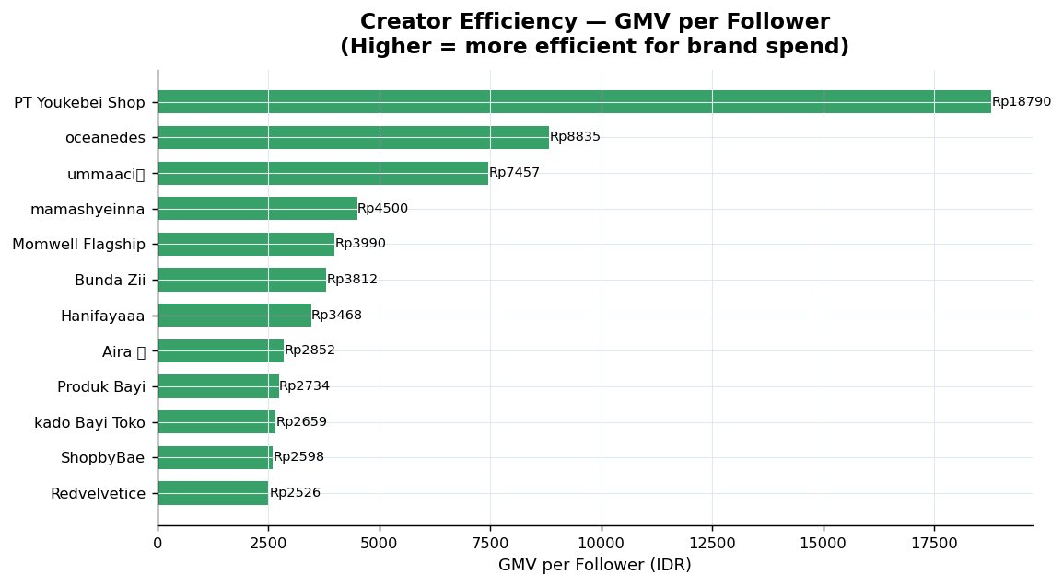
Figure 9: GMV per follower for top creators. Higher = more efficient creator spend for brand investment.

4. Hegen Indonesia — Brand Diagnosis

4.1 Performance Scorecard
The table below benchmarks Hegen Indonesia against category medians across five key metrics. Signal indicates the urgency of each gap.

Metric | Hegen Value | Category Benchmark | Signal
Shop Rating | 3.7 / 5.0 | Top brands: 4.7–4.9 | Warning
7-Day GMV | Rp67.2 jt | Top-10 avg: Rp82.0 jt+ | Warning
GMV MoM Change | -59.9% | Category growers: +15–65% | Critical
Units MoM Change | -62.5% | Category growers: +12–65% | Critical
Total Influencers | 372 | Category median: 1,100 | Critical
Commission Rate | 5% | Category median: 7% | Warning
Best Product Aff. | 9 affiliates | Top product: 7,466 affiliates | Critical
Active Products | 8 (this mo.) | 103 listed, 37 on-sale | Warning

4.2 Benchmark Visualisation
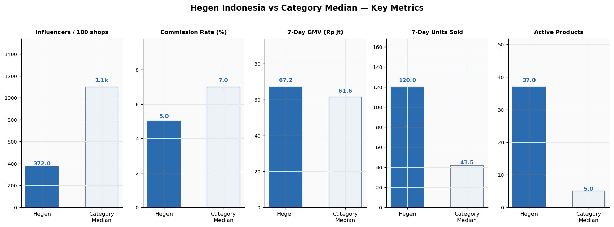
Figure 10: Hegen vs category median across five key metrics. Hegen leads on 7-day GMV and active products but lags significantly on influencer count and commission rate.

4.3 Affiliate Gap Analysis
The affiliate coverage gap is the most stark quantitative finding in this analysis. Hegen's Ocean Odyssey Feeding Bottle — its only product appearing in the most promoted dataset — has accumulated 9 total affiliates. The top competing product has 7,466. Even mid-tier competitor products carry 1,000–2,500 affiliates.
This gap compounds over time: more affiliates generate more content, more content generates more organic impressions, and organic impressions reduce customer acquisition cost. Hegen is not participating in this flywheel.

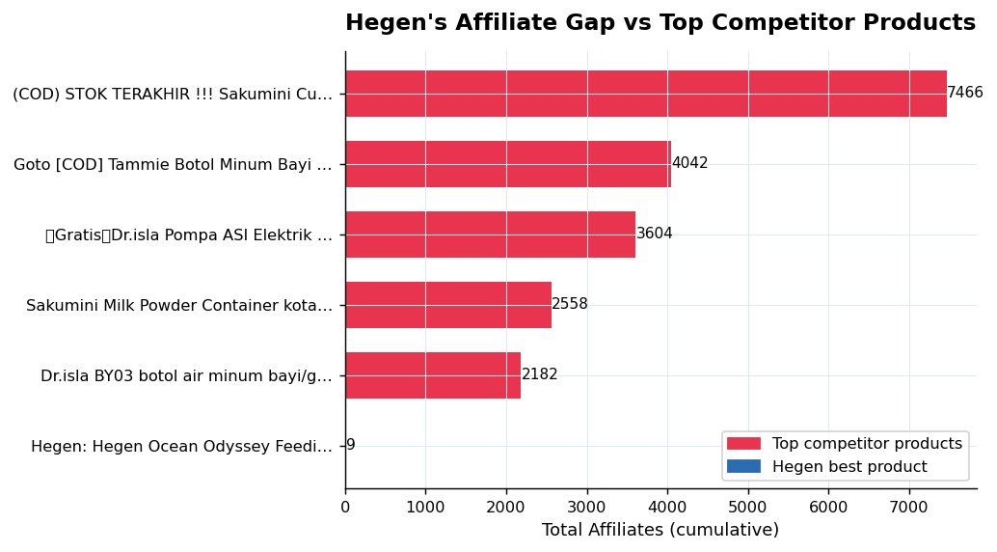
Figure 11: Hegen's affiliate count (9) vs top competitor products. The gap is structural and immediately actionable.

5. Strategic Recommendations
Three data-backed recommendations are presented in order of expected impact and speed of implementation. Each is directly derived from the analysis findings above.

Recommendation 1: Raise commission rate from 5% to 9%
Hegen's 5% commission rate is 2 percentage points below the category median (7%) and 5 points below the highest-affiliate bracket (10%). Products offering 9–10% commission attract a median of 1,000+ affiliates in this category. A targeted rate increase on Hegen's top 3 SKUs would directly improve creator recruitment economics. Expected outcome: 3–5x increase in affiliate applications within 30 days of implementation.

Recommendation 2: Launch a live commerce channel with 1–2 mid-tier Baby creators
Live commerce drives a significant share of top-creator GMV in Nursing & Feeding (Mom Uung Official alone generated Rp52.2 jt from live in this period). Hegen currently has zero live commerce presence. Partnering with 1–2 mid-tier creators (100K–500K followers) in the Baby category for weekly 60-minute live selling sessions — featuring product demonstrations, Q&A, and limited-time discounts — would open a new GMV channel. Target: Rp30–50 jt GMV per session based on category benchmarks.

Recommendation 3: Run a structured micro-creator seeding programme (target: 50 affiliates in 30 days)
Micro-creators (10K–100K followers) generate more total units than any other tier in this category. Hegen should build a seeding programme: identify 100 Baby category micro-creators using the FastMoss creator search tool, offer free product samples in exchange for one shoppable video, and onboard them as affiliates at the new 9% commission rate. Filtering for creators with engagement rate >1.2% and average shoppable video views >10K will prioritise quality. Target: 50 active affiliates within 30 days, closing the gap vs the category median of 1,100.

Data note: MoM percentage figures for shops with prior-month GMV below Rp1,000 (including Glodok123 and RayyanzaShopID) were excluded from trend analysis as these represent statistical anomalies, not real growth signals. All other data reflects FastMoss estimates as of March 12, 2026.

