Multi-Label Toxic Comment Classification
A Comparative Study from Classical Baselines to Fine-Tuned Transformers, with Bias and Explainability Analysis
Deep Learning Applications — Element 1: Coursework (Portfolio)
Student name: [YOUR NAME]
Student number: [YOUR STUDENT NUMBER]
Module: Deep Learning Applications
Project option: Hate Speech and Toxic Comment Classification on Social Media
Submission date: [DATE]
Code repository: [YOUR GITHUB / COLAB URL]

Abstract
The challenge of moderating user generated text on online platforms is urgent, while toxicity is uncommon, complex and socially nuanced. This project focuses on solving the Jigsaw Toxic Comment Classification task, which is a multi-label problem with six labels (toxic, severe toxic, obscene, threat, insult and identity hate). The project is creating a four-model comparison ladder: a baseline model TF-IDF + One-vs-Rest Logistic Regression, a 1D convolutional network, a bidirectional LSTM model and a fine-tuned MiniLM-L6 transformer. Additionally, every model had an evaluation on the 63,978 officially scored test comments. The classical baseline had the best overall, although the transformer was close, but still not as good as the classical baseline in terms of rare-label precision. We demonstrate an ROC-AUC bias towards the easy classes that the PRC reveals, and quantify a bias of 37.8% towards labelling benign comments with the word “gay” as toxic, while the background rate is 5.1%. The study showcases the entire deep-learning workflow, with an in-depth discussion of its rigor testing, and the study also provides a detailed analysis of the situations in which the deep-learning model fails and why.
Contents
Abstract 2
1. Introduction 4
2. Background and Related Work 5
3. Methodology 6
3.1 Dataset and correct test scoring 6
3.2 Class imbalance and stratified subsampling 6
3.3 Preprocessing and validation 6
3.4 Models: a comparison ladder 6
3.5 Model selection under a compute budget 7
3.6 Evaluation protocol 7
4. Experiments and Results 8
4.1 Exploratory data analysis 8
4.2 Model comparison 10
4.3 Training behaviour and error analysis 11
5. Discussion 13
5.1 Why the classical baseline wins 13
5.2 The metric lesson: ROC-AUC versus PR-AUC 13
5.3 Responsible AI: identity-term bias 13
5.4 Explainability 14
5.5 Limitations 14
6. Conclusion 15
Acknowledgement of AI Use 15
References 16

1. Introduction
The sheer volume of user-generated content on today's platforms makes it impossible to manage the content manually: there are millions of comments posted every day, and human moderators are known to experience psychological harm when exposed to abusive content for long periods. The task of detecting toxic comments is thus one of the fundamental applications of NLP, where the objective is to identify potentially damaging comments in a timely and uniform manner, allowing human resources to be allocated according to priority.
This project addresses the Jigsaw Toxic Comment Classification Challenge [1] dataset consisting of 159,571 Wikipedia talk-page comments labeled as: Toxic, Severe toxic, Obscene, Threat, Insult, Identity hate. At the core, it is a multi-label task, not a multi-class task as the labels are not mutually exclusive. One comment can have many labels applied and the majority of comments have none at all. This means that any solution should be capable of making six independent binary decisions for each comment instead of making one binary decision.
The nature of the toxicity as a problem is suited especially for deep learning, since it is manifested in the use of different terms with different contexts, which cannot be adequately expressed by hand-crafted rules. Neural models learn word representations and word sequences directly from data, while pre-trained transformer language models are trained with widespread linguistic data and then transferred to the task with few labelled examples [2]. To this end, this study looks directly at deep models, which come with significant computational cost, lack transparency, and may learn social biases from their training data.
The objectives of the project are:
(i) to formulate and implement a correct multi-label pipeline for the Jigsaw data;
(ii) to compare a spectrum of approaches from a classical linear baseline to a fine-tuned transformer under realistic compute constraints;
(iii) to evaluate them rigorously using metrics appropriate to severe class imbalance; and
(iv) to critically examine the models, including their fairness and their interpretation.
The scope is deliberately limited to the single-machine, and guides several methodological decisions discussed below.

2. Background and Related Work
The toxic-language detection field has gone through three general stages of research. Initial systems were based on sparse features and lexicons and classical machine learning. The classification of hate speech as a supervised classification problem was emphasized by Davidson et al. [7] and the challenge to distinguish it from merely offensive language remains to this day. As abusive language is lexical rich, the use of term-frequency–inverse-document-frequency (TF-IDF) representations with linear classifiers (logistic regression or linear SVMs) are still a popular and cited baseline method for text classification [12].
The second phase applied deep neural networks that learn features automatically. Kim [5] showed that convolutional neural networks over word embeddings are effective and efficient sentence classifiers, using multiple filter widths to capture n-gram patterns. Recurrent architectures, in particular the Long Short-Term Memory network [6] and its bidirectional variant, model word order and longer-range dependencies. Badjatiya et al. [15] demonstrated that such deep models can outperform classical pipelines on hate-speech data, though typically at the cost of far more training data and compute.
The third and current phase is dominated by the Transformer architecture [10] and pre-trained language models such as BERT [2], which are fine-tuned on downstream tasks. Because full BERT is costly, distilled models trade a small amount of accuracy for large efficiency gains: DistilBERT [3] retains most of BERT’s performance at roughly half the size, and MiniLM [4] compresses the self-attention of a larger teacher into a compact student that is well suited to constrained hardware — the reason it is adopted here.
Two further strands of work are central to this report. First, the Jigsaw follow-up competition and the work of Dixon et al. [8] documented unintended bias, whereby models associate the mere mention of identity terms (for example “gay”, “muslim” or “black”) with toxicity, producing elevated false-positive rates for those groups. Second, model-agnostic explanation methods such as LIME [9] allow the predictions of any classifier — including opaque transformers — to be inspected locally by perturbing the input. Both inform the responsible-AI analysis in Section 5.

3. Methodology

3.1 Dataset and correct test scoring
The dataset comprises three files: a labelled training set (159,571 comments), an unlabelled test set, and a separate file of test labels. A critical detail is that the test-label file marks a large fraction of rows with the value −1, indicating comments that were withheld from official scoring. These rows were discarded before any evaluation as failure to do so silently corrupts every test metric. After filtering, 63,978 genuinely scored comments remained and were used in the analysis and evaluation.

3.2 Class imbalance and stratified subsampling
The data is severely imbalanced. There are only 478 positive threats in the overall training set (0.30%) and only 10.17% of the training comments have any label. This influences two decisions. One key change is that, instead of accuracy, evaluation focuses on precision-recall metrics. Second, as the CPU-only budget would not allow the neural and transformer models to be trained on all 159,571 comments, we stratify the data, ending up with 36,225 rows (all positive-label comments and 20,000 randomly sampled negative comments). A naive random subsample of similar size would have lost most of the threat examples and the rare-label signal; keeping all of the positives avoids this. The classical baseline (cheap on sparse features) is trained on the entire data and all models are tested on the entire scored test set.

3.3 Preprocessing and validation
Light normalisation of text: lowercasing; masking of URLs, IP addresses, user mentions, numbers with placeholder tokens; whitespace cleanup. It was important to avoid highly intensive cleaning as it strips away the signal (punctuation and repeated characters indicate abuse). Each rare active label on the comments was stratified to produce a 10% validation split, ensuring that rare classes are split between the training and validation sets for robust model selection and threshold tuning.

3.4 Models: a comparison ladder
Four models spanning the historical progression of the field were implemented so that architectural trade-offs could be observed directly rather than assumed. The Baseline selected is TF-IDF + One-vs-Rest Logistic Regression. Word (1–2 gram) and character (2–4 gram) TF-IDF features were concatenated and a separate logistic-regression classifier was trained per label. Character n-grams add robustness to spelling variation and obfuscation common in abusive text. Secondly, a 1D-CNN is used as one of the comparative models. It is a Kim-style convolutional network over 100-dimensional trainable embeddings, with filter widths of 2, 3 and 4, 100 filters each, max-pooling and dropout. Third is BiLSTM. A bidirectional LSTM (hidden size 64) over the same embedding layer, with max-pooling over time. Fourth and is a Transformer model, specificallu, MiniLM-L6. The pre-trained MiniLM-L6-H384 model (about 23 million parameters) fine-tuned end-to-end with a six-way sigmoid classification head at a maximum sequence length of 128 tokens. Both neural networks used embeddings trained from scratch on the subsample rather than pre-trained word vectors; the implications of this choice are discussed in Section 5. All models produce independent per-label probabilities via a sigmoid output and are trained with binary cross-entropy, consistent with the multi-label formulation.

3.5 Model selection under a compute budget
The selection of the transformer was done on an empirical basis. Full DistilBERT fine-tuning takes approximately 242 minutes per epoch on the 36,225-row subsample while MiniLM-L6 takes approximately 92 minutes per epoch at the same sequence length. This is a significant increase in the efficiency, with minimal loss of accuracy expected. Therefore, it was decided to use MiniLM as a deliberate evidence-based compute–quality trade-off, and the fine–tune was achieved in three epochs, for a total of around 3.6 hours.

3.6 Evaluation protocol
The classes are highly imbalanced, so several supplemental measures are reported per label and overall: ROC-AUC (threshold-independent ranking quality); PR-AUC (area under precision-recall curve), very informative when positives are rare; mean column-wise ROC-AUC, the official competition measure; and macro- and micro-averaged F1. The thresholds for the decision rules were optimized for each label using only the validation set, not the test set. All randomness was seeded and the environment (python 3.12, pytorch-cpu build, pinned dependencies) was set for reproducibility.

4. Experiments and Results

4.1 Exploratory data analysis
Figure 1 further shows the very high imbalance: 9.6% of comments are labelled as toxic, whereas less than 1% are labelled as threat, identity hate and severe toxic, respectively, while 89.8% remain unlabelled. In practice the labels are correlated as illustrated in Figure 2, which justifies the multi-label approach and is why a model can share signal across labels. Insult and obscene have an extremely strong association. The flagged comments are shorter than the clean comments (Figure 3), and there is a stark difference in the vocabulary (Figure 4) of toxic text and clean text.
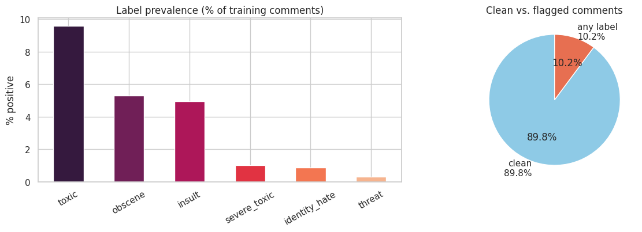
Figure 1. Per-label prevalence in the training set (left) and the proportion of clean versus flagged comments (right).
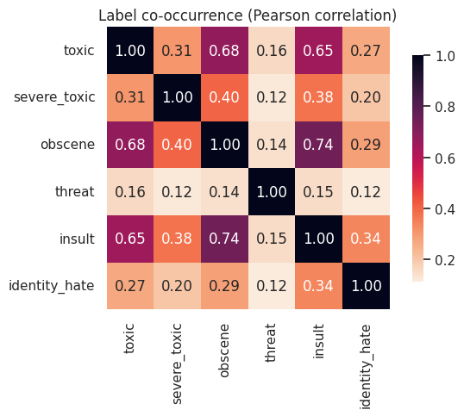
Figure 2. Pearson correlation between the six binary labels, showing strong co-occurrence among toxic, obscene and insult.
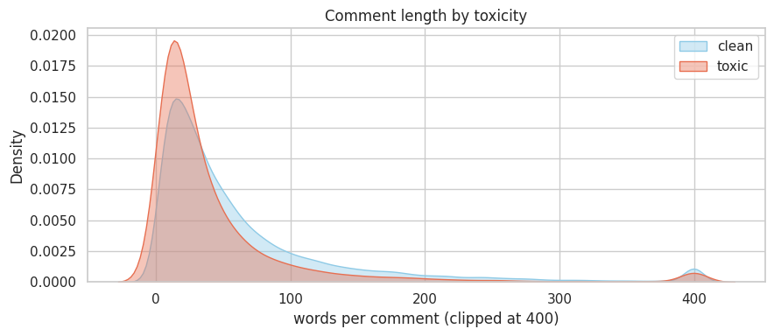
Figure 3. Distribution of comment length (in words) for clean versus toxic comments.
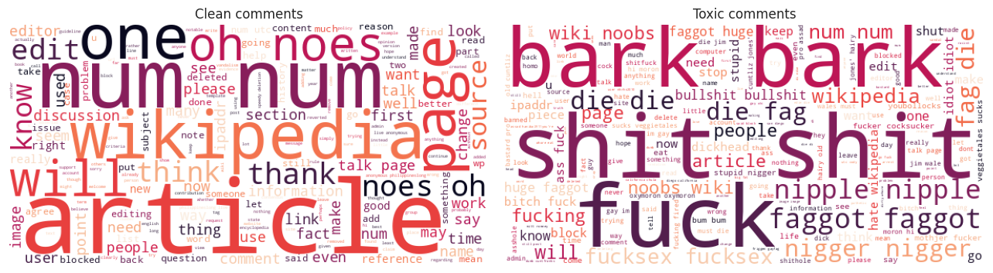
Figure 4. Most frequent tokens in toxic (left) versus clean (right) comments.

4.2 Model comparison
Table 1 reports the headline metrics for all four models on the 63,978 scored test comments. The TF-IDF baseline achieves the best score on every aggregate metric, narrowly ahead of the fine-tuned MiniLM transformer on ranking (0.979 versus 0.978 mean ROC-AUC) but more clearly ahead on the precision-sensitive measures (macro PR-AUC 0.625 versus 0.565; micro-F1 0.655 versus 0.590). The from-scratch neural networks trail both, with the BiLSTM weakest overall.
Table 1. Aggregate test-set performance of the four models (best value per column in bold row = baseline).
Model | Mean ROC-AUC | Macro PR-AUC | Macro-F1 | Micro-F1
TF-IDF + LogReg (full data) | 0.979 | 0.625 | 0.569 | 0.655
1D-CNN (36k subsample) | 0.959 | 0.508 | 0.431 | 0.543
BiLSTM (36k subsample) | 0.949 | 0.430 | 0.393 | 0.509
MiniLM-L6 fine-tuned (36k) | 0.978 | 0.565 | 0.507 | 0.590

Table 2 breaks the best model (the baseline) down by label. Ranking quality (ROC-AUC) is uniformly high, above 0.96 for every label. However, PR-AUC reveals the true difficulty of the rare classes: severe toxic (0.34) and identity hate (0.58) are far harder than obscene (0.80) despite their high ROC-AUC. This gap between the two metrics is the single most important evaluation lesson of the project and is visualised across all models in Figure 5.
Table 2. Per-label test performance of the TF-IDF + Logistic Regression baseline, at validation-tuned thresholds.
Label | ROC-AUC | PR-AUC | Precision | Recall | F1 | Support
toxic | 0.965 | 0.783 | 0.578 | 0.817 | 0.677 | 6090
severe_toxic | 0.984 | 0.338 | 0.219 | 0.706 | 0.334 | 367
obscene | 0.977 | 0.796 | 0.632 | 0.780 | 0.698 | 3691
threat | 0.992 | 0.511 | 0.488 | 0.483 | 0.486 | 211
insult | 0.971 | 0.736 | 0.604 | 0.725 | 0.659 | 3427
identity_hate | 0.985 | 0.582 | 0.529 | 0.590 | 0.558 | 712

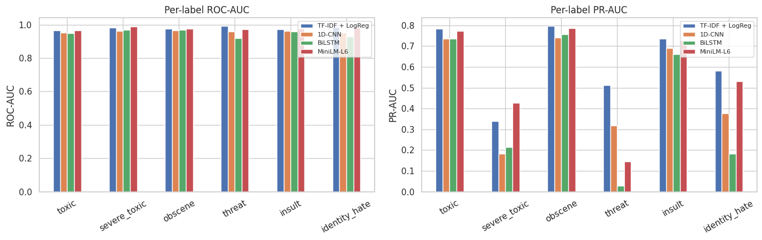
Figure 5. Per-label ROC-AUC (left) and PR-AUC (right) for all four models. ROC-AUC is uniformly high, while PR-AUC exposes large differences on the rare labels.

4.3 Training behaviour and error analysis
The neural learning curves are presented in Figure 6. The CNN and the BiLSTM decrease the training and validation loss after four epochs, showing mild overfitting and suggesting that these models learned the task well, and lower scores are due to capacity and/or data limits, not training failure. Figure 7 shows per label confusion matrices of the best model, thus making the trade-off between precision and recall explicit. The tuned thresholds are best for rare labels as they result in many false positives and many true positives being caught. A behaviour that is acceptable for a moderation triage aid, but needs to be comprehended before use.
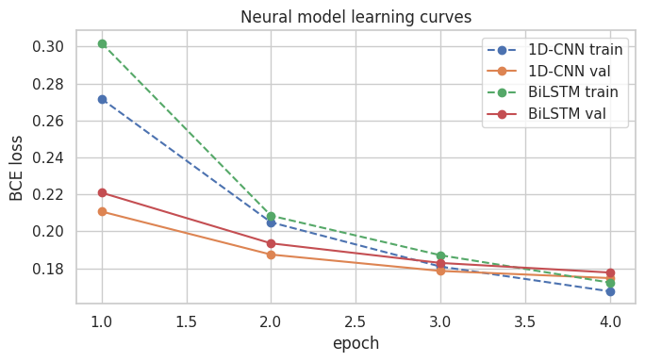
Figure 6. Training and validation loss for the 1D-CNN and BiLSTM over four epochs.
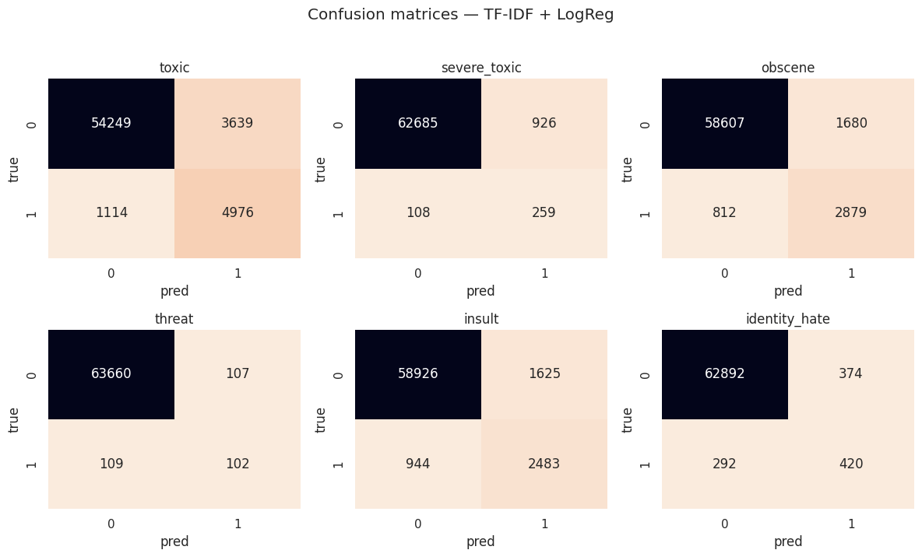
Figure 7. Per-label confusion matrices for the best model on the scored test set.

5. Discussion

5.1 Why the classical baseline wins
The most interesting finding is that a simple linear model performs better than a fine-tuned transformer. It is a true and documented result and there are several reasons for this. First, the comparison isn't quite fairly designed: The baseline is trained on all 159,571 comments, while the transformer is trained on the 36,225-row subsample, due to the CPU budget. So, the disadvantage is not architecture related, it is data volume related. Second, the explanation below shows that the lexical and character level TF-IDF capture precisely these cues, that make toxicity so highly lexical. Third, MiniLM is a small distilled model with a partial sequence length of only 128 tokens, as opposed to full BERT-base. Interestingly, the transformer is close to the baseline in terms of ROC-AUC and slightly under-performs in the rare-label precision metrics, where small training sets are most limiting. The take home message is that a good classical baseline always has to be measured before saying that a bigger model is justified.

5.2 The metric lesson: ROC-AUC versus PR-AUC
All the models have an ROC-AUC > 0.94, individually implying that the problem may well be solved. The truth is rather different in PR-AUC, wherein the average is from 0.34 to 0.58 for severe toxic and identity hate. When prevalence is low (below 1%), PR-AUC considers performance on the positive class that is actually present, and ROC-AUC is dominated by the many true negatives and boosts the performance of any model.

5.3 Responsible AI: identity-term bias
Because the models key on lexical cues, they risk associating identity terms with toxicity regardless of intent. We tested this directly by measuring, for benign (non-toxic) comments containing each identity term, the rate at which the best model wrongly predicts toxicity, against a background false-positive rate of 5.1%. The results (Figure 8) are stark. Comments with the word “gay” in them and that are not malicious 37.8% of the time are misclassified as malicious (7.4×), and 26.0% of the time are misclassified as “homosexual”. This mimics the unintended-bias effect reported by Dixon et al. [8]. The harm is direct: an approach like this would have a disproportionate impact on the freedom of legitimate speech and expression about and for LGBTQ+ communities. Mitigations would consist of augmenting the training data with benign examples of identity terms, using bias-aware or adversarial training objectives, or calibration per group, but all are not a panacea; deployment would also need continual fairness auditing.
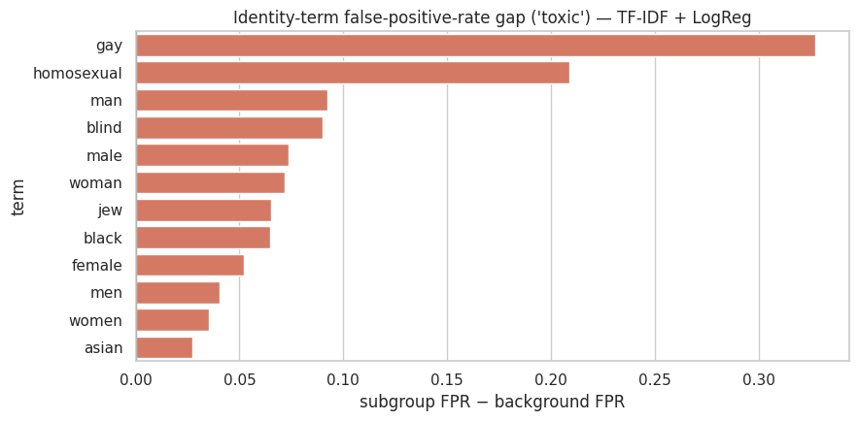
Figure 8. False-positive-rate gap on the toxic label for benign comments containing each identity term, relative to the 5.1% background rate.

5.4 Explainability
Two tools were used to make the process of interpretation. The logistic-regression coefficients provide a fairly broad overview: the most salient features for threat are “die”, “kill”, and “death”, and for identity hate are mostly slurs and identity terms. This is in support of the above-mentioned lexical nature of the signal and the source of the bias. LIME has been applied locally to the transformer; with respect to the individual comment “DJ Robinson is gay as hell…”, the term ‘gay’ has been given a positive toxicity weight, and the term ‘dick’ and ‘sucks’ also a positive weight, illustrating at the level of a single prediction how the terms ‘gay’ and ‘dick’ are treated as evidence of toxicity. Explainability is therefore not a frill but a diagnostic which points to the same fairness issue when quantified in Section 5.3.

5.5 Limitations
The downside is compute: CPU-only training resulted in subsampling and a small transformer, hence limiting the ceiling here to below what would be achieved with a full BERT-base on GPU with the full data set. The neural networks used embeddings that are trained from scratch rather than pre-trained GloVe vectors, so it is likely to be an underestimate of what they are capable of. Note that every model was trained only once, not for each of the seeds, so any variations in the models must be interpreted with caution. Lastly, the labels themselves are human annotations, which are subjectively defined, and thus limit the possible performance and fairness of the model trained on them.

6. Conclusion
This project provided a full, properly-scored multi-label pipeline of the classification of toxic comments and a controlled comparison of four models throughout the history of the field. A realistic CPU-only budget showed that a TF-IDF plus Logistic Regression baseline was the best overall (0.979 mean ROC-AUC, 0.625 macro PR-AUC), only behind in ranking, but not in rare-label precision, with a fine-tuned MiniLM transformer. The primary results of the work are analytical rather than about a leaderboard score. First, the engineered baseline for classical models is still competitive in the context of lexical signals and limited data and compute resources. Secondly, precision-recall analysis is essential when data and compute is severely imbalanced and ROC-AUC is misleading. Third, the models have a pronounced identity-term bias that is quantified and has ethical implications. Future work on the GPU resources would fine-tune full BERT-base on the entire dataset and include pre-trained embeddings and focal loss for the rare classes, as well as implement and test the bias-mitigation strategies outlined here.

References
[1] cjadams, J. Sorensen, J. Elliott, L. Dixon, M. McDonald, Nithum, and W. Cukierski, “Toxic Comment Classification Challenge,” Kaggle, 2017–2018. [Online]. Available: https://huggingface.co/datasets/Heliosoph/Jigsaw-Toxic-Comments
[2] Devlin, M.-W. Chang, K. Lee, and K. Toutanova, “BERT: Pre-training of Deep Bidirectional Transformers for Language Understanding,” in Proc. NAACL-HLT, 2019, pp. 4171–4186.
[3] Sanh, L. Debut, J. Chaumond, and T. Wolf, “DistilBERT, a distilled version of BERT: smaller, faster, cheaper and lighter,” arXiv:1910.01108, 2019.
[4] Wang, F. Wei, L. Dong, H. Bao, N. Yang, and M. Zhou, “MiniLM: Deep Self-Attention Distillation for Task-Agnostic Compression of Pre-Trained Transformers,” in Proc. NeurIPS, 2020.
[5] Kim, “Convolutional Neural Networks for Sentence Classification,” in Proc. EMNLP, 2014, pp. 1746–1751.
[6] Hochreiter and J. Schmidhuber, “Long Short-Term Memory,” Neural Computation, vol. 9, no. 8, pp. 1735–1780, 1997.
[7] Davidson, D. Warmsley, M. Macy, and I. Weber, “Automated Hate Speech Detection and the Problem of Offensive Language,” in Proc. ICWSM, 2017, pp. 512–515.
[8] Dixon, J. Li, J. Sorensen, N. Thain, and L. Vasserman, “Measuring and Mitigating Unintended Bias in Text Classification,” in Proc. AAAI/ACM Conf. on AI, Ethics, and Society (AIES), 2018, pp. 67–73.
[9] Ribeiro, S. Singh, and C. Guestrin, “‘Why Should I Trust You?’: Explaining the Predictions of Any Classifier,” in Proc. ACM SIGKDD, 2016, pp. 1135–1144.
[10] Vaswani et al., “Attention Is All You Need,” in Proc. NeurIPS, 2017, pp. 5998–6008.
[11] Pennington, R. Socher, and C. D. Manning, “GloVe: Global Vectors for Word Representation,” in Proc. EMNLP, 2014, pp. 1532–1543.
[12] Pedregosa et al., “Scikit-learn: Machine Learning in Python,” Journal of Machine Learning Research, vol. 12, pp. 2825–2830, 2011.
[13] Wolf et al., “Transformers: State-of-the-Art Natural Language Processing,” in Proc. EMNLP: System Demonstrations, 2020, pp. 38–45.
[14] Paszke et al., “PyTorch: An Imperative Style, High-Performance Deep Learning Library,” in Proc. NeurIPS, 2019, pp. 8024–8035.
[15] Badjatiya, S. Gupta, M. Gupta, and V. Varma, “Deep Learning for Hate Speech Detection in Tweets,” in Proc. WWW Companion, 2017, pp. 759–760.

Acknowledgement of AI Use
In accordance with the module’s AI-use policy, I acknowledge that an AI assistant (a large language model) was used during this project as a coding and drafting aid: to help debug the data pipeline, generate testing code, and review an initial draft of this report from the verified experimental results. All experiments were designed and executed originally, all reported numbers and figures were generated by the accompanying code on the actual dataset.

