**Trachoma Coverage Evaluation Results Summary: Murkonia , July 2019**

This summary reviews the results from coverage evaluation surveys for **Azithromycin** that were conducted in **Murkonia** in **2019**.

Key Terms

**Reported Coverage-** The coverage calculated from data reported by all drug distributors, with census figures or drug distributor reports used to estimate the population denominator.

**Survey Coverage-** Coverage estimated through the use of population-based survey sampling methods. The denominator is the total number of individuals Survey and the numerator is the total number of individuals Survey who were identified as having ingested the drug.

**Programme Reach-** The proportion of people in the survey area who were given the opportunity to receive the preventive chemotherapy, regardless of whether the drug was ingested.

**Compliance-** The proportion of people in the survey area who are offered the drug that also swallow the drug.

**Implementation Unit (IU)-** Designated survey areas. Coverage surveys are typically conducted at the district level; however, in some cases they may be done at the province, county, or zonal level.

| Implementation Unit Selection |
| --- |
| *REPLACE WITH YOUR TEXT Insert text here explaining how and why these IUs were selected for surveys* |

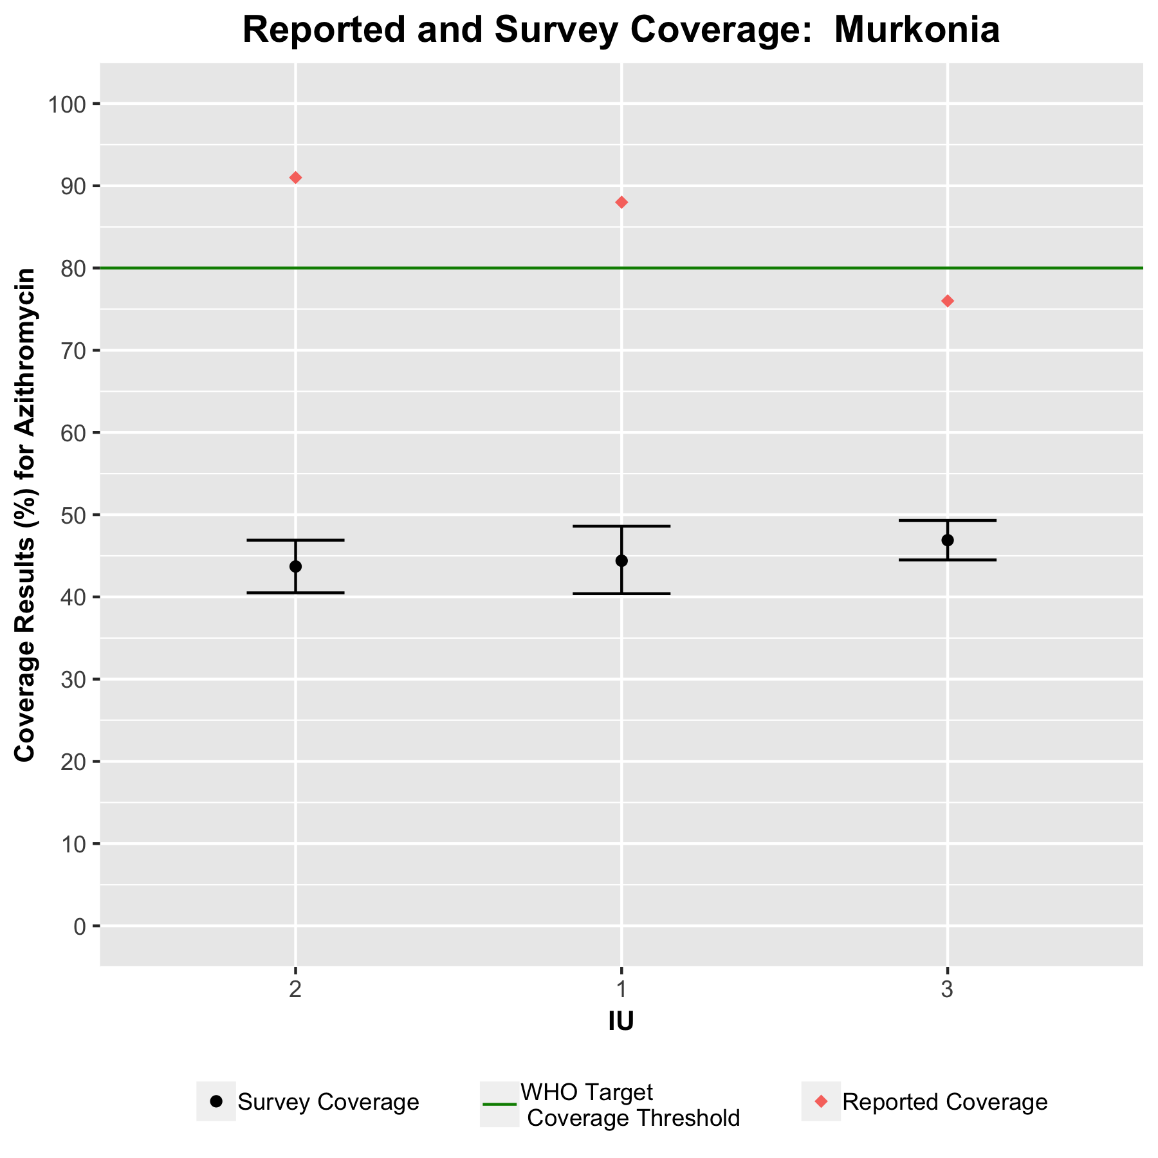

**Table 1. Survey coverage results by IU in Murkonia , 2019 .**

| **IU** | **Reported Coverage** | **Survey Coverage** | **Lower 95% Confidence Interval** | **Upper 95% Confidence Interval** | **Design Effect** | **Programme Reach** |
| --- | --- | --- | --- | --- | --- | --- |
| 1 | 88 % | 44.4 % | 40.4 % | 48.6 % | 1.5 | 66.9 % |
| 2 | 91 % | 43.7 % | 40.5 % | 46.9 % | 0.9 | 65.6 % |
| 3 | 76 % | 46.9 % | 44.5 % | 49.3 % | 0.5 | 67.8 % |

**VALIDATION OF REPORTED COVERAGE**

When there is no significant difference between the reported and survey coverage, or when the two figures are relatively close (indicated by the colors in green) then the survey coverage is considered to “validate” the reported coverage.

**Table 2. Interpretation of survey coverage results to determine if the survey coverage validates the reported coverage and whether the target threshold is met by each IU, Murkonia , 2019 . The coloring of the cells indicates whether programmatic action is required (Green = on track, no action required; Yellow = caution, improvements can be made; Red = inadequate, action is required).**

| **IU** | **Survey Coverage** | **Reported Coverage** | **Difference** | **Survey Coverage &   Reported Coverage   are Similar** | **Meets or Exceeds the   Target 80% Threshold** |
| --- | --- | --- | --- | --- | --- |
| 1 | 44.4 | 88 | -43.6 | No; survey coverage is much less | No |
| 2 | 43.7 | 91 | -47.3 | No; survey coverage is much less | No |
| 3 | 46.9 | 76 | -29.1 | No; survey coverage is much less | No |

| **Conclusion** | **Validation Interpretation** |
| --- | --- |
| Yes; survey coverage validates reported coverage | The reported coverage is contained within the 95% confidence interval around the survey coverage. This means the reported coverage can be considered be “validated” in that IU; no action or improvements are required to the reporting system. |
| Yes; survey and reported coverage are similar | The reported coverage is outside the 95% confidence interval around the survey coverage but is still within ± 10 percentage points of the survey coverage, which suggests the reporting system is working well; no action or improvements are required to the reporting system. |
| No; survey coverage is... | The reported coverage is between ± 10 to 25 percentage points different from the survey coverage. This suggests there could be a problem with the reporting system and action may be required if resources permit. |
| No; survey coverage is much... | The reported coverage is at least ± 25 percentage points different from the survey coverage. This suggests that there is a real problem with the reported coverage and follow-up action to improve the reporting system in the IU is required. |

| **Conclusion** | **Threshold Interpretation** |
| --- | --- |
| Yes | The surveyed coverage is at or above the threshold for Trachoma (80%) |
| No | The surveyed coverage is below the threshold for Trachoma (80%) |

The desired outcome is to have the surveyed coverage within 10% of the reported coverage, as well as meet WHO's target coverage threshold for Trachoma.

| Validation of Reported Coverage |
| --- |
| *REPLACE WITH YOUR TEXT One purpose of acoverage survey is to determine whether the reported coverage (and hence the administrative reporting system) appears to be accurate. Based on the previous table results comparing Reported vs. Survey coverage, how do the results compare? Does the administrative reporting system appear to be working well? Describe what you observe.* |

| Data Accuracy Recommendations |
| --- |
| *REPLACE WITH YOUR TEXT If the reported coverage is similar to the survey coverage, then the reported coverage is saidto be “validated” – meaning that the reporting system is working as desiredand the reported coverage estimates can be relied on for determining if the programme is meeting the target coverage threshold. When they are different, further investigation into the reporting system, with tools such as the Data Quality Self-Assessment, may be required to understand where theinaccuracies are likely taking place. What, if any, next steps will your programme take in response to non-validated (or invalid or poor) coverage results? How do results in the Survey IUs change your interpretation of reported coverage in non-Survey IUs? Insert interpretation.  Insert 1-3 sentences which highlight the specific actions that will be taken to improve data accuracy* |

**Comparison with WHO Target Threshold of 80%**

*If the survey coverage falls below the target coverage threshold, it is evidence that the MDA is considered “LOW” and in need of improvement. If the survey coverage is well above the target coverage threshold it is evidence that the MDA was successful and the programme is functioning well.*

0 % **0** of **3** IUs had GOOD survey coverage (≥80%)*

100 % **3** of **3** IUs had LOW survey coverage (<80%)

*\*Survey coverage is considered ‘good’ when the lower confidence limit exceeds 80 % (Note that in some cases the point estimate of the survey coverage may exceed 80 % but the lower limit may not). Survey coverage is considered ‘low’ if the lower confidence limit falls below 80 %.*

**SURVEY COVERAGE BY SEX**

**Table 3. Programme reach and survey coverage by sex, Murkonia , 2019 .**

| **IU** | **% Reached amongst females interviewed (offered drug)** | **% Reached amongst males interviewed (offered drug)** | **Programme Reach for females statistically different from males** | **% Treated amongst females reached (swallowed drug)** | **% Treated amongst males reached (swallowed drug)** | **Treatment Coverage for females statistically different from males** |
| --- | --- | --- | --- | --- | --- | --- |
| 1 | 66.7 % | 67 % | No | 43.8 % | 45 % | No |
| 2 | 68 % | 62.9 % | No | 45.3 % | 41.8 % | No |
| 3 | 68.7 % | 66.9 % | No | 48.1 % | 45.6 % | No |

**BLUE** indicates females had a significantly higher percentage

**ORANGE** indicates males had a significantly higher percentage

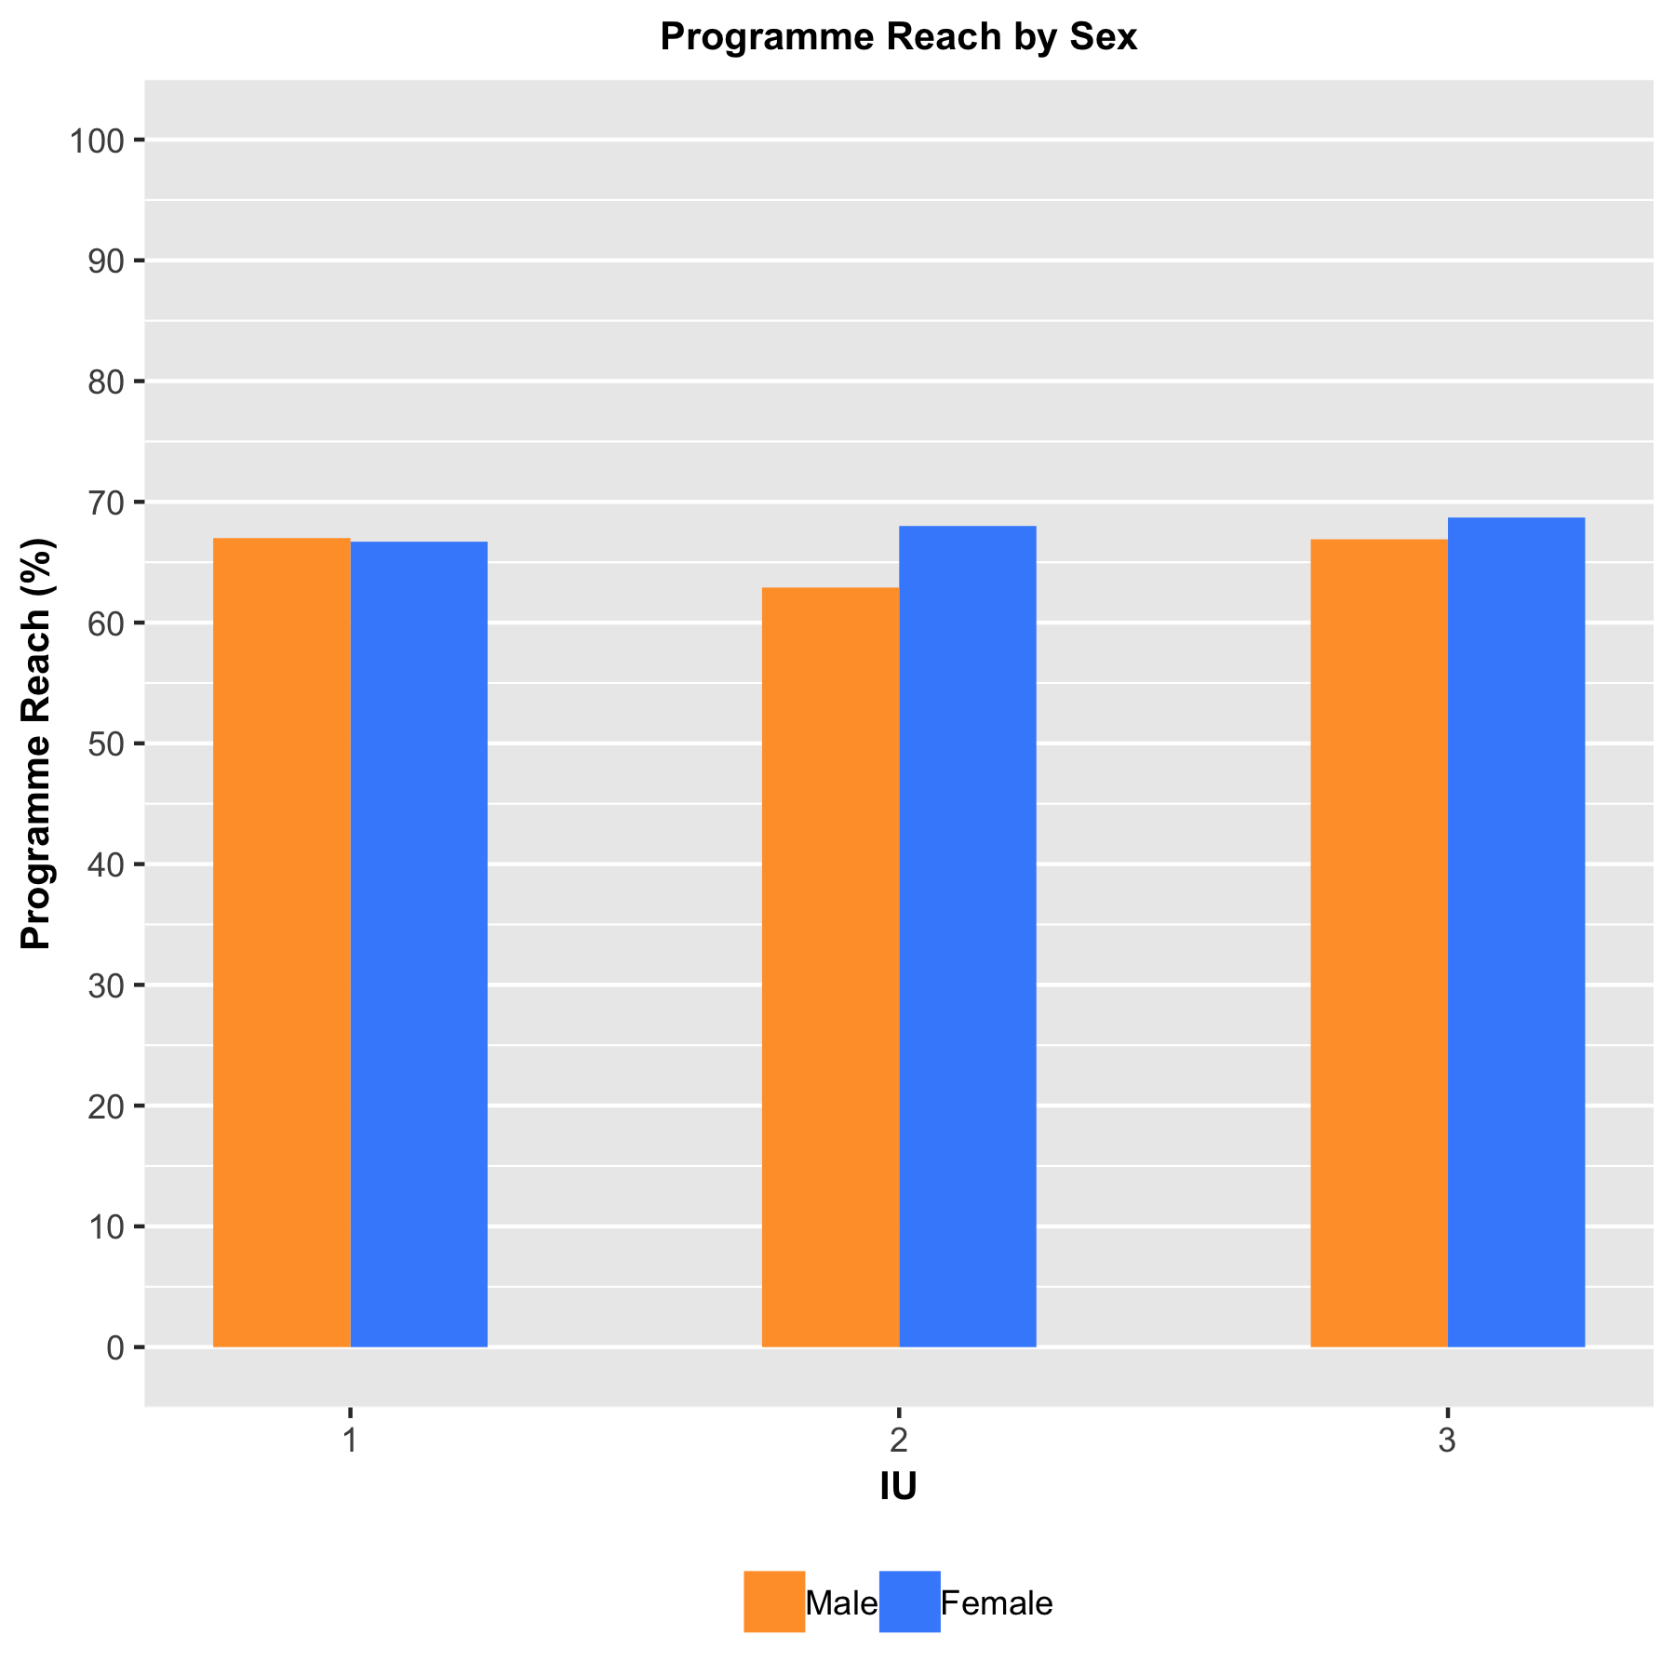

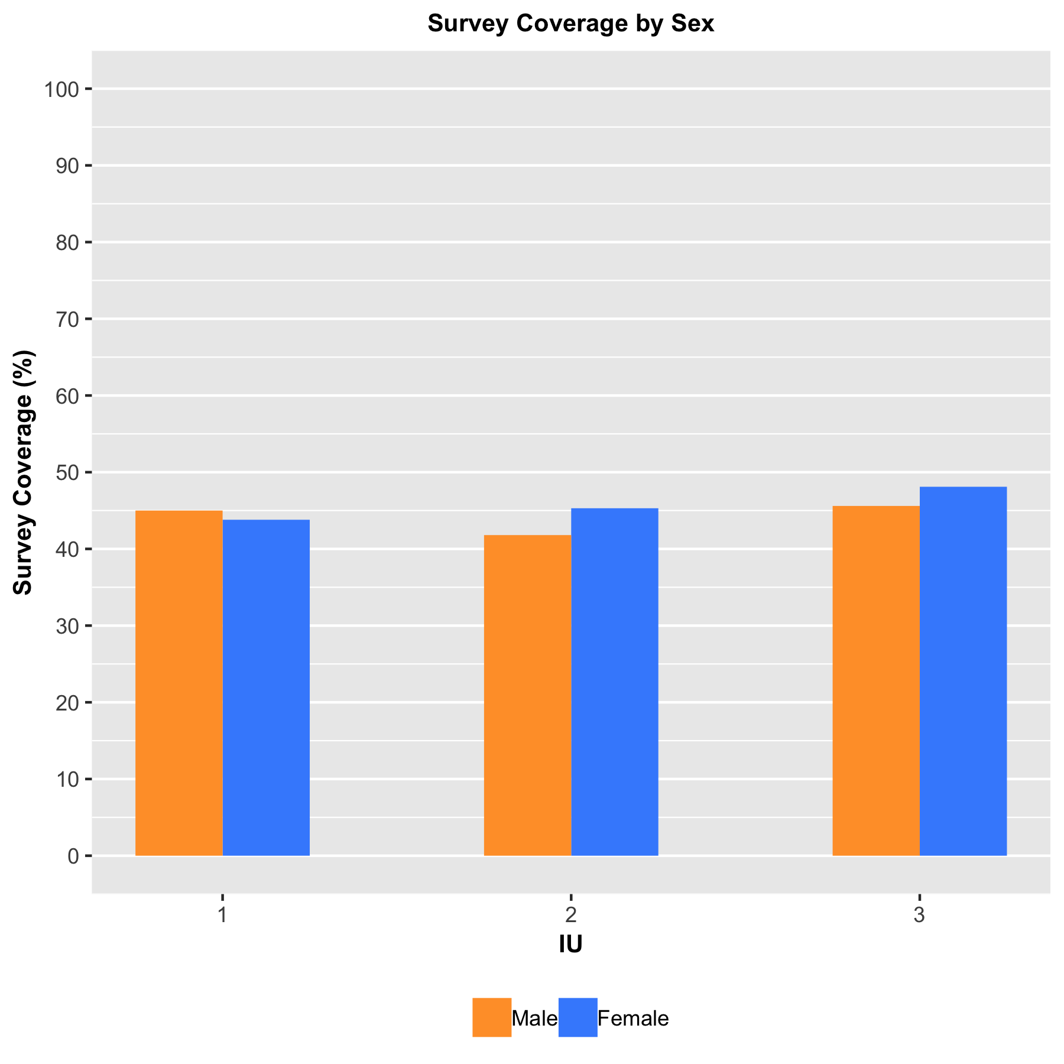

**SURVEY COVERAGE BY AGE\***

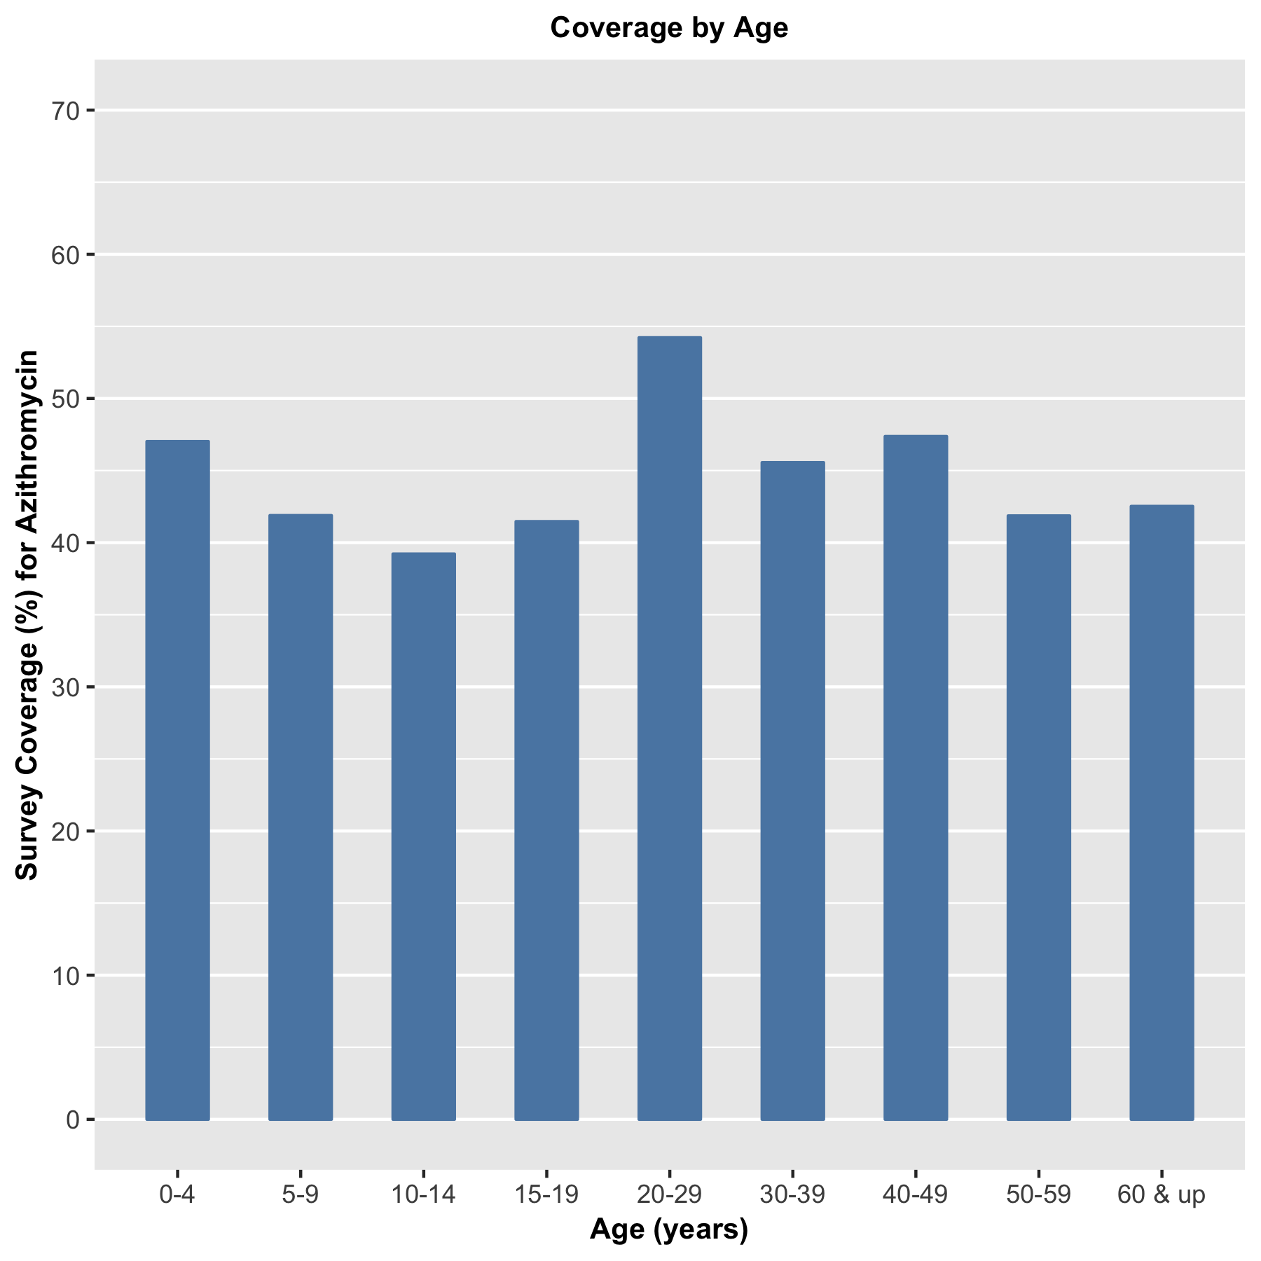

*\*Survey coverage is for all IU(s) combined. Note that this figure does not take into consideration the age groups that are ineligible for treatment (e.g., children <5 years when ivermectin is distributed) and thus will be reflected in this figure by low coverage among the age group(s) ineligible for the MDA.*

**NON-COMPLIANCE**

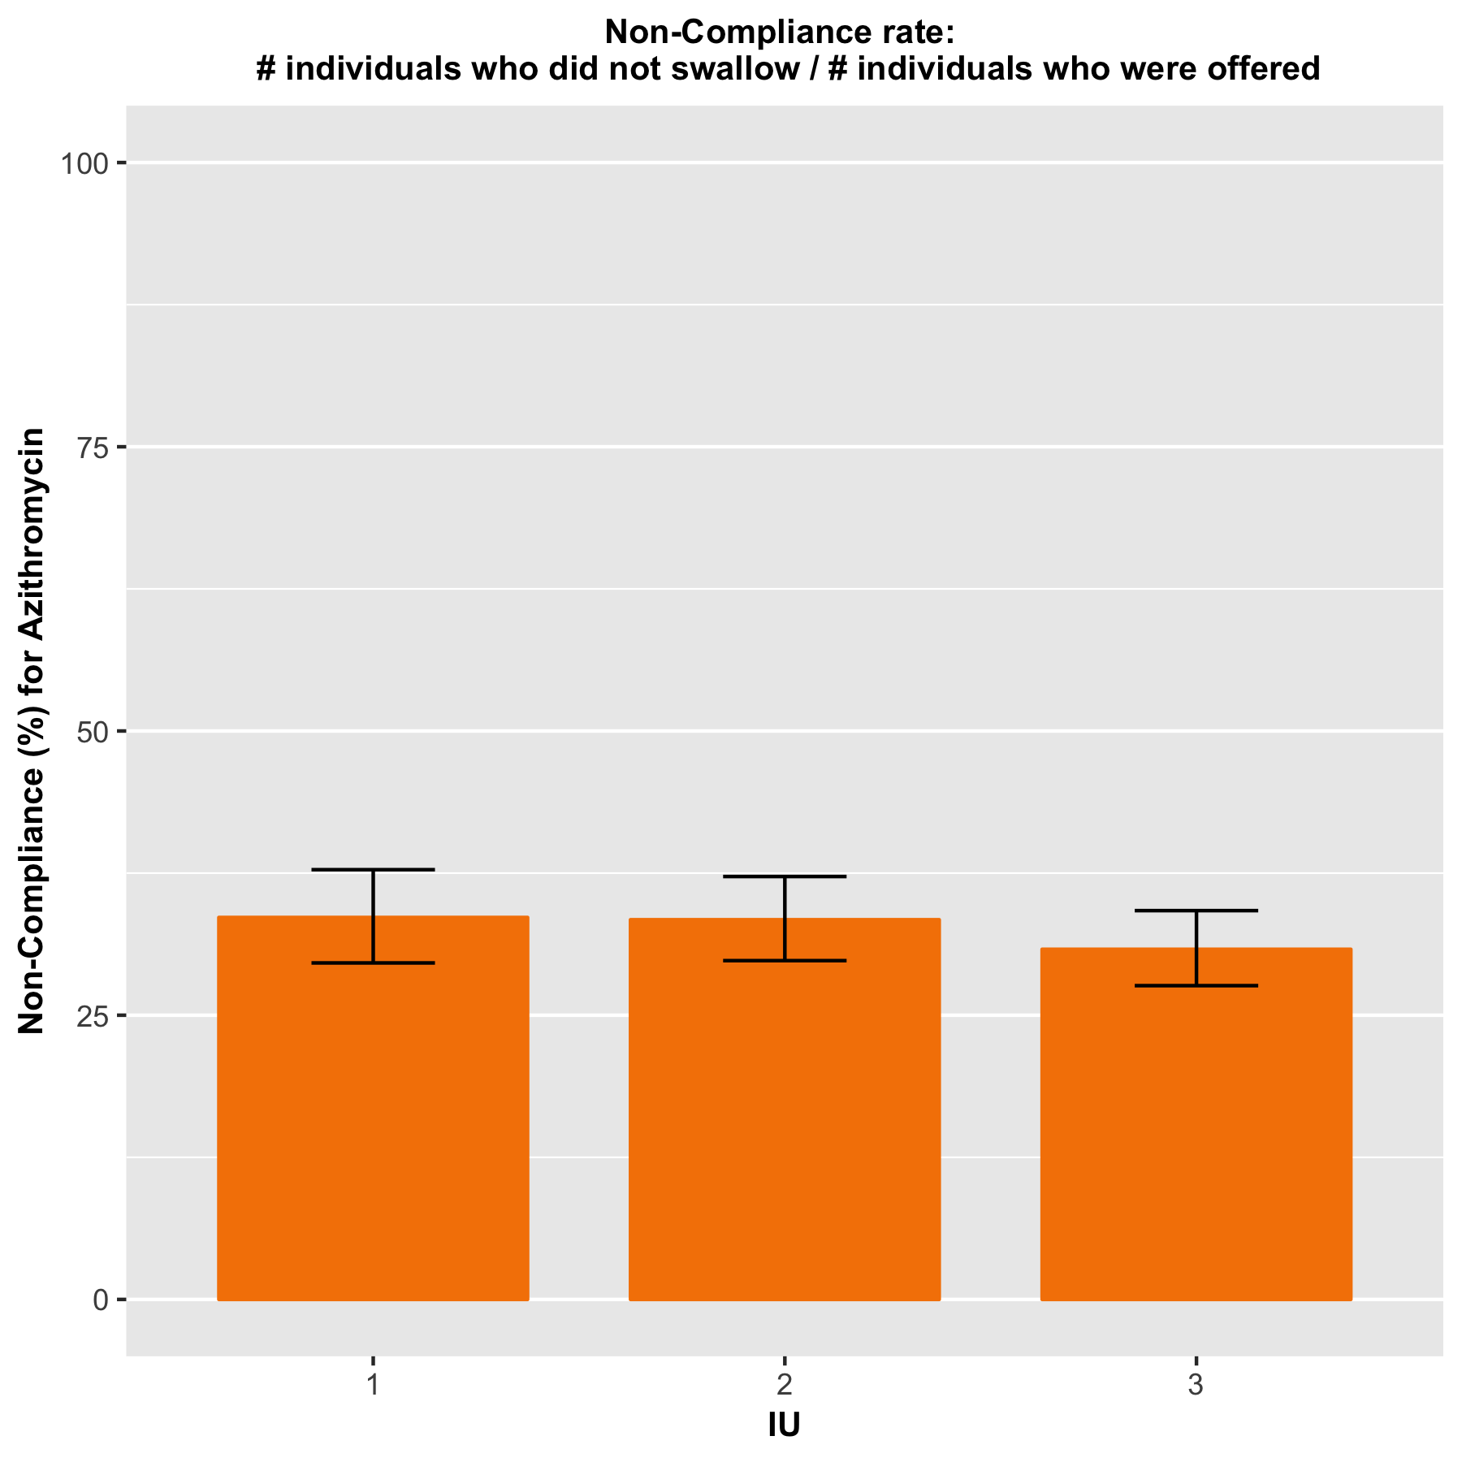

**NON-COMPLIANCE**

**Table 4. Non-Compliance in Murkonia , 2019 .**

| **IU** | **Non-Compliance** | **Lower 95%   Confidence Interval** | **Upper 95%   Confidence Interval** |
| --- | --- | --- | --- |
| 1 | 33.6 % | 29.6 % | 37.8 % |
| 2 | 33.4 % | 29.8 % | 37.2 % |
| 3 | 30.8 % | 27.6 % | 34.2 % |

**ACTIONS TO IMPROVE COVERAGE AND/OR COMPLIANCE**

| **IU(s) where follow-up actions may be needed** | |
| --- | --- |
| **IU(s)** | **Rationale** |
| 1,2,3 | The reported coverage is > ± 10 percentage points from the point estimate of the survey coverage |
| 1, 2, 3 | The survey coverage suggests the true coverage could be below the WHO target threshold of 80 |
| 1, 2, 3 | The compliance suggests the true compliance could be below 90% |

| Potential Reasons for Poor Coverage |
| --- |
| *REPLACE WITH YOUR TEXT If one or more of your districts had POOR coverage, list some potential reasons why this may be. What were the most common reasons given for not being offered the drug? What were the most common reasons for not swallowing the drug when it was offered? Consider the coverage in the different sub-populations to determine whether any particular group is being left out or has lower than average coverage (e.g., males vs. females, school-attendance, particular subdistricts, ethnic minorities, etc.).* |

| Coverage Improvement Recommendations |
| --- |
| *REPLACE WITH YOUR TEXT What actions will your programme take to improve coverage in the poor performing IUs? Refer to Appendix A for suggestions.* |

**Appendix A. Interpreting and following up reported and survey coverage results**

This table is taken from the WHO document,**“Coverage Evaluation Surveys for Preventive Chemotherapy: Field Guide for Implementation”** and is intended to help users in developing their own Action Plan as the result of a coverage survey(s). This table lists the possible findings that can occur when the survey coverage is compared to both the target coverage threshold and the reported coverage. The table provides potential causes to investigate and corrective actions that can be taken.

| **Finding or observation** | **Potential Causes to Investigate** | **Corrective action** |
| --- | --- | --- |
| 1. Comparison of survey coverage to target coverage threshold: To get a better estimate of coverage where there is reason to believe routine reporting is incorrect | | |
| Survey coverage is below the target coverage threshold | Check the coverage in the different sub-populations to determine whether any particular group is being left out or has lower than average coverage (e.g., males vs. females, SAC, particular sub-districts, ethnic minorities, etc.) | Develop and implement targeted social mobilization as required   Investigate the reasons why the sub-population(s) are not adequately covered and make the appropriate change in MDA strategy/platform to reach the sub-population(s)   Consider using Independent Monitoring or the Coverage Supervision Tool with MDA mop-up during the next round to improve coverage |
| Check the reasons for why the eligible population was not offered the drug   Check the reasons for the eligible population not swallowing the drug | Tailor corrective action according to reasons given which include strengthening:  - Drug supply chain  - Social mobilization and information and education campaigns (look at reasons given by those who did swallow the drug)  - Drug delivery platform used  - Training, supervision and motivation of drug distributors  - Communication on adverse events  - Capacity of national and/or district level staff |
| Survey coverage is above the target coverage threshold | Communities and drug distributors are motivated and the programme is functioning well | Congratulate your teams. Sustain programme momentum for the next year to maintain coverage levels |

|  |  |  |
| --- | --- | --- |
| 2. Comparison of survey coverage with reported coverage: To check if the data reporting system is working well | | |
| Reported coverage is much higher than survey coverage   (i.e., routine reporting is likely overestimating true coverage) | Drug distributors are incorrectly reporting on ingestion of the drugs | Conduct a Data Quality Self-Assessment or Data Quality Assessment to diagnose where the data reporting system is breaking down   Improve the skills and motivation of drug distributors through better training and supervision; consider use of mHealth technologies   Make improvements to the tally sheets and/or registers used |
| The total population figure (e.g., the denominator) is incorrect or outdated, or people from outside the survey area are also taking the drugs and are being included in the total treatment tallies | Determine if more accurate population estimates or projections are available and apply a correction factor to routine coverage estimates as appropriate   Ask the drug distributors to record and report non-resident individuals ingesting the drugs separately and do not include them in the numerator for calculating PC coverage |
| Reported coverage is much lower than survey coverage   (i.e., routine reporting is likely underestimating true coverage) | The total population figure (e.g., the denominator) is incorrect or outdated | Refer to corrective actions given for the same problem above |
| Data are not being correctly aggregated or reported | Conduct a Data Quality Self-Assessment or Data Quality Assessment to diagnose where the data reporting system is breaking down |
| Reported coverage and survey coverage are similar | A good reporting system is in place | Congratulate your teams. Continue using the current reporting system, with increased confidence that it provides a good estimate of PC coverage. Less expenditure in future surveys (at least for the current survey area) is required. |

|  |  |  |
| --- | --- | --- |
| 3. Comparison of survey coverage with programme reach: To assess compliance and the success of the programs social mobilization and communication strategy | | |
| Survey coverage is less than programme reach | Check the reasons given for why individuals who were offered the drug did not swallow it | Improved information and education campaigns may be needed prior to the next round to increase compliance |
| Survey coverage is greater than programme reach | There may be a problem with the coverage survey data. Check to see if the survey team implemented the questionnaire correctly; recount results and check for arithmetic errors | Greater training may be needed to make sure the survey team correctly understands the difference between being offered the drug(s) and swallowing the drugs and that this difference is conveyed correctly to the respondents |
| Survey coverage is close to or equal to programme reach | Compliance is high | Congratulate the teams. Continue with the current information and education campaigns, as they appear to be working |