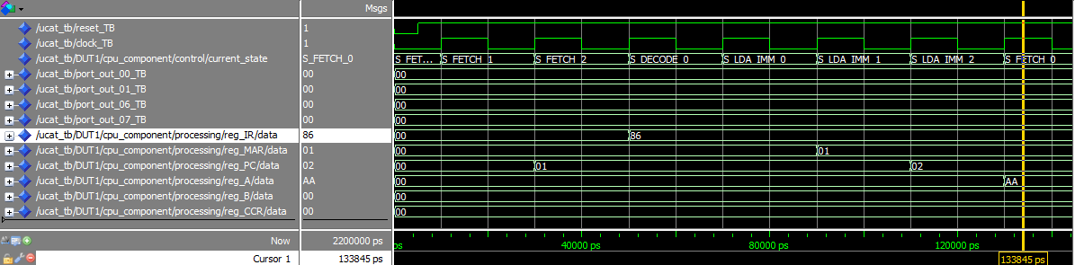

Figure : Fetch-Decode States and LDA_IMM Execution

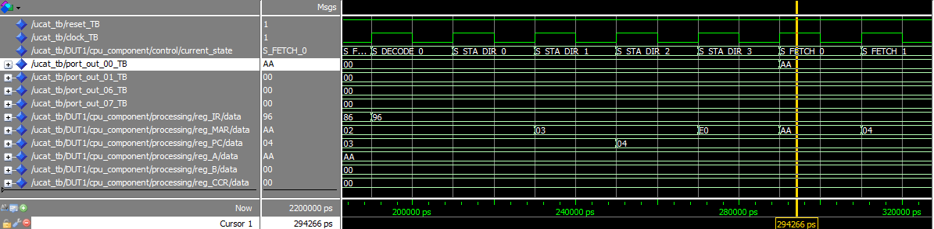

Figure : STA_DIR Execution

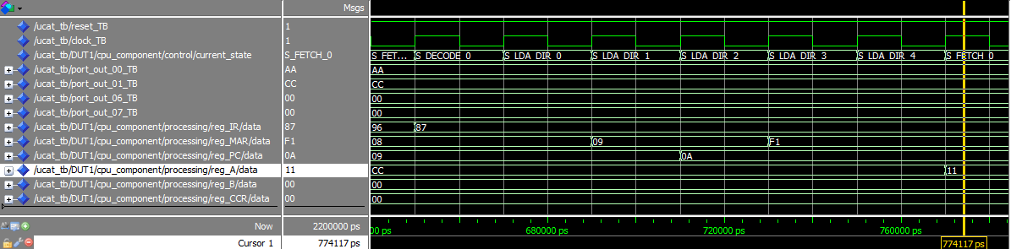

Figure : LDA_DIR Execution

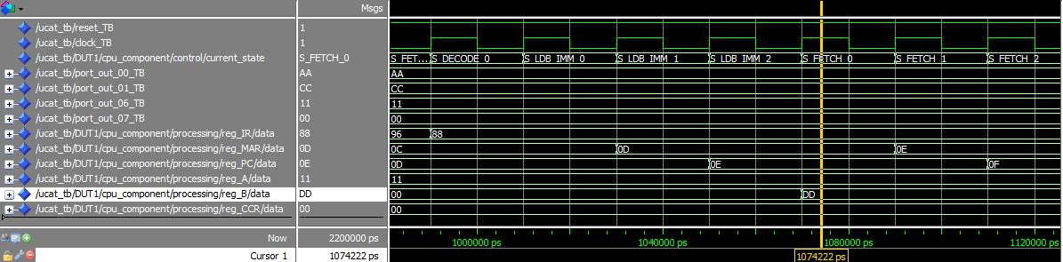

Figure : LDB_IMM Execution

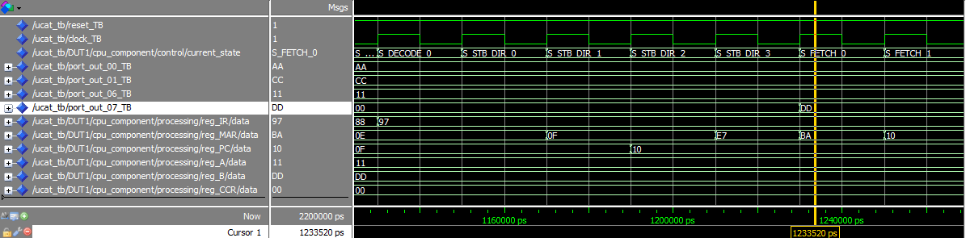

Figure : STB_DIR Execution

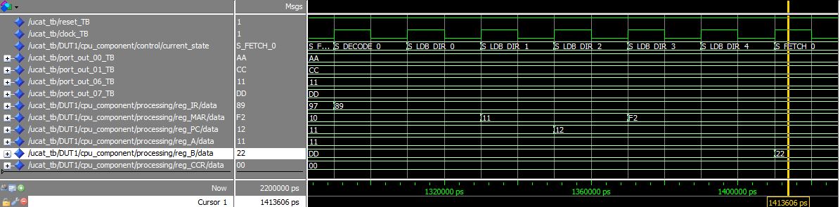

Figure : LDB_DIR Execution

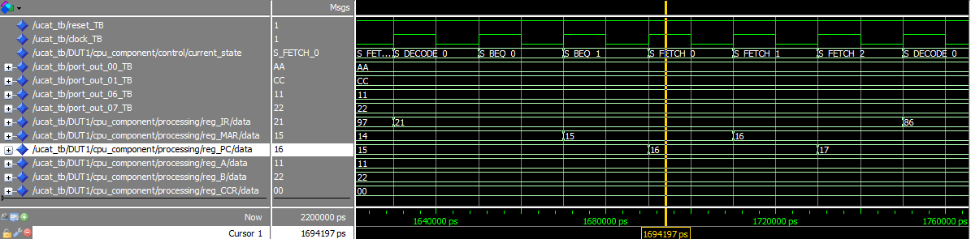

Figure : BEQ Execution

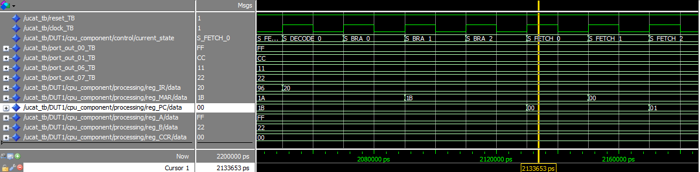

Figure : BRA Execution