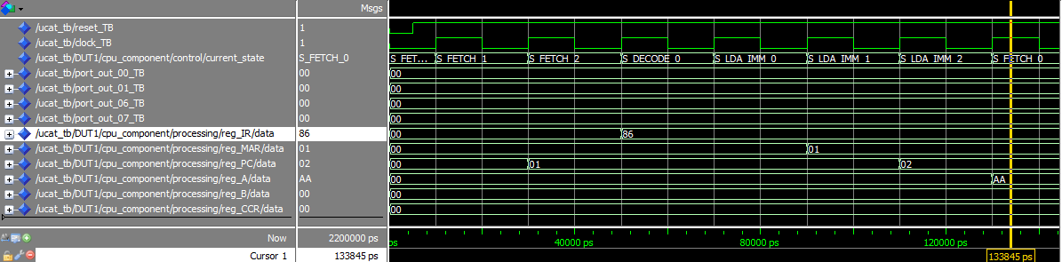

Figure : Fetch-Decode States and LDA_IMM Execution

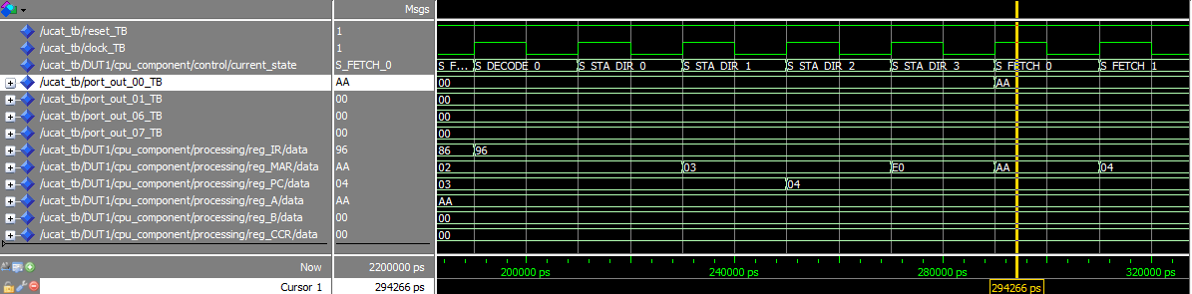

Figure : STA_DIR Execution

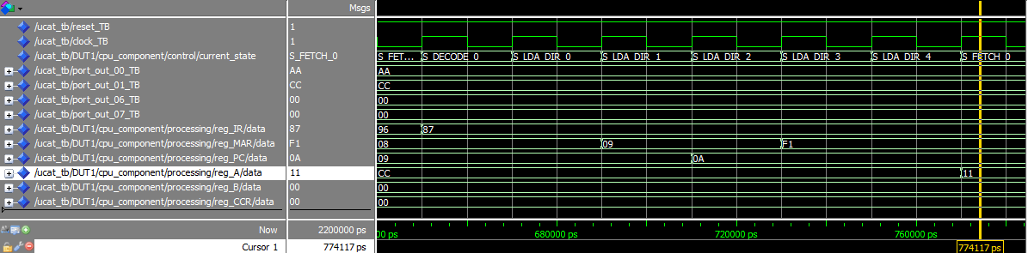

Figure : LDA_DIR Execution

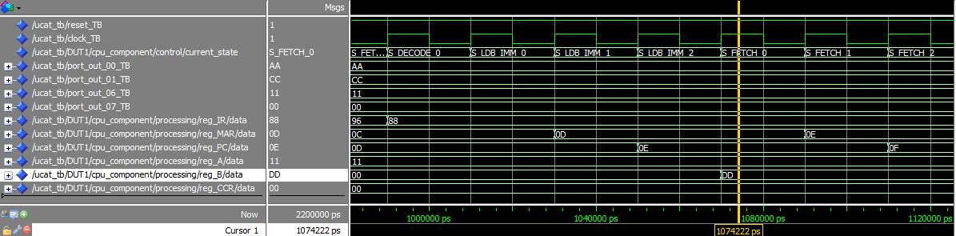

Figure : LDB_IMM Execution

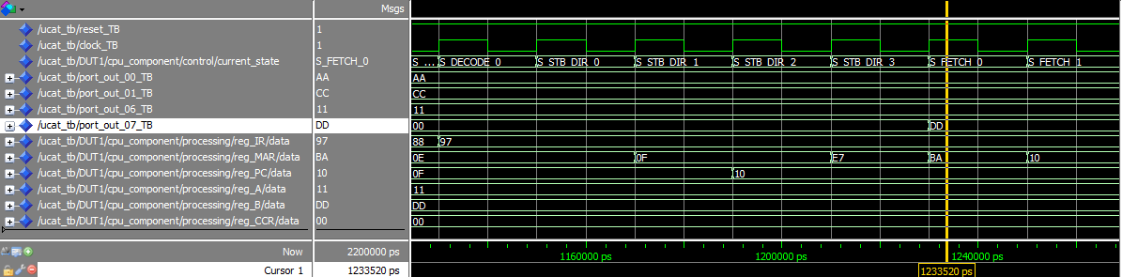

Figure : STB_DIR Execution

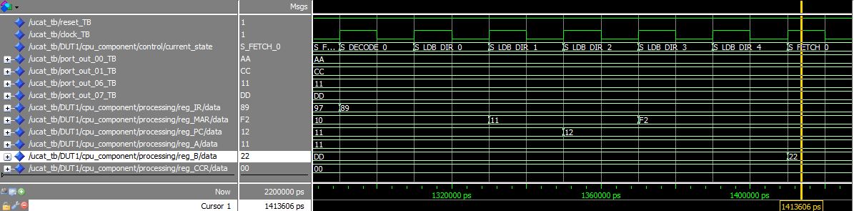

Figure : LDB_DIR Execution

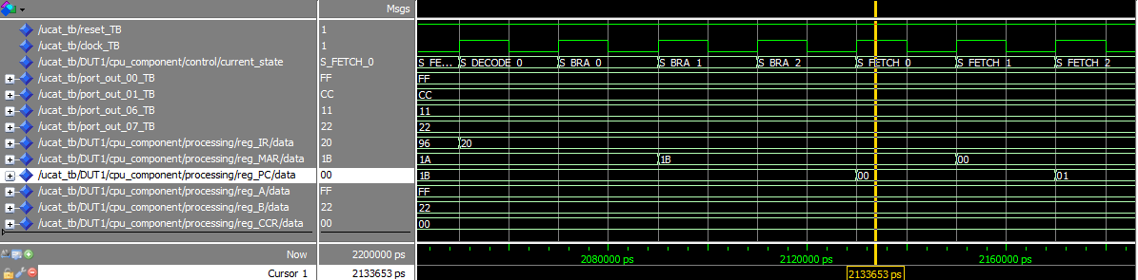

Figure : BRA Execution

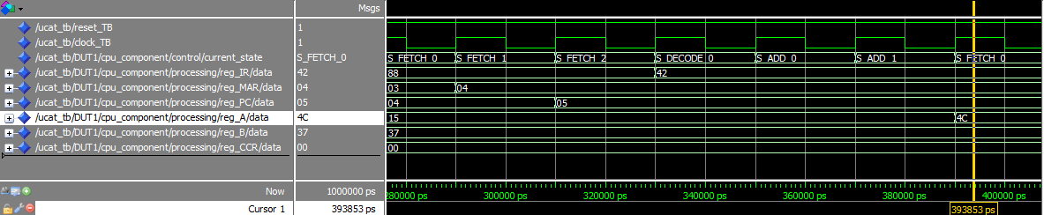

Figure : ADD_AB Execution

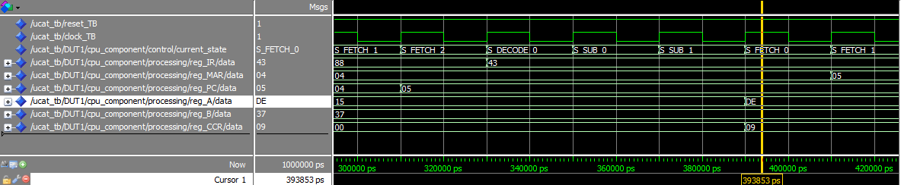

Figure : SUB_AB Execution

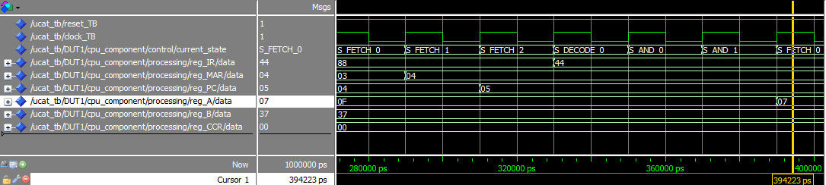

Figure : AND_AB Execution

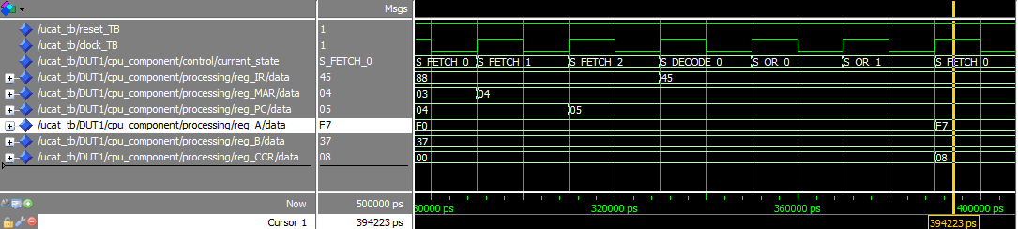

Figure : OR_AB Execution

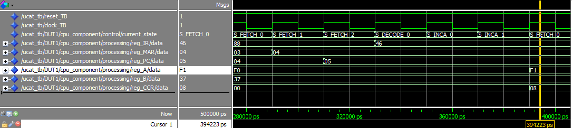

Figure : INCA Execution

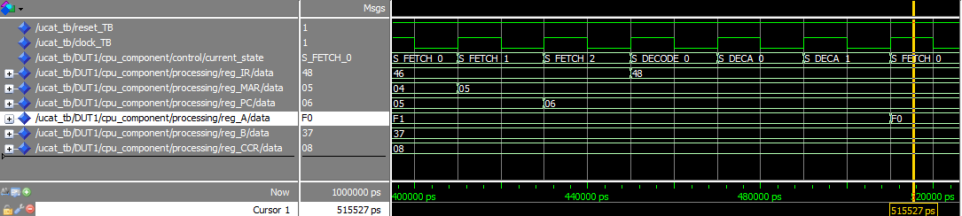

Figure : DECA Execution

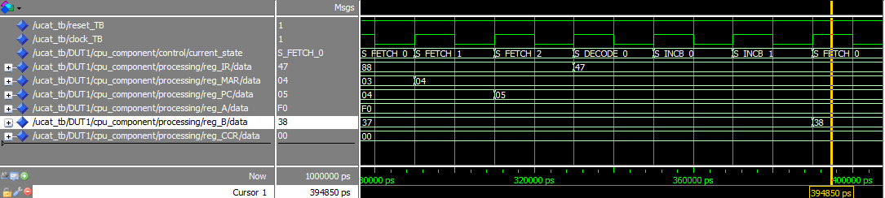

Figure : INCB Execution

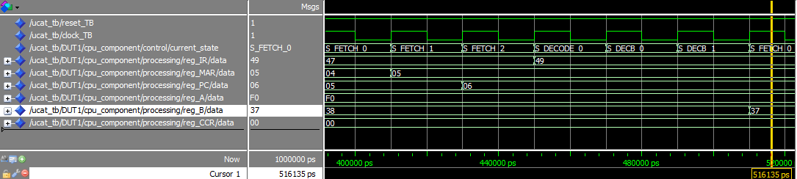

Figure : DECB Execution

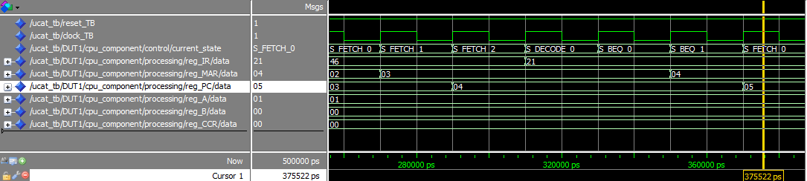

Figure : BEQ Execution 1

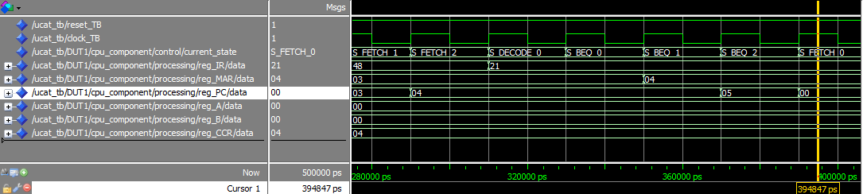

Figure : BEQ Execution 2