Memo to: Randy Larimer
From: Matthew Handley
Date: February 27, 2014
Regarding: EE 465-01, Lab 2 – Liquid Crystal Display and Keypad

Summary:
This lab built on the previous one, by an LCD to the bus. The heartbeat LED was moved to one of the 8 LEDs driven by the DFFs on the bus. The goal was to listen for key presses on the keypad and display the key pressed on the LCD and 4of the DFF-driven LEDs.

Preliminary Solutions:
As before, the TPM module was used to toggle the heartbeat led. However, to improve the response speed of the keypad the scanning and interpretation of keypad data was moved to the main loop. Figure 1 of Appendix A shows the top level design for this lab. The S08 would power up and initialize the required modules (including the LCD), before continuously scaning the keypad and responding to changes. As shown in Figure 1, the TPM interrupt service routine would toggle the heartbeat LED and resetting the TPM overflow flag.

Setup:
To begin programming, the LCD was added to the bread board as well as several components required by the LCD. In order to provide the contrast control required by the LCD, a negative voltage supply and potentiometer were added. Because the LCD’s Enable line latches data from the bus on a falling edge, a logic inverter was placed between the 74AHC138 decoder and LCD. The upper 4-bits of the LCD’s data bus were tied to the existing data bus from the previous lab and the remaining 4 data lines were left floating. The RS and R/W were tied directly to PTA1 and PTA0 on the S08.

Solution:
The bus_read, bus_write, scan_keypad, led_write, and SUB_delay subroutines from previous labs were added first. Then, three new subroutines were added lcd_write, lcd_init, and lcd_char. The lcd_init and lcd_write subroutines were heavily based on the 4-bit example code given Motorola AN1745. Flow charts for the lcd_init and lcd_char subroutines are shown in Figure 4 of Appendix A. The lcd_char subroutine was developed to simplify the process of writing a character to the LCD and keep track of the LCD’s cursor. Whenever lcd_char is called and the cursor is off of the LCD, the LCD is cleared before the new character is written.
In order to interpret the data from the keypad and respond accordingly, the interpret_keypad subroutine was written. The flow chart for this subroutine is shown in Figure 3 of Appendix A. Additionally, the scan_keypad subroutine had to be modified to keep track of current key press data as well as the last set of key press data. The modified flow chart for this subroutine is shown in Figure 2 of Appendix A. The interpret_keypad subroutine checks to see if a key changed from not pressed to pressed. If a key was pressed, it writes the corresponding character to the LCD, and loads the corresponding binary code into 4 bits of led_data.

Summary Comments:
While this lab was fairly straightforward, there were several issues that I ran into. The most time consuming part of this lab was initializing the LCD, however by closely following the AN1745 app note, eventually the LCD was initializing properly. Another interesting problem occurred when I tried writing the bus from both the main loop and TPM ISR. It seems that if the main loop is in the middle of writing to the bus when the TPM ISR occurs and starts writing to the bus, the device which the main loop was writing to will have odd data written to it. The solution was to modify the led_data variable in the ISR, but only write to the bus within the main loop. This also allows both the TPM ISR to toggle the hearbeat while the interpret_keypad modifies the 4 bits of key data in led_data.

Appendix A – Figures

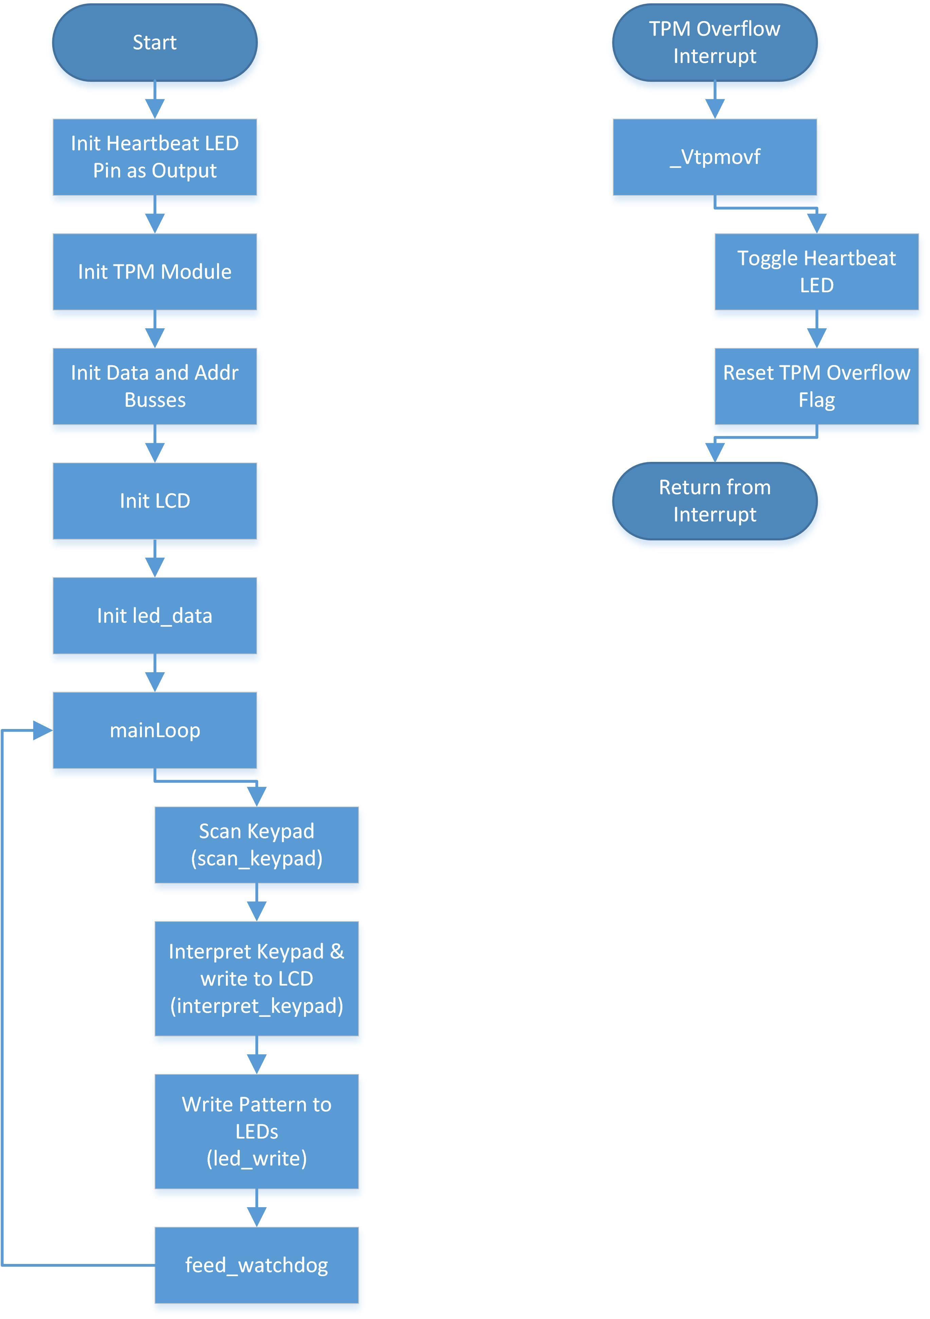
Figure 1: Top Level Flow Chart

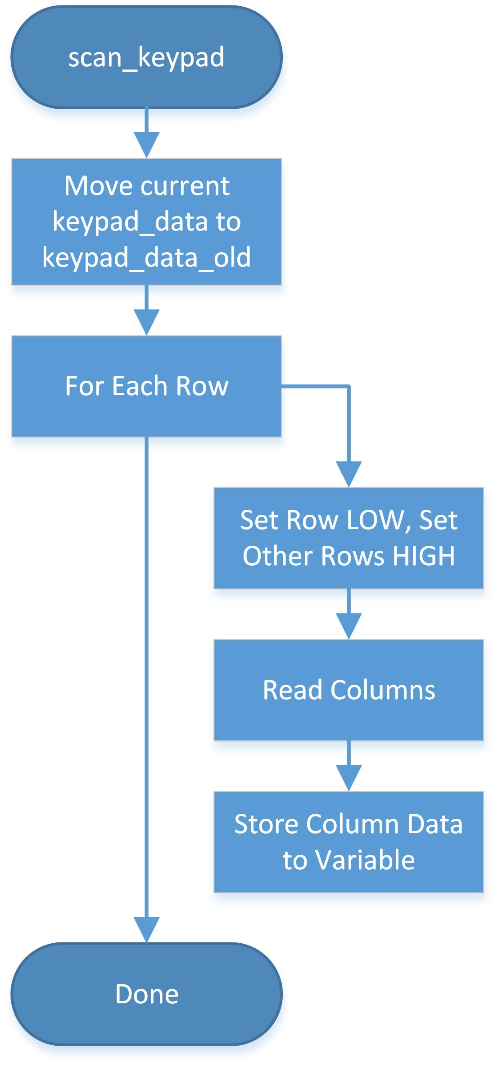
Figure 2: scan_keypad Subroutine Flow Chart

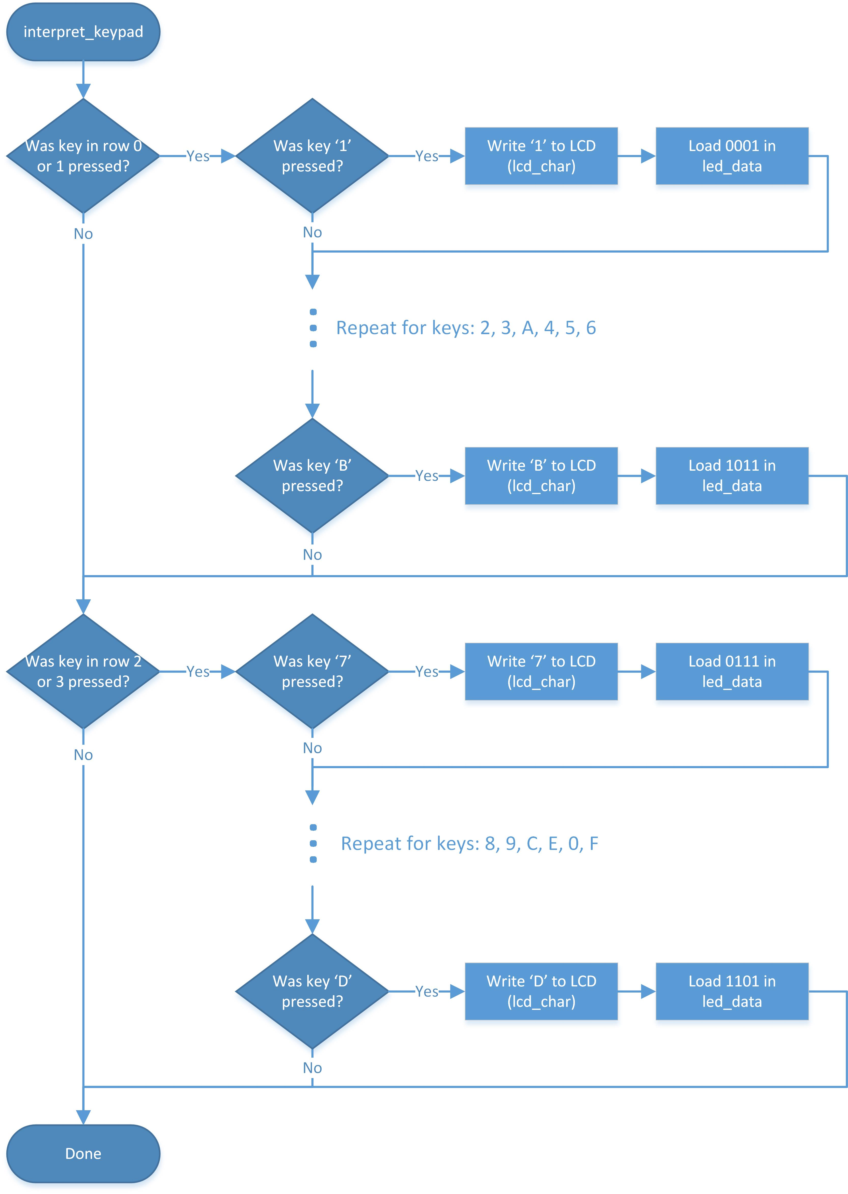
Figure 3: interpret_keypad Subroutine Flow Chart
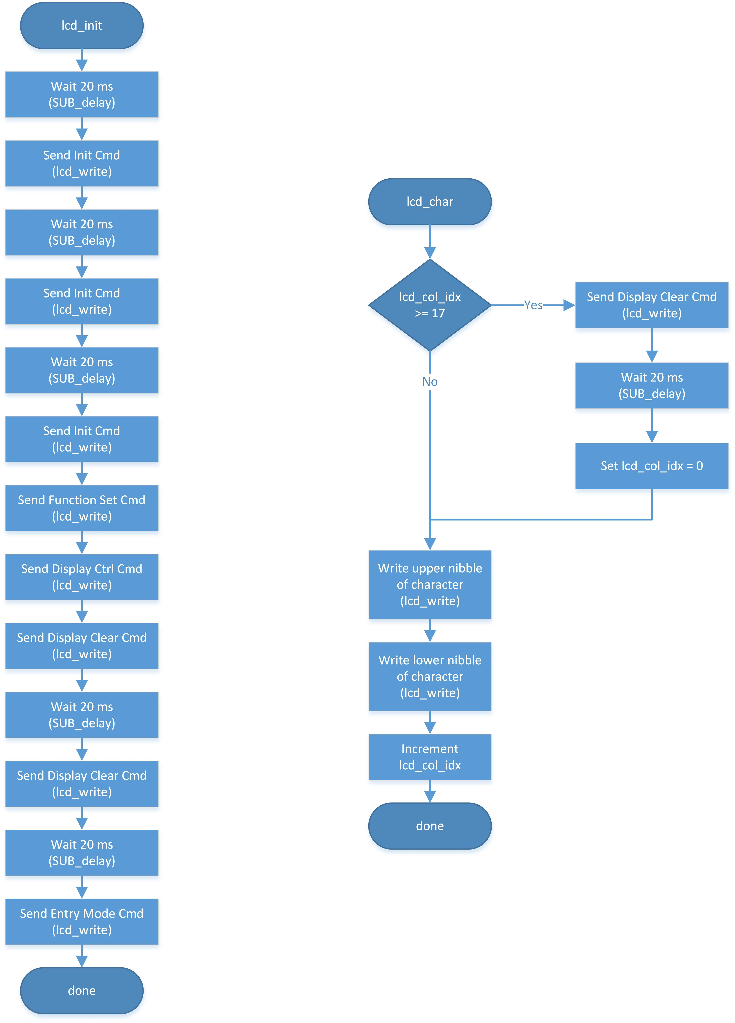
Figure 4: lcd_init and lcd_char Subroutine Flow Chart
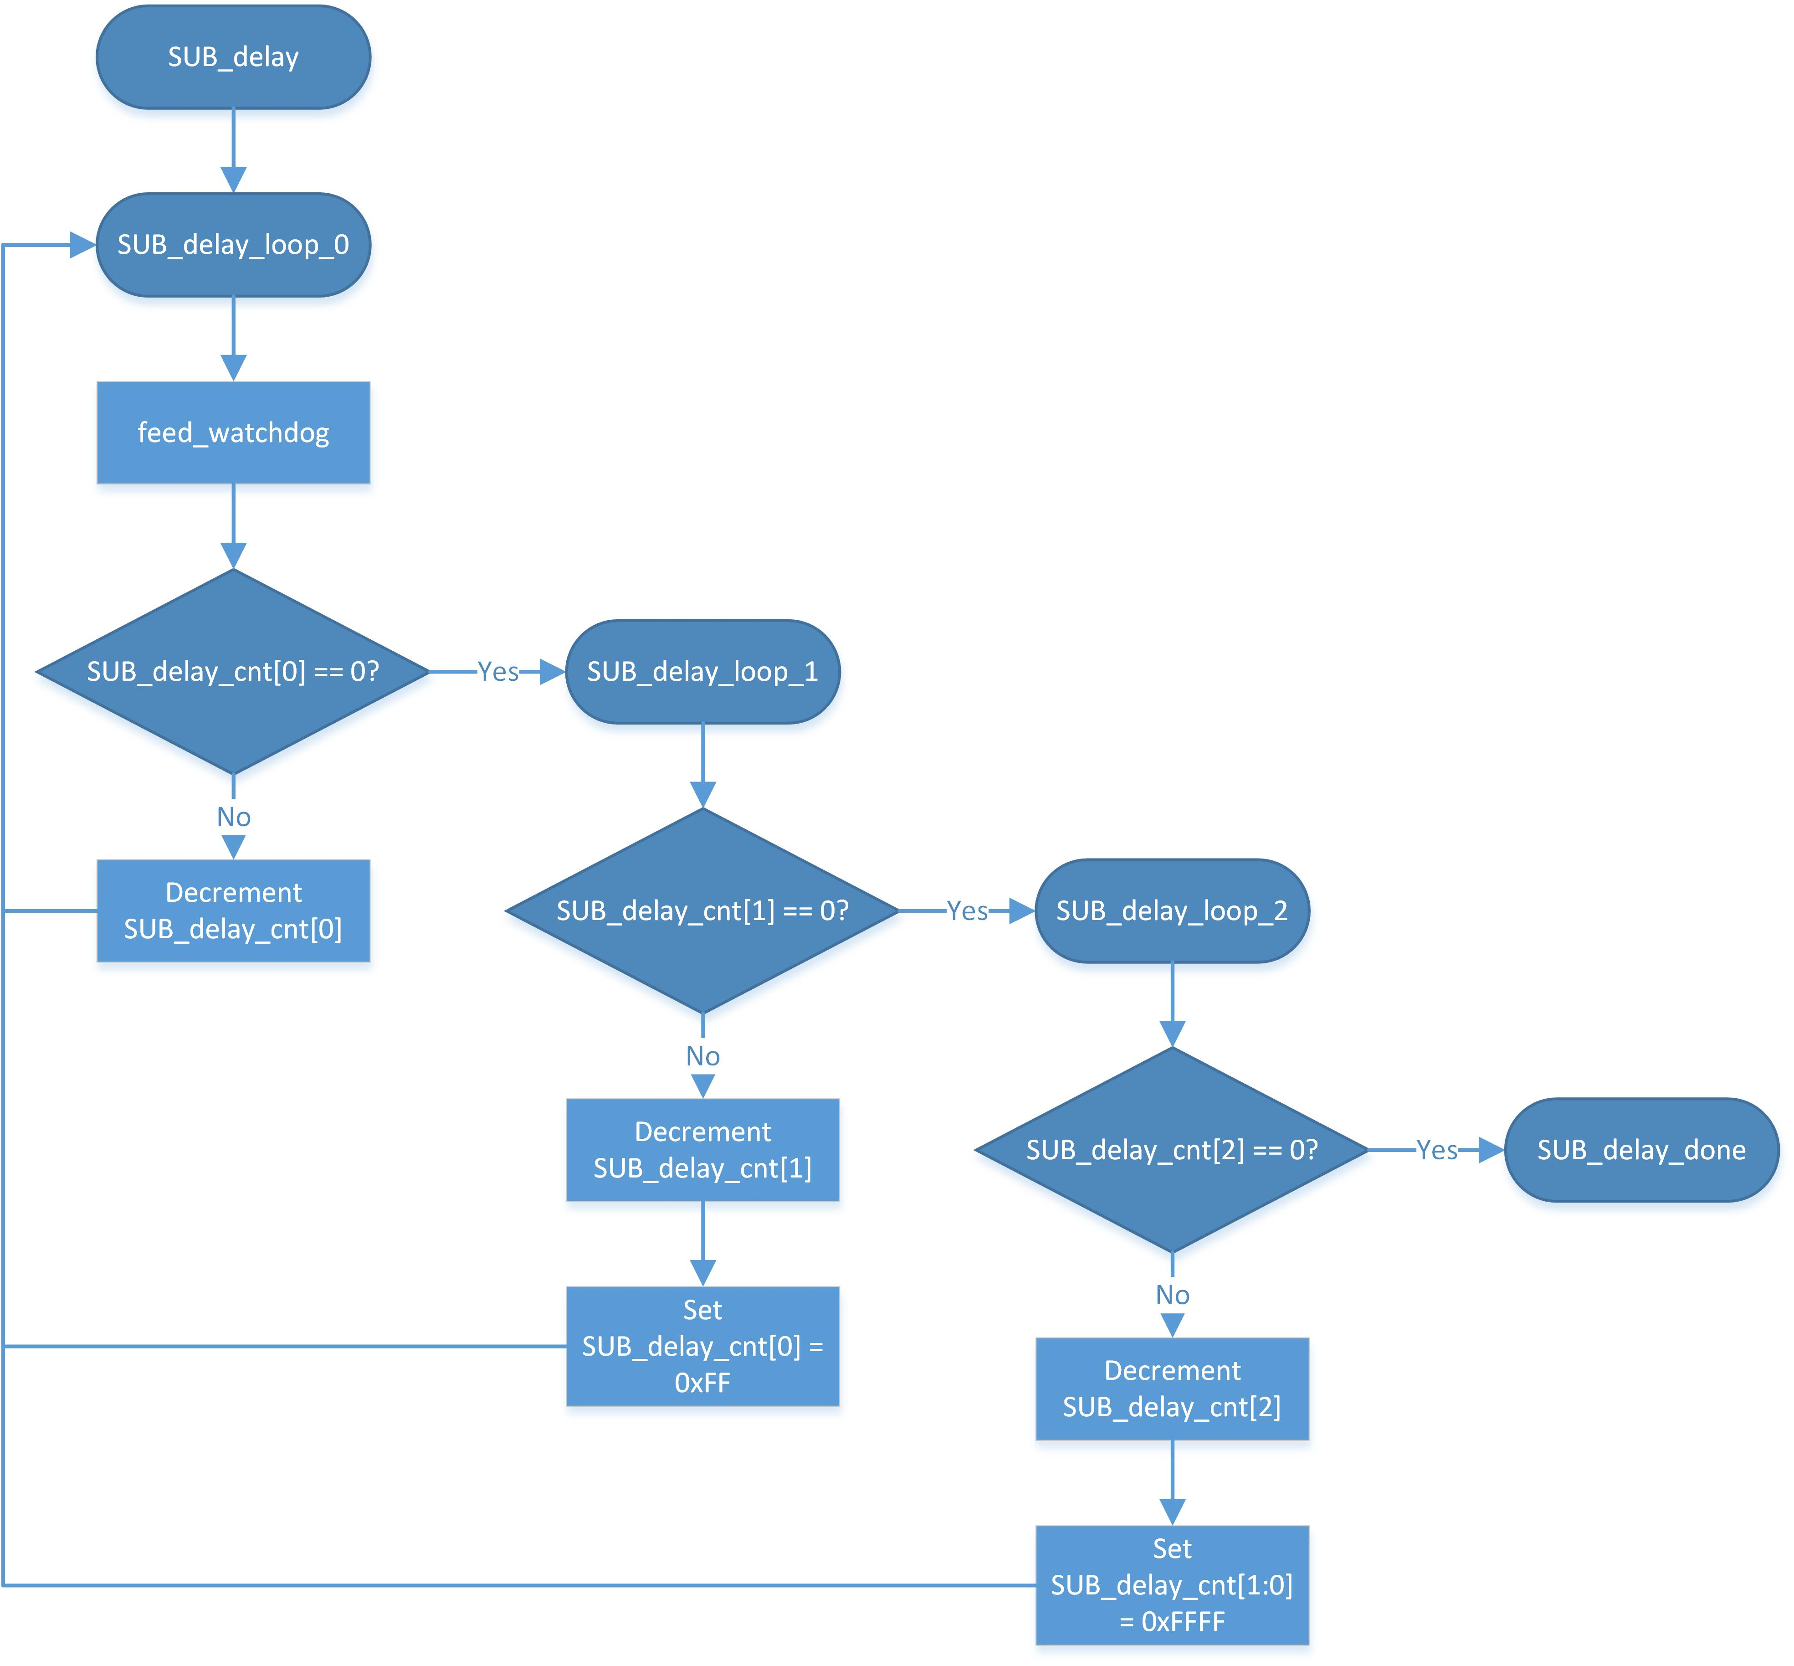
Figure 5: SUB_delay Subroutine Flow Chart
Appendix B – Source Code
;**************************************************************
;* Program Name: Lab#02 - LCD and Keypad
;* Author Names: Matthew Handley
;* Date: 2014-02-27
;* Description: Takes input from the keypad and displays it on
;* the first line of the LCD. When the line is
;* full, it is cleared before writing the next
;* character.
;*
;**************************************************************

mDataBus EQU $F0 ; Mask for the data bus pins on PortB
mAddrBus EQU $0F ; Mask for the address bus pins on PortB

; Include derivative-specific definitions
INCLUDE 'derivative.inc'

; export symbols
XDEF _Startup, main, _Vtpmovf, bus_write, bus_read, scan_keypad, led_write, lcd_init, SUB_delay
; we export both '_Startup' and 'main' as symbols. Either can
; be referenced in the linker .prm file or from C/C++ later on

XREF __SEG_END_SSTACK ; symbol defined by the linker for the end of the stack

; variable/data section
MY_ZEROPAGE: SECTION SHORT

bus_addr: DS.B 1 ; only use lower 3 bits
bus_data: DS.B 1 ; only use lower 4 bits

lcd_data: DS.B 1 ; lower 4 bits = LCD data lines, bit 6 = RS, bit 5 = RW
lcd_char_data: DS.B 1 ; used by lcd_char subroutine to store a character
lcd_col_idx: DS.B 1 ; index of the column of the LCD that the cursor is currently in

keypad_data_0: DS.B 1 ; bit flags representing what keys are pressed on the 4x4 keypad
keypad_data_1: DS.B 1

keypad_data_0_old: DS.B 1 ; bit flags representing which keys were pressed on the keypad, the last time it was scanned
keypad_data_1_old: DS.B 1

keypad_data_cmp: DS.B 1 ; tempory holder for keypad data comparison in interpret_keypad

led_data: DS.B 1 ; 8 bit value for the 8 LEDs

; counter for SUB_delay subroutine
SUB_delay_cnt: DS.B 3

MY_CONST: SECTION
; Constant Values and Tables Section

; code section
MyCode: SECTION
main:
_Startup:
LDHX #__SEG_END_SSTACK ; initialize the stack pointer
TXS

;*** init TPM module - for heartbeat LED ***
; TPMMODH:L Registers
LDA #$00
STA TPMMODH
LDA #$00
STA TPMMODL
; TPMSC Register
LDA #$4E ; TOIE clear, CLKS: Bus clock, Prescale: 128
STA TPMSC

;*** init Data & Address Busses ***
LDA mAddrBus ; Set Address Bus pins as output by default, leave data as input
STA PTBDD
LDA $00 ; Leave all of PortB as input at start
STA PTBD

;*** init LCD and RS, RW pins ***
JSR lcd_init

LDA #$00
STA lcd_col_idx

;*** init led_data variable ***
LDA #$00
STA led_data

CLI ; enable interrupts

mainLoop:
; read keypad
JSR scan_keypad

; interpret keypad data
JSR interpret_keypad

; Display led_data on leds
JSR led_write

feed_watchdog
BRA mainLoop

;**************************************************************
;* Subroutine Name: _Vtpmovf
;* Description: Interrupt service routine for the TPM overflow
;* interrupt. Toggles the heartbeat LED (PortA[0])
;* and resets TPM overflow flag.
;* Registers Modified: None
;* Entry Variables: None
;* Exit Variables: None
;**************************************************************
_Vtpmovf:
; Toggle Heartbeat LED
LDA led_data ; load current LED pattern
EOR #$80 ; toggle bit 7
STA led_data ; Store pattern to var

; clear TPM ch0 flag
LDA TPMSC ; read register
AND #$4E ; clear CH0F bit, but leav others alone
STA TPMSC ; write back register

;*** done ***

;Return from Interrupt
RTI

;**************************************************************

;**************************************************************
;* Subroutine Name: led_write
;* Description: Writes the 8 bits of led_data two the 8 LEDs
;* on the DFFs at address 0 and 1 on the bus.
;*
;* Registers Modified: None
;* Entry Variables: led_data
;* Exit Variables: None
;**************************************************************
led_write:
; preserve accumulator A
PSHA

;*** write lower nibble LEDs ***
; set the address
LDA #$00
STA bus_addr

; set the data
LDA led_data
AND #$0F
STA bus_data

; write the data
JSR bus_write

;*** write upper nibble LEDs ***
; set the address
LDA #$01
STA bus_addr

; set the data
LDA led_data
NSA
AND #$0F
STA bus_data

; write the data
JSR bus_write

;*** done ***
; restore accumulator A
PULA
RTS

;**************************************************************

;**************************************************************
;* Subroutine Name: bus_read
;* Description: Reads data from the device whose address is
;* the lower 3 bits of bus_addr, and store the
;* data to the lower 4 bits of bus_data.
;*
;* Registers Modified: None
;* Entry Variables: bus_addr
;* Exit Variables: bus_data
;**************************************************************
bus_read:
; preserve accumulator A
PSHA

; make address bus output, data bus an input
LDA #mAddrBus
STA PTBDD

; pull the address low
LDA bus_addr ; load address
AND #$07 ; mask off the lower 3 bits to be sure, will leave G2A low
STA PTBD ; write data to address bus, and clear data bus

; read data from the bus
LDA PTBD
NSA ; shift data down to the lower 4 bits
AND #$0F ; mask off the lower 4 bits to be sure
STA bus_data ;

; pull the address high
LDA #$08 ; G2A_not high
STA PTBD ; write, clears address bus

; restore accumulator A
PULA

; return from subroutine bus_read
RTS

;**************************************************************

;**************************************************************
;* Subroutine Name: bus_write
;* Description: Writes the lower 4 bits of bus_data to the
;* device on whose address is the lower 3 bits
;* of bus_addr.
;* Registers Modified: None
;* Entry Variables: bus_addr, bus_data
;* Exit Variables: None
;**************************************************************
bus_write:
; preserve accumulator A
PSHA

; make data and address busses outputs
LDA #$FF
STA PTBDD

; prep data for the bus
LDA bus_data
NSA ; swap the lower 4 bits to be the upper 4 bits
AND #$F0 ; mask off the upper 4 bits to be sure

; prep the addr, G2A_not low, Yx goes low
ORA bus_addr ; add in the address
STA PTBD ; write data and address bus, with G2A_not low

ORA #$08 ; leave data and address, set G2A_not high - Yx goes high
STA PTBD

; restore accumulator A
PULA

; return from subroutine bus_write
RTS

;**************************************************************

;**************************************************************
;* Subroutine Name: scan_keypad
;* Description: Scans the greyhill 4x4 keypad, and saves the
;* result to variable.
;* Note that this method will overwrite values in
;* the bus_addr and bus_data variables.
;*
;* Registers Modified: None
;* Entry Variables: None
;* Exit Variables: keypad_data_0, keypad_data_1
;**************************************************************
scan_keypad:
; preserve registers
PSHA

;*** save old value of keypad_data, before we overwrite it

LDA keypad_data_0
STA keypad_data_0_old
LDA keypad_data_1
STA keypad_data_1_old

;*** scan row 0 ***

;* set row 0 to low, other rows to high *

; set address of keypad driver DFF
LDA #$02
STA bus_addr

; set the data
LDA #%00001110
STA bus_data

; write the data
JSR bus_write

;* read data from row *

; set the address
LDA #$03
STA bus_addr

; read the data
JSR bus_read

;* save row data to variable *

LDA bus_data ; load in data nibble
COMA ; compliment bits, so 1=button press
AND #$0F ; mask off the lower 4 bits
STA keypad_data_0 ; store to vairable

;*** scan row 1 ***

;* set row 1 to low, other rows to high *

; set address of keypad driver DFF
LDA #$02
STA bus_addr

; set the data
LDA #%00001101
STA bus_data

; write the data
JSR bus_write

;* read data from row *

; set the address
LDA #$03
STA bus_addr

; read the data
JSR bus_read

;* save row data to variable *

LDA bus_data ; load in data nibble
COMA ; compliment bits, so 1=button press
NSA ; swap our data to the upper nibble
AND #$F0 ; mask off the data
ORA keypad_data_0 ; add the lower 4 bits in
STA keypad_data_0 ; store to vairable

;*** scan row 2 ***

;* set row 2 to low, other rows to high *

; set address of keypad driver DFF
LDA #$02
STA bus_addr

; set the data
LDA #%00001011
STA bus_data

; write the data
JSR bus_write

;* read data from row *

; set the address
LDA #$03
STA bus_addr

; read the data
JSR bus_read

;* save row data to variable *

LDA bus_data ; load in data nibble
COMA ; compliment bits, so 1=button press
AND #$0F ; mask off the lower 4 bits
STA keypad_data_1 ; store to vairable

;*** scan row 3 ***

;* set row 3 to low, other rows to high *

; set address of keypad driver DFF
LDA #$02
STA bus_addr

; set the data
LDA #%00000111
STA bus_data

; write the data
JSR bus_write

;* read data from row *

; set the address
LDA #$03
STA bus_addr

; read the data
JSR bus_read

;* save row data to variable *

LDA bus_data ; load in data nibble
COMA ; compliment bits, so 1=button press
NSA ; swap our data to the upper nibble
AND #$F0 ; mask off the data
ORA keypad_data_1 ; add the lower 4 bits in
STA keypad_data_1 ; store to vairable

;*** done ***

; restore registers
PULA

; return from subroutine scan_keypad
RTS

;**************************************************************

;**************************************************************
;* Subroutine Name: interpret_keypad
;* Description: Interpres the data from the keypad and writes
;* to the LCD and led_data based on keypad input.
;*
;* Registers Modified: None
;* Entry Variables: None
;* Exit Variables: None
;**************************************************************
interpret_keypad:

; preserve registers
PSHA

;*** was a key pressed in the first 2 rows ? ***

LDA keypad_data_0_old
COMA
AND keypad_data_0
CBEQA #$00, interpret_keypad_lower_rows_jump

; key was pressed
STA keypad_data_cmp

interpret_keypad_1:

; was '1' pressed ?
LDA keypad_data_cmp
AND #%11111110
BNE interpret_keypad_2

; write a '1' to the LCD
LDA #'1'
JSR lcd_char

; put 0x1 on LEDs
LDA led_data
AND #$F0
ORA #$01
STA led_data

interpret_keypad_2:

; was '2' pressed ?
LDA keypad_data_cmp
AND #%11111101
BNE interpret_keypad_3

; write a '2' to the LCD
LDA #'2'
JSR lcd_char

; put 0x1 on LEDs
LDA led_data
AND #$F0
ORA #$02
STA led_data

interpret_keypad_3:

; was '3' pressed ?
LDA keypad_data_cmp
AND #%11111011
BNE interpret_keypad_A

; write a '3' to the LCD
LDA #'3'
JSR lcd_char

; put 0x3 on LEDs
LDA led_data
AND #$F0
ORA #$03
STA led_data

interpret_keypad_A:

; was 'A' pressed ?
LDA keypad_data_cmp
AND #%11110111
BNE interpret_keypad_4

; write a 'A' to the LCD
LDA #'A'
JSR lcd_char

; put 0xA on LEDs
LDA led_data
AND #$F0
ORA #$0A
STA led_data

BRA interpret_keypad_4
interpret_keypad_lower_rows_jump:
BRA interpret_keypad_lower_rows

interpret_keypad_4:

; was '4' pressed ?
LDA keypad_data_cmp
AND #%11101111
BNE interpret_keypad_5

; write a '4' to the LCD
LDA #'4'
JSR lcd_char

; put 0x4 on LEDs
LDA led_data
AND #$F0
ORA #$04
STA led_data

interpret_keypad_5:

; was '5' pressed ?
LDA keypad_data_cmp
AND #%11011111
BNE interpret_keypad_6

; write a '5' to the LCD
LDA #'5'
JSR lcd_char

; put 0x5 on LEDs
LDA led_data
AND #$F0
ORA #$05
STA led_data

interpret_keypad_6:

; was '6' pressed ?
LDA keypad_data_cmp
AND #%10111111
BNE interpret_keypad_B

; write a '6' to the LCD
LDA #'6'
JSR lcd_char

; put 0x6 on LEDs
LDA led_data
AND #$F0
ORA #$06
STA led_data

interpret_keypad_B:

; was 'B' pressed ?
LDA keypad_data_cmp
AND #%01111111
BNE interpret_keypad_lower_rows

; write a 'B' to the LCD
LDA #'B'
JSR lcd_char

; put 0xB on LEDs
LDA led_data
AND #$F0
ORA #$0B
STA led_data

interpret_keypad_lower_rows:
;*** was a key pressed in the second 2 rows ? ***

LDA keypad_data_1_old
COMA
AND keypad_data_1
CBEQA #$00, interpret_keypad_done_jump

; key was pressed
STA keypad_data_cmp

interpret_keypad_7:

; was '7' pressed ?
LDA keypad_data_cmp
AND #%11111110
BNE interpret_keypad_8

; write a '7' to the LCD
LDA #'7'
JSR lcd_char

; put 0x7 on LEDs
LDA led_data
AND #$F0
ORA #$07
STA led_data

interpret_keypad_8:

; was '8' pressed ?
LDA keypad_data_cmp
AND #%11111101
BNE interpret_keypad_9

; write a '8' to the LCD
LDA #'8'
JSR lcd_char

; put 0x8 on LEDs
LDA led_data
AND #$F0
ORA #$08
STA led_data

interpret_keypad_9:

; was '9' pressed ?
LDA keypad_data_cmp
AND #%11111011
BNE interpret_keypad_C

; write a '9' to the LCD
LDA #'9'
JSR lcd_char

; put 0x9 on LEDs
LDA led_data
AND #$F0
ORA #$09
STA led_data

interpret_keypad_C:

; was 'C' pressed ?
LDA keypad_data_cmp
AND #%11110111
BNE interpret_keypad_E

; write a 'C' to the LCD
LDA #'C'
JSR lcd_char

; put 0xC on LEDs
LDA led_data
AND #$F0
ORA #$0C
STA led_data

BRA interpret_keypad_E
interpret_keypad_done_jump:
BRA interpret_keypad_done

interpret_keypad_E:

; was 'E'/'*' pressed ?
LDA keypad_data_cmp
AND #%11101111
BNE interpret_keypad_0

; write a 'E' to the LCD
LDA #'E'
JSR lcd_char

; put 0xE on LEDs
LDA led_data
AND #$F0
ORA #$0E
STA led_data

interpret_keypad_0:

; was '0' pressed ?
LDA keypad_data_cmp
AND #%11011111
BNE interpret_keypad_F

; write a '0' to the LCD
LDA #'0'
JSR lcd_char

; put 0x0 on LEDs
LDA led_data
AND #$F0
ORA #$00
STA led_data

interpret_keypad_F:

; was 'F'/'#' pressed ?
LDA keypad_data_cmp
AND #%10111111
BNE interpret_keypad_D

; write a 'F' to the LCD
LDA #'F'
JSR lcd_char

; put 0xF on LEDs
LDA led_data
AND #$F0
ORA #$0F
STA led_data

interpret_keypad_D:

; was 'D' pressed ?
LDA keypad_data_cmp
AND #%01111111
BNE interpret_keypad_done

; write a 'D' to the LCD
LDA #'D'
JSR lcd_char

; put 0xD on LEDs
LDA led_data
AND #$F0
ORA #$0D
STA led_data

interpret_keypad_done:
;*** done ***

; restore registers
PULA

; return from subroutine scan_keypad
RTS

;**************************************************************

;**************************************************************
;* Subroutine Name: lcd_init
;* Description: Initilizes the LCD.
;*
;* Registers Modified: None
;* Entry Variables: None
;* Exit Variables: None
;**************************************************************
lcd_init:
; preserve registers
PSHA

;*** init RS and RW pins as outputs
LDA PTADD
ORA #$03
STA PTADD

;*** wait for 20 ms
; load address of SUB_delay_cnt
LDHX #SUB_delay_cnt

; configure loop delays: 0x001388 = 20 ms
LDA #$00
STA 2,X
LDA #$13
STA 1,X
LDA #$88
STA 0,X

; jump to the delay loop
JSR SUB_delay

;*** Send Init Command

LDA #$03
JSR lcd_write

;*** Wait for 20 ms
; load address of SUB_delay_cnt
LDHX #SUB_delay_cnt

; configure loop delays: 0x001388 = 20 ms
LDA #$00
STA 2,X
LDA #$13
STA 1,X
LDA #$88
STA 0,X

; jump to the delay loop
JSR SUB_delay

;*** Send Init command

LDA #$03
JSR lcd_write

;*** Wait for 20 ms
; load address of SUB_delay_cnt
LDHX #SUB_delay_cnt

; configure loop delays: 0x001388 = 20 ms
LDA #$00
STA 2,X
LDA #$13
STA 1,X
LDA #$88
STA 0,X

; jump to the delay loop
JSR SUB_delay

;*** Send Init command

LDA #$03
JSR lcd_write

;*** Send Function set command

LDA #$02
JSR lcd_write

LDA #$02
JSR lcd_write

LDA #$08
JSR lcd_write ; goes blank here

;*** Send display ctrl command

LDA #$00
JSR lcd_write

LDA #$0F
JSR lcd_write

;*** Send display clear command

LDA #$00
JSR lcd_write

;*** Wait for 20 ms
; load address of SUB_delay_cnt
LDHX #SUB_delay_cnt

; configure loop delays: 0x001388 = 20 ms
LDA #$00
STA 2,X
LDA #$13
STA 1,X
LDA #$88
STA 0,X

; jump to the delay loop
JSR SUB_delay

;*** Send display clear command

LDA #$01
JSR lcd_write

;*** Wait for 20 ms
; load address of SUB_delay_cnt
LDHX #SUB_delay_cnt

; configure loop delays: 0x001388 = 20 ms
LDA #$00
STA 2,X
LDA #$13
STA 1,X
LDA #$88
STA 0,X

; jump to the delay loop
JSR SUB_delay

;*** Send entry mode command

LDA #$00
JSR lcd_write

LDA #$06
JSR lcd_write

;*** done ***

; restore registers
PULA

; return from subroutine lcd_init
RTS

;**************************************************************

;**************************************************************
;* Subroutine Name: lcd_write
;* Description: Sends data to the LCD.
;*
;* Registers Modified: Accu A
;* Entry Variables: Accu A
;* Exit Variables:
;**************************************************************
lcd_write:
; store param to var for latter
STA lcd_data

; clear RS and RW pins on PTAD
LDA PTAD
AND #$FC
STA PTAD

; put RS an RW on PTAD
LDA lcd_data
NSA
AND #$03
ORA PTAD
STA PTAD

; prep bus data
LDA lcd_data
AND #$0F
STA bus_data
; prep bus addr
LDA #$04
STA bus_addr
; write data to bus (and clock the addr)
JSR bus_write

;*** Wait for 40 us
; load address of SUB_delay_cnt
LDHX #SUB_delay_cnt

; configure loop delays: 0x00000A = 40 us
LDA #$00
STA 2,X
LDA #$00
STA 1,X
LDA #$0A
STA 0,X

; jump to the delay loop
JSR SUB_delay

; done
RTS

;**************************************************************

;**************************************************************
;* Subroutine Name: lcd_char
;* Description: Writes a character to the LCD.
;* If lcd_col_idx is off of the first line, the
;* LCD will be cleared and the new char will be
;* written to the first column of row 0
;*
;* Registers Modified: Accu A
;* Entry Variables: Accu A
;* Exit Variables:
;**************************************************************
lcd_char:

; store input parameter
STA lcd_char_data

; lcd_col_idx < 17
LDA lcd_col_idx
CMP #$10
BNE lcd_char_write_Char

; lcd_col_idx >= 17, clear lcd

; Send display clear command
LDA #$00
JSR lcd_write
LDA #$01
JSR lcd_write

;*** Wait for 20 ms ***
LDHX #SUB_delay_cnt

; configure loop delays: 0x001388 = 20 ms
LDA #$00
STA 2,X
LDA #$13
STA 1,X
LDA #$88
STA 0,X

; jump to the delay loop
JSR SUB_delay

; reset lcd_col_idx
LDA #$00
STA lcd_col_idx

lcd_char_write_Char:

; write upper nibble
LDA lcd_char_data
NSA
AND #$0F
ORA #$20
JSR lcd_write

; write lower nibble
LDA lcd_char_data
AND #$0F
ORA #$20
JSR lcd_write

; increment lcd_col_idx
LDA lcd_col_idx
INCA
STA lcd_col_idx

; done
RTS

;**************************************************************

;**************************************************************
;* Subroutine Name: SUB_delay
;* Description: Decrements SUB_delay_cnt until it reaches zero.
;* 1 count in SUB_delay_cnt is approx 4.019 us
;*
;* Registers Modified: None.
;* Entry Variables: SUB_delay_cnt - 3 byte variable, determines length
;* of time the SUB_delay routine will take to execute.
;* Exit Variables: SUB_delay_cnt - will be zero at exit.
;**************************************************************
SUB_delay:
; save the existing values of registers
PSHH
PSHX
PSHA

; load address of SUB_delay_cnt
LDHX #SUB_delay_cnt

SUB_delay_loop_0:

feed_watchdog

; if byte[0] == 0
LDA 0, X
BEQ SUB_delay_loop_1 ; jump to SUB_delay_outer_loop

;else
DECA ; decrement byte[0]
STA 0, X

;repeat
BRA SUB_delay_loop_0

SUB_delay_loop_1:

; if byte[1] == 0
LDA 1, X
BEQ SUB_delay_loop_2 ; branch to done

;else
DECA ; decrement byte[1]
STA 1, X

LDA #$FF ; reset byte[0]
STA 0,X

;repeat
BRA SUB_delay_loop_0

SUB_delay_loop_2:

; if byte[2] == 0
LDA 2, X
BEQ SUB_delay_done ; branch to done

;else
DECA ; decrement byte[2]
STA 2, X

LDA #$FF ; reset byte[1]
STA 1, X
LDA #$FF ; reset byte[0]
STA 0, X

;repeat
BRA SUB_delay_loop_0

SUB_delay_done:

; restore registers to previous values
PULA
PULX
PULH

RTS
;**************************************************************

