Memo to: Randy Larimer
From: Matthew Handley
Regarding: EE 465-01, Lab 0 – Heartbeat LED

Summary:
The purpose of this lab was to use the MC9S08QG8 microprocessor to flash an external LED at 0.5 Hz (one second on, one second off). This task was accomplished three ways: by using loop on counters, by using the S08’s Timer/Pulse-Width Modulator (TPM) module, and by mixing the two techniques. The end result was a program which can exhibit a “heartbeat” for the S08.

Preliminary Solutions:
Referring to the flowcharts in Appendix A, the three solutions to this lab are fairly straightforward. In all three solutions, the port used to talk with the LED must be initialized for output. Also, the code for turning the LED on and off (output from the port) needs to be determined. In the first solution, shown in Figure 1, the 3 byte counter must also be initialized. The process will continually decrement the counter until all 3 bytes reach zero, then it will toggle the LED, reinitialize the counter, and repeat.
The second solution uses the 16-bit counter of the S08’s TPM module to generate an interrupt at a 1 second cadence. This module must first be initialized with the proper clock prescaler to generate a 16-bit overflow every 1 second. When the overflow interrupt occurs, the LED will be toggled, and the overflow flag cleared, so that the process will repeat.
The third solution is a hybrid of the first two. Rather than using the TPM clock prescaler to generate an overflow every 1 second, the prescaler is set to its minimum value. A 1 byte counter is initialized in the beginning, and each time the TPM interrupt occurs, the counter is decremented. When the counter reaches zero, the LED is toggled and the counter is reset.

Setup:
To begin programming the S08, the chip was placed on a breadboard. The chip was connected to the student learning kit (SLK) board, to provide VDD, VSS (GND), BKG, and RESET connections. The VDD and VSS pins were set up with capacitors (as on p.26 of the HCS908 data sheet), and VDD was set to 3.3V. A LED on the SLK was wired to the PTA0 pin (pin 16).

All Solutions – Initializing & Toggling LED
As mentioned in Setup, an external LED was wired to pin 16 on the S08, which corresponds to PTA0. The least significant bit (LSB) in the Data Direction Register (DDR) for Port A was set to a one to configure it as an output. The LED to which it was connected was active with logic high. Thus, writing a one to PTA0 would turn the LED on. To toggle the LED, the state of Port A was loaded into the accumulator; exclusive-ored with %00000001, which toggles only the state of the least significant bit; and the result was stored into Port A.

First Solution – Counter Loops:
In order to use counters to determine when one second had passed, it was necessary to know how quickly the counter decrement process took to complete. By measuring this frequency (about 18.5MHz), the number of counter loops necessary to count out one second was calculated. The final design resulted in three loops: which would decrement a 3 byte variable until it reached zero. The initial value for the variable was estimated based on the clock speed, then refined to by test. It is worth noting that, within the first nested loop, it was necessary to “feed” the COP watchdog so that the processor would not reset. This was accomplished by using a predefined macro in the derivatives.inc file.

Second Solution – Processor Beans Timer Interrupts:
For the second solution, the overflow interrupt for the 16-bit counter of the S08’s TPM module was used to generate an interrupt at a 1 second cadence. With the prescaler set to 64 and the overflow interrupt enabled the timer would fire an interrupt approximately every 1 second.

Third Solution – Mix of Solutions 1 & 2:
Design constraints for the third solution dictated that the prescaler used in solution two be set at one. This necessitated the addition of a counter to take the place of the prescaler function. This counter was created as a 1-byte variable in RAM, was initialized to 72, and was decremented by the timer IRQ. When the counter became zero, the LED state would be toggled and the counter would be reset to 60.

Summary Comments:
In performing this lab, several problems were encountered. None took more than a lab period to troubleshoot. The most annoying part was the implementation of the 3-byte counter decrementer. First I tried to use the accumulator A and the H:X register together, however it quickly became apparent that using a variable in RAM would make things easier, so that the accumulator and register could be used elsewhere. The first implementation of the decrementer loops failed, and was scrapped. After developing a flow chart for this process (as shown in Figure 1), the implementation was much easier and performed correctly.
Appendix A – Figures
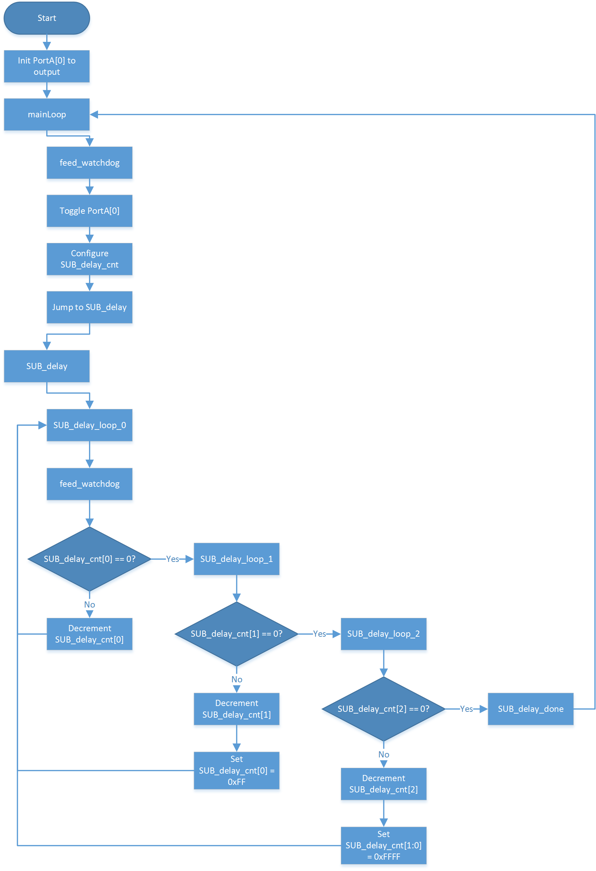
Figure 1: Counter Loop Implementation Flowchart
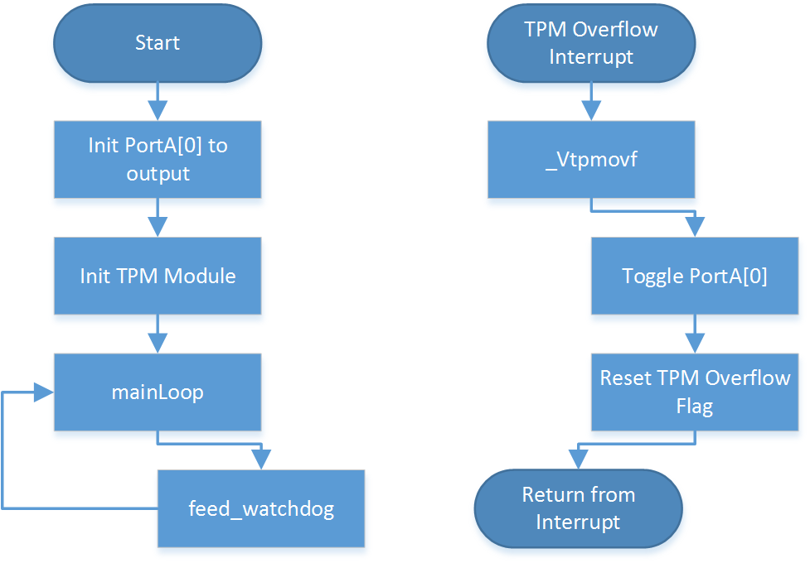
Figure 2: TPM Interrupt Implementation Flow Chart

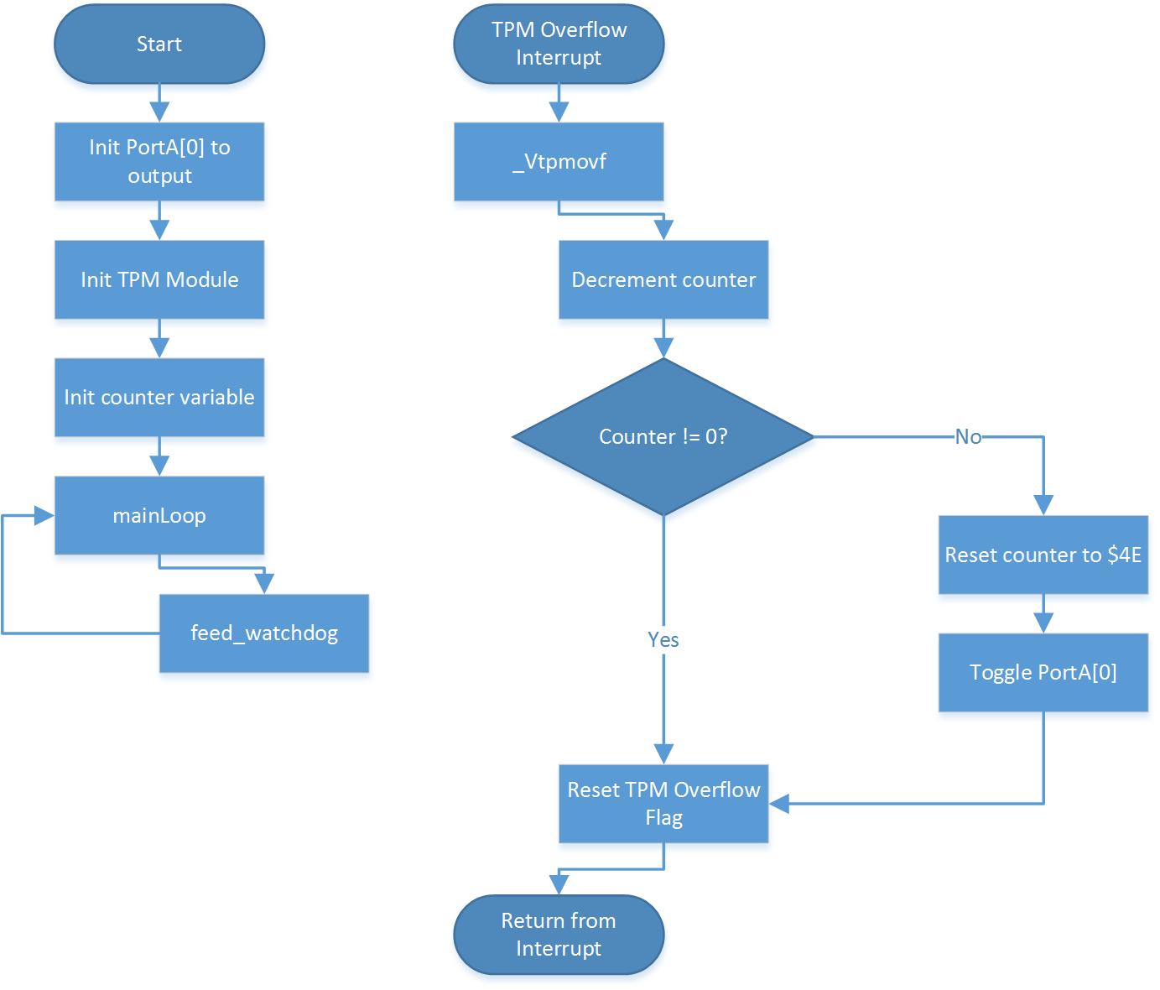
Figure 3: TPM Interrupt-Counter Hybrid Implementation Flow Chart

