# Introduction

This is an idea that in my head for several years but I don’t have time to implement it, my idea is artificial intelligence neural network based on reinforcement learning, and the neural network can create its own neural during the learning process.

Recently, I have time to work on it, so I drop down some ideas and worked on the code. It is good to start with the easy one, a tic-tac-toe game. My plan is to create 2 artificial neural and let them play with each other. They will learn the steps by themselves. I know this one is not a new thing at all but it will be a good way to start with. There always has a “Hello World!” process, right?

Here are my draft ideas about the neural network, not all the ideas are implemented in this tic-tac-toe game. I want to start from the basics.

* Neural trained by reinforcement learning, will create a new neural if find a new path.
* Neural are connected by a link, each link has a weight, and the process will go one by one based on the weight.  
  The neural network must have input and output.
* In some cases, update the weight after every episode. ( e.g. Monte Carlo Simulation)
* In some cases, update the weight after every step. (e.g. Temporal Difference)
* Neural has its own attributes setting, it is for a different set of the AI.
* There has a neural layer to group the input, understand that the input is the same. (This one is not implemented)
* There has a neural layer to find the shortcut, and understand the target, not just the steps. (This one is not implemented)

# The program

I am using python for the test, training.py is the starting class

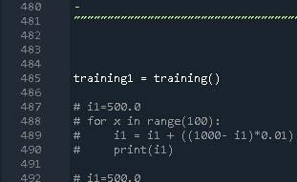

The current setting will show on the screen.

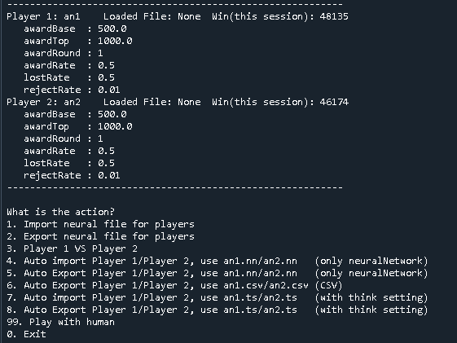

PS:

The easiest way to start is to use “7” to import the settings and neural network automatically. It is ok to play with human.

I also uploaded some files for import.

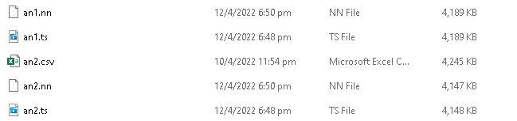

# Test log

There are the logs that I test with different neural attributes.

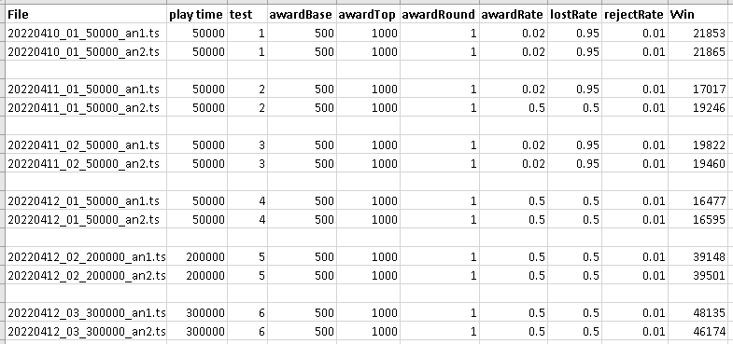

PS:

The higher award rate and lost rate will do better.

## Test 1 - Run 50000 times

50000

10%....

20%....

30%....

40%....

50%....

60%....

70%....

80%....

90%....

Total seconds of the run: 6874.21

Player 1

getNextStepTime= 2539.46

rejectStepTime= 364.15

startGameTime= 0.17

endGameTime= 507.75

Player 2

getNextStepTime= 2535.67

rejectStepTime= 364.17

startGameTime= 0.08

endGameTime= 505.3

Player 1: an1 Loaded File: Win: 21853

awardBase=500.00

awardTop=1000.00

awardRound=1

awardRate=0.01

lostRate=0.95

rejectRate=0.01

Player 2: an2 Loaded File: Win: 21865

awardBase=500.00

awardTop=1000.00

awardRound=1

awardRate=0.01

lostRate=0.95

rejectRate=0.01

## Test 2 - Run 50000 times

50000

10%....

20%....

30%....

40%....

50%....

60%....

70%....

80%....

90%....

Total seconds of the run: 6404.9

Player 1

getNextStepTime= 2354.55

rejectStepTime= 323.77

startGameTime= 0.2

endGameTime= 486.52

Player 2

getNextStepTime= 2395.48

rejectStepTime= 331.54

startGameTime= 0.07

endGameTime= 484.93

-----------------------------------------------------------

Player 1: an1 Loaded File: None Win(this session): 17017

awardBase : 500.0

awardTop : 1000.0

awardRound : 1

awardRate : 0.01

lostRate : 0.95

rejectRate : 0.01

Player 2: an2 Loaded File: None Win(this session): 19246

awardBase : 500.0

awardTop : 1000.0

awardRound : 1

awardRate : 0.5

lostRate : 0.5

rejectRate : 0.01

## test 3 - Run 50000 times

50000

10%....

20%....

30%....

40%....

50%....

60%....

70%....

80%....

90%....

Total seconds of the run: 7268.11

Player 1

getNextStepTime= 2703.26

rejectStepTime= 388.47

startGameTime= 0.19

endGameTime= 536.57

Player 2

getNextStepTime= 2689.72

rejectStepTime= 383.7

startGameTime= 0.1

endGameTime= 532.81

-----------------------------------------------------------

Player 1: an1 Loaded File: None Win(this session): 19822

awardBase : 500.0

awardTop : 1000.0

awardRound : 1

awardRate : 0.01

lostRate : 0.95

rejectRate : 0.01

Player 2: an2 Loaded File: None Win(this session): 19460

awardBase : 500.0

awardTop : 1000.0

awardRound : 1

awardRate : 0.01

lostRate : 0.95

rejectRate : 0.01

## Test 4 - Run 50000 times

How many times?

50000

10%....

20%....

30%....

40%....

50%....

60%....

70%....

80%....

90%....

Total seconds of the run: 6497.31

Player 1

getNextStepTime= 2400.72

rejectStepTime= 328.29

startGameTime= 0.19

endGameTime= 505.59

Player 2

getNextStepTime= 2401.16

rejectStepTime= 331.0

startGameTime= 0.14

endGameTime= 501.51

-----------------------------------------------------------

Player 1: an1 Loaded File: None Win(this session): 16477

awardBase : 500.0

awardTop : 1000.0

awardRound : 1

awardRate : 0.5

lostRate : 0.5

rejectRate : 0.01

Player 2: an2 Loaded File: None Win(this session): 16595

awardBase : 500.0

awardTop : 1000.0

awardRound : 1

awardRate : 0.5

lostRate : 0.5

rejectRate : 0.01

-----------------------------------------------------------

## Test 5 - Run 150000 times

150000

10%....

20%....

30%....

40%....

50%....

60%....

70%....

80%....

90%....

Total seconds of the run: 12231.99

Player 1

getNextStepTime= 4537.59

rejectStepTime= 404.92

startGameTime= 0.59

endGameTime= 1137.03

Player 2

getNextStepTime= 4530.88

rejectStepTime= 405.33

startGameTime= 0.29

endGameTime= 1124.92

-----------------------------------------------------------

Player 1: an1 Loaded File: None Win(this session): 39148

awardBase : 500.0

awardTop : 1000.0

awardRound : 1

awardRate : 0.5

lostRate : 0.5

rejectRate : 0.01

Player 2: an2 Loaded File: None Win(this session): 39501

awardBase : 500.0

awardTop : 1000.0

awardRound : 1

awardRate : 0.5

lostRate : 0.5

rejectRate : 0.01

-----------------------------------------------------------