CE / CS / SE 3354 · SOFTWARE ENGINEERING · FALL 2026
Project Deliverable P1
Proposal and Requirements — Team Template
Weight 4% · Due Sunday 18 October 2026, 11:59 PM Central · Submit one PDF per team on Canvas
Field | Your entry
Project title | Study Room Reservation System for UTD
Team number and section | Team 07, Section 010
Team members (name · net ID) | Andrew Artiaga (axa220205), Artyom Gevorgyan (axg200155), Arjun Sharma (axs220320), Matthew Low (mjl230002), Ernie Hsiao (exh230014), Param Kathiravan (pxk230069)
Repository URL | https://github.com/matthewlow262-jpg/Study-Room-Reservation-System.git
Document version | 0.1
Date | 10/17/2026

▸ How to use this template
This template is the structure we expect, not a form to pad out. It follows the section ordering of ISO/IEC/IEEE 29148, the current international standard for requirements engineering, so that the document you start now grows into a full requirements specification by P2 rather than being thrown away and rewritten.
Delete every blue box like this one before you submit. They are instructions, not content, and a document that still contains them has not been read by its own authors.
Length: aim for 10 to 14 pages of your own content. A longer document is not a better one. Every section below carries a budget; a section that runs to twice its budget is usually padded, and padding is visible.

▸ What P1 does NOT ask for
P1 is a baseline, not a finished specification. At this milestone we are NOT asking for:
— a software architecture or any design decision (that is P2, after Chapter 8)
— class diagrams, sequence diagrams or state models (that is P2, after Chapters 7 and 9)
— a test plan (that is P3, after Chapter 11)
— any code, screens or a working prototype (P1 is marked on reasoning, not on implementation)
A team that submits an architecture diagram at P1 has spent its effort in the wrong place and will not be credited for it.

0 Revision History and Contribution Record
Both tables below are graded. The contribution record carries the individual 20% of this milestone and must be consistent with your repository history.
Version | Date | Author | Summary of change
0.1 | 10/17/2026 | All team members | Initial baseline for P1
0.2 | 10/17/2026 | All team members | Drafting Sections 1-5
0.3 | 10/17/2026 | Matthew Low | Finished Section 3.1, 4.1, 5
0.4 | 10/18/2026 | Andrew Artiaga | Finished Section 1.2, GitHub draft upload, Section 2.2

0.1 Individual contribution record
Team member | What this person produced for P1 | Evidence in the repository
Matthew Low | Worked on part 1 introduction, section 2.6, section 3.1, section 4.1, section 4.2, section 5 | Part 1 Intro, Section 3.1, Section 4.1, Section 4.2, Section 2.6, Section 5,
Andrew Artiaga | Worked on part 1, section 1.2, section 2.2, accepting/denying suggestions, GitHub management & contribution record | Initial upload · Record creation · Completed Section 2.2
Artyom Gevorgyan
Arjun Sharma | Worked on part 2 product perspective(section 2.1), part 3 quality/constraint requirements and initial use cases(sections 3.2, 3.3 and 3.4) and part 4 risks(section 4.3) | Section 3.3, Section 4.3 Section 3.4 Section 3.2 Section 2.1
Ernie Hsiao | Worked on part 2.2 - 2.5, part 3.5 | Sections 2.2-2.5 · Section 3.5
Param Kathiravan | Developed the two expanded use cases in Section 3.4 (UC-02: Reserve a Study Room and UC-05: Manage Room Listings)

1 Introduction
1.1 Purpose of this document and of the system
This document is going to define the initial project proposal as well as the software requirements for the Study Room Reservation System for the University of Texas at Dallas. This document will describe the purpose, scope, stakeholders, constraints, requirements, and use cases. It is intended for the project team, instructor, and other stakeholders involved in reviewing, developing, and evaluating the project.

The Study Room Reservation System is going to give students a convenient way to find available study rooms on campus and reserve them for individual or group study. This system will allow students to search for rooms based on availability, time, and capacity. It will also let authorized personnel manage the room information.

1.2 Scope
In scope — we will build this | Out of scope — we will not, and why
Display a list of all study rooms with their locations and vacancies | Interacting with any physical locks and doors that require comet cards, keys, etc. Because this would require us to have access to external hardware and infrastructure that is only available to certain staff in UTD.
Allow students to search for rooms based off date, time, and capacity | Tracking real-time room occupancy through cameras or sensors because we are focusing on reserving rooms rather than monitoring the physical occupancy of the room
Display available time slots for a room | Integrating with UTD’s current campus scheduling system or software because we do not have access to those systems
Allow students to make reservations for available time slots | Sending SMS notifications because we would require access to personal information from the students and that information is not currently required for the start of this project
Prevent overlapping reservations for the same room and time | Implementing UTD Duo authentication because that would require access to UTD’s authentication system
Allow authorized administrators to manage the study room listings | Processing payments or charging students for room reservations. This feature is not necessary for the purpose of this system
Send email notifications regarding status of the room reservation (confirmation/cancellation). | Integrate with external university services that have not been approved or made available to the team

Why the exclusions were excluded:
If we did include the exclusions, then the project would be much more difficult to create and to implement. The exclusions would require that we have access to external permissions and tools that go beyond the intended purpose of the program. By focusing on the aspects of the project that are in scope, we will be able to lower the complexity of the project and allow it to be used for its intended purpose.

1.3 Definitions, acronyms and abbreviations
Term or abbreviation | Meaning as used in this project
UTD | University of Texas at Dallas
Study room | A designated space for students to reserve for self-study or group study
Reservation | A booking that assigns a study room to whichever student booked it
System | An operating system designed and coded to allow students to make reservations
Availability | The status of a study room that shows if it is reserved or if it is free

1.4 References
[R1] CE 3354 Fall 2026 course syllabus and P1 project template
[R2] UTD library policies; https://library.utdallas.edu/about-the-library/library-policies/
[R3] UTD policies on information security or privacy; https://policy.utdallas.edu/utdbp3096

2 Overall Description
2.1 Product perspective and context
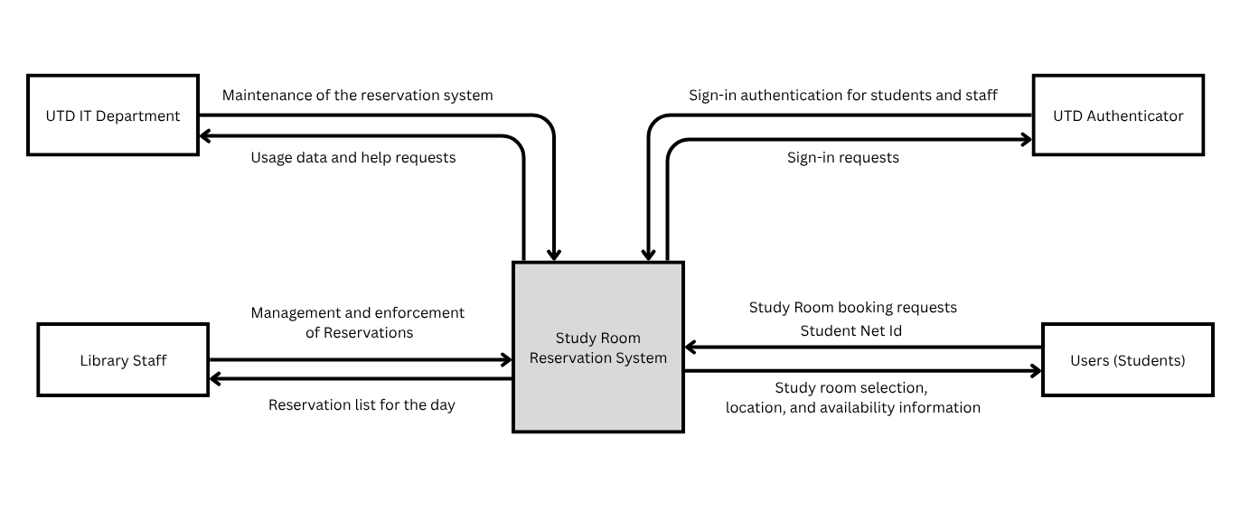
Why the boundary sits here: Inside the box is everything we build: the room catalogue, availability search, reservation rules, admin tools for room listings, and the logic that triggers emails. Outside is everything we depend on but don’t control: UTD’s identity records, its email service, and the physical doors, locks and Comet Card readers. Only students and library staff use the system directly.

2.2 Stakeholders and how you reached them
Stakeholder | Role in relation to the system | What they need from it | How you learned this
Students | Users that use the system | - Reservation of rooms  - Cancellation of reservations  - Confirmation of reservation  - Way to view availability | Based on our experiences as students, finding a study room in the library can be difficult at times, such as during midterms. These needs are currently based on our observations and assumptions.
Library Staff | Manage the study room area | - Room management capabilities, both physical and remote | We assume library staff are responsible for managing study room availability and resolving room-related issues. These assumptions have not yet been confirmed through interviews.
UTD IT Department | Create and maintain the system | - System security and user authentication integration  - Database management capabilities  - Compliance with UTD privacy policies | Based on our understanding of the technical requirements for a university reservation system. The specific authentication, infrastructure, and privacy requirements still need to be verified with UTD IT staff.
UTD Office of Budget and Finance | Fund the servers and system | - Proof that the system is being used  - Proof that the system is helpful | We assume that funding decisionmakers would need evidence of system usefulness and operating costs before supporting continued funding.

2.3 User characteristics
Users: Students at UTD
They know: Where the study rooms are, study room hours, size of their party
They don't know: Which rooms are available, when rooms are available, how big the rooms are
User constraints: UTD ID

2.4 Constraints
The registration service must be hosted by UTD's servers. The data used to track students is personal and should remain on the UTD servers.
The system must comply with UTD’s rules and policies
The students must leave the study rooms at least 30 minutes before the library closes. This is to give the library staff time to clean up.

2.5 Assumptions and dependencies
# | Assumption or dependency | What breaks if it does not hold
A1 | We depend on the library staff to manage the study rooms. | There will be no one to update or enforce the reservations.
A2 | We assume the students and library staff have access to the internet. | They will not be able to place or change a reservation.
A3 | An email delivery method will be available if email notifications are in scope | Confirmation and cancellation emails may not be deliverable
2.6 Feasibility summary
▸ WHAT GOES HERE
Four short verdicts, each with the evidence behind it. This is the Chapter 4 material, applied to your own project.
A verdict with no evidence is an opinion. “Technically feasible — two team members have used this framework before, see repository /spike-01” is evidence. “We think we can do it” is not.
Feasibility gate | Verdict | Evidence behind the verdict
Technical | Potentially feasible | The functions that the project needs involve room listings, time-slot searches, reservation records, and conflict checks. To tell if this is technically feasible we will need to include a working proof of concept, repository code, and tests to check if the requirements can be met. Until then this will remain potentially feasible
Operational | Potentially feasible | Students can make reservations for available study rooms and the system will deal with conflicting reservations and if needed, the staff can manage the reservations as well. The team still needs to test the workflow with students and staff in the library
Schedule | Feasible | We have identified core functions that the system needs to be successful and have a milestone plan. Evidence of schedule feasibility will include assigned tasks to owners, completed milestones, recorded progress, etc. This way the schedule remains achievable
Economic / resource | Potentially feasible | The proposed scope does not include tools like paid reservation processing or integration with whole university systems. These conflicts could prove to be difficult because even if our project works it only remains potentially feasible because we cannot control things like integrating our system with the universities software.

3 Specific Requirements
3.1 Functional requirements
ID | Requirement — one “shall” sentence | Priority | Source | Acceptance criterion
FR-01 | The system shall display the list of study rooms in its room listing | MUST | Students | A tester can confirm this by verifying that every room in the test dataset appears in the list
FR-02 | The system shall display the location of each listed study room | MUST | Students | Verify that each of the listed rooms displays its location
FR-03 | The system shall display the capacity of each listed study room | MUST | Students | Verify that each listed room displays its capacity
FR-04 | The system shall allow students to search for rooms by reservation date. | MUST | Students | Search using a date and ensure that only rooms with availability are returned
FR-05 | The system shall allow students to search for rooms by reservation time | MUST | Students | Search using a time range and make sure that the results match the availability of the rooms
FR-06 | The system shall allow students to filter rooms by minimum capacity | SHOULD | Students | Enter a capacity and verify that each result either meets or exceeds it
FR-07 | The system shall display available time slots for a selected room | MUST | Students | Select a room and verify that the time slots match the rooms reservations
FR-08 | The system shall allow a student to reserve an available time slot | MUST | Students | Submit a valid reservation and verify that the reservation is recorded
FR-09 | The system shall prevent a reservation from overlapping with an existing reservation in the same room | MUST | Students | Attempt an overlapping booking and verify that it is rejected
FR-10 | The system shall allow a student to cancel an existing reservation that they submitted | MUST | Students | Cancel a reservation and verify that its status is updated and the slot is now free
FR-11 | The system shall display reservations made by the student requesting a reservation | COULD | Students | Verify that the student can see their own reservation records without seeing other students' reservation records
FR-12 | The system shall allow authorized library staff to update the location and capacity of existing study room listings. | MUST | Library Staff | Log in as an authorized administrator, modify a room's location and capacity, save the changes, and verify that the updated information appears in the room listing.

3.2 Quality requirements
ID | Requirement — with threshold, condition and method | Priority | Source | How it will be verified
QR-01 | 95% of room searches (FR-02) will return results within 2 seconds for up to 25 concurrent users and 50 rooms. | MUST | Students | Load script of 200 searches run with 25 simultaneous users; the 95th-percentile response time is read from the script log.
QR-02 | When 20 users attempt to reserve the same room and time slot at the same moment, exactly one reservation shall be created and 19 shall be rejected, in each of 100 repeated runs. | MUST | Students | Automated concurrency tests run 100 times; the database is checked after each run for a single confirmed reservation.
QR-03 | At least 80 percent of first-time student testers (minimum 5 testers) shall find a room and complete a reservation in under 3 minutes without help, on a phone-size screen 360 pixels wide. | SHOULD | Students | Moderated usability test with a stopwatch and a task script; completion times and unaided successes are recorded.
QR-04 | The system shall be available at least 99 percent of the time during library opening hours, measured over any 14-day period. | SHOULD | Students | A monitoring service requests the home page every minute during library opening hours; availability is computed from its log.

3.3 Constraint requirements
ID | Constraint — one sentence | Source | Why it cannot be negotiated
CON-01 | The system shall be hosted on UTD-operated servers, and student personal data shall not be stored anywhere else. | UTD IT | Student identity data is personal, and UTD IT is responsible for keeping it on UTD servers.
CON-02 | The system shall comply with UTD's rules and policies, including those on student privacy. | UTD IT | A university rule is not the team's to waive.

3.4 Initial use cases
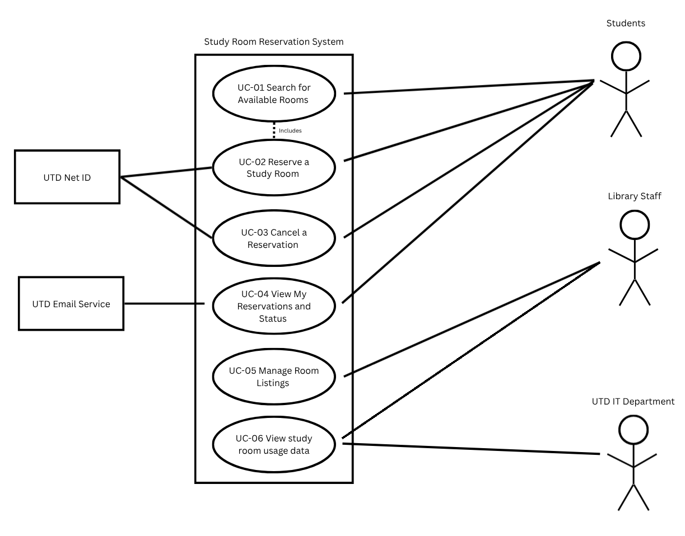
Actors: Student and Library staff (administrator); supporting actor: UTD email service. System boundary as in 2.1.
UC-01 Search for Available Rooms
UC-02 Reserve a Study Room
UC-03 Cancel a Reservation
UC-04 View My Reservations and Status
UC-05 Manage Room Listings
UC-06 View study room usage data

Signing in is a precondition of UC-02 to UC-05, not a use case on its own: it is a step toward a goal, not a goal.

Expanded use case — copy this block for each of your two
Field | Content
Identifier and name | UC-02 Reserve a Study Room
Primary actor | Student
Supporting actors | None confirmed; email service
Preconditions — what must be true before it starts | The student is identified by the system, and an available study room and time slot exist
Trigger — what starts it | The student selects an available room and chooses to reserve it
Main success scenario — numbered steps | - The student selects an available study room  - The system displays available time slots  - The student selects a time slot  - The student submits the reservation request  - The system checks for conflicting reservations.  - The system records the reservation  - The system displays confirmation to the student
Alternative and exception flows | - If the selected time slot is unavailable, the system rejects the request and asks the student to select another slot.  - If the student’s identity cannot be confirmed, the system prevents the reservation.  - If the reservation cannot be saved, the system reports the failure without confirming the booking
Postconditions — what is true when it succeeds | The reservation is recorded, and the selected room and time slot are no longer available for overlapping reservations.
Requirements realized | FR- 07, FR-08, FR-09

Expanded use case — copy this block for each of your two
Field | Content
Identifier and name | UC-05 Manage Room Listings
Primary actor | Library Staff (Administrator)
Supporting actors | None confirmed
Preconditions — what must be true before it starts | The library staff member is signed in with administrator permissions. The system has access to the current room listings.
Trigger — what starts it | The library staff member chooses to manage the study room listings.
Main success scenario — numbered steps | - 1. The administrator opens the room management section.  2. The system displays the current study room listings.  3. The administrator selects a room to update.  4. The system displays the room's current information.  5. The administrator modifies the room's information, such as location or capacity.  6. The administrator submits the changes.  7. The system validates the updated information.  8. The system saves the changes and displays confirmation.
Alternative and exception flows | - If the administrator enters invalid room for information, the system rejects the changes and requests corrections.  - If the changes would conflict with existing reservations, the system rejects the update and informs the administrator.  - If the administrator does not have the required permissions, the system denies access.  - If the changes cannot be saved, the system displays an error and keeps the previous room information unchanged.
Postconditions — what is true when it succeeds | The updated room location or capacity is saved in the system and displayed in the room listings. Existing reservations remain unchanged.
Requirements realized | FR- 10

3.5 Requirements to use case traceability
Requirement ID | Use case(s) that realize it | If blank — why, and what you will do
FR-01 | UC-01, UC-05
FR-02 | UC-01, UC-05, UC-06
FR-03 | UC-01, UC-04
FR-04 | UC-01, UC-05
FR-05 | UC-01, UC-05
FR-06 | UC-01
FR-07 | UC-01, UC-05, UC-06
FR-08 | UC-02
FR-09 | UC-02
FR-10 | UC-03
FR-11 | UC-04
FR-12 | UC-05

This reveals that our matrix has no current gaps, but it also shows which use cases are involved in most requirements. Because of this, we decided not to change anything, but will monitor any potential weak tests.

4 Project Plan
4.1 Team roles and working agreement
Team member | Role for P1 to P2 | How the team makes a decision when it disagrees
Matthew Low | Requirements manager and repository maintainer | Discuss issues with the team, compare alternatives against the agreed requirements and record the decision
Andrew Artiaga | Scope, system context, and repository coordinator | Discuss disagreements with the team, compare options against the project scope and stakeholder needs and document decision
Arjun Sharma | Stakeholder and elicitation manager | Discuss disagreements with the team, review/evaluate stakeholder needs and document decision
Ernie Hsiao | Non-functional, constraints, and prototyping analyst | Discuss disagreements with the team, evaluate decisions against system performance and quality attributes, and document the decision
Artyom Gevorgyan
Param Kathiravan | Use Case Analyst | Discuss disagreements with the team, compare proposed solutions against functional requirements and use cases, and document the agreed decision.

4.2 Plan to P2
Date | What will be finished | Owner
Oct 18 | Finalize and submit P1 requirements baseline | All team members
Oct 21 | Review P1 feedback and identify problems and propose corrections to the overall project | All team members
Oct 25 | Finalize stakeholder assumptions, reservation rules, and open questions | Arjun Sharma
Oct 28 | Review requirements and use cases, update traceability and resolve gaps | Matthew Low
Nov 1 | Complete P2 design-related deliverables | Ernie Hsiao
Nov 6 | Complete the team review and resolve identified document issues | All team members
Nov 8 | Submit the revised project documentation for P2 | All team members

4.3 Risks
# | Risk | Likelihood | Impact | Mitigation — action and owner
R1 | Student sign-in cannot be connected to UTD's identity service, so the system cannot confirm who is booking. | High | Medium | Arjun Sharma – Define a simple identification method that does not require UTD identity integration.
R2 | Requirements change after this baseline and cause rework in P2 and P3. | Medium | High | Matthew Low – Record the requirement changes in the repository and assess the impact on scope and deadlines. Also make sure the team agrees to any changes proposed for the baseline
R3 | A member is unavailable during exam season, and their work is delayed or missing. | Medium | Medium | Have each member document their progress and upload their work to GitHub regularly. Share status on tasks with the team and reassign unfinished tasks if necessary
R4 | Two students are able to reserve the same room and time under load. | Low | High | Artyom Gevorgyan – Design a reservation conflict check that will recheck availability on reservations when submitted.
R5 | Scope grows to include excluded items such as SMS, Duo, or door locks. | Medium | Medium | Keep a list of extra features whether they are used or not and decide with the team whether these features fit in the scope of the project or not.

4.4 Repository and tooling
https://github.com/matthewlow262-jpg/Study-Room-Reservation-System.git
Commit conventions and Branch: We have decided to focus on using the Main branch as this will contain all of the team's reviewed project files.
Access and permissions: Team members should have the repository permissions needed to access all the team's files.
How issues are used: We will mainly use GitHub to document our progress, and issues will be discussed by team members to come to a consensus.

4.5 Declaration of AI tool use
Tool | What it was used for | Who used it | How the output was checked
ChatGPT | Understanding what section 1.4 References needs and should be | Matthew Low | Compared the guidance with P1 project template and course requirements to come up with the three references
ChatGPT | Helped refine the project description and format the P1 contribution record, including GitHub commit links | Andrew Artiaga | Reviewed the wording for accuracy and that the GitHub commit links matched the project work

5 Open Questions
# | The question | Who can answer it | Needed by | What you assumed in the meantime
Q1 | Will the system use actual UTD study room information or a simulated dataset? | Team members; UTD library staff | October 25, 2026 | The system will use a simulated dataset if actual UTD room information is unavailable.
Q2 | How will the students identify themselves when making, viewing, or canceling reservations? | Project team; UTD IT staff authentication is available | October 25, 2026 | The initial version will use a simple project-level identification method and will not integrate with UTD Duo.
Q3 | Will the system send email confirmations, and what email service can the team use? | Project team; the instructor or UTD IT staff | October 25, 2026 | Email notifications are optional until the team confirms that an email service is an available option.

6 Baseline Declaration
We confirm that the requirements in section 3 represent our agreed baseline as of the submission date, and that every team member has read this document in full.
Team member | Signature or typed name | Date
Matthew Low | Matthew Low | 10/17/2026
Artyom Gevorgyan | Artyom Gevorgyan | 10/17/2026
Ernie Hsiao | Ernie Hsiao | 10/17/2026
Arjun Sharma | Arjun Sharma | 10/18/2026
Andrew Artiaga | Andrew Artiaga | 10/18/2026
Param Kathiravan | Param Kathiravan | 10/18/2026

