CE/CS/SE 3354 · Software Engineering · Fall 2026
Project Milestone P2

Analysis and High-Level Design
Study Room Reservation System for UTD
Team | Team 07, section .010
Document version | 2.0
Date | 11/8/2026
Repository URL | https://github.com/matthewlow262-jpg/Study-Room-Reservation-System
Git tag for this milestone | p2 (points at the commit that contains this exact PDF)
Submitted on Canvas by | [one member only]

Team member | NetID | GitHub username
Matthew Low | Mjl230002 | matthewlow262-jpg
Arjun Sharma | axs220320 | sharmararjun-droid
Ernie Hsiao | exh230014 | ErnieHsiao
Andrew Artiaga | axa220205 | AndyA64
Artyom Gevorgyan | axg200155 | ptdg
Param Kathiravan | Pxk230069 | paramkathir

HOW TO USE THIS TEMPLATE
This is not a new document. P2 continues the document you baselined at P1. Copy your P1 sections 1 to 3 into this file (updated under change control), then fill in the new sections 4 to 9. Your P1 project plan, open questions and baseline move to the end and are renumbered:
P1 section 4 (project plan) becomes section 10. P1 section 5 (open questions) becomes 11. P1 section 6 (baseline) becomes 12.
Delete every guidance, example and warning box (blue, amber and red) and the two marking pages at the end before you submit. They are instructions, not content. Boxes or placeholders such as "[TBD]", "PR #[n]" or "[Member 3]" left in the submitted document lose document-quality points.
Length: sections 4 to 9 should add roughly 12 to 18 pages, diagrams included. Every section below carries a budget. A longer document is not a better one.
Diagrams: draw them in any tool (draw.io, Lucid, PlantUML, or a tidy hand drawing that is scanned). Export each as an image for this document and commit the source file to /docs/p2/diagrams. A diagram that cannot be read cannot be credited for its content.
Required structure: using this file is optional, but its section numbering is required, because the rubric refers to it.
Rubric: the marking pages at the end show where the 60 points sit. Read them before you divide the work.

WHAT P2 DOES NOT ASK FOR (DELETE THIS BOX BEFORE SUBMITTING)
P2 is analysis and high-level design. At this milestone we are NOT asking for:
design class diagrams with operations, parameter types or visibility, and design-level sequence diagrams with operation signatures (Chapter 9 detailed design; they enter the document during P3 work)
production code (the only code in P2 is the small architecture spike in section 8)
a test plan (P3, after Chapter 11)
screen mock-ups or a visual design (not graded at this milestone; add them only if they settle an open question)
design patterns from the Gang of Four catalog, ATAM or utility trees (not required; do not spend your time there)
Work placed in the wrong milestone is not credited. Spend the time on sections 4 to 9.

0 Revision History, Contribution Record and Changes Since P1
All three tables below are graded. The contribution record carries the individual 20% of this milestone and must agree with your repository history.
Version | Date | Author | Summary of change
1.0 | 11/6/2026 | All team members | P1 baseline (copy your last P1 row)
1.1 | 11/8/2026 | All team members | P2 baseline: analysis and high-level design added
1.2 | 11/8/2026 | Matthew Low | Finished Section 4
1.3 | 11/8/2026 | Andrew Artiaga | Finished Section 6.3, Section 6.4, GitHub diagram uploads
1.4 | 11/8/2026 | Param Kathiravan | Finished Section 8 and 9
1.5 | 11/8/2026 | Arjun Sharma | Filled in sections 6.1, 6.2, 6.5, 6.6 and 7.2
1.6 | 11/8/2026 | Matthew Low | Filled in sections 7.1
2.0 | 11/8/2026 | All team members | Finished all sections

0.1 Individual contribution record (P2)
Team member | Sections and artifacts this person produced for P2 | Evidence in the repository (commit hashes, PR numbers) | Reviews given (PR numbers)
Matthew Low | Section 4.1-4.3  Section 7.1 | Eb15a8063b685d720b880ad6b2428711aba33c8a (#6)  c6b8ca06f3ba1fa467db7be6d314988784e1fafc (#11) | #7  #8
Arjun Sharma | Section 6.1, 6.2  Section 6.5  Section 6.6  Section 7.2 | 1932ae5980d612fd23ea1a233be7ef097cdfdc68 (#3)  D9dedff03cfb2e9ef2f5b308590e68aacd1ff8e4 (#5)  11f53e806a2dd4d0e4155912791706d3911ddcff (#7)  Afd7f68ecef716bc6024443b91ca3ce402b6caa9 (#9) | #1
Ernie Hsiao | Section 5, Section 10 | 0732e2db6a9ecf8ad38da142e0aad6cd6911451c (#4) | #5, #2, #6, #10
Andrew Artiaga | Sections 1-3 from P1 copied to P2, Section 6.3, Section 6.4, GitHub diagram uploads & contribution record | e48c95d1691b5d2bbfdba4d9ce8b178a9fdb4ae8 (#2)  4bf9b89d4ed01dae64e1fd5c1818df5d3c50acfb (#8) | #3, #4, #9
Artyom Gevorgyan | Section 5.2 | 4c9cd8d2656c77bf94be5ed37f3a7042d38fbbda (#10) | #11
Param Kathiravan | Section 8 — Architecture Spike S-01; Section 9.1 — Extended Traceability Matrix; Section 9.2 — Gap Analysis | 8fac0da3b6f49bed1f460e19e5d5fef1eee30145 (#1) | #11

GUIDANCE: DELETE THIS BOX BEFORE SUBMITTING
Evidence means something a reader can open and that existed before the deadline: a commit hash, a pull request, a file in the repository. Issues you own count as indirect evidence; link the commits that close them for full credit.
Commit your own work from your own GitHub account. If one person uploads everyone's text from a shared document, the history shows one author and the other members have no verifiable evidence. A shared drafting document is fine; the final text of each section is committed by its owner.
Cite only what exists. Every commit, pull request, branch and file named in this table is checked. Citing evidence that is not in the repository is an academic-honesty matter, not a formatting slip.
Every member appears with a distinguishable contribution. Two rows with identical wording are marked as vague claims. If a member did not contribute, write that plainly in their row rather than leaving it blank or covering for them.

0.2 Changes since the P1 baseline
Change ID | What changed (IDs affected) | Why (P1 feedback, new finding, spike result) | Knock-on effect | Agreed on
CH-01 | UC-01 condensed steps | Steps were too simple and added unnecessary clutter | 5.2.1 is easier to read | Agreed Nov. 7
CH-02 | US-01 split last step into 2 | Too complex to map in the scenario table | 5.2.1 is easier to read | Agreed Nov. 7
CH-03

GUIDANCE: DELETE THIS BOX BEFORE SUBMITTING
Start with your P1 feedback. Every point raised in your P1 comment should appear here as a change, or with one sentence explaining why you kept the original. This table is where the baseline-and-change-control idea from Chapter 5 becomes real.
Requirement IDs are never reused. A removed requirement stays in section 3 marked "Withdrawn (CH-nn)" so the traceability matrix does not silently lose it.
Budget: half a page.

EXAMPLE (COMETPARK): DELETE BEFORE SUBMITTING
CH-02 · QR-02 rewritten as quality-attribute scenario QAS
-01 · Why: P1 feedback said "fast enough" had no response measure · Knock-on: ADR-02 now cites QAS-01 · Agreed 30 Oct.

1 to 3 Introduction, Overall Description and Requirements (carried forward)
GUIDANCE: DELETE THIS BOX BEFORE SUBMITTING
Paste your P1 sections 1, 2 and 3 here and bring them up to date. Keep their numbering and IDs.
Fix before you build on it: any requirement that is still untestable, any source that still says "pending", any open question your P1 feedback flagged. Analysis and design inherit every ambiguity you leave in section 3.
Use cases: section 3.4 keeps the use-case diagram and the list at actor-goal level. The detailed expansion now lives in section 4; do not copy it twice.
Traceability: replace the P1 matrix in section 3.5 with a one-line pointer to section 9.1, where it is extended.
If nothing in a subsection changed, keep it and say so in one line under its heading ("Unchanged since v0.x").
1 Introduction
1.1 Purpose of this document and of the system
This document is going to define the initial project proposal as well as the software requirements for the Study Room Reservation System for the University of Texas at Dallas. This document will describe the purpose, scope, stakeholders, constraints, requirements, and use cases. It is intended for the project team, instructor, and other stakeholders involved in reviewing, developing, and evaluating the project.

The Study Room Reservation System is going to give students a convenient way to find available study rooms on campus and reserve them for individual or group study. This system will allow students to search for rooms based on availability, time, and capacity. It will also let authorized personnel manage the room information.

1.2 Scope
In scope — we will build this | Out of scope — we will not, and why
Display a list of all study rooms with their locations and vacancies | Interacting with any physical locks and doors that require comet cards, keys, etc. Because this would require us to have access to external hardware and infrastructure that is only available to certain staff in UTD.
Allow students to search for rooms based off date, time, and capacity | Tracking real-time room occupancy through cameras or sensors because we are focusing on reserving rooms rather than monitoring the physical occupancy of the room
Display available time slots for a room | Integrating with UTD’s current campus scheduling system or software because we do not have access to those systems
Allow students to make reservations for available time slots | Sending SMS notifications because we would require access to personal information from the students and that information is not currently required for the start of this project
Prevent overlapping reservations for the same room and time | Implementing UTD Duo authentication because that would require access to UTD’s authentication system
Allow authorized administrators to manage the study room listings | Processing payments or charging students for room reservations. This feature is not necessary for the purpose of this system
Send email notifications regarding the status of the room reservation (confirmation/cancellation). | Integrate with external university services that have not been approved or made available to the team

Why the exclusions were excluded:
If we did include the exclusions, then the project would be much more difficult to create and to implement. The exclusions would require that we have access to external permissions and tools that go beyond the intended purpose of the program. By focusing on the aspects of the project that are in scope, we will be able to lower the complexity of the project and allow it to be used for its intended purpose.

1.3 Definitions, acronyms and abbreviations
Term or abbreviation | Meaning as used in this project
UTD | University of Texas at Dallas
Study room | A designated space for students to reserve for self-study or group study
Reservation | A booking that assigns a study room to whichever student booked it
System | An operating system designed and coded to allow students to make reservations
Availability | The status of a study room that shows if it is reserved or if it is free

1.4 References
[R1] CE 3354 Fall 2026 course syllabus and P1 project template
[R2] UTD library policies; https://library.utdallas.edu/about-the-library/library-policies/
[R3] UTD policies on information security or privacy; https://policy.utdallas.edu/utdbp3096

2 Overall Description
2.1 Product perspective and context
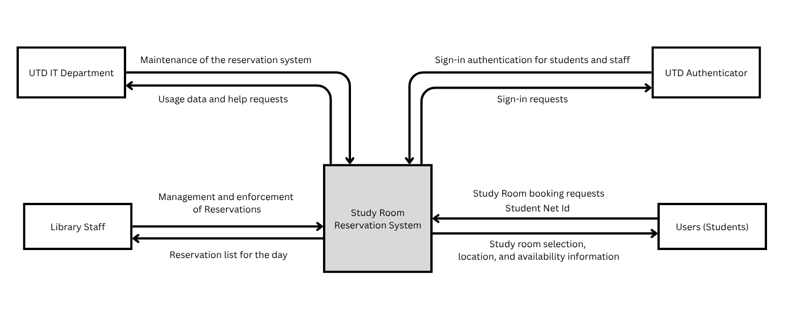
Why the boundary sits here: Inside the box is everything we build: the room catalogue, availability search, reservation rules, admin tools for room listings, and the logic that triggers emails. Outside is everything we depend on but don’t control: UTD’s identity records, its email service, and the physical doors, locks and Comet Card readers. Only students and library staff use the system directly.

2.2 Stakeholders and how you reached them
Stakeholder | Role in relation to the system | What they need from it | How you learned this
Students | Users that use the system | - Reservation of rooms  - Cancellation of reservations  - Confirmation of reservation  - Way to view availability | Based on our experiences as students, finding a study room in the library can be difficult at times, such as during midterms. These needs are currently based on our observations and assumptions.
Library Staff | Manage the study room area | - Room management capabilities, both physical and remote | We assume library staff are responsible for managing study room availability and resolving room-related issues. These assumptions have not yet been confirmed through interviews.
UTD IT Department | Create and maintain the system | - System security and user authentication integration  - Database management capabilities  - Compliance with UTD privacy policies | Based on our understanding of the technical requirements for a university reservation system. The specific authentication, infrastructure, and privacy requirements still need to be verified with UTD IT staff.
UTD Office of Budget and Finance | Fund the servers and system | - Proof that the system is being used  - Proof that the system is helpful | We assume that funding decisionmakers would need evidence of system usefulness and operating costs before supporting continued funding.

2.3 User characteristics
Users: Students at UTD
They know: Where the study rooms are, study room hours, size of their party
They don't know: Which rooms are available, when rooms are available, how big the rooms are
User constraints: UTD ID

2.4 Constraints
The registration service must be hosted by UTD's servers. The data used to track students is personal and should remain on the UTD servers.

The system must comply with UTD’s rules and policies regarding information security and acceptable use when handling university and student data.

The students must leave the study rooms at least 30 minutes before the library closes. This is to give the library staff time to clean up.

2.5 Assumptions and dependencies
# | Assumption or dependency | What breaks if it does not hold
A1 | We depend on the library staff to manage the study rooms. | There will be no one to update or enforce the reservations.
A2 | We assume the students and library staff have access to the internet. | They will not be able to place or change a reservation.
A3 | An email delivery method will be available if email notifications are in scope | Confirmation and cancellation emails may not be deliverable
2.6 Feasibility summary
Feasibility gate | Verdict | Evidence behind the verdict
Technical | Potentially feasible | The functions that the project needs involve room listings, time-slot searches, reservation records, and conflict checks. To tell if this is technically feasible, we will need to include a working proof of concept, repository code, and tests to check if the requirements can be met. Until then this will remain potentially feasible
Operational | Potentially feasible | Students can make reservations for available study rooms and the system will deal with conflicting reservations and if needed, the staff can manage the reservations as well. The team still needs to test the workflow with students and staff in the library
Schedule | Feasible | We have identified core functions that the system needs to be successful and have a milestone plan. Evidence of schedule feasibility will include assigned tasks to owners, completed milestones, recorded progress, etc. This way the schedule remains achievable
Economic / resource | Potentially feasible | The proposed scope does not include tools like paid reservation processing or integration with whole university systems. These conflicts could prove to be difficult because even if our project works it only remains potentially feasible because we cannot control things like integrating our system with the universities software.

3 Specific Requirements
3.1 Functional requirements
ID | Requirement — one “shall” sentence | Priority | Source | Acceptance criterion
FR-01 | The system shall display the list of study rooms in its room listing | MUST | Students | A tester can confirm this by verifying that every room in the test dataset appears in the list
FR-02 | The system shall display the location of each listed study room | MUST | Students | Verify that each of the listed rooms displays its location
FR-03 | The system shall display the capacity of each listed study room | MUST | Students | Verify that each listed room displays its capacity
FR-04 | The system shall allow students to search for rooms by reservation date. | MUST | Students | Search using a date and ensure that only rooms with availability are returned
FR-05 | The system shall allow students to search for rooms by reservation time | MUST | Students | Search using a time range and make sure that the results match the availability of the rooms
FR-06 | The system shall allow students to filter rooms by minimum capacity | SHOULD | Students | Enter a capacity and verify that each result either meets or exceeds it
FR-07 | The system shall display available time slots for a selected room | MUST | Students | Select a room and verify that the time slots match the rooms reservations
FR-08 | The system shall allow a student to reserve an available time slot | MUST | Students | Submit a valid reservation and verify that the reservation is recorded
FR-09 | The system shall prevent a reservation from overlapping with an existing reservation in the same room | MUST | Students | Attempt an overlapping booking and verify that it is rejected
FR-10 | The system shall allow a student to cancel an existing reservation that they submitted | MUST | Students | Cancel a reservation and verify that its status is updated and the slot is now free
FR-11 | The system shall display reservations made by the student requesting a reservation | COULD | Students | Verify that the student can see their own reservation records without seeing other students' reservation records
FR-12 | The system shall allow authorized library staff to update the location and capacity of existing study room listings. | MUST | Library Staff | Log in as an authorized administrator, modify a room's location and capacity, save the changes, and verify that the updated information appears in the room listing.
FR-13 | The system shall allow authorized library staff to view study room reservation usage data for a selected date range. | SHOULD | Library Staff | Select a date range as an authorized administrator and verify that the system displays reservation usage data for that range.
FR-14 | The system shall send an email notification to the student after a reservation is made successfully | MUST | Students | Create a valid reservation and verify the confirmation email was sent to the student
FR-15 | The system shall send an email notification to the students after a reservation is canceled | MUST | Students | Cancel an existing reservation and verify that the cancellation email is sent to the student

3.2 Quality requirements
ID | Requirement — with threshold, condition and method | Priority | Source | How it will be verified
QR-01 | 95% of room searches (FR-04 and FR-05) will return results within 2 seconds for up to 25 concurrent users and 50 rooms. | MUST | Students | Load script of 200 searches run with 25 simultaneous users; the 95th-percentile response time is read from the script log.
QR-02 | When 20 users attempt to reserve the same room and time slot at the same moment, exactly one reservation shall be created and 19 shall be rejected, in each of 100 repeated runs. | MUST | Students | Automated concurrency tests run 100 times; the database is checked after each run for a single confirmed reservation.
QR-03 | At least 80 percent of first-time student testers (minimum 5 testers) shall find a room and complete a reservation in under 3 minutes without help, on a phone-size screen 360 pixels wide. | SHOULD | Students | Moderated usability test with a stopwatch and a task script; completion times and unaided successes are recorded.
QR-04 | The system shall be available at least 99 percent of the time during library opening hours, measured over any 14-day period. | SHOULD | Students | A monitoring service requests the home page every minute during library opening hours; availability is computed from its log.

3.3 Constraint requirements
ID | Constraint — one sentence | Source | Why it cannot be negotiated
CON-01 | The system shall be hosted on UTD-operated servers, and student personal data shall not be stored anywhere else. | UTD IT | Student identity data is personal, and UTD IT is responsible for keeping it on UTD servers.
CON-02 | The system shall comply with UTD's rules and policies, including those on student privacy. | UTD IT | A university rule is not the teams to waive.

3.4 Initial use cases
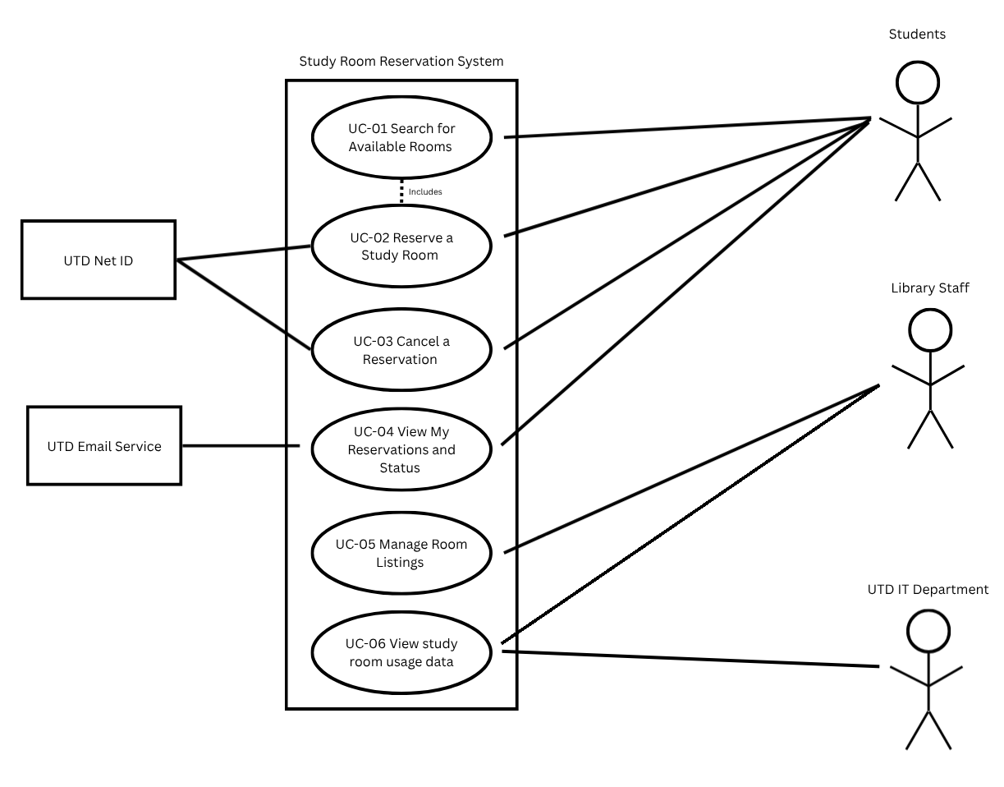
Actors: Student and Library staff (administrator); supporting actor: UTD email service. System boundary as in 2.1.
UC-01 Search for Available Rooms
UC-02 Reserve a Study Room
UC-03 Cancel a Reservation
UC-04 View My Reservations and Status
UC-05 Manage Room Listings
UC-06 View study room usage data

Signing in is a precondition of UC-02 to UC-05, not a use case on its own: it is a step toward a goal, not a goal.

Expanded use case — copy this block for each of your two
Field | Content
Identifier and name | UC-02 Reserve a Study Room
Primary actor | Student
Supporting actors | None confirmed; email service
Preconditions — what must be true before it starts | The student is identified by the system, and an available study room and time slot exist
Trigger — what starts it | The student selects an available room and chooses to reserve it
Main success scenario — numbered steps | - The student selects an available study room  - The system displays available time slots  - The student selects a time slot  - The student submits the reservation request  - The system checks for conflicting reservations.  - The system records the reservation  - The system displays confirmation to the student
Alternative and exception flows | 3a. If the selected time slot is unavailable, the system rejects the request and asks the student to select another slot.  4a. If the student’s identity cannot be confirmed, the system prevents the reservation.  6a. If the reservation cannot be saved, the system reports the failure without confirming the booking
Postconditions — what is true when it succeeds | The reservation is recorded, and the selected room and time slot are no longer available for overlapping reservations.
Requirements realized | FR- 07, FR-08, FR-09

Expanded use case — copy this block for each of your two
Field | Content
Identifier and name | UC-05 Manage Room Listings
Primary actor | Library Staff (Administrator)
Supporting actors | None confirmed
Preconditions — what must be true before it starts | The library staff member is signed in with administrator permissions. The system has access to the current room listings.
Trigger — what starts it | The library staff member chooses to manage the study room listings.
Main success scenario — numbered steps | 1. The administrator opens the room management section.  2. The system displays the current study room listings.  3. The administrator selects a room to update.  4. The system displays the room's current information.  5. The administrator modifies the room's information, such as location or capacity.  6. The administrator submits the changes.  7. The system validates the updated information.  8. The system saves the changes and displays confirmation.
Alternative and exception flows | 1a. If the administrator enters invalid room for information, the system rejects the changes and requests corrections.  7a. If the changes would conflict with existing reservations, the system rejects the update and informs the administrator.  7b. If the administrator does not have the required permissions, the system denies access.  8a. If the changes cannot be saved, the system displays an error and keeps the previous room information unchanged.
Postconditions — what is true when it succeeds | The updated room location or capacity is saved in the system and displayed in the room listings. Existing reservations remain unchanged.
Requirements realized | FR-01, FR-02, FR-03, FR-12

3.5 Requirements to use case traceability
The extended traceability matrix is provided in section 9.1 and it connects the functional requirements, quality requirements, and constraints to the use cases, analysis classes, architectural components, and supporting evidence.

4 Use-Case Analysis
Chapter 7, first half. Here you take the use cases from section 3.4 and write the most important of them out turn by turn, still with the technology switched off.

4.1 Use cases selected for analysis
Use case | Name | Why it was selected | Non-trivial steps
UC-02 | UC-02 Reserve a study room | One of the 2 we specified at P1 | Selecting a room and time slot, checking for existing reservations, validating the reservation request, recording the reservation, displaying confirmation
UC-05 | UC-05 Manage Room Listings | One of the 2 we specified at P1 | Selecting a room, modifying room information, validate changes, checking for conflicts, updating saved information
UC-01 | UC-01 Search for available rooms | This was selected because being able to find an available study room is one of the main purposes of the system. Students need to be able to search for rooms without any errors | Entering search criteria, checking for availability, filtering rooms by capacity, displaying results

GUIDANCE: DELETE THIS BOX BEFORE SUBMITTING
Analyze at least three use cases, including the two you specified in full at P1. We recommend that one of them involves an external system or a failure that the actor can see.
Choose by risk and value, not by ease: the use case that carries most of the product, the one that touches most of your quality requirements, the one you are least sure you can build.
Budget: a quarter of a page.

4.2 Expanded use cases
Copy the block below once for each use case in 4.1.

UC-01 [Search for Available rooms]
Primary actor | Student
Supporting actors and external systems | None
TUCBW (this use case begins when) | The student wants to find an available study room for a specific date, time and minimum room capacity
TUCEW (this use case ends when) | The system displays the study rooms that match the student’s search criteria
Preconditions | Study room listings are available in the system  The student has access to the study room reservation system
Postconditions | Matching study rooms and their availability are displayed  No reservation is created with this use case
Traces to requirements | FR-01, FR-02, FR-03, FR-04, FR-05, FR-06, FR-07, QR-01

UC-02 [Reserve a study room]
Primary actor | Student
Supporting actors and external systems | UTD email service
TUCBW (this use case begins when) | The student selects an available study room and wants to reserve a specific date and slot
TUCEW (this use case ends when) | The system records the reservation, marks the time slot as unavailable, displays a reservation confirmation, and sends a confirmation email to the user
Preconditions | The student is identified by the system  The student selects an available study room  The selected reservation time does not conflict with other
Postconditions | The reservation is recorded by the system  The selected time slot is now unavailable for other reservations  A reservation confirmation is displayed and sent to the student
Traces to requirements | FR-07, FR-08, FR-09, QR-02, QR-03, CON-01, CON-02

UC-05 [Manage room listings]
Primary actor | Staff
Supporting actors and external systems | None
TUCBW (this use case begins when) | A library staff member wants to update the information of existing study rooms
TUCEW (this use case ends when) | The system successfully saves the updated room information and displays confirmation that the room listing was updated
Preconditions | The staff member has been identified by the system  The staff member has administrative permissions  The existing study room listings are available in the system
Postconditions | The updated room location or capacity is saved  The updated information is shown in the room listings  Existing reservations are unchanged unless needed to
Traces to requirements | FR-01, FR-02, FR-03, FR-12, CON-01, CON-02

UC-01 [Search for Available rooms]
Actor input / action | System response
 | (0) The system displays the available room search options
(1) The student enters the desired reservation date and time | (2) System accepts the selected date and time
(3) The student enters the minimum room capacity needed | (4) The system accepts the minimum capacity
(5) The student submits the search request | (6) The system searches for rooms matching the date, time, and capacity.  (7) The system displays matching rooms with their locations, capacities, and available time slots.

Alternate flow | At step | Condition | What happens | Ends or rejoins at
A1 | 7 | The student enters incomplete or invalid search criteria | The system tells the student that the search criteria is wrong | Rejoins at step 1
A2 | 8 | No rooms match the search criteria | The system informs the student that no rooms are available | Ends
A3 | 8 | Some rooms do not meet the minimum capacity | The system excludes those rooms from the search results | Rejoins at step 9

UC-02 [Reserve a study room]
Actor input / action | System response
 | (0) The system displays available study rooms and time slots
(1) The student selects a study room and an available time slot | (2) The system displays the selected room, date and time for review
(3) The student confirms the reservation request | (4) The system checks whether the selected time slot is available or not
 | (5) The system records the reservation and marks the selected time slot as unavailable
(8)The student reviews the reservation confirmation | (6) The system displays a confirmation  (7) The system sends a confirmation email to the student

Alternate flow | At step | Condition | What happens | Ends or rejoins at
A1 | 4 | Another student has already reserved the selected time | The system rejects the request and tells the student that the time is not available | Ends
A2 | 5 | The system cannot save the reservation | The system informs the student that the reservation can’t be completed | Ends
A3 | 7 | The confirmation email can’t be sent | The system informs the student that the reservation was recorded but the confirmation email can’t be sent | Ends

UC-05 [Manage room listings]
Actor input / action | System response
 | (0) The system displays the room management options
(1) The staff member selects the option to manage room listings | (2) The system displays the current list of study rooms
(3) The staff member selects a room to update | (4) The system displays the selected rooms current location and capacity
(5) The staff member enters the updated room location or capacity | (6) The system accepts the updated information
(7) The staff member submits the changes | (8) The system validates the update room information and saves the changes.

Alternate flow | At step | Condition | What happens | Ends or rejoins at
A1 | 1 | The staff member does not have administrator permissions | The system denies access to room management options | Ends
A2 | 8 | Updated information is invalid or incomplete | The system informs the staff member that the information must be corrected | Rejoins at step 5
A3 | 8 | The updated room information conflicts with existing reservations | The system informs the staff member that the changes cannot be completed because of the conflict | Ends
A4 | 9 | The system cannot save the changes | The system informs the staff that the update failed and the room keeps its original information | Ends

GUIDANCE: DELETE THIS BOX BEFORE SUBMITTING
The rules from Lesson 13, all of which are checked:
Step (0) is what the actor sees before touching anything. It is often skipped, and it is where many missing requirements are found.
One turn per row. An actor action on the left, the system response on the right. Two steps merged into one row become a missing message on your sequence diagram in section 5.
End with an acknowledgment the actor can perceive. No acknowledgment, no TUCEW, no use case.
No background processing. If the actor neither sees it nor waits for it, it belongs to another use case.
Precondition or alternate flow? If it can be false while the system works normally, it is a flow you must handle, not an assumption.
No technology yet. No screen widgets, no database, no framework names. "Taps the green button" and "queries the PostgreSQL table" both fail the analysis check.
Every item the actor column names should already be an attribute in your domain model (5.1). Where it is not, you have found one.
Budget: about one page per use case.

EXAMPLE (COMETPARK): DELETE BEFORE SUBMITTING
UC-02 Find an Open Space · Primary actor: Driver · External system: Lot Sensor Network · TUCBW the driver asks for parking near a destination building · TUCEW the driver sees the recommended lot with its number of open spaces.
(0) The system shows the campus lots with the time of the latest occupancy update. (1) The driver chooses a destination building and permit type. (2) The system shows the three nearest lots the permit allows, each with open spaces and walking time. (3) The driver selects a lot. (4) The system shows the lot entrance and confirms the count is no older than 60 seconds.
A1 at step (2): no permitted lot has an open space · the system shows the nearest lot with expected turnover and the visitor option · ends.

4.3 Self-review log
Use case | Check from the Lesson 13 review checklist | Defect found | How it was fixed
UC-01 | Verified that the use case has a clear trigger, preconditions, postconditions, and a complete sequence of actor-system interactions | The initial description did not clearly explain what happens when no rooms match the student’s search criteria | Added an alternative flow explaining that the system informs the student when no matching rooms are available
UC-02 | Checked that the use case shows a clear confirmation and explains what happens when something goes wrong | The initial description did not explicitly address what would happen if two students try and reserve the same room and time slot | Added an alternative flow explaining that the system rejects a reservation if another student has already reserved the spot
UC-05 | Verified that the primary actor is clearly identified, preconditions are defined, and alternative flows cover invalid information | The initial description did not explain what happens if updated room information conflicts with existing reservations | Added an alternative flow explaining that the system rejects changes that conflict with existing reservations

GUIDANCE: DELETE THIS BOX BEFORE SUBMITTING
Run the review checklist from Lesson 13 on each expanded use case before anyone draws a diagram, and record what each check found, including any defects you fixed. Report honestly; a clean result is acceptable when it is true. Budget: a quarter of a page.

5 Analysis Models
Chapter 7, second half. What has to exist inside the system for the use cases in section 4 to happen, and how those parts talk to each other.

5.1 Domain model
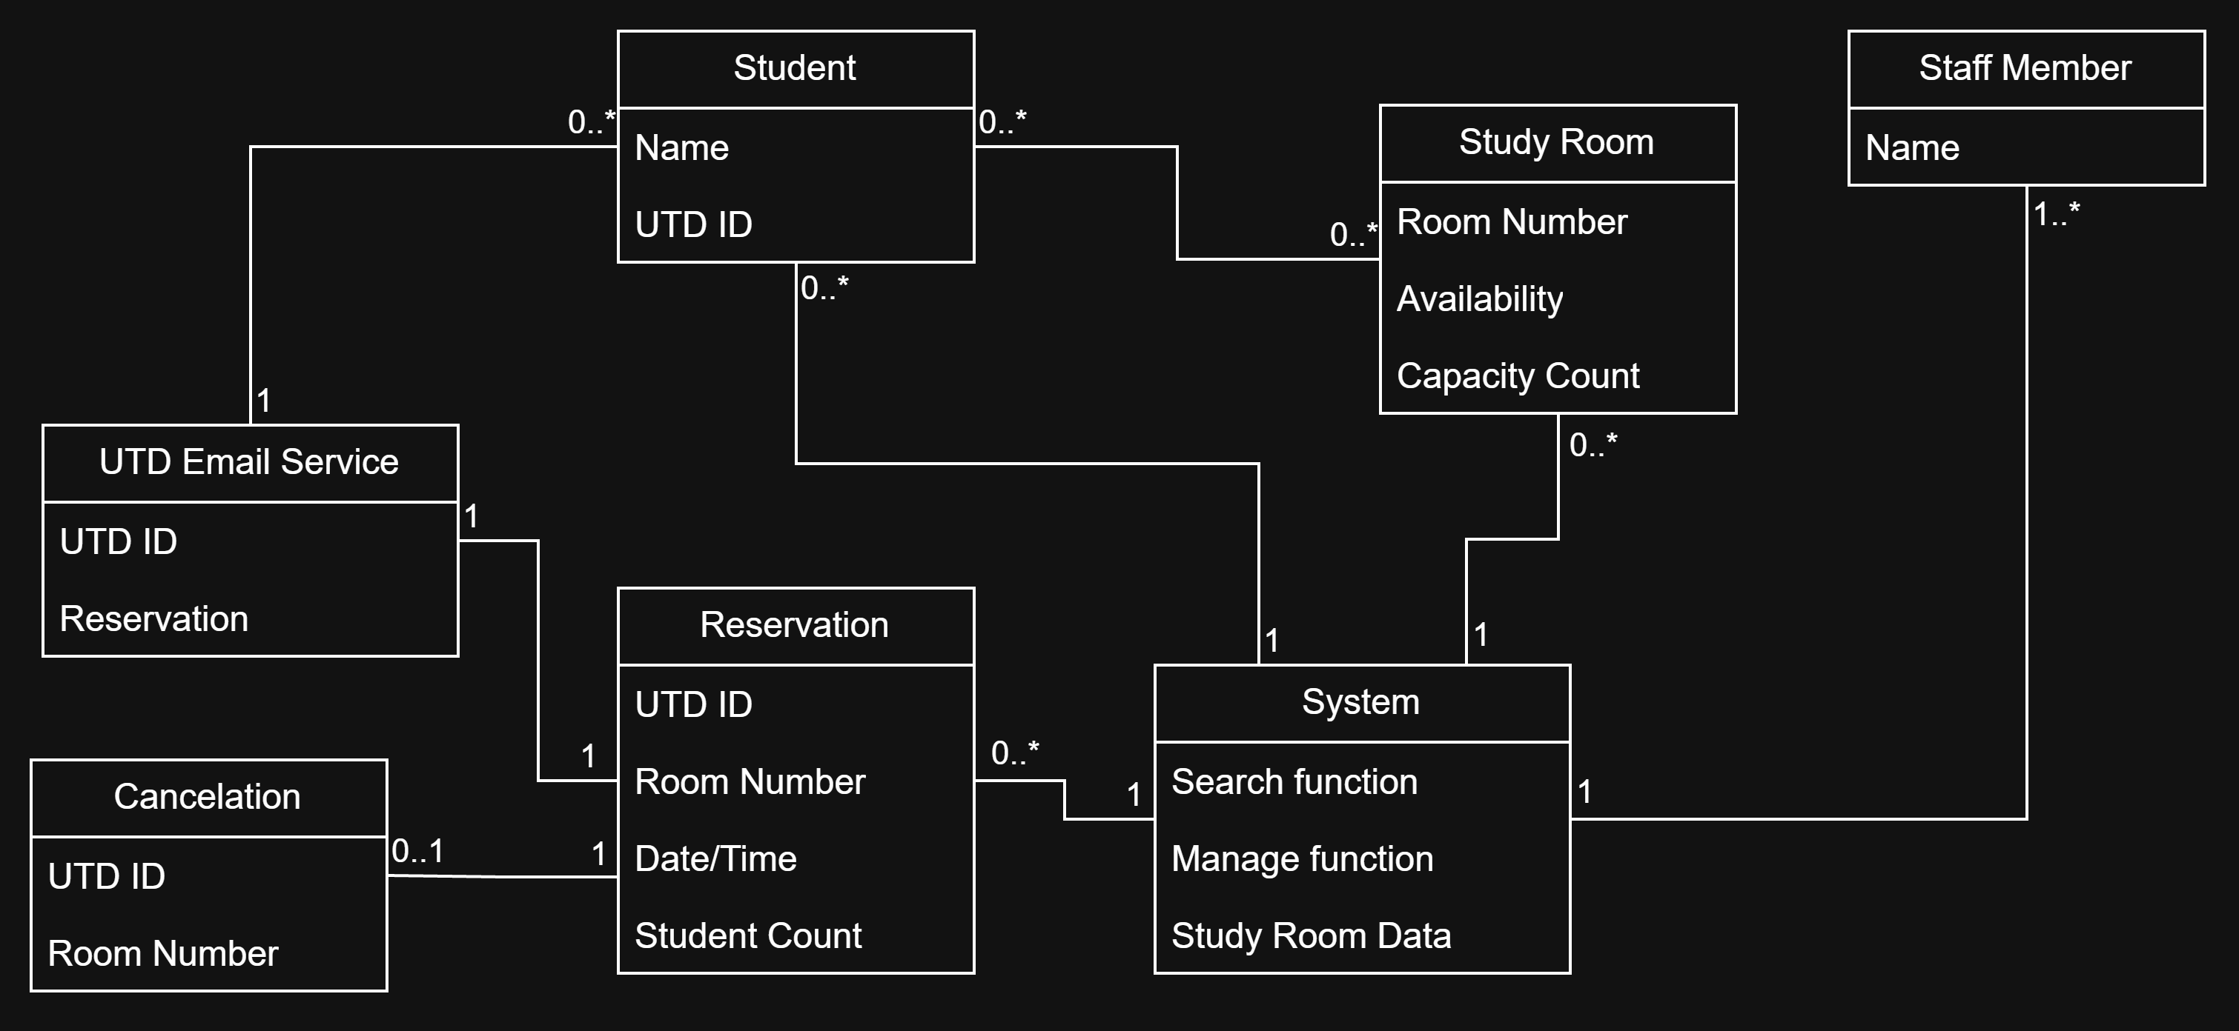
Figure 5.1 Domain model (conceptual classes, attributes, associations with multiplicities)
Class | What it represents (one line) | Key attributes | Associations (with multiplicity)
Student | Person making a reservation | Name, UTD ID | 0..*
Staff Member | Person managing the reservations | Name | 1..*
Study Room | Room being reserved by a student | Room Number, Availability, Capacity Count | 0..*
Reservation | Details of a reservation by a student | UTD ID, Room Number, Date/Time, Student Count | 0..*
System | System controlling the reservations | Search function, Manage function, Study Room Data | 1
Cancelation | Canceled reservation | UTD ID, Room Number | 0..1
UTD Email Service | Email service provided by UTD | UTD ID, Reservation | 1

GUIDANCE: DELETE THIS BOX BEFORE SUBMITTING
Conceptual classes only: things and records from the problem domain, with attributes and associations. No operations, no data types, no database tables, no screen classes.
Every item the actor column of section 4.2 mentions is an attribute somewhere in this model. Every association has a multiplicity at both ends.
Budget: one page including the diagram.

EXAMPLE (COMETPARK): DELETE BEFORE SUBMITTING
Lot (name, zone, capacity) 1 ── 0..* Space (number, type) ; Space 1 ── 0..* OccupancyReading (time, state) ; Permit (type, valid until) * ── 1..* Lot "is valid in" ; Building (name) * ── * Lot "is near" (walking time).

5.2 Object interaction models
Copy the block below for at least two of the use cases in 4.1; preferably including your riskiest.

5.2.1 UC-01 [Search for Available Rooms]
(a) Steps 1-7 require objects inside the system. The other steps only display values that already exist.
(b) Scenario table.
Step | Subject (who acts) | Subject action (what it does) | Other data / objects (what is used) | Object acted upon (who receives)
1 | Student | Inputs the desired date and time | Date, time | System
2 | System | Save date and time | Search bar | System
3 | Student | Inputs the student count | Student count | System
4 | System | Save that many students | Search bar | System
5 | Student | Submits search request | Search criteria, available study rooms | System
6 | System | Filter through to find available rooms | Search function, room number | Study Room
7 | System | Return available study rooms |  | Student

(c) Analysis sequence diagram.
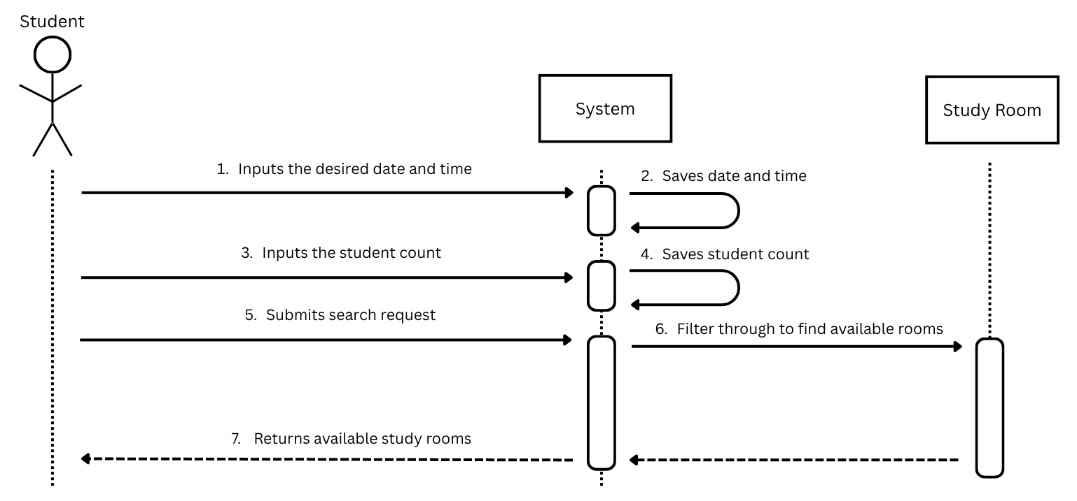
Figure 5.2.1 Analysis sequence diagram for UC-01

5.2.2 UC-05 [Manage Room Listings]
(a) Steps 1-8 require objects inside the system. The other steps only display values that already exist.
(b) Scenario table.
Step | Subject (who acts) | Subject action (what it does) | Other data / objects (what is used) | Object acted upon (who receives)
1 | Staff member | Selects option to manage room listings | Manage function | System
2 | System | Fetches the current list of study rooms | Reserved study rooms | Study Room
3 | System | Returns list of study rooms | Study room list | Staff member
4 | Staff member | Selects a room to update | Reserved study rooms | System
5 | System | Fetches selected room data | Room number, availability, capacity count | Study Room
6 | System | Returns selected room data | Room number, availability, capacity count | Staff member
7 | Staff member | Updates room data | Room Number and/or Availability and/or Capacity Count | System
8 | System | Accepts the information | Room Number and/or Availability and/or Capacity Count | System
9 | Staff member | Submits the changes | Manage function | System
10 | System | Validates and saves changes | Reservation | Study Room

(c) Analysis sequence diagram.
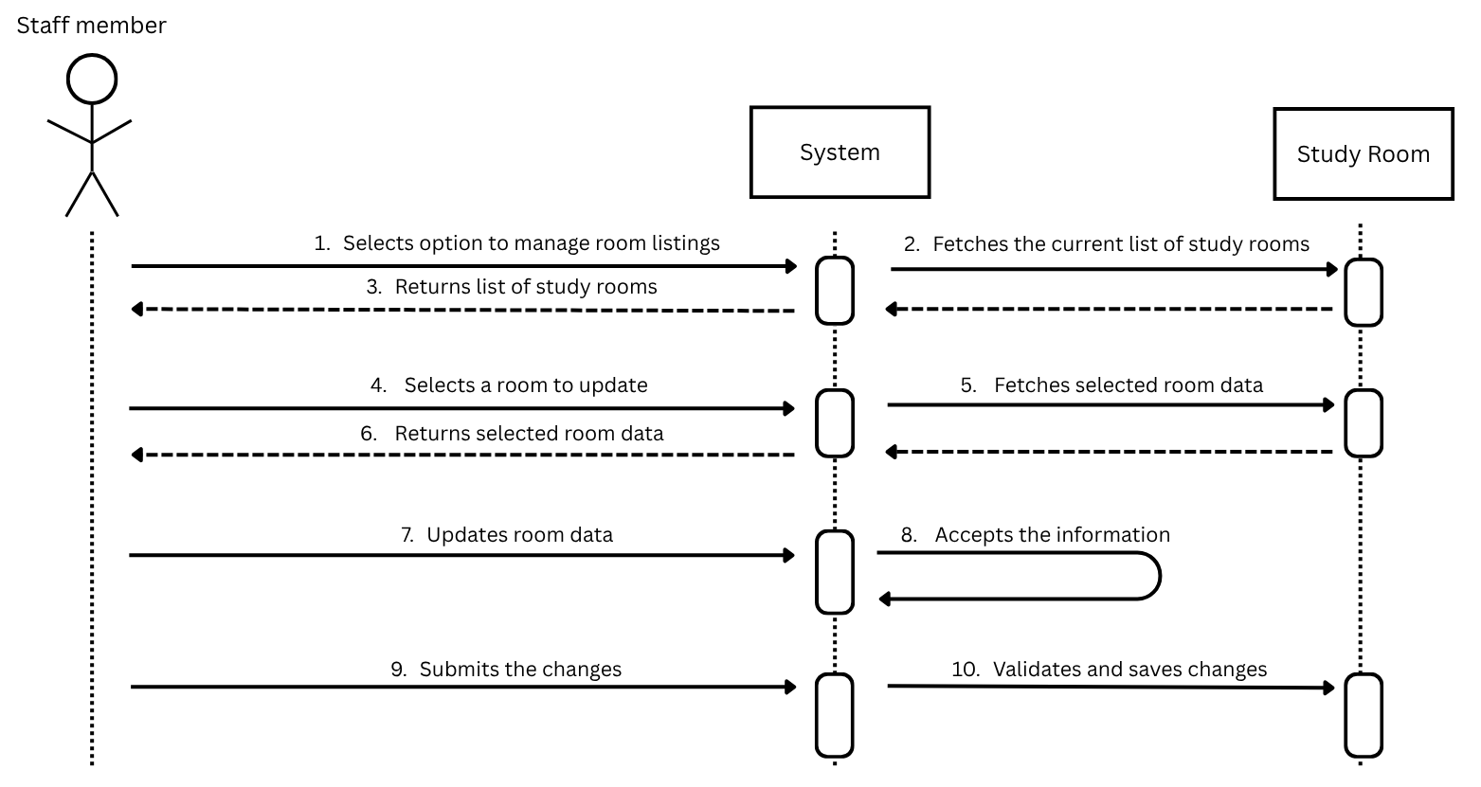
Figure 5.2.2 Analysis sequence diagram for UC-05
GUIDANCE: DELETE THIS BOX BEFORE SUBMITTING
Write each step as a declarative sentence first, subject, verb, object, then fill the columns. Tables filled directly produce rows with no subject.
One message per table row, same numbers. Use the four translation cases from Lesson 14; the diagram is a conversion of the table, not a new drawing.
Messages are verb phrases, not operation signatures. "asks for the routes calling at the stop" is analysis; "getRoutes(stopId: int): List<Route>" is Chapter 9 and is not credited here.
Every object on the diagram is a class in 5.1 or an interaction object you name and explain in one line. One object is clearly in control of the interaction.
Budget: one to one and a half pages per use case.

EXAMPLE (COMETPARK): DELETE BEFORE SUBMITTING
Step 2 · Subject: LotFinder · Action: asks for the lots the permit allows · Data: permit type, destination · Object acted upon: PermitRules.

5.3 Consistency cross-check
Check | Result (pass, or what failed) | Fixed in
K1 Every item in an actor column (4.2) is an attribute in the domain model (5.1) | Pass
K2 Every object on a sequence diagram is a domain class or a declared interaction object | Pass
K3 Every message on a sequence diagram corresponds to exactly one scenario-table row | Pass
K4 Every non-trivial step in 5.2 (a) has at least one scenario-table row | Pass
K5 Every analyzed use case traces to at least one functional requirement | Pass
K6 The last messages of each diagram make the use case postcondition true | Pass

GUIDANCE: DELETE THIS BOX BEFORE SUBMITTING
Run the six checks across the work of different authors; they are designed to catch the seams between people. A failed check that you found and fixed is more convincing than a column of passes. Budget: a quarter of a page.

6 High-Level Design (Architecture)
Chapter 8. The rule now reverses: a high-level design that does not say where things run, what they are built from and what that choice cost has not been done.

6.1 Architectural drivers: quality-attribute scenarios
QAS | Quality attribute | Stimulus | Artifact | Response | Response measure | From
QAS-01 | Performance | Up to 25 concurrent users submit room searches against a catalogue of 50 rooms | Search Controller, Room Catalogue, Reservation Repository | Return matching rooms and time slots without making the student wait excessively | At least 95% of 200 searches complete within 2 seconds | QR-01; UC-01
QAS-02 | Concurrency | 20 students attempt to reserve the same room and time slot simultaneously | Reservation Service and Reservation Database | Exactly one reservation is committed; all other requests are rejected without duplicate bookings | In each of the 100 repeated runs, 1 confirmed reservation and 19 rejected requests | QR-02;  UC-02;  R4
QAS-03 | Usability | A first-time student uses a phone-size screen to find and reserve a room | Web UI and reservation workflow | The student completes the task without assistance using clear search and confirmation steps. | At least 80% of at least 5 first-time testers complete within 3 minutes on a 360-pixel-wide screen | QR-03;  UC-01;  UC-02

GUIDANCE: DELETE THIS BOX BEFORE SUBMITTING
At least three scenarios, preferably covering more than one quality attribute (for example performance, availability, security, modifiability, usability). Derive them from your P1 quality requirements and say which.
The response measure is the part teams leave out, and it is the only part that lets anyone tell whether the architecture worked. A scenario without a number is an opinion.
Below the table, list in two or three lines the constraints (CON IDs) that shape the architecture.
Budget: half a page.

EXAMPLE (COMETPARK): DELETE BEFORE SUBMITTING
QAS-01 · Performance · Stimulus: 400 drivers request lot status during the 7:45 to 8:15 AM peak · Artifact: the occupancy service · Response: returns current open-space counts · Measure: within 2 s for 95% of requests · From QR-02.

6.2 Architectural style and alternatives
Style considered | Drivers it serves | What it costs | Verdict
Layered three-tier web application (presentation, application/domain, data) | Clear separation of UI, reservation rules, catalogue/reporting logic, and persistence; supports QR-01/QR-02 and straightforward deployment. | Requires disciplined interfaces between layers; a single application deployment limits independent scaling. | Chosen
Microservices | Independent scaling and deployment of search, reservation, reporting, and notification functions. | More deployment, network, monitoring, and consistency complexity than this course project needs; cross-service reservation integrity is harder. | Rejected
Event-driven architecture | Loose coupling for notifications and asynchronous work. | Add broker/event delivery and eventual-consistency concerns; unnecessary for the small core reservation workflow. | Rejected

GUIDANCE: DELETE THIS BOX BEFORE SUBMITTING
Name the style (or combination) you chose and at least two you rejected, using the vocabulary from Lessons 15 and 16: layered (N-tier), client-server, repository, model-view-controller, pipe-and-filter, event-driven, service-oriented or microservices.
One paragraph below the table explains the choice in terms of the scenarios in 6.1. "We are most comfortable with it" is not a driver. ADR-01 in section 7 records this decision formally.
Budget: half a page.

6.3 Component view
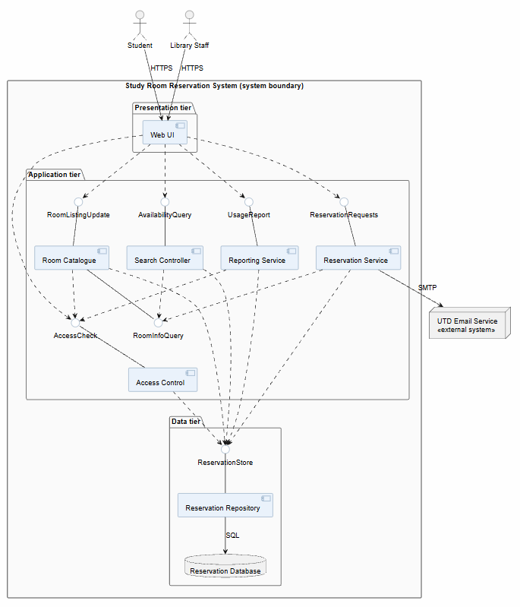
Figure 6.3 Component diagram: components, provided and required interfaces, external systems

Component | Responsibility (one sentence) | Provides | Requires | Answers to (UC / QAS / ADR)
Web UI | Phone-friendly pages for students and staff. | HTTPS pages | AccessCheck, AvailabilityQuery, ReservationRequests, RoomListingUpdate, UsageReport | UC-01–UC-06, QAS-03, ADR-01
Access Control | Signs users in and checks the staff role. | AccessCheck | ReservationStore | UC-02–UC-06 (sign-in precondition), UC-05
Search Controller | Finds rooms free for a date, time and capacity. | AvailabilityQuery | RoomInfoQuery, ReservationStore | UC-01, QAS-01
Room Catalogue | Keeps room details and applies staff edits that don’t conflict with existing bookings. | RoomInfoQuery, RoomListingUpdate | AccessCheck, ReservationStore | UC-01, UC-05, QAS-01
Reservation Service | Validates, creates, cancels and lists reservations, and emails a confirmation. | ReservationRequests | RoomInfoQuery, ReservationStore, SMTP | UC-02–UC-04, QAS-02
Reporting Service | Summarizes room usage for a date range. | UsageReport | AccessCheck, ReservationStore | UC-06
Reservation Repository | Does all database access and commits each booking in a single transaction. | ReservationStore | SQL | QAS-01, QAS-02
Reservation Database | Stores rooms, reservations and users on UTD servers; a unique constraint is the final guard against double bookings. | SQL | none | QAS-02, ADR-01
UTD Email Service (external) | Delivers confirmation emails. | SMTP | none | UC-02 (supporting actor)

GUIDANCE: DELETE THIS BOX BEFORE SUBMITTING
Point at any box and say which use case, which quality scenario or which decision put it there. A box with no answer cannot be credited.
Show external systems outside the boundary. Name interfaces by what they offer ("OccupancyQuery"), not by operation signatures, which are Chapter 9.
Budget: one page including the diagram.

6.4 Deployment view
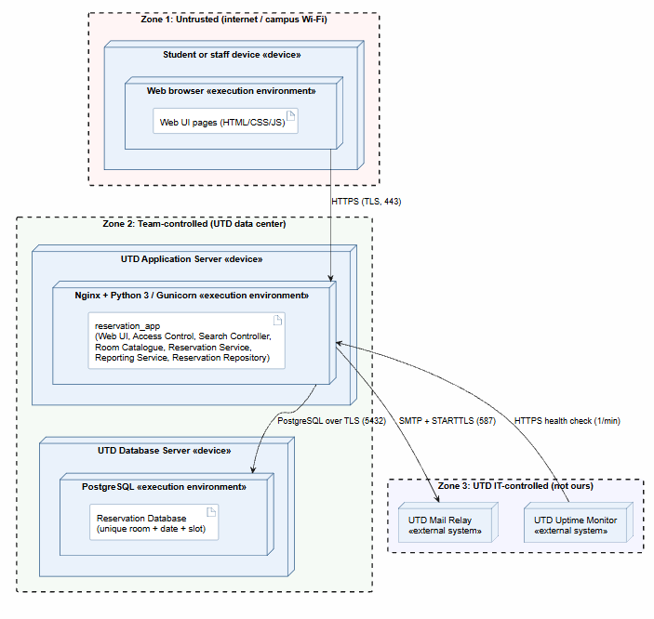
Figure 6.4 UML deployment diagram: nodes, execution environments, deployed artifacts, communication paths with protocols, trust boundaries
Node | What runs on it (artifacts, components) | Communicates with (protocol) | Trust zone
Student or staff device (web browser) | Web UI pages (HTML/CSS/JS) served by the app | UTD Application Server (HTTPS, TLS, port 443) | Zone 1: untrusted
UTD Application Server (Nginx + Python 3 / Gunicorn) | reservation_app: Web UI, Access Control, Search Controller, Room Catalogue, Reservation Service, Reporting Service, Reservation Repository | Browser (HTTPS 443); Database Server (PostgreSQL over TLS, 5432); UTD Mail Relay (SMTP + STARTTLS, 587) | Zone 2: team-controlled
UTD Database Server (PostgreSQL) | Reservation Database, with a unique constraint on room + date + slot | Application Server only (PostgreSQL over TLS, 5432) | Zone 2: team-controlled
UTD Mail Relay | UTD Email Service (external) | Application Server (SMTP + STARTTLS, 587) | Zone 3: UTD IT
UTD Uptime Monitor | External monitor that checks the home page every minute (QR-04) | Application Server (HTTPS health check) | Zone 3: UTD IT

GUIDANCE: DELETE THIS BOX BEFORE SUBMITTING
Every component in 6.3 is deployed somewhere in 6.4. Every communication path names its protocol. Mark the trust boundaries: where data crosses from a zone you control into one you do not.
If you use a cloud service, say which responsibilities stay with your team under the shared-responsibility model.
Budget: one page including the diagram.

6.5 From analysis to architecture
Analysis object (from 5.1 and 5.2) | Component that owns it (6.3) | Note (split, merged, external)
Student; Staff Member | Application Services (identity/role context) | Identity and role data are checked by the application; no separate identity integration is assumed in P2
Study Room; Room Listing Update | Room Catalogue | Room and listing-update concepts have persisted through the Reservation Database
Reservation; Availability Slot | Reservation Database | The database owns persistent reservation and slot state; Application Services applies reservation rules before committing (intentional split between behavior and persistence)

GUIDANCE: DELETE THIS BOX BEFORE SUBMITTING
Every class and interaction object from section 5 lands in exactly one component, or the note says why it was split, merged or left to an external system. This table is how the reader sees that the architecture realizes the analysis rather than replacing it. Budget: a quarter of a page.

6.6 Design principles applied
Principle | Where it shows in your design | Evidence (component, interface, ADR)
Separation of concerns | Presentation, application/domain logic, and persistence are separate layers | Web UI, Application Services, Reservation Database; ADR-01
Information hiding | The UI and application services use catalogue and persistence interfaces rather than database details | Room Catalogue and Reservation Database interfaces; ADR-01
Low coupling | Email delivery is isolated behind the Notification Adapter and cannot reverse a committed reservation. | Notification Adapter; ADR-03
High cohesion | Reservation validation and conflict handling are kept in Application Services and the reservation persistence boundary. | Application Services + Reservation Database; ADR-02
Design for change | The email provider and database implementation are accessed through defined interfaces; actual UTD deployment remains a constraint. | Notification Adapter and persistence interface; ADR-03
Keep it simple (KISS) | A layered application is used instead of separate microservices or a message broker. | Section 6.2; ADR-01

GUIDANCE: DELETE THIS BOX BEFORE SUBMITTING
One line per principle, pointing at something concrete. A principle you cannot point at in your own design should be left blank and explained in one sentence, not filled with a definition from the slides. Budget: a third of a page.

7 Design Rationale

7.1 Architecture decision records
At least three. ADR-01 records the style decision from 6.2. Use the format you practiced in the Lesson 16 workshop, written about your own project. Copy the block for each decision.

ADR-01 [Use a layered three-tier Architecture]
Status | Accepted
Date and owner | 11/8/2026 – Team 07
Context (drivers) | The system needs to separate the user interface, reservation logic and data storage. QAS -01 requires fast room searches, QAS-02 requires reliable reservation handling, and QAS-03 requires making the reservation system easy for students to understand.
Options considered | - Layered three-tier web application  - Microservices architecture which splits the system into smaller services that can run independently  - Event driven architecture: uses events to let different parts of the system to communicate with one another
Decision | Layered three-tier web application architecture
Consequences | The decision makes it easier to organize, understand and update. The downside is that the system will run on one main application, so individual parts cannot be scaled separately
Evidence | Section 6.2 compares the three architectural styles.
Related | QAS-01, QAS-0-2, QAS-03, CON-01, CON-02

ADR-02 [Use Database transactions to prevent overlapping reservations]
Status | Accepted
Date and owner | 11/8/2026 – Team 07
Context (drivers) | Multiple students could try and reserve the same room and time slot at the same time. The system must prevent duplicate reservations and satisfy QR-02, which needs one successful reservation out of 20 simultaneous attempts.
Options considered | - Check room availability in the application before saving a reservation  - Use database transactions to coordinate reservation attempts and prevent conflicting bookings
Decision | Use database transactions to handle the reservation creation and prevent any overlap. The database will enforce consistency when multiple requests are made at the same time
Consequences | This decision will prevent double bookings and keep the reservation data accurate. The downside of that is that saving reservations would be more complicated and students would be rejected if someone books the room first
Evidence | Architecture spike S-01 tested 20 simultaneous reservation attempts across 100 trials using Python and SQLite. All 100 trials passed.
Related | QR-02, FR-08, FR-09, UC-02, S-01, CON-01

ADR-03 [Separate Email notifications from reservation processing]
Status | Accepted
Date and owner | 11/8/2026 – Team 07
Context (drivers) | The system must send confirmation emails when a reservation activity happens. Email delivery depends on UTD email service which is out of the systems control. The architecture should allow a reservation to process even if a email delivery fails
Options considered | - Have the reservation service communicate directly with the UTD email service  - Use a separate notification adapter to handle communication with UTD email service
Decision | Use a separate notification adapter to handle email communication between the system and the UTD email service
Consequences | This decision makes it easier to update the email service without having to change the reservation system. The downside is that the system will have another component that it has to maintain
Evidence | Section 6.6 identifies the Notification adapter as the component that is responsible for isolating email delivery. No separate email integration spike is done yet
Related | UC-02, UC-03, CON-01, CON-02

GUIDANCE: DELETE THIS BOX BEFORE SUBMITTING
A decision without a cost is a preference. If you cannot say what you gave up, you have not finished the record.
Options must be real alternatives the team discussed, not a straw man added to fill the row.
Budget: about a third of a page per ADR.

EXAMPLE (COMETPARK): DELETE BEFORE SUBMITTING
ADR-02 · Push occupancy changes to clients rather than polling · Context: QAS-01, CON-02 (campus Wi-Fi limits) · Options: client polling every 10 s; server push over a persistent connection · Decision: server push · Consequences: favors performance and freshness; costs connection management on the occupancy service and a fallback when push fails (A2 in UC-02) · Evidence: spike S-01.

7.2 Trade-off summary
Quality favored | Architectural move | Cost accepted | Recorded in
Simplicity, maintainability, cohesion | Layered three-tier application rather than microservices or event-driven services | No independent deployment or scaling of individual services | ADR-01
Integrity and concurrency correctness | Atomic transaction and persistence-level conflict protection | Transaction contention and database-specific implementation work | ADR-02
Availability and loose coupling | Best-effort email through Notification Adapter after reservation commit | Email may be delayed or undelivered even when reservation succeeds | ADR-03

GUIDANCE: DELETE THIS BOX BEFORE SUBMITTING
One row per real trade-off. This is the table a reviewer reads first. Budget: a quarter of a page.

8 Prototype Evidence: Architecture Spike
Spike ID and title | S-01 - Concurrent Reservation Conflict Prevention
Risk or decision it addresses | The Study Room Reservation System must prevent multiple students from successfully reserving the same room during the same time slot, even when reservation requests occur concurrently. This spike evaluates the feasibility of using database transactions to ensure reservation consistency.
Question (answerable yes or no) | Can a transaction-based reservation mechanism ensure that exactly one of 20 simultaneous reservation attempts succeed while the remaining 19 are rejected?
Set-up | A standalone prototype was developed using Python 3.14 and SQLite. The program simulated 20 concurrent students attempting to reserve the same study room for the same time slot. SQLite transactions were used to coordinate reservation operations and prevent conflicting reservations. The experiment was repeated for 100 independent trials.
How it was measured | Each trial recorded the number of successful reservations, rejected requests, database errors, stored reservations, and total execution time. Results were exported to results.csv.
Result (numbers) | 100/100 trials passed (2,000 total reservation attempts). Exactly 100 reservations succeeded, and 1,900 conflicting requests were rejected. There were 0 database errors and 0 double-bookings. Every trial stored exactly one reservation. Mean trial duration: 146.86 ms. Maximum trial duration: 288.33 ms.
What it changed or confirmed | The spike confirmed that transaction-based reservation handling prevented double-booking in all 100 local trials, satisfying the concurrency-correctness outcome of QR-02 and supporting FR-09 and UC-02. It supports enforcing reservation conflicts at the database transaction level rather than relying only on application-level availability checks. The final architecture should retain this protection, with additional integration testing during P3.
Where to see it | Source code, execution instructions, and experimental results are available in the GitHub repository under /spikes/S-01/. Files include reservation_spike.py, README.md, and results.csv. Commit: 8fac0da. Pull Request: #1.

GUIDANCE: DELETE THIS BOX BEFORE SUBMITTING
Build the smallest thing that answers your riskiest architectural question, run it, and measure it. Time-box it to a few hours. It may be thrown away afterwards; it is not the product.
Good spikes answer questions such as: can we read the external data source, and is it fresh to within 60 seconds? Does the chosen hosting meet QAS-01 under a simulated peak? Does the authentication provider fit our trust boundary?
Never commit passwords, API keys or other credentials; keep them in local configuration excluded from the repository.
The code, the measurement and a short README are committed to /spikes before the deadline. A spike described but not in the repository is not evidence.
Budget: half a page.

9 Traceability

9.1 Extended traceability matrix
Requirement | Use case | Analysis classes | Component(s) | QAS / ADR | Evidence
FR-01 | UC-01, UC-05 | Study Room | Room Catalogue | QAS-01 | UC-01, UC-05; §6.3
FR-02 | UC-01, UC-05 | Study Room | Room Catalogue | QAS-01 | UC-01, UC-05; §6.3
FR-03 | UC-01, UC-05 | Study Room | Room Catalogue | QAS-01 | UC-01, UC-05; §6.3
FR-04 | UC-01 | Study Room, Reservation | Search Controller; Reservation Repository | QAS-01 | UC-01; §6.3
FR-05 | UC-01 | Study Room, Reservation | Search Controller; Reservation Repository | QAS-01 | UC-01; §6.3
FR-06 | UC-01 | Study Room | Search Controller; Web UI | QAS-01, QAS-03 | UC-01; §6.3
FR-07 | UC-01, UC-02 | Study Room, Reservation | Search Controller; Reservation Service | QAS-01, QAS-02 | UC-01, UC-02; §6.3
FR-08 | UC-02 | Student, Reservation, Study Room | Reservation Service; Reservation Repository | QAS-02, ADR-02 | UC-02; S-01
FR-09 | UC-02 | Reservation, Study Room | Reservation Service; Reservation Repository; Reservation Database | QAS-02, ADR-02 | S-01; 8fac0da
FR-10 | UC-03 | Student, Reservation | Reservation Service; Reservation Repository | ADR-02 | UC-03; §6.3
FR-11 | UC-04 | Student, Reservation | Reservation Service; Reservation Repository | ADR-01 | UC-04; §6.3
FR-12 | UC-05 | Staff Member, Study Room | Room Catalogue; Access Control | ADR-01 | UC-05; §6.3
FR-13 | UC-06 | Study Room, Reservation | Reporting Service; Reservation Repository | ADR-01 | UC-06; §6.3
FR-14 | UC-02 | Student, Reservation | Reservation Service; Notification Adapter | ADR-03 | UC-02; §6.3; §7.1
FR-15 | UC-03 | Student, Reservation | Reservation Service; Notification Adapter | ADR-03 | UC-03; §6.3; §7.1
QR-01 | UC-01 | Study Room, Reservation | Search Controller; Reservation Repository | QAS-01 | §6.1; test pending
QR-02 | UC-02 | Reservation, Study Room | Reservation Service; Reservation Repository; Reservation Database | QAS-02, ADR-02 | S-01; 8fac0da
QR-03 | UC-01, UC-02 | Student, Study Room, Reservation | Web UI | QAS-03, ADR-01 | §6.1; test pending
QR-04 | All online UCs | — | Web UI; Reservation Service; Reservation Repository | ADR-01 | §6.3; monitoring pending
CON-01 | All data-handling UCs | Student, Reservation | Web UI; Reservation Repository; Reservation Database | ADR-01, ADR-02 | §6.3; §7.1
CON-02 | All data-handling UCs | Student, Reservation | Access Control; Reservation Repository; Reservation Database | ADR-01, ADR-03 | §6.3; §7.1
GUIDANCE: DELETE THIS BOX BEFORE SUBMITTING
Extend the P1 matrix one column at a time: from each requirement to the use case, to the analysis classes that realize it, to the component that will own it, to the decision or scenario that shaped it, and to whatever evidence exists (spike, measurement).
Requirements realized by the use cases you analyzed need the full chain. Every other MUST requirement needs at least its component. Withdrawn requirements stay in the matrix, marked as such.
Budget: one page.

9.2 Gap analysis
Gap | Items | What you did about it
Requirements with no component | None identified in the matrix | Mapped all 19 requirements to components from Section 6.3, including the Reservation Repository and Reservation Database for concurrency of correctness.
Components with no requirement, QAS or ADR | UTD Email Service (external supporting system) | Identified email delivery supporting UC-02, UC-03 and ADR-03. All internal components have a requirement, use case, QAS, or ADR connection.
Use cases not analyzed (and why that is acceptable) | UC-03, UC-04, UC-06. | Detailed analysis focused on UC-01, UC-02, and UC-05. The remaining use cases are documented in Section 3.4 and mapped to components in Section 6.3; detailed analysis is deferred.

GUIDANCE: DELETE THIS BOX BEFORE SUBMITTING
An empty gap table is believable only if the matrix above is complete. Say what each gap means and what you did. Budget: a quarter of a page.

10 Project Plan (updated; was P1 section 4)

10.1 Roles and working agreement
GUIDANCE: DELETE THIS BOX BEFORE SUBMITTING
Keep your P1 text and record only what changed. If roles moved between members, say so here and in 0.2.
Team member | Role for P1 to P2 | How the team makes a decision when it disagrees
Matthew Low | Requirements manager and repository maintainer | Discuss issues with the team, compare alternatives against the agreed requirements and record the decision
Andrew Artiaga | Scope, system context, and repository coordinator | Discuss disagreements with the team, compare options against the project scope and stakeholder needs and document decision
Arjun Sharma | Stakeholder and elicitation manager | Discuss disagreements with the team, review/evaluate stakeholder needs and document decision
Ernie Hsiao | Non-functional, constraints, and prototyping analyst | Discuss disagreements with the team, evaluate decisions against system performance and quality attributes, and document the decision
Artyom Gevorgyan | Verification and quality requirements analyst | Discuss disagreements with the team, compare and analyze options for reaching quality requirements, and document the decision
Param Kathiravan | Use case analyst | Discuss disagreements with the team, compare proposed solutions against functional requirements and use cases, and document the agreed decision.

10.2 Plan to P3
Milestone (note: maybe not in order) | Date | Owner | Done when
Build a baseplate for the code | 11/8/2026 | Matthew Low & Arjun Sharma | Nov 19
Test code and edge cases | 11/8/2026 | Matthew Low & Arjun Sharma | Nov 29
Document test and edge cases | 11/8/2026 | Andrew Artiaga & Param Kathiravan | Nov 29
Complete a final product for the code | 11/8/2026 | All team members | Dec 6
Complete the team review and resolve identified document issues | 11/8/2026 | All team members | Dec 7
Submit the final system, testing, report, and demo for P3 | 11/8/2026 | All team members | Dec 9

10.3 Risks (updated)
Risk | Status since P1 | Likelihood / impact | Mitigation and owner
R1  Student sign-in cannot be connected to UTD's identity service, so the system cannot confirm who is booking. | Unchanged  This requires us to build our own system to recognize different students and will take time. | High / Medium | Arjun Sharma – Define a simple identification method that does not require UTD identity integration.
R2  Requirements change after this update and cause rework in P3. | Downgraded  Requirements are unlikely to change at this point. | Low / High | Matthew Low – Record the requirement changes in the repository and assess the impact on scope and deadlines. Also make sure the team agrees to any changes proposed for the baseline
R3  A member is unavailable during exam season, and their work is delayed or missing. | Unchanged  Members should still communicate when delayed work is expected. | Medium / Medium | Ernie Hsiao – Have each member document their progress and upload their work to GitHub regularly. Share status on tasks with the team and reassign unfinished tasks if necessary
R4  Two students are able to reserve the same room and time under load. | Closed  ADR-02 addresses this issue. | Low / High | Artyom Gevorgyan – Design a reservation conflict check that will recheck availability on reservations when submitted.
R5  Scope grows to include excluded items such as SMS, Duo, or door locks. | Downgraded  Plans to include these would cause major changes towards the direction of the project. These changes are likely to cause delays. | Low / Medium | Andrew Artiaga – Keep a list of extra features whether they are used or not and decide with the team whether these features fit in the scope of the project or not.
R6 (new)  Reservation information may be stolen or manipulated. | Security issue if we need to create our own identification method. | Medium / High | Ernie Hsiao - Define a simple encryption method that stores the user's identification.

GUIDANCE: DELETE THIS BOX BEFORE SUBMITTING
Close or downgrade P1 risks with a reason. Add the architectural risks your design created, and point to the spike or ADR that addresses each.

10.4 Repository
GUIDANCE: DELETE THIS BOX BEFORE SUBMITTING
State the repository URL, the folder layout (/docs/p2, /docs/p2/diagrams, /spikes), your branch and pull-request rule, and confirm that the tag p2 points at the commit containing this PDF.
Access: the repository is public, or the instructor account announced on Canvas has read access before the deadline. A repository that cannot be opened at grading time cannot earn repository or contribution credit.
https://github.com/matthewlow262-jpg/Study-Room-Reservation-System.git
Folder layout: /P2-Files, /P2-Files/Diagrams, /spikes/S-01
Commit conventions and Branch: We have decided to split the sections into branches and commit from there. We then pull requests for the sections and review each other's work through the document.
Access and permissions: Team members should have the repository permissions needed to access all the team's files.
How issues are used: We will mainly use GitHub to document our progress, and issues will be discussed by team members to come to a consensus.

10.5 Use of AI tools in P2

Member | Tool | What it was used for | What you checked or changed
Andrew Artiaga | Claude | Understanding component diagram | Components of 6.3 and reviewed Provides and Requires relationships
Param Kathiravan | ChatGPT | Assisted with developing the S-01 Python/SQLite concurrency spike | Executed 100 trials locally, verified all results, and cross-checked requirements against Sections 6 and 7.

GUIDANCE: DELETE THIS BOX BEFORE SUBMITTING
Declare every use, including code assistants used in the spike. Commit messages carrying an AI co-author line must be matched by a row here. Using AI is permitted; using it without declaring it is not. Write "None" if no tool was used.

11 Open Questions (updated; was P1 section 5)
ID |  |  |  |  | Question | Raised by | Owner and due date | Status or answer | Assumption meanwhile
Q1 | Will the system use actual UTD study room information or a simulated dataset? | Team members; UTD library staff | October 25, 2026 | We will use a simulated dataset. | The system will use a simulated dataset if actual UTD room information is unavailable.
Q2 | How will the students identify themselves when making, viewing, or canceling reservations? | Project team; UTD IT staff authentication is available | October 25, 2026 | We will likely use UTD net IDs. | The initial version will use a simple project-level identification method and will not integrate with UTD Duo.
Q3 |  |  |  |  | Will the system send email confirmations, and what email service can the team use? | Project team; the instructor or UTD IT staff | October 25, 2026 |  | Email notifications are optional until the team confirms that an email service is an available option.

GUIDANCE: DELETE THIS BOX BEFORE SUBMITTING
Close the P1 questions you answered and say how. Add the questions analysis and design raised: a step whose triviality was unclear, a scenario with no agreed response measure. If no questions remain open, say how the earlier ones were resolved.

12 Baseline v1.0 Declaration (was P1 section 6)
We declare this document, version 1.0, the baseline for P2. Sections 1 to 9 describe what we will build in P3. Any later change to them is recorded in section 0.2 with its reason.
Team member | Signature or typed name | Date
Matthew Low | Matthew Low | 11/8/2026
Artyom Gevorgyan | Artyom Gevorgyan | 11/8/2026
Ernie Hsiao | Ernie Hsiao | 11/8/2026
Arjun Sharma | Arjun Sharma | 11/8/2026
Andrew Artiaga | Andrew Artiaga | 11/8/2026
Param Kathiravan | Param Kathiravan | 11/8/2026

How P2 Is Marked
Delete this page and the next before submitting. 60 points: 48 for the shared team artifact (80%) and 12 for individual contribution evidence (20%).
Criterion | Points | What full marks look like
Baseline, change control, plan and repository (sections 0.2, 1 to 3, 10 to 12) | 6 | Every point of the P1 feedback is answered in 0.2. Requirement IDs are preserved and withdrawn items marked. The plan to P3, risks, AI-use declaration, open questions and signed v1.0 baseline are up to date. The repository is accessible and, before the deadline, holds this PDF, the diagram sources and the spike, with the tag p2 on that commit.
Use-case analysis (section 4) | 8 | At least three use cases expanded turn by turn with step (0), one turn per row, an acknowledgment at the end, real alternate flows, and no technology. Preconditions are true assumptions, not hidden alternate flows. The self-review log records what each check found, including any defects fixed.
Domain model and object interaction (section 5) | 10 | A conceptual domain model with attributes and multiplicities that contains every item the actor columns mention. At least two use cases carried through non-trivial steps, a five-column scenario table and an analysis sequence diagram whose messages match the table row for row. The six cross-checks are run honestly.
High-level design (section 6) | 10 | At least three quality-attribute scenarios with response measures. A named style chosen over at least two alternatives for reasons tied to those scenarios. A component view in which every component answers to a use case, scenario or decision; a UML deployment view with protocols and trust boundaries; every analysis object mapped to a component; design principles pointed out in the design itself.
Design rationale (section 7) | 6 | At least three decision records, each with real alternatives, a decision and a stated cost. The trade-off summary agrees with them.
Prototype evidence (section 8) | 4 | One spike that answers a real architectural question with a measured result, committed with its README before the deadline, and linked to the decision it changed or confirmed.
Traceability (section 9) | 4 | Every requirement realized by the analyzed use cases is traced through analysis classes to a component, and to the scenario or decision that shaped it where one exists. Every other MUST requirement reaches at least a component. Gaps are named, explained and acted on.
Document quality | up to −3 | Deducted from the team points, not awarded: guidance, example or warning boxes left in, placeholders, sections out of order or renumbered, unreadable diagrams, or a document far beyond its length budget.
Individual contribution evidence (section 0.1) | 12 each | 12: owns specific sections or artifacts, with own commits or pull requests before the deadline and at least one review of a teammate's pull request. 9: specific ownership and own commits, but thin or no review evidence. 6: specific claim with indirect evidence only (issues owned, or work uploaded explicitly on the member's behalf). 4: specific claim with no repository evidence. 2: vague or duplicated claim. 0: no credited work. A member with no credited work at all (absent from the contribution record and with no commits) may also lose the team portion, because the syllabus does not allow credit for work completed by others. This applies to individual non-participation only, never to a whole team.

WHERE P1 MARKS WERE LOST (DELETE THIS BOX BEFORE SUBMITTING)
Repositories that were empty, unreachable, or held a single upload from one account at the deadline. Repository and contribution credit could not be given, however good the document was.
Contribution records that cited commits, pull requests or files that were not in the repository. Everything cited is checked.
Guidance boxes, placeholders and unconfirmed draft text left in the submitted document.
Several members uploading different versions to Canvas. One member submits. If more than one file is uploaded, the latest upload is the one graded.
Quality requirements with no number in them, and requirements whose source was still "pending".
Work committed after the deadline. It is not counted, even a few minutes after.

