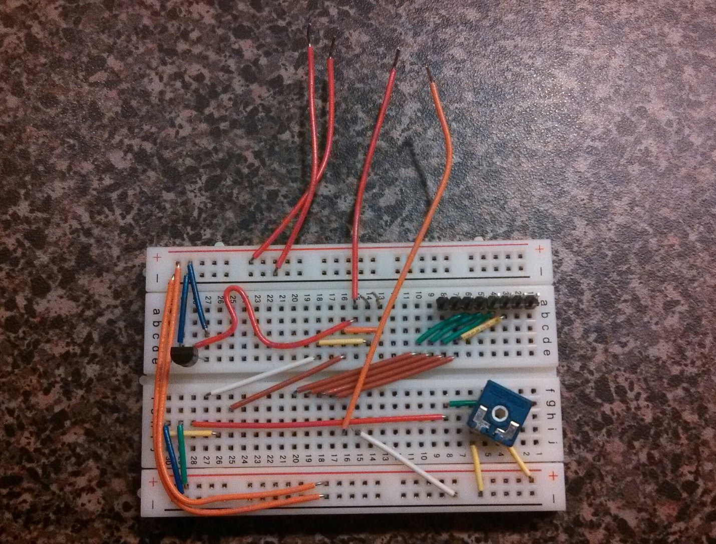

🡨 Digital Pins 12-13

**13**

**12**

**7**

**0**

🡨 10K Var. Resistor

**1**

**16**

🡨 LCD Pins 1-16

🡨 Digital Pins 0-7

Temp Sensor 🡪

3.3V

A0

5V

GND