**Countersinking:**

* What is the difference between countersinking and pre-drilling?
  + Countersinking uses a **beveled** entry to make the screw sit flush; as a result, the hole can then be filled with a wood plug appropriately
  + 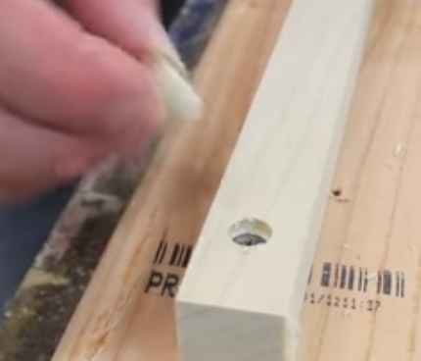
  + 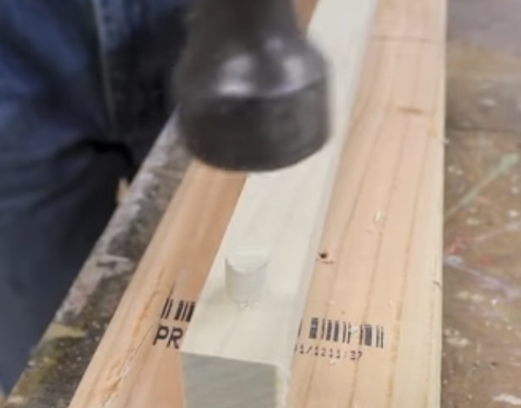

**Every Beginning Woodworker Needs to Know This (Checking for Square):**

* “Checking for square” just means checking all sides of a wooden board for squareness.
  + In a bigger sense, though, it also menas checking the squareness of a large project (e.g. a picture frame, cabinet, etc.)
* How do we do this? Let’s start w/ a combo or precision square. Tutorial (on a board):
  + 1. Choose a reference face (from which all else will be compared)
  + 2. Check it for flatness
  + 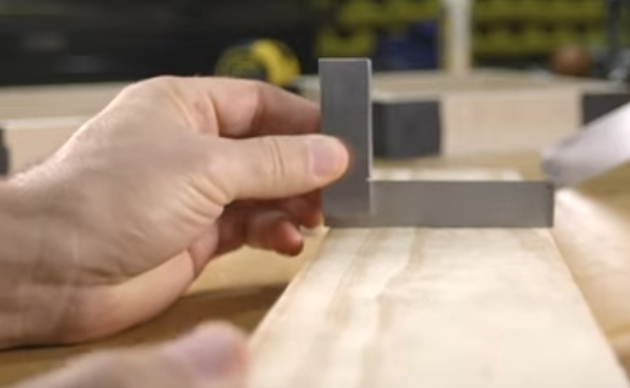
    - It will be flat if you don’t see any light coming in beneath the blade (maybe even hold it up to light to check!)
  + 3. Look for squareness of edges:
    - 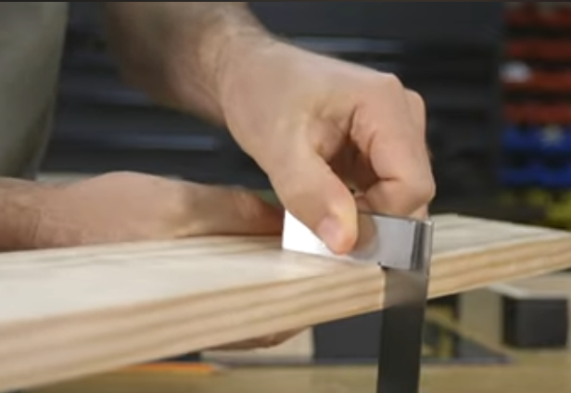
  + 4. Look for squareness of the ends:
    - 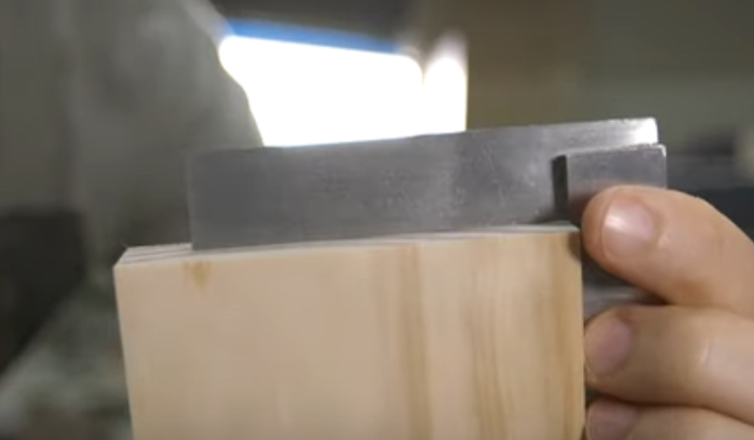
* Best way to fix an edge or face is a **jointer**
  + If you don’t have a jointer, you should look for **S4S** lumber, which is *supposed to be* all squared up
* Best way to fix the *end* of a board is by **sawing it off**
* Squaring up *projects*:
  + Note that you want to avoid *paralellograms* when you are supposed to be woodworking squares/rectangles!
    - Parallelograms can have compounding
  + To do this, you should first confirm that the 4 sides are appropriately equal
  + 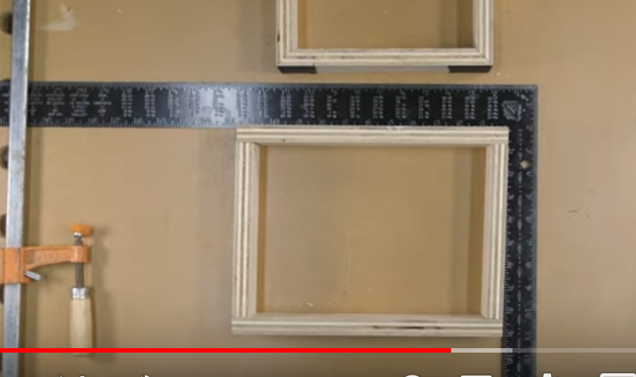
  + With a tape measure, you can also confirm that the **diagonals** are equal!
  + 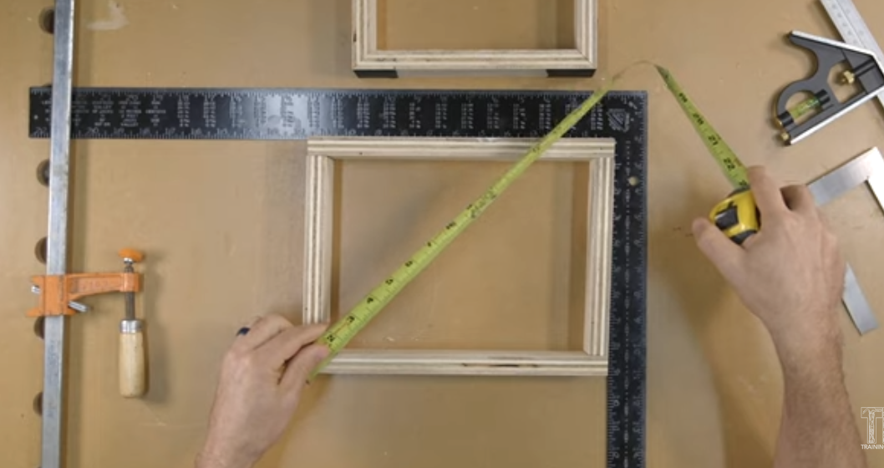

**Types of Wood Clamps:**

* Quick Grip Bar clamp (~150 lbs of clamping force)
  + 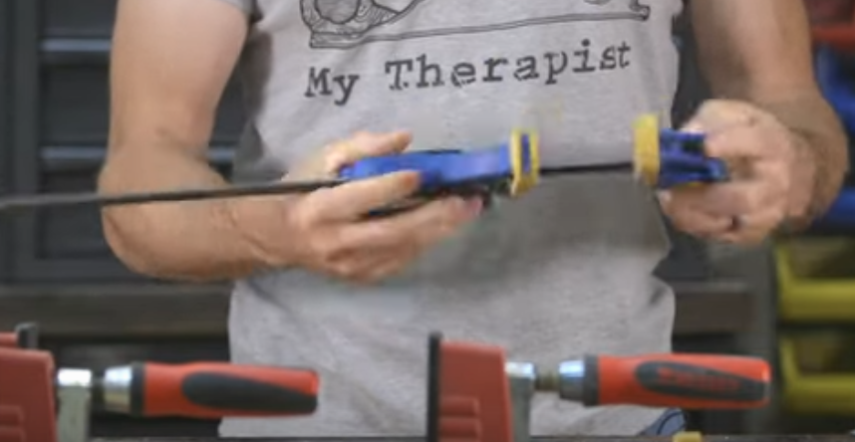
  + Note that these clamps can be used for **spreading** in addition to clampimg, by simply re-attaching the non-fixed end
  + 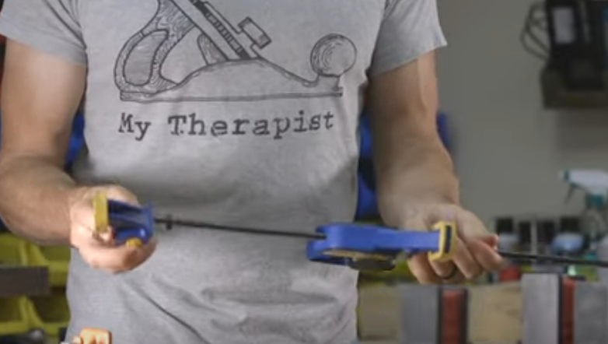
  + Disadvantage = free degreees of motion outside of the clamping plane
* Clutch Style Bar Clamp:
  + 