1. **Subcuticular Running Suture:**
   1. .
2. Figure of 8:
   1. Use: Good hemostatic stitch to stop bleeding. E.g. on the uterus.
   2. Steps:
      1. Enter w/ needle and simply come out one side. Pull until there is a short tail but do not tie anything yet.
      2. Enter **again** w/ needle just adjacent to your first needle placement. Pull all the way through. You will form a loop that then can be cinched down. You will subsequently have **two ends of stitch** that end up on *either side* of the cinched-down loop.
      3. Tie the two ends of stitch over top of the cinched-down loop w/ an instrument tie.
      4. 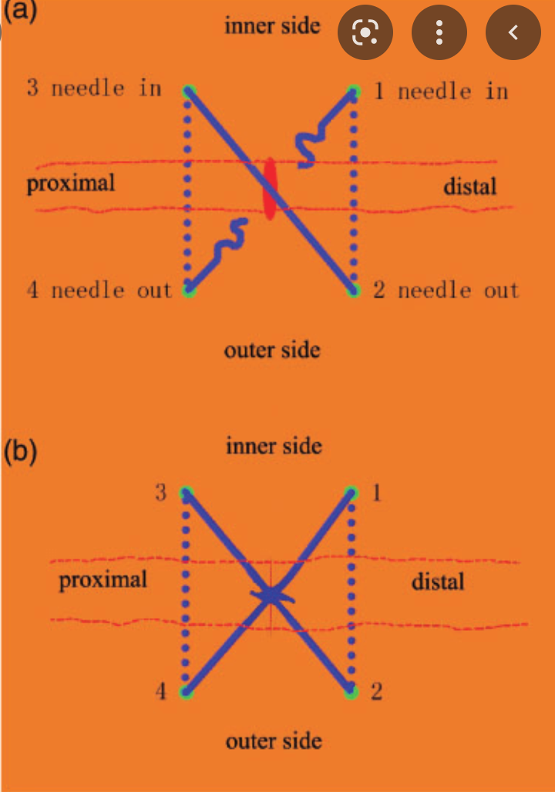
3. Horizontal mattress suture
   1. Use: Allows you to cover more incision at a greater speed than a simple interrupted suture.
   2. Steps:
      1. Put the needle through the wound as if you were suturing a simple interrupted. Pull your tail through.
      2. When you get to the other side, reverse your needle and come back through the wound *backhand*.
   3. 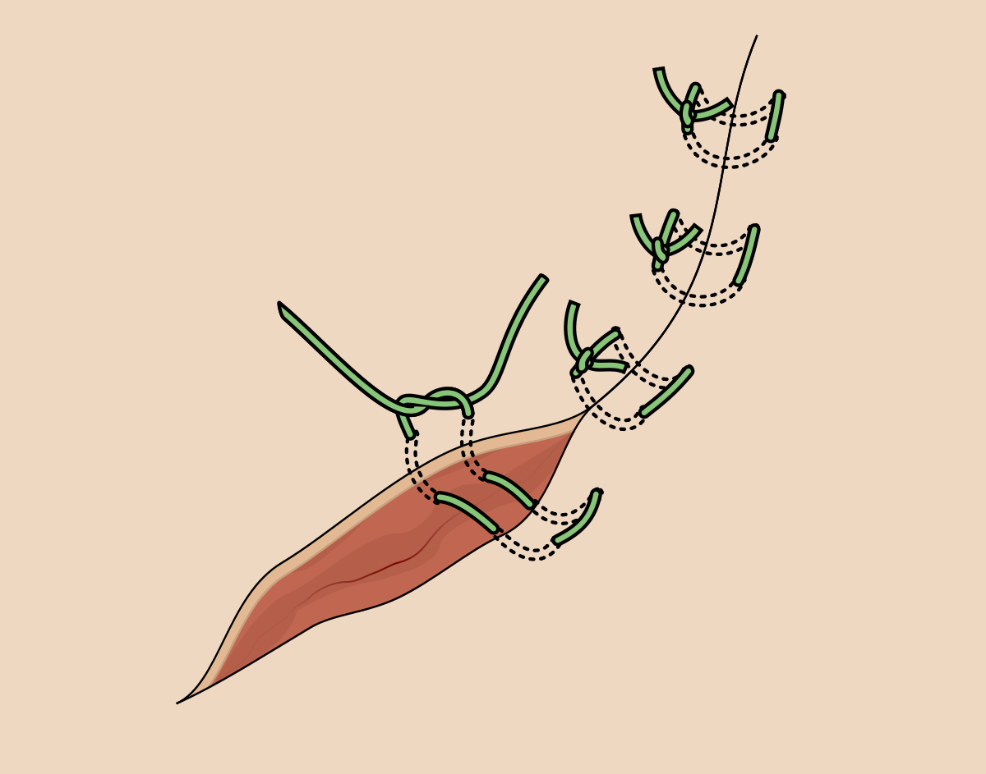
4. Vertical mattress stitch
   1. Use: Approximates skin edges while also effectively **everting** them. This is good b/c everted skin edges abet healing.
   2. Steps:
      1. Basically the same as the horizontal suture. But w/ two minor adjustments:
         1. Your first (non-backhand) throw should start/end **far** from the edges of the wound.
         2. Your *backhand* throw should start **very close (~2-3 mm)** to the edges of the wound.
5. Locking running suture:
   1. Uses: For hemostasis. Most commonly used in obstetrics (e.g. episiotomies)
   2. Steps:
      1. Same as *simple* running suture. However: the needle will **pass through the loop** created by each throw.
      2. At the end, to finish it off, just tie **1x** **non-locking throw** and tie it off.
6. Deep dermal suture:
   1. Uses:
      1. Close up deep layers before running a more superficial stitch over top (e.g. subcuticular)
      2. Combine multiple deep dermals superficially to close up a port site or melanoma excision
   2. Steps:
      1. Steps:
         1. Remember: deep 🡪 superficial; superficial 🡪 deep
            1. Start on the “left” side of the wound
            2. Use adsons to **really** evert the skin edges.
         2. Make sure that the **tail ends up close to you**. The loop should end up relatively further away.
         3. At the end, you should be tying **in line with the wound**
7. Subcuticular suture:
   1. Uses: skin closure
   2. Steps:
      1. Start at ~2-3 mm from the **apex** of the wound.
      2. Throw a deep anchoring stitch on one side. Then throw another deep stich on the **opposite** side.
         1. As w/ deep dermal, it should go deep 🡪 superficial; superficial 🡪 deep
      3. Tie down the anchoring knots at the apex.
      4. Subsequently: pass a suture **beneath** the anchoring stitch from deep🡪 superficial and have it exit through the apex of the wound below the surface of the skin.
      5. Reverse the needle and now snake back and forth along the length of the wound.
      6. At the end of your incision, tie an Aberdeen knot.
      7. Once Aberdeen knot is complete, go from deep to superficial with needle exiting **well outside of the wound**. Once you’ve pulled it through, you should also have buried the Aberdeen knot. Cut the loose end and **you’re finished!**

**Extra: Injecting Lidocaine**

* Needle selection: ~25-30G needle, 1.5-2 inches llong
* Do you inject **into** the laceration or **around it?**
  + Depends on how clean it is
    - If there’s a bunch of shit in the lac (gravel, etc.) then **clean the skin around it w/ like, betadyne or something,** and **inject through the surrounding skin**
    - If it’s an OR incision, inject **into** the wound (will help w/ anesthetic time!)
  + Steps:
    - Go **bevel up**
    - Once you are in, pull back on the plunger a bit to make sure you haven’t hit an artery
    - Inject **as you withdraw**
    - DO NOT WITHDRAW ALL THE WAY!
      * Instead, get to a point where the needle is *mostly out* but still buried
      * From that position, you can then **fan over a few degrees** and advance to a new spot in the wound; again injecting as you withdraw
    - **REPEAT THE ABOVE STEPS, UNTIL YOU HAVE MADE A NUMBER OF ADVANCES/WITHDRAWALS THAT COVER THE ENTIRETY OF THE WOUND IN A ‘FANNING’ MOTION**
* Steps: