**Anatomy of a Bike:**

* Frame:
  + Made up a “front triangle” and “rear triangle”
    - More or less self-explanatory
* Cockpit:
  + Made up handlebar and stem
* Wheel:
  + Hub
  + Spokes
  + Rim
* Brakes:
  + Rim-brakes
  + Disk-brakes
* Valves:
  + Schrader
  + Presta (the one that *you* have)
* Drivetrain:
  + All the things that make your bike go:
    - Chain
    - Cassette
    - Derailleurs
    - Crank
  + 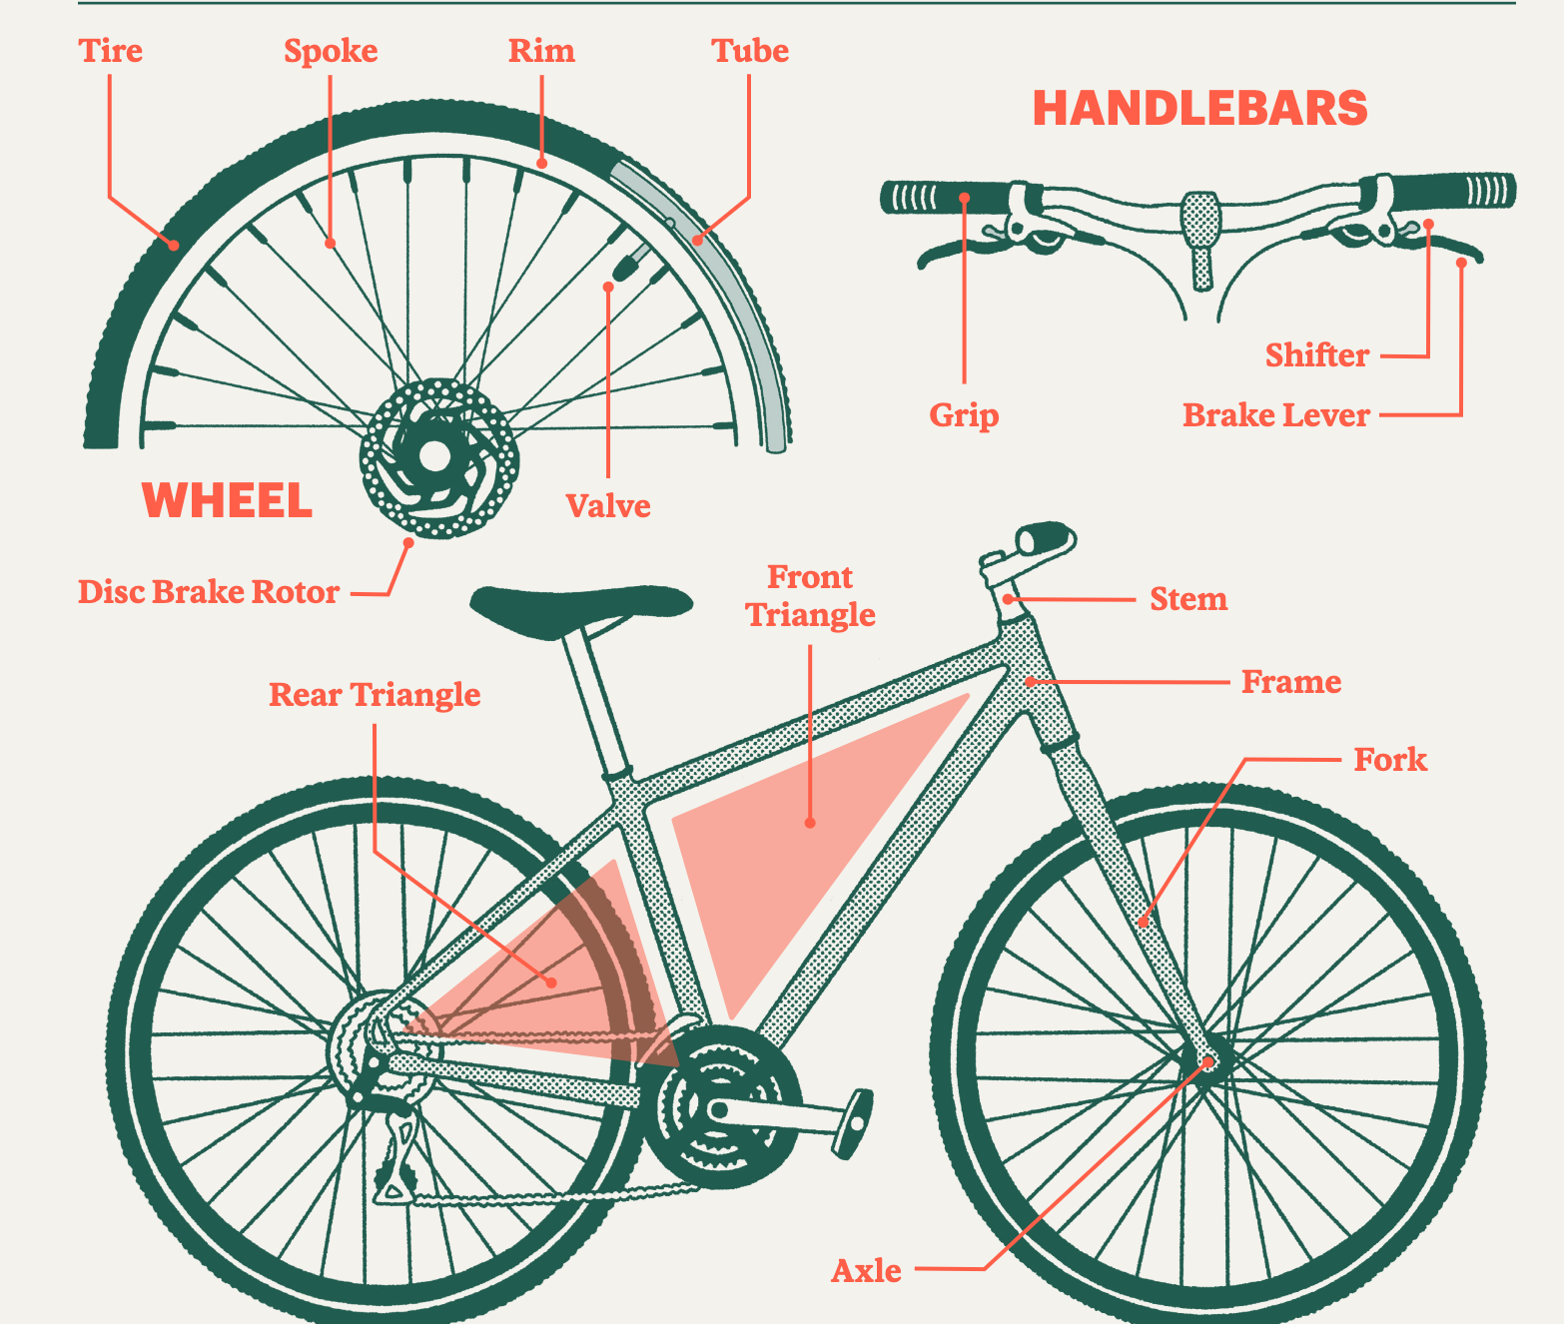
  + 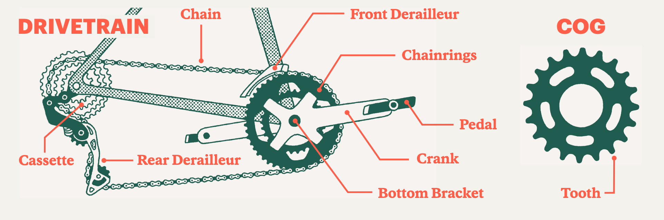

How to Clean your Bike and Lube Your Chain:

* Grit and grime in your drivetrain will wear out the bike over time. Be careful!
* Steps:
  + Apply degreaser to drive trrain
  + Wash frame
  + Wash wheels
  + Scrub drivetrain
  + Lube chain
* What you’ll need:
  + Warm soapy water
  + Soft brush
  + Brush for nook and crannies
  + Hard bristle brush
  + Degreaser applicator brush
  + Chain lube and rag