**Shore School:**

1. Sailing Maneuvers:
   1. How to tell where wind is coming from?
      1. Look at the “telltale’s”
      2. Look at the flags on the dock/around the city
      3. Look at how the bows of docked boats line up
   2. Points of sail:
      1. 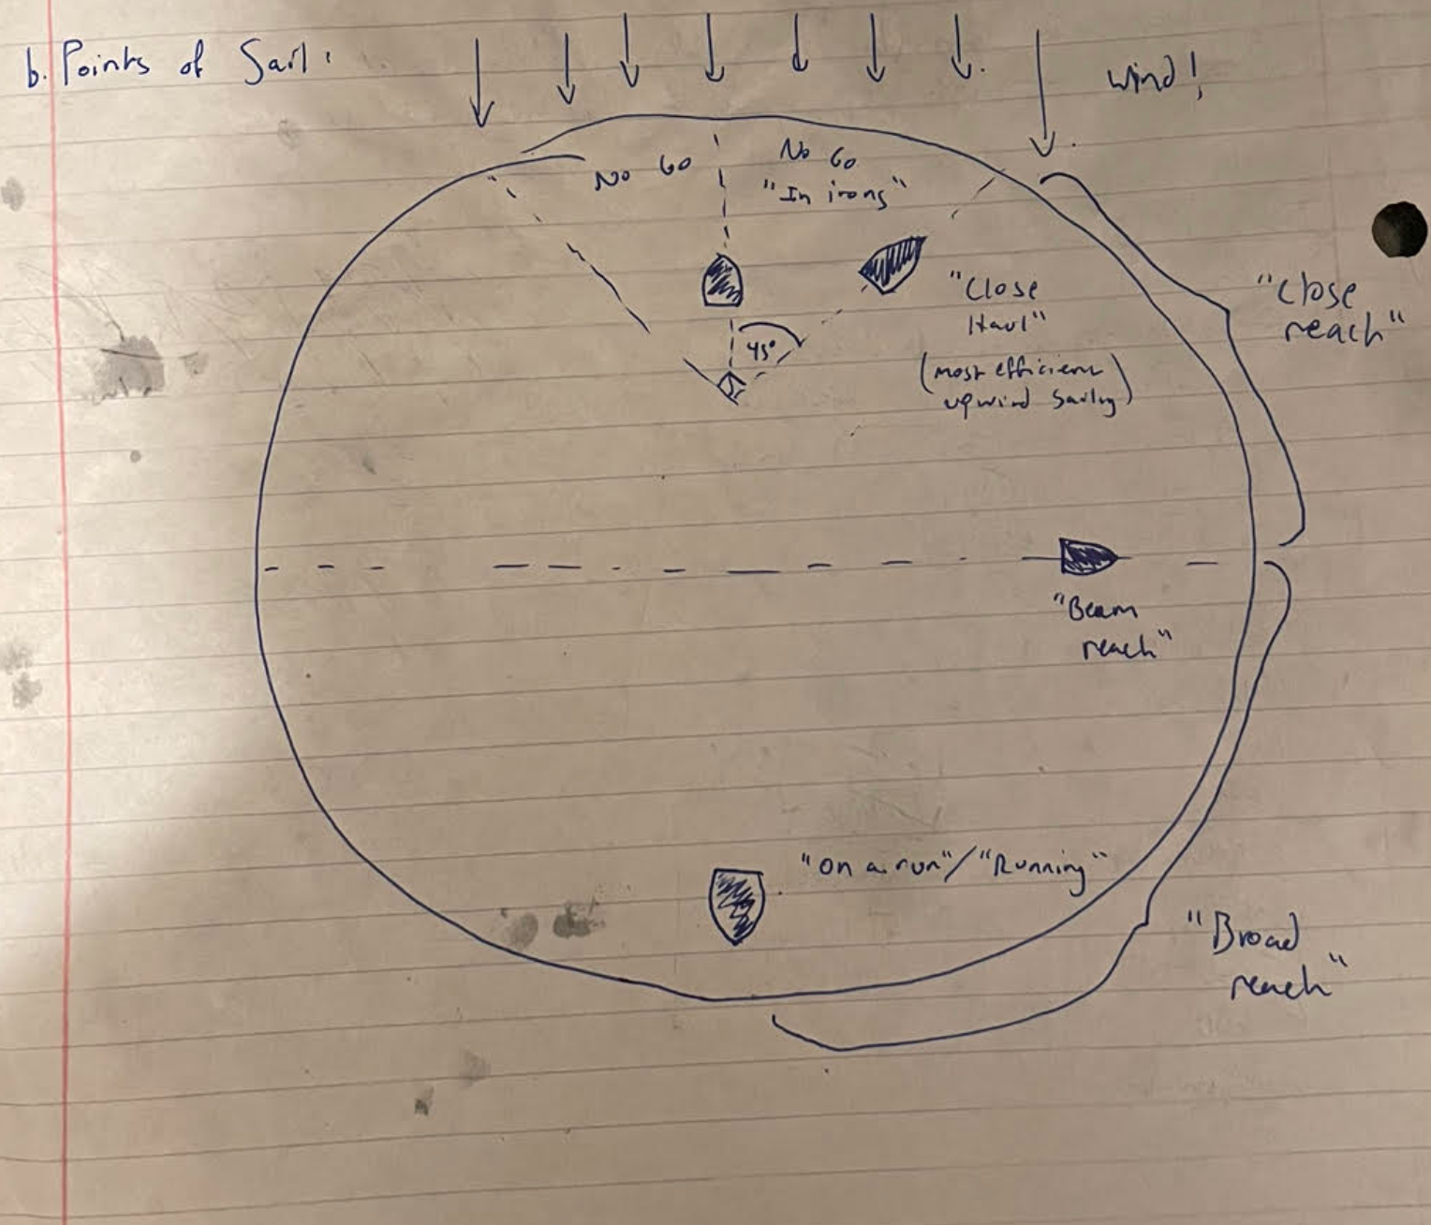
   3. Sail “trim”
      1. Def: How far to pull in the main sail.
      2. In general, pull it in until it **just** stops luffing
   4. Tacking vs. Gybing:
      1. Tack: Close haul 🡪 Close haul (**upwind** maneuver)
         1. Be sure to **push yourself through irons**
         2. Push tiller **towards** the sail
            1. “**T**acking points **T**iller **T**oward the sail”
      2. Gybe: Broad reach 🡪 broad reach (**downwind** maneuver)
         1. Force of boom change is greater b/c there is not a “no-go zone” (i.e. *irons*) b/t broad raches
         2. Push tiller **away** from the sail
   5. “Heading Up” vs. “Bearing Off”
      1. Heading up = turning **towards** the wind *without actually tacking*
      2. Bearing off = turning **away from** the wind w*ithout actually gybing*!
   6. “Safety position”
      1. Safety position = **mainsheet totally slack in close reach**
2. Right of Way, Restricted Areas:
   1. Remember: “When in doubt, chicken out”
      1. Try to stay about ~1 boat length away from others at all times
   2. Give way to:
      1. Commercial boats
      2. Human-powered vessels
   3. Restricted areas (Mercuries):
      1. Mooring areas
      2. B/t islands
3. Getting out of Trouble:
   1. Capsizing:
      1. Stay close to the boat w/o touching it (risk of “turtling”)
      2. Just sit in the water and **wait for someone!**
      3. You will need to file a capsize report
   2. Needing assistance from dock staff:
      1. Lower sail halfway to get attn. of dock staff
   3. Heeling too much:
      1. Head up boat towards irons (but not all the way to no-go zone)
      2. Lean back!
      3. Ease out main sheet
   4. Running aground:”
      1. Remove the rudder
      2. Lower sail halfway
      3. Raise centerboard
   5. Man overboard!
      1. Lower sail halfway
      2. Stay close to them, try not to be windward of the person