**A Privacy Guard System**

**Requirements:**

Python 3.5.1 (the major programming language for this project)

Django 1.10.5 (the web development framework)

NLTK 3.2.2 (the natural language toolkit)

Beautifulsoup4 4.5.3 (the CSS styling library for web application)

dj-database-url 0.4.2 (the library managing the database in Django)

PyPDF2 1.26.0 (the library used for extracting texts from pdf file)

python-docx 0.8.6 (the library used for extracting texts from docx file)

ResponseVoice 1.4.0 (the text-to-speech library)

PS: In the file ‘dependencygraph.py’ from NLTK, the original method of ‘def triples(self, node=None)’ does not generate index for each words. For convenience, I modified and saved a new file in root folder. After install NLTK, this new file is required to replace original file at default location:

C:\Users\user_name\AppData\Local\Programs\Python\Python35\Lib\site-packages\nltk\parse

The approach is temporary and can be improved later.

**How to run the system:**

Open a cmd and run command ‘python manage.py runserver’ in the root folder of ‘privacy_django’. More useful commands can be found in README.md file.

**Accounts:**

The keywords set is stored in SQLite DB and protected with password. There are two types of accounts being setup, admin and user.

1. Admin account has full access as superuser. (id: admin, ps: admin+2017)
2. User account can only manage keywords (id: user, ps: user+2017)

**UIs of the system:**

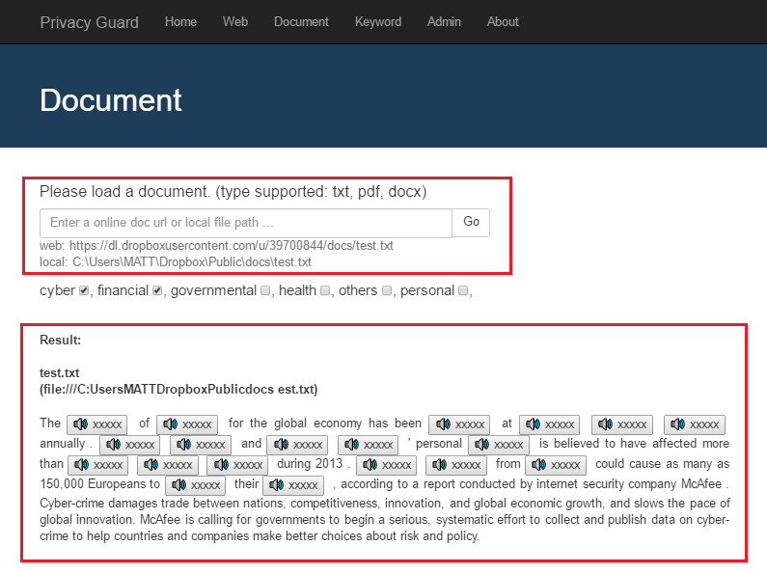

The input box is used to enter a document path. There are two examples underneath for both web and local files. The categories can be selected by ticking the checkbox with unchecked as default. After click ‘Go’ button, the system will generate outputs with hidden sensitive words and text-to-speech ability. ‘Web’ has similar interface but process webpages. ‘Keyword’ is used to display all sorted keywords. By clicking any keyword, it will redirect to WordNet page for searching synonyms.

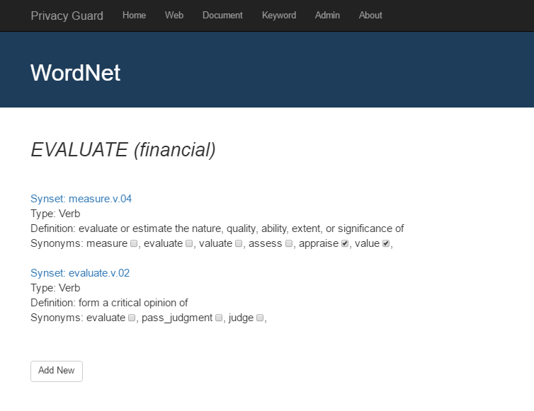

This is used to expand predefined keywords set. ‘Admin’ has a built-in interface for managing keywords in SQLite DB. The login info is listed above.