My multi-million dollar mistake

What I wish I knew about finances as a young adult

Your Name

2025

Table of Contents

# My Multi-Million Dollar Mistake

## What I Wish I Knew About Finances as a Young Adult

# Why I’m Writing This {#why-i’m-writing-this}

I served a 2-year full-time mission for the Church of Jesus Christ of Latter-day Saints right after high school. I returned at 21 years old, married my wife a few months later, and together we started in the world of “adulting.”

Financially, I thought I had it all figured out. My wife and I had both been taught about the dangers of debt and excessive consumption. We had worked hard before we married, and were blessed to start married life with a few thousand dollars in the bank!

We lived frugally, squeezing every penny. We did all the *hard* work to create financial success. But we didn’t do the *easy* work. And that’s where it all went wrong.

When my dad tried to wakeboard for the first time, he just couldn’t get it. Everyone tried to tell him “when the boat starts going fast enough, just stand up!” But every time he “*just* stood up,” he fell ungracefully into the water. He felt embarrassed and defeated. Finally, one of his friends said “Keith, here’s the science of what’s going on,” and explained the physics of *how* wakeboarding works. Once he explained the physics, Dad didn’t feel he was blindly following instructions (“*just* stand up”). He was able to wakeboard after that. He could intuit *what* to do because he now understood the *how*.

My brain works the same way. My risk-averse, analytical mind needed the same explanation for finance that my dad received for wakeboarding. None of this “*just* open a Roth IRA” stuff. I needed someone to explain “here’s how the financial world works and *why* this is the right way.”

I wish I could go back in time and have a 3-hour visit with my 21-year old self and teach him what I’m writing here. That 3-hour discussion would have changed my entire financial life. The *level of effort* I would have expended through that first decade would have been exactly the same. But simply changing the *direction* of that effort would have put me hundreds of thousands of dollars ahead of where I’m at now (2025) and will have made *several million dollars* of difference by the time I retire. That’s no typo. **One three-hour discussion would have saved me several million dollars by the time I retire.**

I’m writing this because I know many young adults are like me. They want to succeed financially, and they understand the basics of avoiding debt, but they were never taught the principles of wealth-building. They don’t know the *incredible* opportunities staring them in the face. And by the time they learn these lessons in their 30s or 40s, they, like me, will have missed out on the multi-million dollar opportunities that were available only in their twenties.

# Chapter 1: The eighth wonder of the world

## The rich uncle

Let’s play a game and see how human intuition plays out. Suppose a rich uncle leaves you and your brother an inheritance in his will. His estate will create a simple checking account for you and contribute money into it every day for the next 4 years, after which, the money in the account is yours. You can choose two different ways to earn:

**The $100/day plan:** Very simple. His estate deposits $100 into your account every day for the next 4 years.

**The 1% plan:** Your account gets one dollar to start. Then his estate increases the account value by 1% every day for the next 4 years.

The answer seems pretty clear: $100 per day for free, that’s *awesome*! You and your brother both sign up. But to your horror, you get too excited and accidentally sign up for the 1% plan!

You’re understandably bummed. Intuitively, this doesn’t sound terribly exciting. 1% of your dollar is just a penny. Earn a penny a day for four years, and you’ll have earned a whopping $14.61 in interest. Meanwhile, your friends in Account B will have earned $146,100 during those four years!

You’re feeling pretty bitter about this, so you track your account balance over time so you can quantify just how much that mistaken button click will cost you. Looking at the first two weeks, your depression is completely justified:

| Day | The 1% plan balance | The $100 plan balance |
| --- | --- | --- |
| 1 | $1.01 | $100 |
| 2 | $1.02 | $200 |
| 3 | $1.03 | $300 |
| 4 | $1.04 | $400 |
| 5 | $1.05 | $500 |
| 6 | $1.06 | $600 |
| 7 | $1.07 | $700 |
| 8 | $1.08 | $800 |
| 9 | $1.09 | $900 |
| 10 | $1.10 | $1,000 |
| 11 | $1.12 | $1,100 |
| 12 | $1.13 | $1,200 |
| 13 | $1.14 | $1,300 |
| 14 | $1.15 | $1,400 |

As expected, you receive a penny into your account each day while your brother is raking in *10,000x* that much every day. But I’ll point you to Day 11 where you’ll see something weird there– you got an extra cent on that day– a *whole extra cent*! That extra penny is why I’m so excited for you choosing the 1% plan.

*“So, I get an extra penny every week or two? So I won’t earn $13 over four years, maybe I’ll earn $16 or something? Not exactly a great consolation prize.”*

Look, I get this example underwhelming so far. But I want to show you the power behind that extra penny. This tiny little example is your first introduction to the eighth wonder of the world: *compound growth*. That’s when the interest you earned earlier multiplies and creates its own interest on top of itself. It’s like your money is having babies!

Still not convinced? I get it. Let’s give it some time and check back after a month:

| Day | The 1% plan balance | The $100 plan balance |
| --- | --- | --- |
| 30 | $1.34 | $3,000.00 |

Okay, so another *three* “extra pennies” were added during the final two weeks of the month. That’s nice, but you still don’t even have enough to buy a Costco hotdog. Meanwhile while your insufferable brother is apparently earning enough to pay his mortgage, and with cash to spare!

Let’s check back after about 3 months:

| Day | The 1% plan balance | The $100 plan balance |
| --- | --- | --- |
| 90 | $2.44 | $9,000.00 |

In the past *90* days, you got *144* pennies– that’s *54 extra pennies!* It’s encouraging to see a little increase in the frequency of our “extra penny” phenomenon. But it doesn’t change the vast overwhelm. Here we are 3 months out and you can’t even buy a value menu burger from McDonalds. But your brother can now buy a decent used car.

You’re getting really depressed. Let’s stop obsessing over this and check back at the end of the year:

| Day | The 1% plan balance | The $100 plan balance |
| --- | --- | --- |
| 365 (1 year) | $37.78 | $36,500.00 |

Well it’s been a long year. Has your account blossomed into something cool? Well, I think so! You expected a penny per day– a little over $4.00 by this point, but you have almost $40! Those extra pennies are coming in all the time now, not just every several days. Isn’t that exciting?

*“No, my brother has enough for a down payment on a new house, while I still can’t even afford to take a date to get some decent Mexican food!”*

Understood. Let’s take a break for another year and check back then.

| Day | The 1% plan balance | The $100 plan balance |
| --- | --- | --- |
| 730 (2 years) | $1,427.59 | $73,000.00 |

Huh, that’s different! You had less than $40 after a year, you might have expected $80 or so after 2 years– maybe a little more from those “extra pennies.” But your account balance is now *18 times* that! If you look at the day by day balance changes, you’ll find that you’re not earning an occasional extra penny anymore– now you’re earning a solid $12+ dollars *per day*. Cool!

*“Yeah but $12/day is nothing compared to $100/day. We’re already halfway through the 4 years and my brother is WAY ahead and I’m still earning nowhere close to him. He’s getting rich and there’s no way I’ll come close to catching up! Maybe he’ll have pity on me and invite me on his nice vacation. Well, at least maybe I see it’s starting to grow fast. Who knows, maybe it will grow to $5,000 by the time this is done. Do I dare hope to see ten?”*

Okay, okay, let’s check again after year 3.

| Day | The 1% plan balance | The $100 plan balance |
| --- | --- | --- |
| 1,095 (3 years) | $53,939.17 | $109,500.00 |

Well your brother has crossed into six figures, and he’s gleefully telling you all the things he’s going to do now that he’s “wealthy.” You were maybe afraid to look at your own balance. You’re starting to realize this interest rate thing is weird, so you don’t know what to expect last year’s $1,400 grew into.

You open your account and you’re shocked to see you are almost halfway to your brother’s account balance. Your days of me celebrating an extra penny every few weeks feel like just yesterday, but it looks like if you’re lucky you might just come close to catching up to your brother after all! Hopeful, you close your laptop and check back at the end of the experiment.

As expected, your brother closed his journey with his $146,000 and “generously” invited you to join him on his vacation to Cancun. You check on your account to see how far behind you are. Maybe, if you’re not *too* far behind, you’ll surprise him by offering to contribute to the cost.

| Day | The 1% plan balance | The $100 plan balance |
| --- | --- | --- |
| 1,461 (4 years) | $2,058,387.31 | $146,100.00 |

Your mouth drops. No, that can’t be right. *Over 2 million dollars?* There must be some mistake.

But there isn’t. Your little $1 account that earned “an extra penny” every few weeks at the beginning is now earning almost ***$21,000 every single day***. Maybe you should *buy* a property in Cancun and offer to let your poor brother stay there? 😉

## What happened? {#what-happened?}

How in the world did you end up with more than 2 million dollars? Well, for the first two years, your initial gut instinct was 100% right– the $100/day linear approach (red) far outperforms the 1% approach (green):

Compound interest: linear vs exponential

Compound interest: linear vs exponential

But sometime shortly into year three, the lines swap places and your previously laughable 1% per day account absolutely destroys your brother’s account:

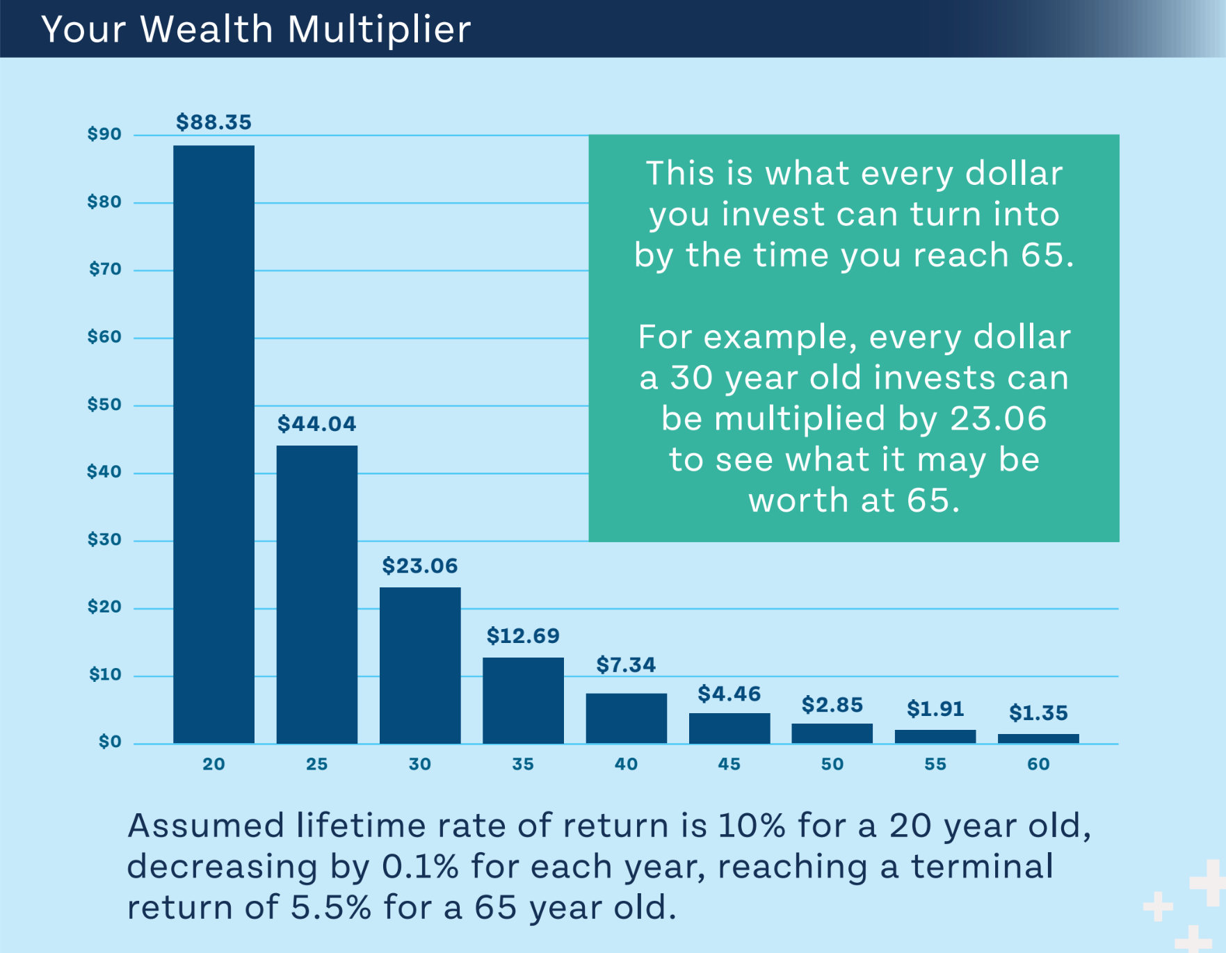

Compound interest crossover point

So here’s lesson #1: humans think *linearly*, but compound interest works *exponentially*. It doesn’t matter how often I run these simulations, it doesn’t matter how often I do the math, this fact constantly surprises and delights me. It never really becomes intuitive– that’s why it’s the eighth wonder of the world.

Now, you’re not going to find any bank that will offer you a 1% per day interest rate (if you do, let me know, because I wouldn’t mind becoming a trillionaire 😉). This is just an example to illustrate the power of compound interest:

No matter what the interest rate, no matter what the initial amount, *any* interest rate will exponentially outperform *any* linear graph *if you give it enough time*.

## Calculating compound growth

As I said earlier, compound growth is hard for us humans to naturally intuit because our brains can’t help but think linearly, so we need math. There is a formula you can use to calculate the value of a number if it grows at a certain percentage rate:

Final value = Starting value * ((1 + interest rate)number of times compounded)

Let’s apply that to the 1% per day example from earlier. We represent the 1% = .01 as a decimal, and plug in 1,461 (the number of days in 4 years)

Final value = $1.00 * (1 + .01)1461

If you plug that into your calculator, you’ll see that beautiful $2+ million number from before.

But of course real banks and investments don’t pay 1% per day. Let’s try a realistic example.

The S&P 500 is an index that tracks the stock values of the largest 500 public companies in the US. It’s a decent indicator of the overall US stock market, and has historically increased at an average of 10% per year. Let’s see how $1,000 would do on average across 1 year, 5 years, 10 year, and 25 years, compounded annually:

| Time | Formula | Result |
| --- | --- | --- |
| Stating amount |  | $1,000 |
| 1 year | $1,000 * 1.1**1** | $1,100 |
| 2 years | $1,000 * 1.1**2** | $1,210 |
| 5 years | $1,000 * 1.1**5** | $1,610 |
| 10 years | $1,000 * 1.1**10** | $2,594 |
| 25 years | $1,000 * 1.1**25** | $10,835 |

## Estimating compound growth

You’ll notice in the example above that between years 5 and 10 we passed an interesting milestone— we *doubled* the initial amount. Specifically, we reached the doubling point for a 10% return after about 7 years, 3 months. Try plugging in different starting amounts– it doesn’t matter– at a 10% rate of return, you’ll always have double whatever you started with after about 7 years, 3 months.

If you try with a 9% rate of return, you’ll find that doubling takes a little longer at 8 years.  
If you try with an 8% rate of return, it takes even longer, doubling after 9 years.  
And if you try with a 1% interest rate, it doubles after about 72 years.

Do you see the pattern between the rate of return and the time in which your investment first doubles? Congratulations, you just discovered the famous “rule of 72.” Whenever someone tells you a yearly rate of return, just divide 72 by that number and the answer tells you about how many years it will take for that interest rate to double the amount you put in.

72 / 6 is 12. So a 6% interest rate will double its value every 12 years.  
72 / 4 is 18. So a 4% interest rate will double its value every 18 years.

So, without using your calculator, can you estimate how much you’d have if you put $1,000 into an account earning 10% yearly after 29 years?

72 / 10 = 7.2, meaning the account doubles every 7.2 years. We know 7 goes into 28 four times. And the 0.2s added four times on top give us an extra one to arrive at about 29. So we can expect the amount will double 4 times over the 29 years. So we should see the amount go from $1,000 to $2,000 over the first seven years, from $2,000 to $4,000 during the second seven years, from $4,000 to $8,000 over the third seven years, and from $8,000 to $16,000 over the fourth seven years.

## You are *already* a millionaire (of time) {#you-are-already-a-millionaire-(of-time)}

Let’s look again at the example we tried earlier with the S&P index which historically grows about 10% per year. Let’s use the same $1,000 initial investment to keep things simple.

| Time | Formula | Result |
| --- | --- | --- |
| Stating amount |  | $1,000 |
| 1 year | $1,000 * 1.1**1** | $1,100 |
| 2 years | $1,000 * 1.1**2** | $1,210 |
| 5 years | $1,000 * 1.1**5** | $1,610 |
| 10 years | $1,000 * 1.1**10** | $2,594 |
| 25 years | $1,000 * 1.1**25** | $10,835 |

If you chart this out, you’ll see that the S&P 500 graph has the same hockey stick shape as the rich uncle graph from earlier– gradual growth at first, then it accelerates and accelerates, driving exponentially upward, each year much more powerful than the previous year.

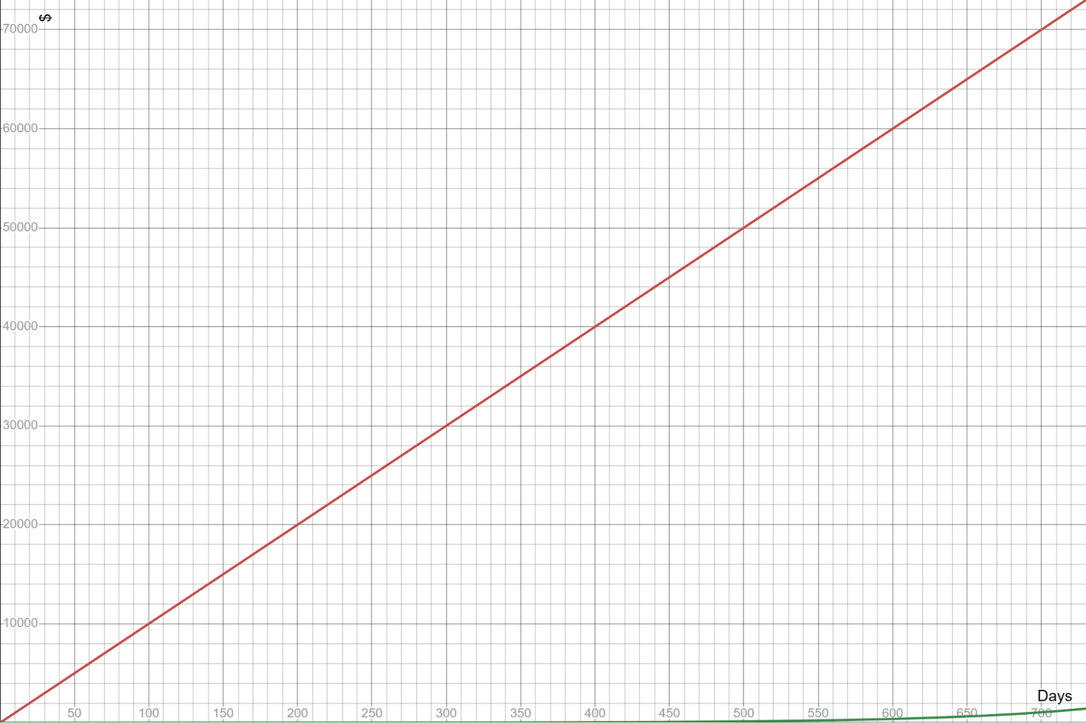 But what would happen if we delay that investment by just 5 years? Maybe we really want to get that new game console. Maybe the market is looking shaky right now. Maybe we want to take some time to wait until we feel confident taking the plunge to tie up our money in the stock market.

Let’s game that out. Let’s hold on to that $1,000 and invest it *5 years from now*. In other words, let’s let it grow for 20 years instead of 25.

It should be no big deal, right? Shaving 5 years off our 25 year investment time reduces our time in the market by only 20%. We saw that our $1,000 grew an extra $10,000 over 25 years, So if we’re leaving the money in there for 80% of that time, we should see 80% of that growth– $8,000 on top of our $1,000. Sure, it’s not 10x like before, but 8x is still pretty good, right?

Let’s model it out and see what this looks like. To make things simple, I’ll start it from year 5. The red line shows the value of what you would have had if you’d invested 5 years earlier, and the blue shows what you would have if you waited 5 years.



Impact of delayed investment

Ouch.

Our $1,000 over 25 years reached almost $11,000. But if we delay our investment by just 5 years, we finish with only about $6,700. We invested the same $1,000 in both scenarios. But the decision to delay our long-term investment by only 5 years cost us $4,300 or 43% of the growth we would have had if we’d started 5 years earlier.

Uh-oh, we were thinking linearly again!

You might think, “well I’m investing for retirement, I’m thinking *50 years* down the road, not 25! 5 years is a big chunk of 25 years, but surely it’s just a drop in the bucket *50* years from now!”

You might think that. But you’d be wrong.

The 5-year delayed investment would certainly perform well. 45 years of growth at 10% would turn your $1,000 into $72,890. An almost 73x increase, nice! But if we had invested from the start and gotten the full 50 years of growth, it would have been $117,390– a mind-boggling *118x* increase! At a 50 year time horizon, the 5 year delay will have cost you $44,500– still a whopping 38% of what you could have had, and more than half of what you actually have now.

What do we learn from this?

**TIME IS YOUR MOST VALUABLE RESOURCE.**

Every year, every month, every *day* you delay putting a dollar to work decreases the future earning power of that dollar. If $1 invested today has the potential to become $100 by the time you retire, that’s exciting! But it also means that last year it probably had the potential to become $120. And next year, it will only have the potential to be $80. Thus the adage: “The best time to invest was yesterday which means the second best time is today.”

## Your Wealth Multiplier

What a great idea– that each of your dollars has a different potential growth factor depending on how long it has left in the market. The great folks at the Money Guy have given this growth factor idea a name. They call it the Wealth Multiplier.

You could come up with a simple formula yourself using the equations we covered earlier. If you assume you invest in the S&P 500, earning 10% annually, you can run this equation:

Wealth Multiplier = 1.1years until retirement

So if you’re 30 and you plan to retire at 65, your wealth multiplier is 1.135, which is about 28. You can expect every dollar you invest today to grow to about $28 by the time you retire.

But that’s not realistic. You’re not going to want to stay invested solely in the high-growth but highly volatile S&P 500 your whole life[1]– you’re going to want to gradually start trading higher returns for higher stability as you get closer to retirement age.

So the folks at the Money Guy Show put together a more realistic (but also more complicated) formula that assumes a 10% rate of return 45+ years out from retirement, decreasing by 0.1% per year until retirement, compounded monthly. It’s too complex to put into a memorable formula, so I won’t bother writing it here, but how the number changes as you age:

Here’s how the wealth multiplier works out over time, assuming a target retirement age of 65. Again, linear thinking will sabotage you; notice how quickly the number falls off a cliff as you age.

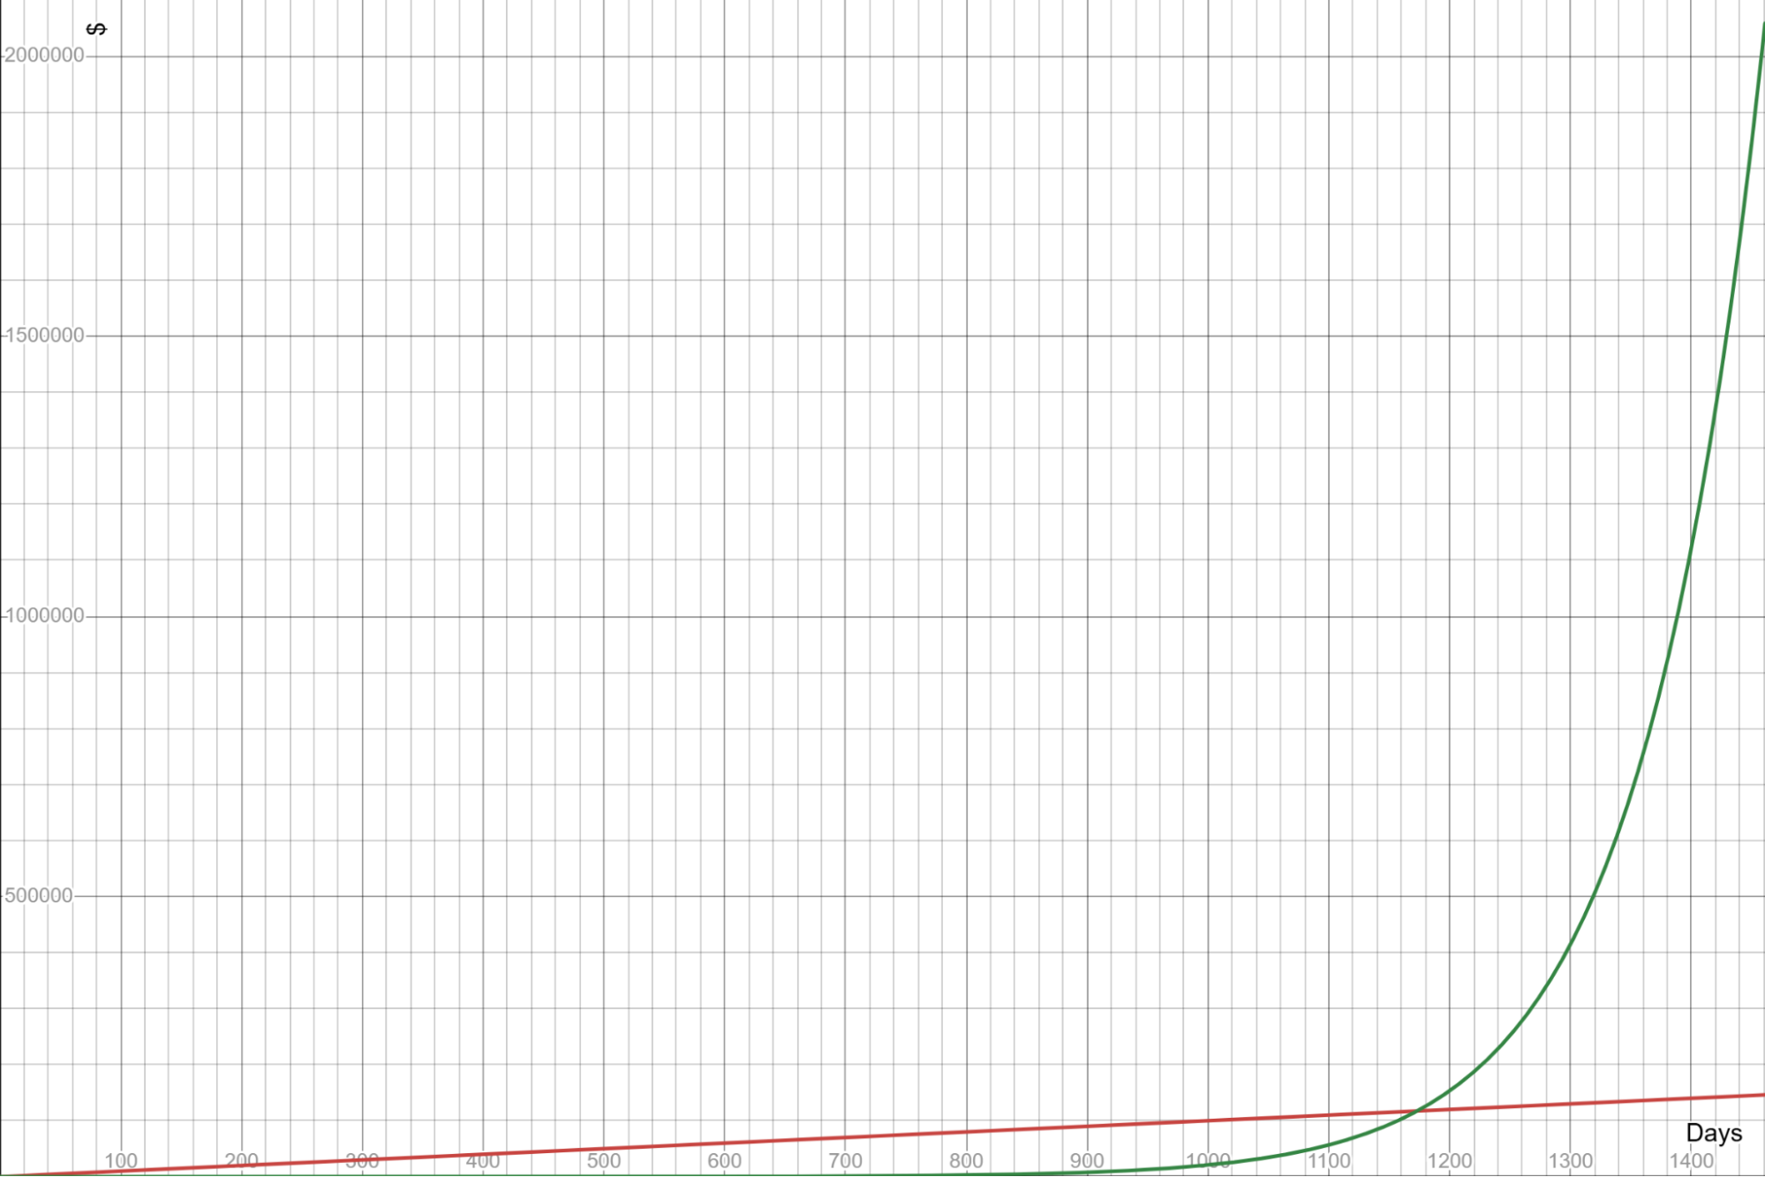

Wealth multiplier by age graph

I’m currently 35, so My wealth multiplier is 12.69. I can reasonably expect that any money I have in the market (or put into the market) today will grow to 12.69x its current value by the time I turn 65.

What was my wealth multiplier at 30? It was about 23. When I was 25, that number was 44. when I was 20, it was an astounding 88!

Which leads to my unpleasant confession…

## My multi-million dollar mistake

This is where my regret comes and kicks me in the teeth. In the introduction, I said my wife and I did all the *hard* work of saving and budgeting, but didn’t do the *easy* work. Here’s what I mean.

Where did we put all the money we worked so hard to save? In a *savings* account, of course (isn’t that what it’s for?). I had no idea how the financial world of investment worked. The little I’d heard from news articles and blog posts scared me. I knew that investing entailed “risk–” a word that sounded like gambling in my mind. I heard investing was complicated, and people were constantly disagreeing on how to do it, and many offered “advice” that was dangerous or actually a sales pitch for their product. And I heard there were a bunch of tax rules that could ruin you if you didn’t know exactly what you were doing.

I was terrified of falling for some bad investment or making a tax mistake so year after year, I procrastinated doing the work to learn how this whole “investing” thing works. I kept all that money on the sidelines while my wealth multiplier dropped from 88… to 44… to 23… etc. I didn’t learn about the wealth multiplier until mine had dropped all the way to *18*.

Once I learned about the power of compound interest and the wealth multiplier, I flushed my cash into the market as quickly as I dared… but the damage was already done. If I had been pumping the money I saved into *investments* instead of just *savings accounts* during my 20s, that money would have grown to *several million dollars* by the time I retire.

I’m still working to pump extra in to try and accelerate my growth, and we’ll do okay in the end. But if we had just nudged the direction of our existing effort a few degrees, we could have retired very early and taken our foot off the savings pedal way earlier. But it’s impossible to buy back that lost time. That’s why I want you to start *now*.

# Chapter 2: Your Financial Success Plan

We’ve talked about the big ideas, now let’s start getting into the specifics. I’ll keep each section as brief as possible.

## Optimize your spending

### Live within your means (obviously) {#live-within-your-means-(obviously)}

This is the hard part– the part I actually did! Spend less than you make and follow a budget. If you’re like me, having software to categorize your expenses and track how you’re doing is a must-have. But whether you like to go the pen-and-paper route, a spreadsheet, etc, it doesn’t matter. Just remember: every dollar is a soldier in your army. If you aren’t keeping track of where your soldiers are and what they’re doing, you’re not getting the value you need out of them.

### Use credit cards (but don’t let them use you) {#use-credit-cards-(but-don’t-let-them-use-you)}

Credit cards give you consumer protections you don’t get with a debit card. Plus, many offer rewards (like 2%+ cash back). Choose 2-3 credit cards that will give you the best rewards for your expenses ([here’s a good guide on choosing the best cards](https://clark.com/credit-cards/)) and set them up to auto-pay in full every month. Credit card *debt*, we hate; credit card *use* is great!

### Stretch your dollars

My cell phone plan costs a quarter of the plan my friends have, and I’m on the same network as them. The cereal my kids eat costs half of their friends’ cereal and tastes just as good. Our family spends half the amount as other families on the same medicines. And we spend far less than the average family in our area on groceries.

How do we do this? By taking a little bit of time to research. I use an MVNO carrier for my phone plan instead of AT&T, T-Mobile, or Verizon. We shop at Walmart, Aldi, and Sam’s Club instead of Publix or Target or Trader Joes. We buy store brand instead of name brand. We unit price instead of blinding grabbing the first item on the shelves. We compare prescription prices across pharmacies.

It’s amazing how much further you can make your dollars go when you are willing to go against the stream, find out what providers are out there others may not be aware of, and compare your options.

The best general resource I’ve found for learning how to save money across the many aspects of your life is [Clark Howard](https://clark.com/). His website (and daily show) will help you save money on everything from health to cell phones to streaming to groceries to travel. Many people and families can easily save 20+% on their daily spending.

## Debt: a powerful, deadly tool {#debt:-a-powerful,-deadly-tool}

Debt is like a chainsaw. If you’re careful, you can do awesome things like clear acres of wilderness. If you’re not careful, you can clear your head from your body. A good rule of thumb: never take on debt except for the following:

### Mortgage

You likely won’t afford to buy a house in cash. But your first house should be modest. Make sure to put at least 5% down on your first house (20%+ down on future home purchases). Make sure your mortgage (principal + interest + property tax + homeowners insurance) is 25% or less of your total income.

### Education

If needed, you can go into debt to pay for your school. But make sure your total loan amount doesn’t exceed what you expect to earn during your first year’s salary out of school. You can save a LOT of money by doing your first few years of school at a community college before transferring to a university. Pursue scholarships and grants– that’s free money, and many are not tied to income.

### Vehicle

Paying for a car in cash is ideal. But if you really need to get a car loan, you can. Make sure you are buying a modest car (“think Corolla, not Land Cruiser”). Prioritize buying used cars so someone else eats the depreciation. And for the loan, the rule is 20/3/8. Pay 20+% down, take on a loan no longer than 3 years, and don’t let your loan payments exceed 8% of your income.

## Saving and investing

### 25% can do wonders for you {#25%-can-do-wonders-for-you}

Strive to save/invest 25% of your income each paycheck. 25% is higher than the traditional 10-15% rate many financial pundits have traditionally required and far beyond the <5% of the average American. But you probably won’t have social security to fall back on and you’re not average. Saving 25%– especially right now when your dollars are orders of magnitude more powerful than they will be in another 5, 10, 20 years– will give you immense flexibility down the road, maybe to even retire 10 or 15 years early!

When you’re just starting out and you have very little income, that may seem insane. In which case, start by doing what you can. 10%, 15%, whatever. Make 25% your goal, and work on raising your savings rate each year. Then, as you get raises through the next several years, dedicate half of your raise to increasing your savings rate and you’ll hit 25% in a few years.

## Where to put that 25%: the Financial Order of Operations {#where-to-put-that-25%:-the-financial-order-of-operations}

Remember the order of operations from math class? “Please Excuse My Dear Aunt Sally” helped you remember to calculate Parentheses, Exponents, Multiplication, Division, Addition, and Subtraction in that order and gave you clear instructions for what to do with your next calculation.

The Financial Order of Operations gives you clear guidelines on what to do with your next dollar. Every time you get a paycheck, you need to ask yourself, “what step am I on?” and put at least 25% of your paycheck toward that step.

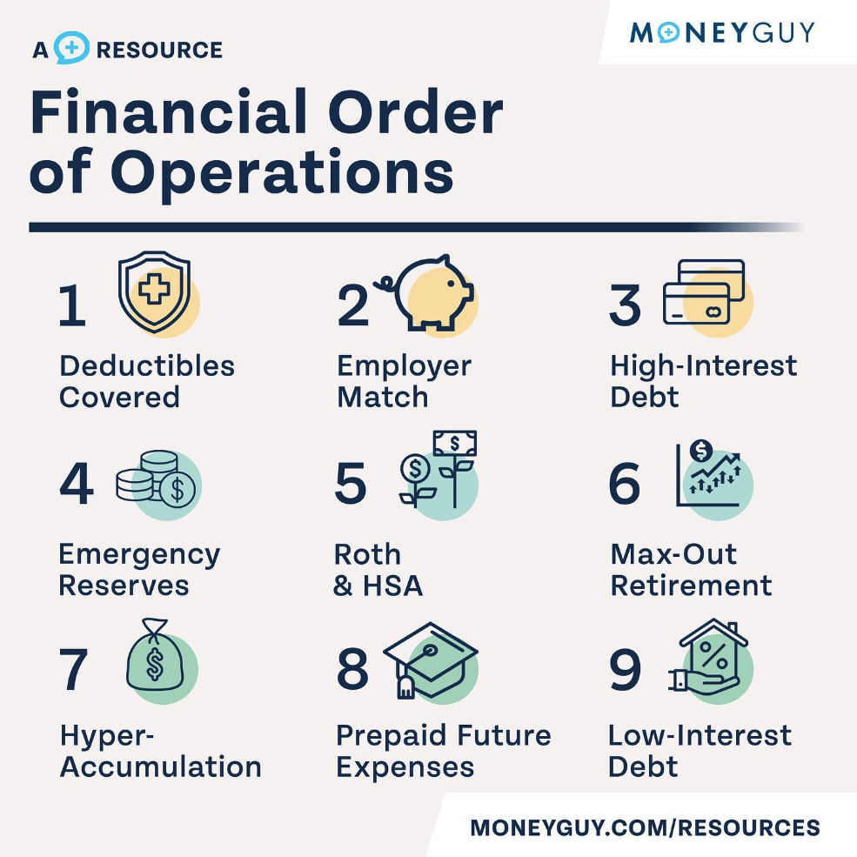

Financial order of operations

### Step 1: Deductibles Covered

#### First, let’s talk about insurance

People fear catastrophe. So we all pitch a few dollars into a big pool of money. The person running the pool takes a cut. And when catastrophe hits a few of us, they get the money in the pool. The rest of us get no money, but that’s good because that means catastrophe didn’t hit us. And we sleep better at night knowing there’s a big pool of money waiting for us if it does.

That’s insurance– it protects you from some of the major risks of life. Auto insurance pays for replacement or repair to your car if it gets wrecked. Homeowners insurance if your house gets wrecked. Health insurance pays when your body gets wrecked. And life insurance pays your family if your “stay alive” parts get completely wrecked.

Insurance includes a few different costs:

* **Premiums**: this is what you pay for the privilege of being in the insurance. It’s like a gym membership or a Spotify subscription– it doesn’t matter whether you use it or not, you have to pay for it every month.
* **Deductible**: This is the amount of your costs that’s completely on you. For example, if you have a $1,000 deductible, insurance isn’t going to lift a finger to cover costs until you have paid $1,000 of your own money to the problem (which is what it means to “meet your deductible”). Requiring you to put some skin in the game first means you will be more careful in how you act and spend. Not every insurance plan has a deductible (this will be important when we talk about HSAs later).
* **Coinsurance:** If you have no deductible (or if you’ve already met it), the insurance is likely not going to start covering *all* your expenses right away. Instead, you will share the responsibility of paying. Insurance will pay some percentage (50%, 75%, 90%, etc) and you’ll pay the rest.
* **Copays:** Even when the insurance company is paying their percentage, they still want you to have more skin in the game and avoid unnecessary expenses. So they will often require you to pay a flat amount of each service (like $25 per doctor visit) before they will start splitting the rest of the cost with you.
* **Out of pocket maximum:** Finally, a term that is intuitively named! Once you’ve paid this amount of money in deductibles and coinsurance and copays, you’re done! Everything for the rest of the year is free (except your premiums, of course).

When you enroll in an insurance plan, you’ll trade off one cost for another cost. Think of it this way: if you have no insurance, you have no guaranteed cost every month, but you have a very high possible cost if something goes wrong. On the other end of the spectrum, you can pay a ton in guaranteed monthly costs and in exchange the insurance company will pay almost everything for you. When you are presented with multiple insurance options, you will need to figure out where you want to be along that spectrum of risk and responsibility.

#### Applying that to step 1

Between your health, home, and car insurance, what’s the highest deductible you’d have to pay in those policies if something went wrong? The first step is to save up that amount in a high-yield savings account you can access any time. This should give you a little bit of an emergency cushion so if something goes wrong, you don’t have to go get a loan.

### Step 2: Employer Match

At most companies you’ll likely have access to an employer-sponsored retirement plan. If you do, your employer may offer a match on your contributions. For example, if you contribute 4% of your income to your retirement plan, your employer may add another 2% on top of that. This is **literally free money**, and you’re stupid if you turn it down. Enroll in at least the bare minimum contribution to your 401k to get the full employer match. If you have the choice between Roth and traditional 401k accounts, go with the Roth.[2]

If you are enrolled in a high-deductible health plan through your employer, your employer may also offer a match on your contributions to an HSA (more on HSAs and health insurance in a minute). Again, that match is **free money**, and you should get on that right away!

### Step 3: High-Interest Debt

Once you’ve built up some breathing room and got your free money, let’s do a gut-check on your spending. If you didn’t follow the debt advice from earlier in the chapter, that’s your next priority. A debt with an interest rate > 8-10% is going to hurt you more than an investment is going to help you.

If it feels depressing to spend so much on debt, think of it this way: paying off a $1,000 balance on a 20% credit card has the same effect on your overall net worth as investing $1,000 in an account earning 20%– which is far above any return you’ll see in the market in a normal year. So every dollar you spend on step 3 is FAR more powerful than the dollars you’ll be investing later. Fight through it!

### Step 4: Emergency Reserves

You started your emergency fund in step 1 to give yourself a little bit of breathing room. And now that you’re not in danger from debt, you can shift your attention and expand that “breathing room” into a runway you can use to launch forward into *growth*. Save up enough money in your emergency fund to cover 3-6 months of your normal living expenses. So if you lose your job or unexpectedly have to replace your car, you’re not back to square one.

### Step 5: Roth & HSA

Now we’re ready to finally get serious about investing for your future! We’ll start with your HSA and Roth accounts:

#### HSA: your most powerful account

When you choose a health insurance plan, I strongly urge you to consider a “high-deductitble” health plan, especially when you’re young and healthy. A high-deductible plan is simply a health plan with a deductible high enough that it meets the IRS definition of “high” (at the time of this writing, that’s $1,650 for individuals and $3,300 for families). Having a high-deductible plan gives you many benefits:

1. Lower premiums
2. “Skin in the game” encouraging you to comparison-shop and reduce your health costs
3. It makes you eligible for a Health Savings Account (HSA).

That last one is key. An HSA is the most powerful account type in your arsenal for saving for the future because not only will many employers match your contributions (see step 2), but HSAs are triple– sometimes even *quadruple* tax-advantaged! What does that mean?

1. If it’s an employer-sponsored HSA, you can likely tell your employer to take your contributions directly out of your paycheck. This contribution comes out before payroll (social security and medicare) taxes.
2. Any amount you contribute is also exempt from your income taxes
3. The contributions and the growth of the account over time grows tax-free
4. And you can withdraw them tax-free!

Additionally, unlike HSA’s disappointing cousin (the FSA), the money in your HSA is yours forever– there is no “use it or lose it” rule at the end of the year. You can keep using your HSA funds for the rest of your life, no matter what health plan you have at the time!

# How You Can Get Started

I’ve tried to collect the “big ideas” together and help you understand the *amazing* potential your dollars have if you start early. I hope this lit a fire under you to hit the ground running. Your most powerful year to shape your financial future is the year you first get started. Don’t lose out.

But you’ll need more than just big ideas about compound interest and the wealth multiplier. You need to know how to choose an affordable brokerage, how to prioritize emergency savings, what types of accounts to use to minimize your tax burden, and so much more.

Your best friend in this journey is going to be the book [Millionaire Mission by Brian Preston](https://moneyguy.com/millionairemission/). He covers the big principles I talked about here in much greater detail. But he also outlines a 9-step “order of operations” for your personal financial life so you always know the most efficient thing to do with your next dollar in each stage of life. He also gives you great rules of thumb around mortgage, car, and school loans, Roth v traditional retirement accounts, and many other important guides. No gimmicks, no sales pitches, nothing fancy or risky. You aren’t trying to beat the market– just *ride* the market in the safest, most tax-efficient way possible.

The next resource would be Brian’s show, [The Money Guy Show](https://moneyguy.com/) on YouTube or podcasts. His website also has a ton of free resources like the wealth multiplier calculator, a net worth tool, and other great stuff. He also has a few paid video courses to calculate your retirement number, learn the financial order of operations, and much more that are well worth it in my opinion.

If you’re new to this world, some parts of his show itself will seem confusing at first. Just like how the Latter-day Saint culture and vocabulary is overwhelming to a new convert at first. Read or listen to the book first, and then stuff in the show will make more sense. Immerse yourself in it, and you’ll start picking it up faster than you would have thought.

The next resource would be [the Clark Howard show](https://clark.com). He is less focused on big picture financial planning concepts and more the day to day application of wise financial principles and squeezing the best out of every dollar. He’s got great information on everything from how to get the best cell phone plan for your needs, how to save on airfare, the best way to maximize your credit card rewards, and so much more. He speaks slowly, so listen to his podcast on 1.5x speed!

1. I assume no “VOO for Life” folks are reading this 😉
2. Unless you’re in a high tax bracket (greater than 25 - 30%).