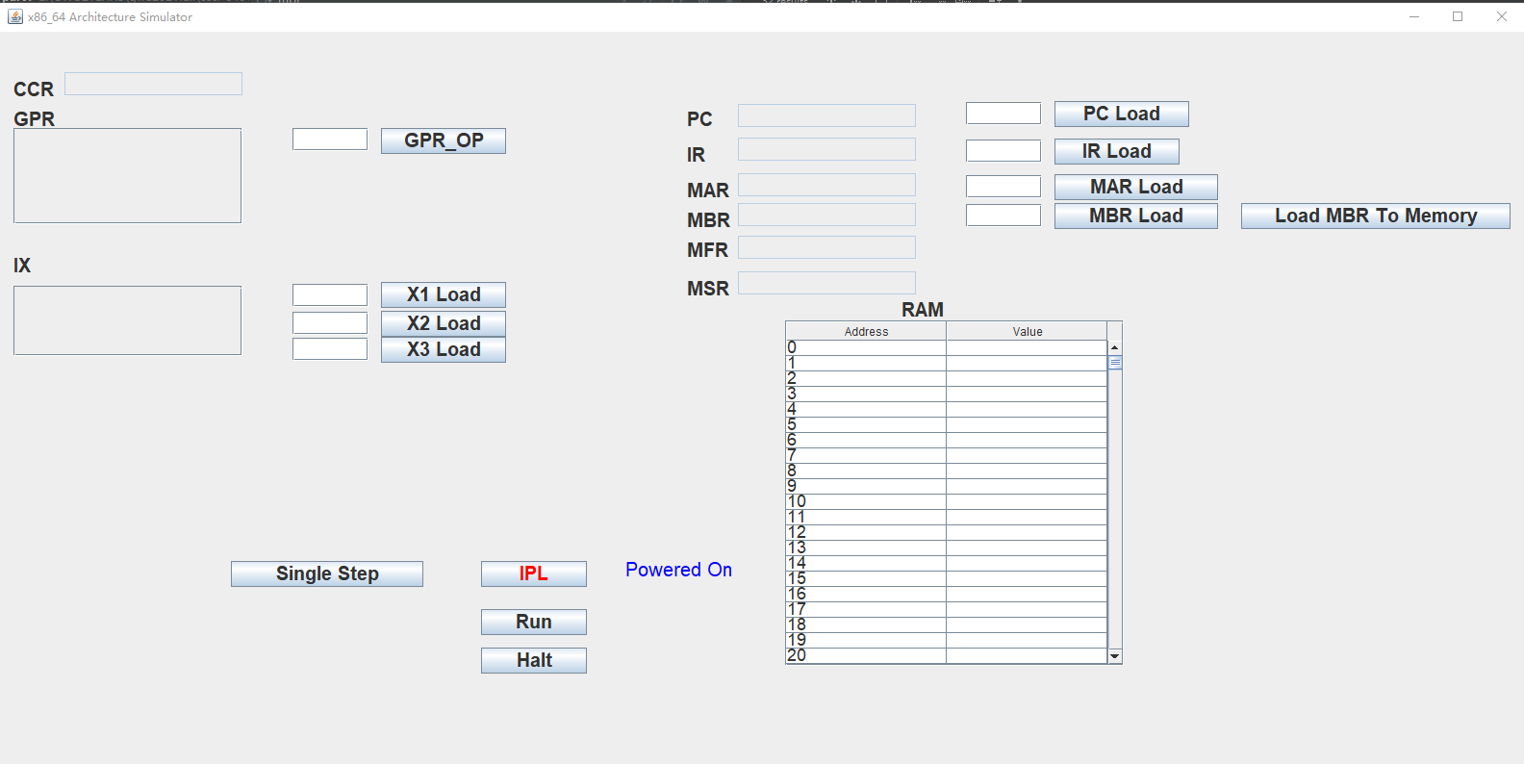

Single Step:

PC = PC + 1, get the next instruction and run for one step

IPL:

Initialize and load the instruction to the RAM, get the first instruction

Single Step:

PC = PC + 1, get the next instruction and run for one step

Run:

Run the instructions in the list

XXX Load：

Load the data into the register