**Testing Agent-based Virus Simulation in MATLAB**

1. Testing that infecting works (1 healthy agent, 1 infected agent)
2. Testing that recovering works (1 infected agent)
3. Testing that non-asymptomatic agents stop moving after incubation period (1 infected agent)
4. Testing that asymptomatic agents continuously move (1 infected agent)
5. Testing that immunity works (1 healthy agent, 1 infected agent)

This document is designed to provide evidence that testing of the key features of the system has occurred.

|  |  |  |  |
| --- | --- | --- | --- |
| Test # | Input Function | Expected Outcome | Success/Failure |
| 1 | ecolab(15,1,1,100) | Healthy agent becomes infected | Success |
| 2 | ecolab(15,0,1,200) | Infected agent recovers after 168 iterations | Success |
| 3* | ecolab(15,0,1,100) | Agent stops moving after incubation period | Success |
| 4* | ecolab(15,0,1,100) (& force agent to be asymptotic) | Agent continues to move throughout the simulation | Success |
| 5 | ecolab(15,1,1,100) (& force infected agent to stay infected) | Healthy agent gets infected, recovers, then ceases to get infected again | Success |

*Note: in the case of tests 2, 3 and 4, the code which creates the graph for the healthy human count must be commented out in order for the run statement to execute.*

*In tests 3 and 4 we noticed that, for the first 2 iterations, migration is not shown to occur on the graph. Having examined the code we could not find the source of this bug, as the code should allow migration from the start. To add to the confusion, the agents do move during this time. We know this because the command window output includes a count of how many agents are migrating. Because of this, we decided this must be an issue with how the model interfaces with the graphical elements. As it doesn’t seem to affect anything other than the migration graphs in these tests, we concluded that it was not something that was important to fix (although, given more time, this would be in our list of potential improvements). Please find the output graphs which correspond to each test on the following page.

**Test 1 (testing that infecting works):**

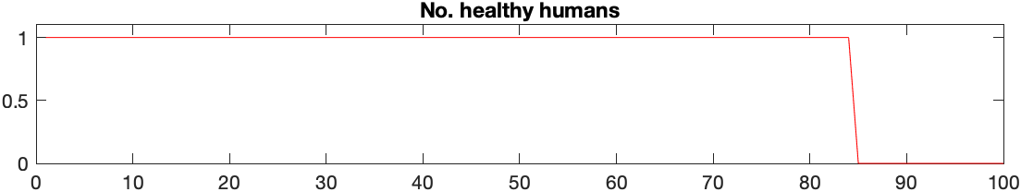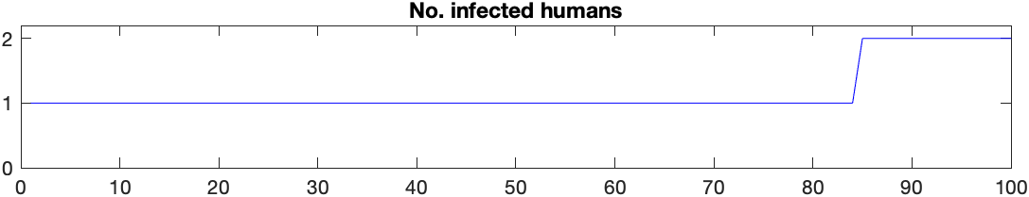

**Test 2 (testing that recovering works):**

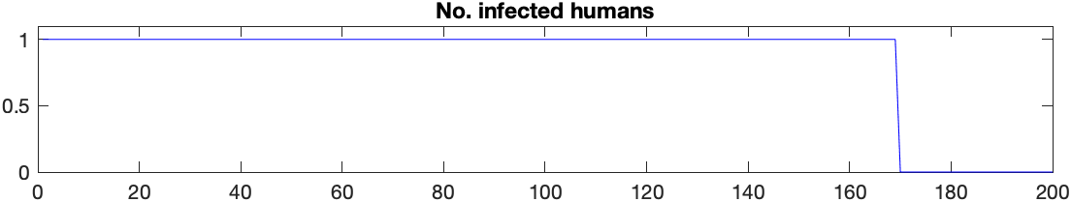

**Test 3 (testing that non-asymptomatic agents stop moving after incubation period):**

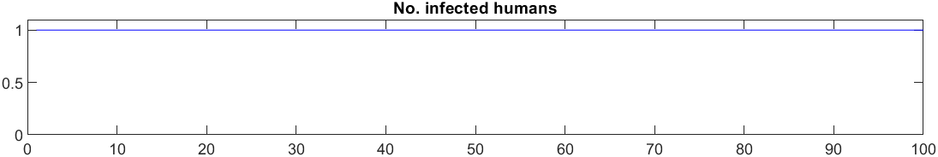

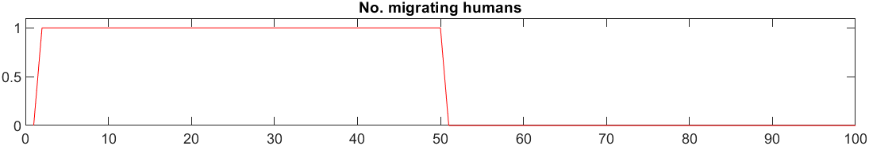

**Test 4 (testing that asymptomatic agents continuously move):**

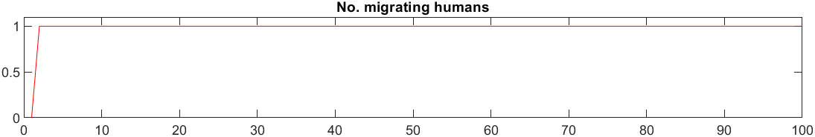

**Test 5 (testing that immunity works):**

