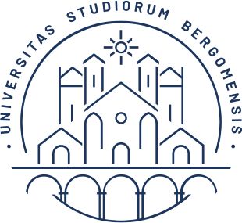

UNIVERSITY OF BERGAMO

School of Doctoral Studies

Doctoral Degree in Engineering and Applied Sciences

XXXVI Cycle

SSD: ING-INF/05

**Asset Protection by Providing Fine-grained Access Control to Mobile and Cloud Applications**

Advisor

*Prof. Stefano Paraboschi*

Doctoral Thesis by

*Matthew Rossi*

Student ID 1025234

Academic Year 2022/2023