

Installation & setup guide

AT&T Developer Program

Payment Web Setup Guide
Date: 10/15/2012
Version: 1a

Document Versions
Version No | Release Date | Author | Description
1a | 10/15/12 | Globallogic

InTENDED Audience
- Internal AT&T Users

Legal Disclaimer
This document and the information contained herein (collectively, the "Information") is provided to you (both the individual receiving this document and any legal entity on behalf of which such individual is acting) ("You" and "Your") by AT&T, on behalf of itself and its affiliates ("AT&T") for informational purposes only. AT&T is providing the Information to You because AT&T believes the Information may be useful to You. The Information is provided to You solely on the basis that You will be responsible for making Your own assessments of the Information and are advised to verify all representations, statements and information before using or relying upon any of the Information. Although AT&T has exercised reasonable care in providing the Information to You, AT&T does not warrant the accuracy of the Information and is not responsible for any damages arising from Your use of or reliance upon the Information. You further understand and agree that AT&T in no way represents, and You in no way rely on a belief, that AT&T is providing the Information in accordance with any standard or service (routine, customary or otherwise) related to the consulting, services, hardware or software industries.

AT&T DOES NOT WARRANT THAT THE INFORMATION IS ERROR-FREE. AT&T IS PROVIDING THE INFORMATION TO YOU "AS IS" AND "WITH ALL FAULTS." AT&T DOES NOT WARRANT, BY VIRTUE OF THIS DOCUMENT, OR BY ANY COURSE OF PERFORMANCE, COURSE OF DEALING, USAGE OF TRADE OR ANY COLLATERAL DOCUMENT HEREUNDER OR OTHERWISE, AND HEREBY EXPRESSLY DISCLAIMS, ANY REPRESENTATION OR WARRANTY OF ANY KIND WITH RESPECT TO THE INFORMATION, INCLUDING, WITHOUT LIMITATION, ANY REPRESENTATION OR WARRANTY OF DESIGN, PERFORMANCE, MERCHANTABILITY, FITNESS FOR A PARTICULAR PURPOSE OR NON-INFRINGEMENT, OR ANY REPRESENTATION OR WARRANTY THAT THE INFORMATION IS APPLICABLE TO OR INTEROPERABLE WITH ANY SYSTEM, DATA, HARDWARE OR SOFTWARE OF ANY KIND. AT&T DISCLAIMS AND IN NO EVENT SHALL BE LIABLE FOR ANY LOSSES OR DAMAGES OF ANY KIND, WHETHER DIRECT, INDIRECT, INCIDENTAL, CONSEQUENTIAL, PUNITIVE, SPECIAL OR EXEMPLARY, INCLUDING, WITHOUT LIMITATION, DAMAGES FOR LOSS OF BUSINESS PROFITS, BUSINESS INTERRUPTION, LOSS OF BUSINESS INFORMATION, LOSS OF GOODWILL, COVER, TORTIOUS CONDUCT OR OTHER PECUNIARY LOSS, ARISING OUT OF OR IN ANY WAY RELATED TO THE PROVISION, NON-PROVISION, USE OR NON-USE OF THE INFORMATION, EVEN IF AT&T HAS BEEN ADVISED OF THE POSSIBILITY OF SUCH LOSSES OR DAMAGES.

Table of Contents

1 Introduction 5
2 Installation Guidelines and Notes 6
2.1 Pre-requisite to use payment web application 6
2.2 Installation Process 7

Table of Figures

Figure 1: Build Process in VS2010 7
Figure 2: Web Setup Wizard 8
Figure 3: Virtual Directory Setup 9
Figure 4: Installation Confirmation 11
Figure 5: Installation Progress 12
Figure 6: Installation Completion 13
Figure 7: Application Deployed To IIS 14
Figure 8: Configuration Setting In web.config 15
Figure 9: Merchant Account Setting 15

- Introduction

This document is intended for providing the instructions for installing a web application using the web set up installers. Web application that is deployed using the set up will log the notification id received from AT&T servers in to the xml file and same will be used in the AT&T titanium application.

- Installation Guidelines and Notes
  - Pre-requisite to use payment web application
- Operating System Windows XP SP3, Windows Vista SP1,Windows 7
- .Net Framework 4.0
- IIS 7.5
  - Installation Process
- Click on the ATTPaymentWebSetUp msi which will open the dialog as shown in Fig 2.

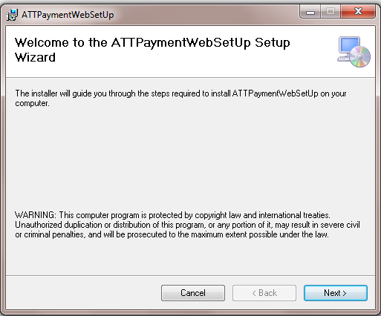

Figure 1: Web Setup Wizard

- Clicking on next will open the dialog as shown in Fig 3.
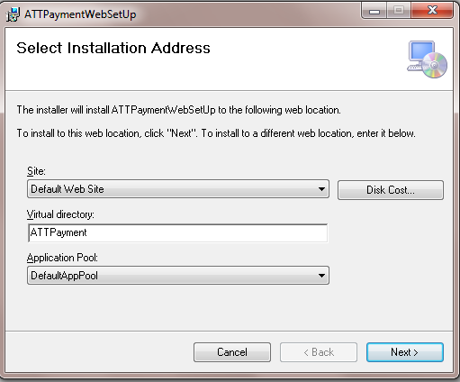

Figure 2: Virtual Directory Setup

- Specify the virtual directory name (By default it will be ATTPayment) and then click next which will open the dialog as shown in Fig 4.

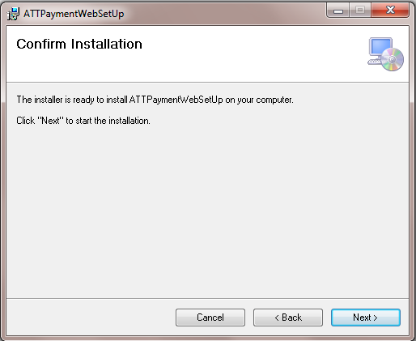

Figure 3: Installation Confirmation

- Click on next which will start the installing the application in IIS as shown in Fig 5. Once the application is completely installed it will show the confirmation dialog as shown in Fig 6.

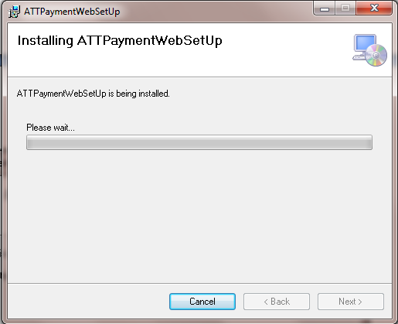

Figure 4: Installation Progress

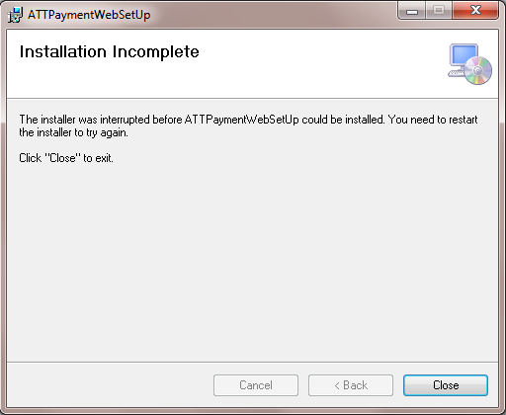

Figure 5: Installation Completion

- Click on close and application will be deployed in IIS as shown in Fig 7.
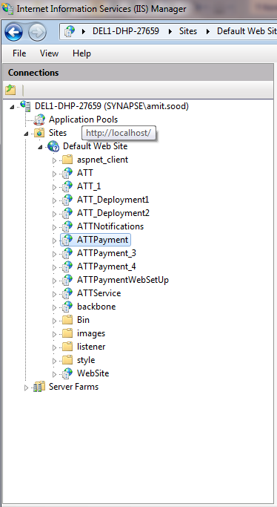

Figure 6: Application Deployed To IIS

- Open web.config and change the api key and the secret as shown in Fig 8.
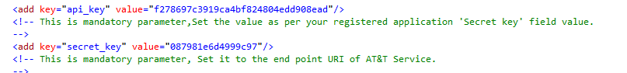
Figure 7: Configuration Setting In web.config

*Note:The api key and secret should have the same value as in the titanium application.

- Modify the MerchantPaymentRedirectUrl property in the sign payload method to point PaymentSuccess.apsx. The address format for the page is given below.
http://<domainname>/<application name in IIS>/PaymentSuccess.aspx

- Modify the value of ProductionNotificationURL and SandBoxNotificationURL in the merchant details section to the listener in the deployed application as shown in Fig 9.The address format for listener will be in the format as given below.
http://<domainname>/<application name in IIS>/Listener/Default.aspx

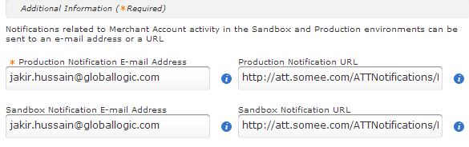
Figure 8: Merchant Account Setting

