Cookbook

Software Analysis Specification
1.0
February 20, 2015

Prepared by
L. Martin, D. Romero, M. Saunders, D. Young

Prepared for
CEN 4010 - Software Engineering I
Instructor: Masoud Milani, Ph.D.
Spring 2015

Revision History
Date | Revision | Author | Comments
2/20/15 | 0 | M. Saunders | Initial Draft.

Document Approval
The following Software Requirements Specification has been accepted and approved by the following:
Signature | Printed Name | Title | Date
 | Leonardo Martin | Student
 | David Romero | Student
 | Matthew Saunders | Student
 | David Young | Student
 | Masoud Milani, Ph.D. | Instructor, CEN 4010

Table of Contents
Table of Contents iii
1 Introduction 1
1.1 Purpose 1
1.2 Scope 1
1.3 References 1
1.4 Overview 1
2 Proposed System 1
2.1 General Description 1
2.2 Functional Requirements 2
2.2.1 Creation & Modification 2
2.2.2 Search 2
2.2.3 Membership 2
2.3 Use Case Model 2
2.3.1 Cookbook Creation 3
2.3.2 Recipe Creation 3
2.3.3 Ingredient Creation 4
2.3.4 Add ingredients 6
2.3.5 Modify Recipe by Registered 7
2.3.6 Modify Ingredients 8
2.3.7 Modify Recipe by Administrator 9
2.3.8 Register User 10
2.3.9 Login 11
2.3.10 Add Recipe to Cookbook 12
2.3.11 Search 13
2.3 Object Model 14
2.4 Dynamic Model 15
2.4.11 Sequence Diagrams 15
1.3.11 State Diagrams 21
1.3.11.4 Account 21
1.3.11.5 Cookbook 22
1.3.11.6 Recipe 23
1.4 Non-Functional Requirements 23
1.5 Constraints 23
2. Glossary 23

Introduction

Purpose
This document serves as the analysis of the Cookbook application. It is written for the Instructor of this group’s CEN 4010 (Software Engineering I) Course. The document is intended to outline the details of the proposed Cookbook application. Once the document has been reviewed and approved by all parties, the members of each party will sign and the document.

Scope
This document describes the analysis of the Cookbook application. This application will allow users to register accounts and create cookbooks for storing collections of recipes. The recipes are created by a particular user but can be viewed and shared by all users via the search functionality.
This application does not involve any social networking capabilities past seeing other user’s recipes. The application requires access to the web server it is running on, and is not available on any mobile specific platforms. It is accessible via a web browser only on all devices.
The benefits of this application include learning new recipes, sharing your favorite recipes, and organizing your recipes. In this way, the application aims to promote the sharing of recipe information.

Overview
This analysis documents contains three sections: Introduction, Proposed System, and Data Dictionary.
The introduction contains the purpose of this document, its scope, and the overview describing what is contained in this document and how it is organized.
The proposed system contains the functional requirements, nonfunctional requirements, and constraints of the system. The functional requirements are organized into three subsections based on functionality. These sections are Creation& Modification, Search, and Membership. After the functional requirements are the use case model, object model, and dynamic model. The dynamic model contains both sequence diagrams for each use case and state chart diagram for the objects of the object model.
The Glossary section contains a data dictionary. The dictionary includes the name, type (and length is applicable), the class the data type is associated with, and the definition describing what the data type is and how it is used within the Cookbook application.

Proposed System

General Description
Cookbook is a web based application that allows users to easily store and share their favorite recipes. Users can view any recipe on the Cookbook system without registering, but more functionality is gained when a user creates an account. A registered user gains the ability to add, modify, and delete recipes, as well as store recipes into cookbooks. The recipes stored in a cookbook can be created by that user or a different user, promoting recipe sharing. To assist users in browsing available recipes, the Cookbook application will have a search functionality that will allow a user to refine their browsing based on recipe characteristics.

Functional Requirements
The functional requirements are split into three main categories: Creation & Modification, Search, and Membership. Creation and Modification requirements are directly involved with the cookbook, recipe, and ingredient parts of the Cookbook Application. The search requirements define how the search should operate and which parameters the user can use to refine recipe searches. The Membership section differentiates between unregistered, registered, and administrator accounts.

Creation & Modification
- The system will allow registered users to create cookbooks.
- The system will allow registered users to create recipes.
- The system will allow registered users to create ingredients.
- The system will allow registered users to add ingredients to recipes.
- The system will allow registered user to edit recipes they have previously added.
- The system will allow administrators to modify ingredients.
- The system will allow administrators to modify recipes.
- The system will allow registered users to add recipes to cookbooks.

Search
- The system will allow all users to browse all recipes by category, difficulty, time, title, author.
- The system will allow users to place recipes into one of that user’s cookbooks.

Membership
- The system will allow anonymous user to sign up as a registered user to store user data.
- The system will allow users to login to registered user accounts.

Use Case Model
The following subsections are use cases that correspond directly with the functional requirements of the previous section. The use cases IDs map directly with the functional requirement number.
Each use case contains a standard set of subsections describing that use case. The summary section will include high level information like a brief description, pre- and post- conditions, and book keeping information to help organize and distinguish it from the other use cases. The inputs section includes all expected inputs during the flow of events and the source of each input. The normal course describes the procedure for the normal course of events. Likewise, the alternative course and exactions contains the alternative and exceptional course of events respectively. Finally, the outputs section includes all expected outputs during the flow of events and the source of each output.

Cookbook Creation

Summary
Name | Cookbook Creation
ID | 01
Description | The system will allow registered users to create cookbooks. These cookbooks will be used to store recipes.
Actor | Registered User
Trigger Event | The user clicks a button to “Create a Cookbook”.
Pre-conditions | The website is available.  The user is registered.
Post-conditions | The new cookbook is created.  The new cookbook is displayed on the user’s homepage

Inputs
Input | Source
User Account | System
Cookbook name | User

Normal Course
- The system displays a registered users homepage ← User Account
- The user clicks the button to “Create a Cookbook”
- The system displays a dialog box for the cookbooks name ←
- The user inputs the name of the cookbook and clicks OK ← Cookbook name
- The system creates a new cookbook object and displays it to the users home page → new cookbook

Alternative Course
This use case does not contain any alternative course of events.

Exceptions

Cancel creation
- The user selects cancel on the dialog box prompting for the cookbook name.
- The user is returned to the user’s homepage and the cookbook is not created.

Outputs
Output | Source
Cookbook | Cookbook DB

Recipe Creation

Summary
Name | Recipe Creation
ID | 02
Description | The system will allow registered users to create recipes. These recipes will be used to store ingredients.
Actor | Registered User
Trigger Event | The user clicks a button to “Create a Recipe”.
Pre-conditions | The website is available.  The user is registered.
Post-conditions | The new recipe is created.  The new recipe is displayed to the user  The recipe is linked to the user’s cookbook (if applicable)

Inputs
Input | Source
User Account | System
Recipe Information | User

Normal Course
- The system displays a registered users homepage ← User Account
- The user clicks the button to “Create a Recipe”
- The system displays a form for the user to input the recipe name, ingredients, procedure, cook time, difficulty, creator, category, and cookbook (if applicable) ← Recipe Form
- The user inputs the recipe information and clicks Create ← Recipe Information
- The system creates a new recipe object and displays the recipe object for the user → Recipe Object

Alternative Course
This use case does not contain any alternative course of events.

Exceptions

Cancel creation
- The user selects cancel on the recipe form.
- The user is displayed the recipe.

Outputs
Output | Source
Recipe Form | System
Recipe | Recipe DB

Ingredient Creation

Summary
Name | Ingredient Creation
ID | 03
Description | The system will allow registered users to create ingredients. These ingredients will be used in recipes.
Actor | Registered User
Trigger Event | The user clicks a button to “Create an Ingredient”.
Pre-conditions | The website is available.  The user is registered.  The user is in the process of creating a recipe.
Post-conditions | The new ingredient is created.  The new ingredient is displayed on the recipe creation form page

Inputs
Input | Source
User Account | System
Recipe name | User
Ingredient Row in Form | System
Ingredient Dialog Box | System
Updated Recipe Form | System

Normal Course
- The system prompts the user that the ingredient does not exist and asks if the user wants to create it.
- The user click OK to create the ingredient
- The user enters new ingredient information ← Ingredient object created
- The system displays the updated recipe form with the added ingredient ← updated recipe form

Alternative Course

User removes added ingredient
- The user click to delete the new ingredient row. ← Ingredient row removed
- The recipe form is displayed without the new ingredient row. ← Recipe form

Exceptions

Cancel creation
- The user clicks cancel on the create ingredient dialog box → Cancel
- The system displays the recipe form ← recipe form

Outputs
Output | Source
Ingredient | Ingredient DB

Add ingredients

Summary
Name | Cookbook Creation
ID | 01
Description | The system will allow registered users to add ingredients to recipes.
Actor | Registered User
Trigger Event | The user clicks a button to “Add Ingredients”.
Pre-conditions | The website is available.  The user is registered.  The recipe already exists in the database.  The recipe belongs to the user.
Post-conditions | An ingredient is added to the recipe.

Inputs
Input | Source
Recipe form | System
Add Ingredient button clicked | User
Ingredient specified | User
Quantity specified | User

Normal Course
- The system displays the recipe creation form
- The user clicks the button to “Add Ingredients”
- The system displays ingredient adding form
- The user specifies the name of the ingredient
- The system checks if the ingredient exists
  - if the ingredient exists, the user selects the ingredient
  - if the ingredient is not found, the system prompts the user to create the ingredient
6. The system prompts the user for the measurement and unit of the ingredient
7. The user enters a quantity followed by selecting a unit of measurement
8. The selects “Ok”
9. The system adds the ingredient to the recipe
10. The system prompts the user to keep adding ingredients.
11. The user selects “Yes” or “No”
- if “Yes” the system repeats case
- if “No” the system returns to recipe display

Alternative Course
This use case does not contain any alternative course of events.

Exceptions

Cancel Ingredient
- The user selects cancel button at anytime during the adding process
- The system does not add the ingredient

Ingredient already exists in recipe
- The user tries to add an ingredient that already exists in the recipe
- The system alerts the user and prompts if they want to increase the quantity
- The user cancels or enters new quantity
- The system cancels the addition of the ingredient or updates the quantity

Outputs
Output | Source
Ingredient added | Recipe

Modify Recipe by Registered

Summary
Name | Modify Recipe by Registered
ID | 05
Description | The system will allow registered users to modify an existing recipe.
Actor | Registered User
Trigger Event | The user clicks a button to “Modify a Recipe”.
Pre-conditions | The website is available.  The user is registered.  The recipe being modified exists and was created by this user.
Post-conditions | The recipe is modified.  The modified recipe is displayed to the user.

Inputs
Input | Source
User Account | System
Recipe form with existing data | System
Recipe form with modified data | User

Normal Course
- The system displays a registered users homepage ← User Account
- The user clicks the button to “Open Cookbook”.
- The system displays the cookbooks recipes.
- The user clicks a recipe.
- The system displays the recipe selected by the user.
- The user select to “Modify Recipe”.
- The system displays the same recipe form displayed when creating a recipe, but the fields are pre-populated with the existing data. ← Recipe form with existing data
- The user edits the recipe data and click “Submit”. ← Recipe form with modified data
- The system updates the recipe in the database and displays the updated recipe page. → Modified Recipe

Alternative Course

Cancel modification (deviates after step 7)
- The user selects cancel on the recipe form
- The user is returned to the recipe page and the recipe remains unmodified.

Exceptions
This use case does not contain any exceptional course of events.

Outputs
Output | Source
Modified Recipe | Recipe DB

Modify Ingredients

Summary
Name | Modify Ingredients
ID | 06
Description | The system will allow administrator users to modify ingredients.
Actor | Registered User
Trigger Event | The user clicks a button to “Modify an Cookbook”.
Pre-conditions | The website is available.  The user is an administrator.  The ingredient exists in the database.
Post-conditions | The ingredient information is modified  The new ingredient shows up on the new page of ingredients

Inputs
Input | Source
User Account | System
Ingredient form with existing data | System
Ingredient form with modified data | User

Normal Course
- The system displays an administrator users homepage ← User Account
- The user clicks the “Ingredients” tab to display all ingredients.
- The user selects an ingredient and clicks “Modify”.
- The system displays a dialog box with the ingredient selected by the user and the existing data pre-populated in the same dialog box as the create ingredient form. ← Ingredient form with existing data
- The user edits the ingredient data and click “Submit” ← Ingredient form with modified data
- The system updates the ingredient in the database and displays the updated page of ingredients. → Modified Ingredient

Alternative Course
This use case does not contain any alternative course of events.

Exceptions

Cancel modification
- The user selects cancel on the dialog box for modifying an ingredient
- The user is returned to the user’s homepage and the ingredient remains the same.

Outputs
Output | Source
Modified Ingredient | Ingredient DB

Modify Recipe by Administrator

Summary
Name | Modify Recipe by Administrator
ID | 07
Description | The system will allow administrator users to modify an existing recipe.
Actor | Registered User
Trigger Event | The user clicks a button to “Modify a Recipe”.
Pre-conditions | The website is available.  The user is registered.  The recipe being modified exists and was created by this user.
Post-conditions | The recipe is modified.  The modified recipe is displayed to the user.

Inputs
Input | Source
User Account | System
Recipe form with existing data | System
Recipe form with modified data | User

Normal Course
- The system displays a registered users homepage ← User Account
- The user clicks the “Recipes” tab to display all recipes.
- The user selects a recipe.
- The system displays the recipe selected by the user
- The user select to “Modify Recipe”
- The system displays the same recipe form displayed when creating a recipe, but the fields are prepopulated with the existing data. ← Recipe form with existing data
- The user edits the recipe data and click “Submit” ← Recipe form with modified data
- The system updates the recipe in the database and displays the updated recipe page. → Modified Recipe

Alternative Course

Cancel modification (deviates after step 7)
- The user selects cancel on the recipe form
- The user is returned to the recipe page and the recipe remains unmodified.

Exceptions
This use case does not contain any exceptional course of events.

Outputs
Output | Source
Modified Recipe | Recipe DB

Register User

Summary
Name | Register User
ID | 08
Description | The system will allow anonymous users to sign up as a registered user to store user data.
Actor | Unregistered User
Trigger Event | User selects “Register”
Pre-conditions | The website is available.  Registration is available.  The user is unregistered.
Post-conditions | User account is created

Inputs
Input | Source
Name | User
Email | User
Password | User

Normal Course
- User selects to “Register”
- Information is collected from the user: username, password, email
- Information is tested for veracity
- User account is created with supplied credentials
- Welcome email is sent to the supplied address

Alternative Course
This use case does not contain any alternative course of events.

Exceptions

Cancel Registration
- The user selects cancel button at anytime during the registration process
- The system discards the temporary data and returns the user to the homepage

Username already exists in system
- The user tries to register a username that already exists in the system
- The system alerts the user and prompts if they want to change the username
- The user cancels or enters a new username
- The system cancels the registration or continues the registration

Outputs
Output | Source
Cookbook | Cookbook DB

Login

Summary
Name | Login
ID | 09
Description | The system will allow users to log into registered accounts
Actor | Registered User
Trigger Event | User selects “Login”
Pre-conditions | Website is available  Login system is available  User is not logged in
Post-conditions | User is logged in

Inputs
Input | Source
Username | User
Password | User

Normal Course
- User selects to “Login”
- User is presented with a login screen
- User enters their credentials
- User selects login and the supplied credentials are verified

Alternative Course
This use case does not contain any alternative course of events.

Exceptions

Cancel Login
- The user selects cancel button at any time during the login process
- The system discards the temporary data and returns the user to the homepage

Username does not exist in the system
- The user tries to login with a username that does not exist in the system
- The system alerts the user and prompts if they want to change the username
- The user cancels or enters a new username
- The system cancels the registration or continues the registration

Password does not match the username
- The user tries to login with a password that does not match the username
- The user is prompted to re-enter the password
- The user cancels or enters a new password
- The system cancels the registration or continues the registration

Outputs
Output | Source
Account is logged in | Account DB

Add Recipe to Cookbook

Summary
Name | Add Recipe to Cookbook
ID | 10
Description | The system will allow registered users to add recipes to their cookbooks.
Actor | Registered User
Trigger Event | The user clicks a button to “Add Recipe to Cookbook”.
Pre-conditions | The website is available.  The user is registered.  The user is currently viewing a recipe.
Post-conditions | The recipe is added to the selected user cookbook.

Inputs
Input | Source
Cookbook ID | User
Recipe Page | System

Normal Course
- The system displays a recipe page to the user.
- The user clicks the button to “Add Recipe to Cookbook”
- The system displays a list of the user’s cookbooks to add the recipe to. → Cookbook List
- The user selects the cookbook to add the recipe and clicks Add ← Cookbook ID
- The system add the recipe to the cookbook → Recipe ID
- The system displays the recipe page of the recipe just added to the cookbook ← Recipe Page

Alternative Course
This use case does not contain any alternative course of events.

Exceptions

Cookbook does not exist
- The user does not have any cookbooks to choose.
- The user is displayed the recipe with an error message.

Outputs
Output | Source
Cookbook List | System
Recipe ID | Cookbook DB

Search

2.3.11.1Summary
Name | Search
ID | 11
Description | The system will allow users to search for recipes based off keywords in query.
Actor | Anonymous User
Trigger Event | User commits to search by clicking search or hitting enter in search bar
Pre-conditions | The website is available.
Post-conditions | User receives a list of recipes which match keywords

2.3.11.2Inputs
Input | Source
Query | User

2.3.11.3Normal Course
1 The system displays a search bar on all pages.
2 The user inputs the recipe or other keywords in the search bar
- The system returns a list of search results that match keywords in the query
- User interacts with search results, selecting those which best fit query

2.3.11.4 Alternative Course
This use case does not contain any alternative course of events.

Exceptions

2.3.11.5.1No results found
1. User attempts to search for recipes
2. The system fails to make a match and notifies the user.

2.3.11.5.1Search interrupted
1. User types a new query in the search bar and clicks search or presses enter
2. User inputs a new query in search bar in the middle of the search

2.3.11.6 Outputs
Output | Source
Search results | System

Object Model
Figure 1 shows the object model of the Cookbook Application. All user accounts are first described by the Account interface which contains the username field. The Unregistered class directly inherits from this interface, setting the username to a default value like “Guest” to indicate the user is not registered with the system. The Registered class adds the fields necessary for a user to become registered with the system. The Administrator class is a child class of the Registered class and adds no additional fields. The only difference between these wo classes is the value of the “isAdministrator” field and the privileges that are granted to an administrator user.
The other three classes are Cookbook, Recipe, and Ingredient. A Cookbook contains references to Recipe objects. Similarly, a Recipe object contains references to Ingredients. Cookbook is related to account because a Cookbook object is dependent on an Account for ownership and existence.
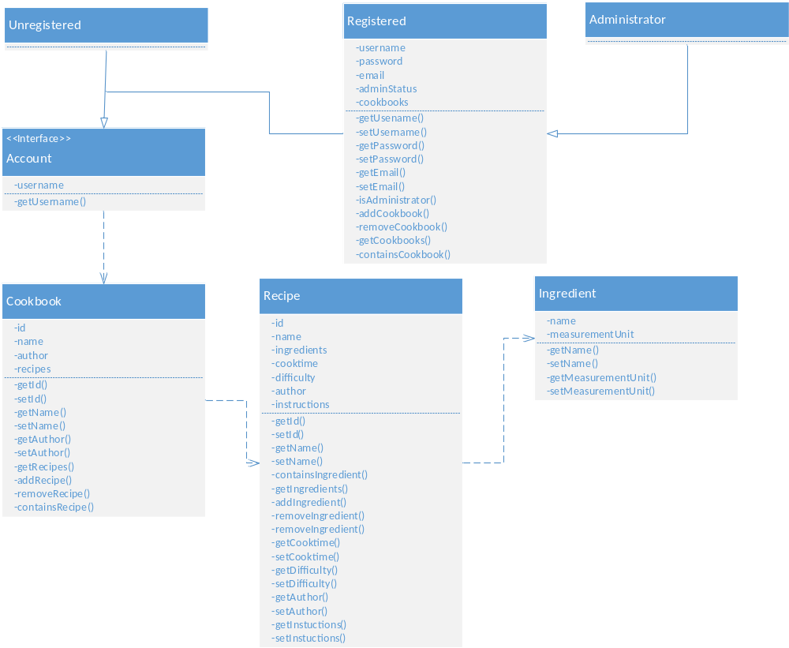
Figure 1 – Object Model

Dynamic Model

Sequence Diagrams
Below are the sequence diagrams for each of the Use Cases.

Cookbook Creation
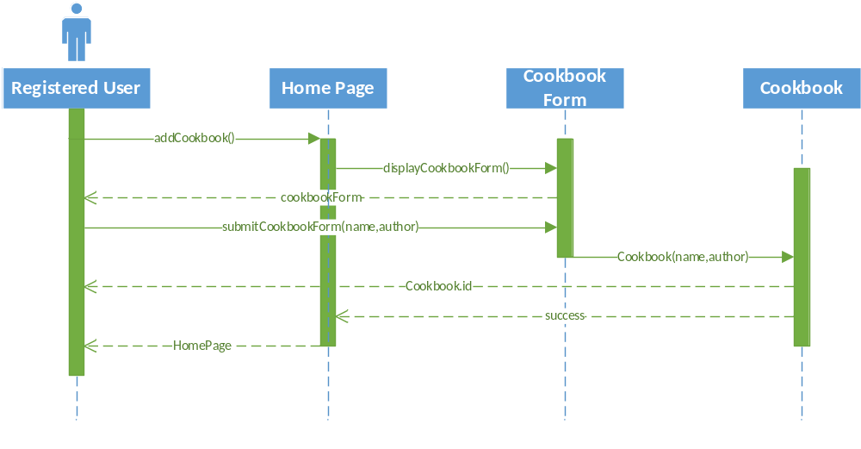

Recipe Creation
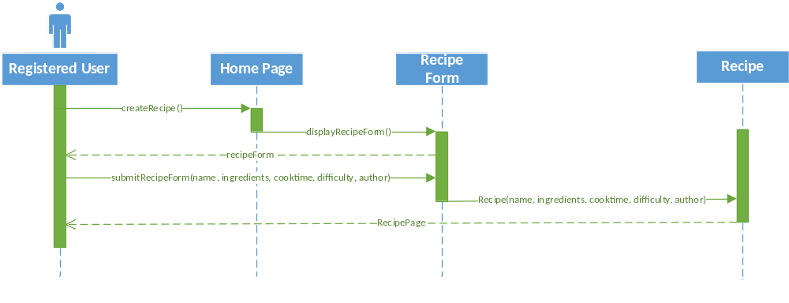

Ingredient Creation
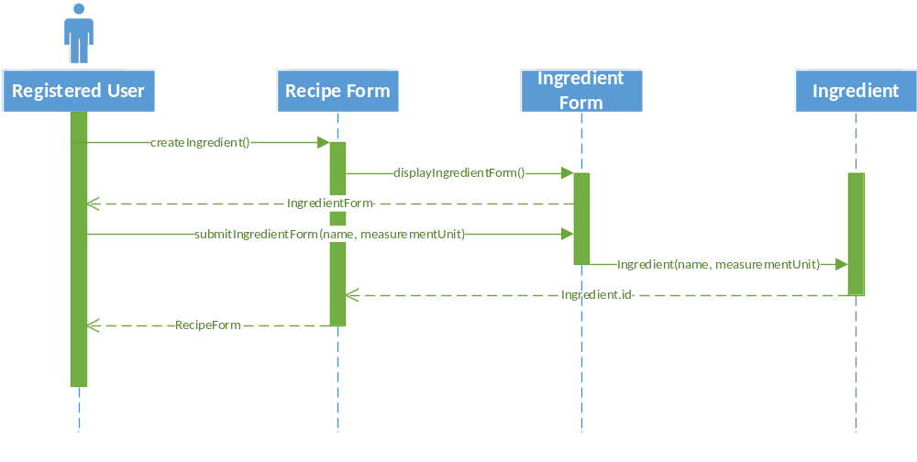

Add Ingredient
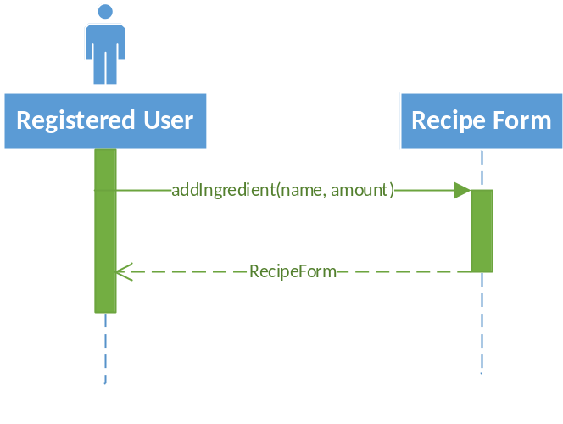

Modify Recipe by Registered
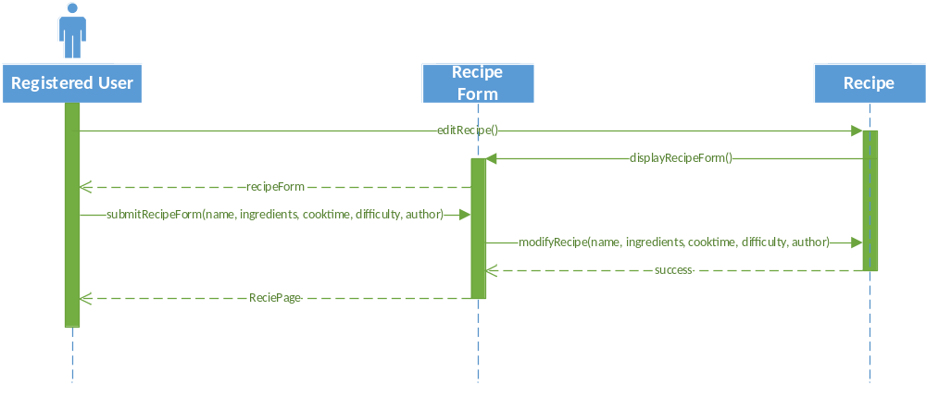

Modify Ingredient
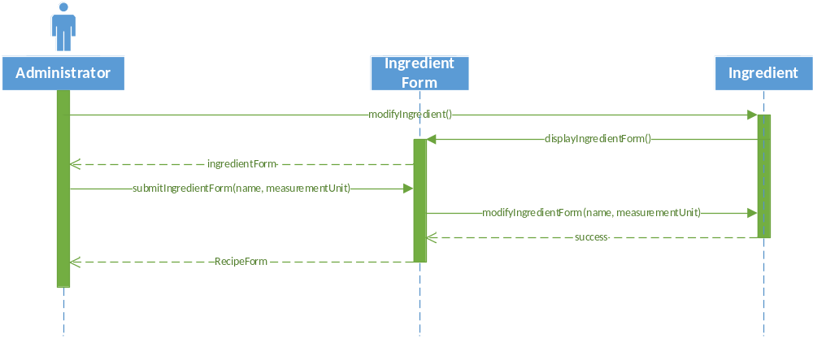

Modify Recipe by Administrator
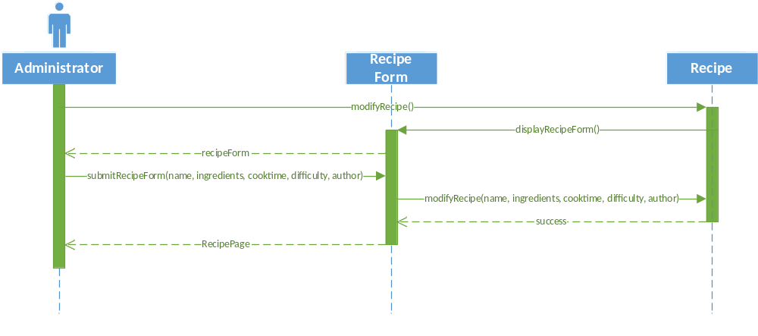

Register User
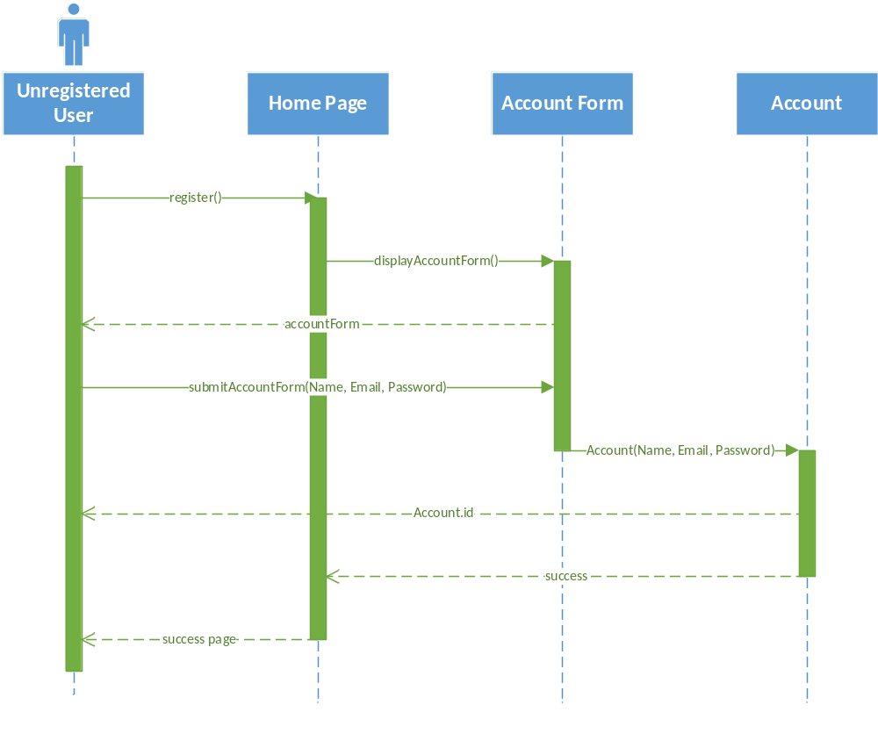

Login
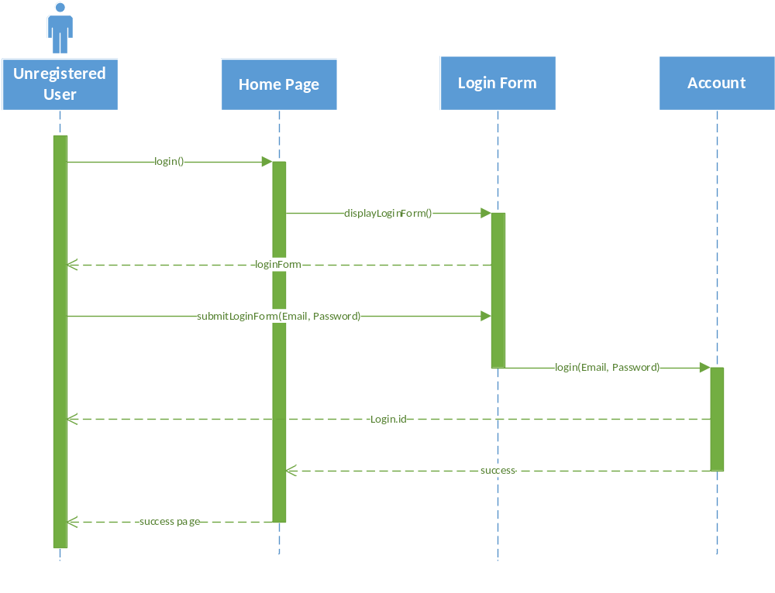

Add Recipe to Cookbook
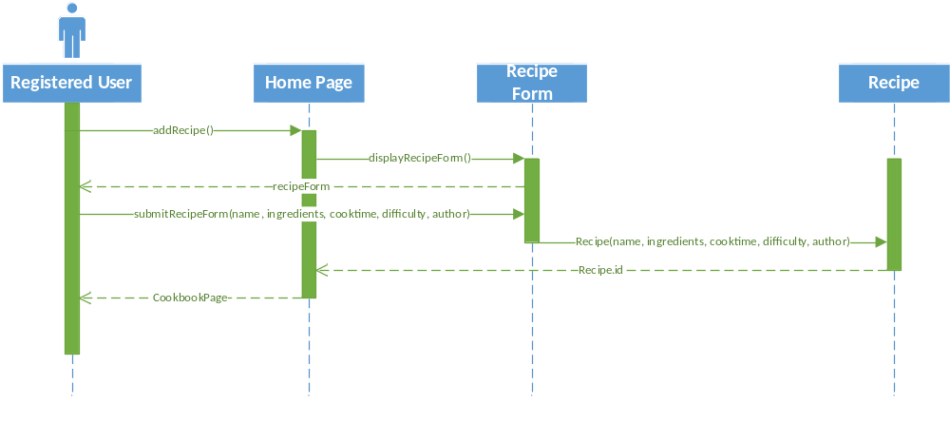

Search

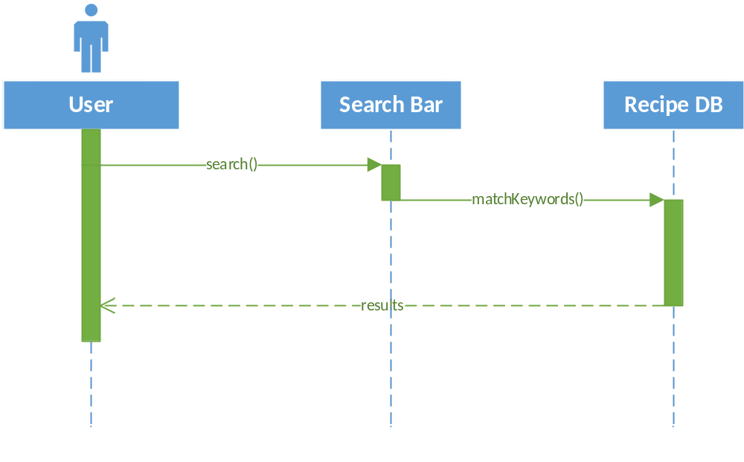

State Diagrams
Below are the sequence diagrams for the Account, Cookbook, and Recipe Objects.

Account
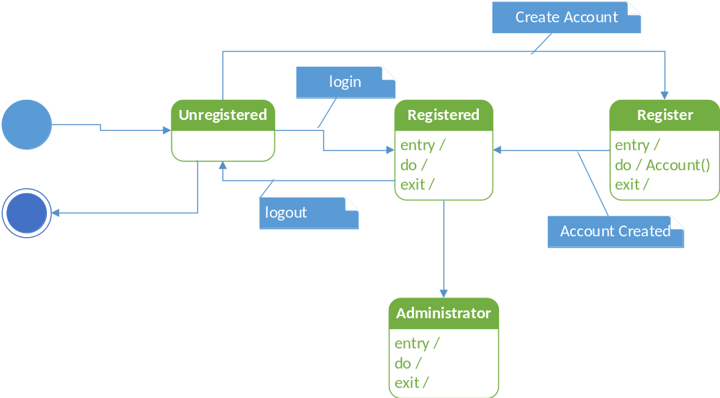

Cookbook
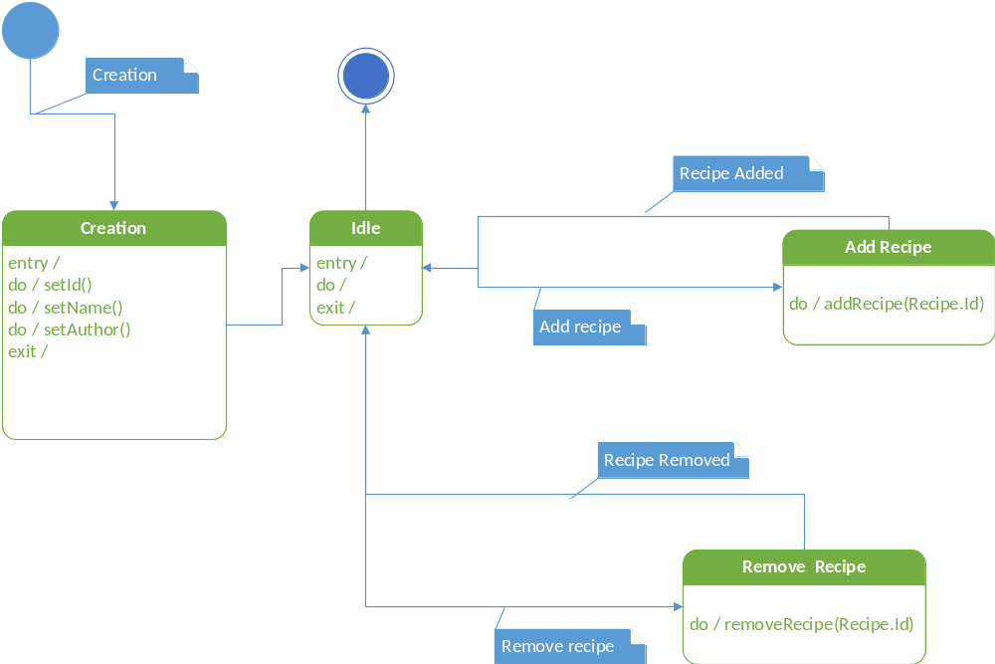

Recipe
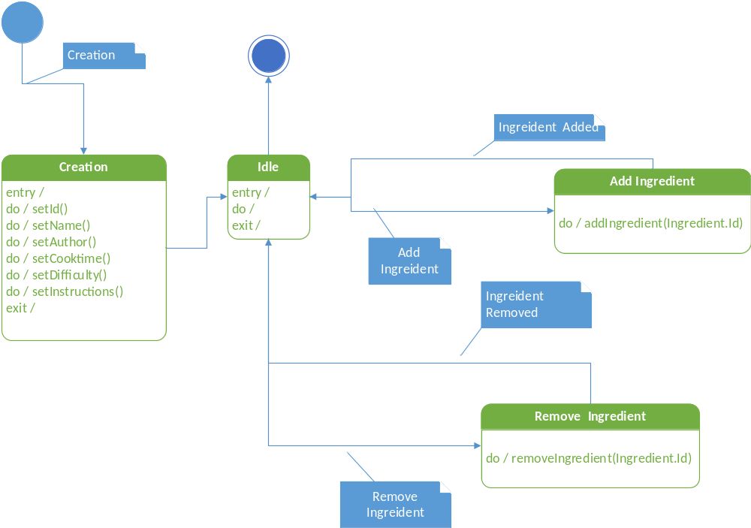

Non-Functional Requirements
- The system will allow the application to run on any browser that supports HTML 5
- User information will be secured by password

Constraints
- There must be a database in this application
- The front-end of this application must run in a web browser
- The system will allow for 3 actors/types of users
- The application must be completed by April 21, 2015

Glossary

Data Dictionary
The dictionary includes the name, type (and length is applicable), the class the data type is associated with, and the definition describing what the data type is and how it is used within the Cookbook application.
Data Field | Type(Length), Nullability | Class | Definition
username | char(25), not NULL | Account (Interface) | Unique username of Registered User. Will also be used as author tag for Cookbooks and recipes.
password | char(25), not NULL | Registered User | Password of Registered User that will be used for login purposes.
email | char(25), not NULL | Registered User | Email of Registered User.
adminStatus | boolean, not NULL | Registered User | Shows whether the Registered User is an Administrator.
name | char(25), not NULL | Ingredient | Unique name of Ingredient.
measurementUnit | char(25), Can be NULL | Ingredient | Determines what the Ingredient will be measured in for determining quantities.
name | char(25). Can be NULL | Recipe | Name of Recipe
id | int, not NULL | Recipe | Unique Identification number of Recipe
ingredients | Ingredient, Can be NULL | Recipe | Array of pointers to ingredients that are included in a Recipe
cooktime | int, Can be NULL | Recipe | The time it takes to make a Recipe
difficulty | int, Can be NULL | Recipe | How difficult it is to make this Recipe (1-5)
author | char(25), not NULL | Recipe | Author of the Recipe. Received from Username
instructions | BLOB, Can be NULL | Recipe | Text that defines the necessary steps to make a Recipe
name | char(25), not NULL | Cookbook | Name of Cookbook
author | char(25), not NULL | Cookbook | Author of Cookbook; received from Username
recipes | Recipe, Can be NULL | Cookbook | Array of pointers to Recipes that are included in a Cookbook
id | int, not NULL | Cookbook | Unique Identification number of Cookbook

