|  |
| --- |
| West Herts College |
| [Document title] |
| Asteroids Odyssey | Capstone |

|  |
| --- |
| Matthew Sides  2-18-2018 |

|  |
| --- |
| Version 1.02 |
|  |
| 18/02/2018 |

**Current Version**

**Revision List**

|  |  |  |  |
| --- | --- | --- | --- |
| Version | Author | Date | Comments |
| 1.00 | Matthew Sides | 4th December 2017 | Initial Version |
| 1.01 | Matthew Sides | 5th February 2018 | Altered Layout |
| 1.02 | Matthew Sides | 18th February 2018 | Elaborated on Management |
|  |  |  |  |

**Table Contents**

[1] Project Management

[2] Design

[3] Evaluation

**Project Management** [1]

**Scope** [1.1]

This documentation is intended to be read by programmers, artists and producers involved in the design implementation and testing of the the Desktop-game and Asteroids recreation "Asteroids Odyssey".

**Type Conventions** [1.2]

Things that have been discussed in a meeting are presented in this document with no asterisks.

Things that have not been officially agreed on but which are suggested by the author are presented with asterisks, like this (*), being marked as omitted until it has been agreed upon that it may be of use or implemented.

**Outline** [1.3]

This document pertains to the management and design for the conceptual features and mechanics (gameplay) of a game (project) with the provisional title “Asteroids Odyssey”.

Further delving into an evaluation, once all the required criteria has been met, to check standards of the quality of work and game produced based on design and following a schedule (shaped through management).

The conceptual idea is set to be based on the 1979 arcade game "Asteroids". Asteroids Odyssey a rendition of "Asteroids" will hone the elements used in Asteroids and its style, merging the ideology and methodology of Asteroids with newer ideology’s, methodologies and technology, being re-built from the ground up and not ported (ported Asteroids version edited), Asteroids Odyssey will be compatible and be able to function on newer systems.

**Aims and Objectives** [1.4]

* Carry out (\**superstantial*) substantial research that garners discussion and opinions, including both qualitative and quantitative data.
* Link two systems through a database (cloud), displaying real time changes on two separate screens.
* Incorporate two sets of controls, enabling both keyboard | mouse (in conjunction) and the Microsoft Xbox controller (with interchangeable controls).
* Create a functional rendition of asteroids, that herald’s similar elements.

**Management Strategy** [1.5]

The subsequent management strategy set to be used during the projects design and production of an Asteroids rendition, "Asteroids Odyssey" is Scrum, a globally acquitted and noted methodology that heralds from and places emphasis on software development.

The Methodology is essentially designed for teams of three to nine developers who break their work into actions that can be completed within time boxed iterations, called sprints (typically two-weeks) and track progress and re-plan in 15-minute stand-up meetings, called daily scrums.

Though in this instance the project team only consists of one developer, key concepts brought about through the methodology regarding the organisation of the project may and will be applied to better structure the project and create/enhance a management strategy, ensuring the project is completed in intervals to an acceptable standard and rushed out at the appropriate pre-defined or set date (meeting standards, timings and setting self discipline).

Following the use of Scrum the appropriate tools and techniques that will be used in correlation to ensure the project is completed in a timely manner to a set standard, consists of the generation of a Gant chart, laying out the foundation for the project and what should be followed.

Moreover using user stories and epics in which to base what the Gant chart will follow in regards to what will be mapped and tracked in the chart. Further using Milestones to separate the tasks and allow for revision of the current task and overall situation of the project, noting key points throughout and enabling prolonged breaks for forethought.

**Requirements** [1.6]

The requirements in correlation with the project consist of the use of Visual studios and Unity during the procedural build phase.

The reason behind the use of unity in particular is due to the available options and tools that can hoist certain operations and also produce shortcuts throughout the project, for instance Multiplayer is a requirement, Unity heralds a built-in Multiplayer Networking and the associated High Level API (HLAPI), thus making the process easier.

Whilst Visual studios is compatible with both Unity and the language in which the game is set to be programmed in (C#)

Moreover, the costs relating to the project are interchangeable any may vary depending on the amount and cost of said graphics and music purchased for said game rendition.

Furthermore, another requirement, quality assurance is detrimental to the project ensuring consistency and will be monitored constantly throughout, testing occurring during production to ensure that a certain standard is being met, meeting self and others evaluation.

**General Plan** [1.7]

The plan consists of essentially detailing designs through storyboards and paragraphs, further showing functionality through flow charts and algorithm. Whilst this will be enacted through this documentation and a schedule will be mapped out using said charts (showing management).

Following the design in conjunction research will be carried out pertaining to the ideology and methodology on how to reduce vulnerabilities. This research warranting the use of secondary and primary, using questionnaires and surveys to measure people awareness on the subject and then finding related articles on the subject to get an idea on how to reduce vulnerabilities myself.

Moreover, after the design and project management planning, during production phase, a multiplayer rendition of Asteroids will formulate using googles free fire database to add online/multiplayer elements and so that the program may be accessed on two systems (concurrent), furthermore the final version should incorporate a function that enables players/users to be able to use their controllers as well as keyboard and mouse (controller compatible).

**Research Plan** [1.8]

The research being carried out pertains to how to reduce vulnerabilities in a system and will include both quantitative and qualitative data being both secondary and primary.

Further elaborating on the primary data being gathered, a questionnaire will be formulated and handed out to people that are likely required to have some basic knowledge in the respective subject, essentially questioning business and ICT students at the 3rd level of their education pathways, which is the equivalent to six form.

Following the research, the data and congregated information gathered will be put into practice through the project, using said information gathered in an attempt to reduce vulnerabilities in the games system using techniques and methodology’s learned.

**GANTT chart** [1.9]

The Gantt chart below is inapplicable to the later tasks as the Gantt chart had to be shortened due to a lack of space and limitations in Microsoft word, though the duration is displayed in the part of the table labelled "Duration".

|  |  |  |  |  |  |  |  |  |  |  |  |
| --- | --- | --- | --- | --- | --- | --- | --- | --- | --- | --- | --- |
| ID | Task Name | Predecessors | Duration | 18 | 02 | 18 |  |  |  |  |  |
|  |  |  |  | S | M | T | W | T | F | S | S |
| 1 | Start |  | 0 Days |  |  |  |  |  |  |  |  |
| 2 | Project Management |  | 3 Days (Including Sat) |  |  |  |  |  |  |  |  |
| 3 | Design |  | 6 Days |  |  |  |  |  |  |  |  |
| 4 | Project Demo |  | 34 Days |  |  |  |  |  |  |  |  |
| 5 | Demo Review |  | 39 Days |  |  |  |  |  |  |  |  |
| 6 | Evaluation |  | 39 Days |  |  |  |  |  |  |  |  |

**Target User**[10.1]

Through analysis of the originals audience and genre coupled with the inclusion of new key aspects and concepts being brought in and incorporated/designed for the game or new rendition, the target audience seen to be players or user’s that have an interest in the following Genres; Sci-Fi, Multi Directional Shooter and Multiplayer.

Moreover in regards to the age range, this tightly connects and links to the pegi rating, if it were to be rated by their scale, which in this instance would be termed as a “7” (though could reach for a 3 rating) since no profanity, gore or any violent nature is shown except for the inclusion of igniting or shooting a gun positioned onto the side of a ship, though no representation of the weapon will be displayed rather bullets just appearing near the ships front.

* Following the above examination to better define what the seven pegi rating entails, it is “any game that would normally be rated at 3 but contains some possibly frightening scenes or sounds may be considered suitable in this category”. -

Whilst any destruction of alien life-forms or portrayed as alien ships will only show the overall destruction or an explosion of the ship made of in organic material pertaining to no form of gore, Illustrating the explosion in a way in which disconnects from realism, to ensure no emotional instability or effect to a players psychic, which may lead to the player disremembering the verity, that this is essential a game and has in no form a connection or attachment to their physical life.

Therefore through thorough consideration of the pegi rating and the markets current situation with regards to whose currently playing video games, this rendition will sought to target those of around 18-35 years, though will not necessary be limited to that demographic, if others wish to purchase the game as long as the Pegi rating scale is abided by to protect minors from psychological harm.

* The age range 18-35 was ultimately chosen as it is only second to those under the age of 18 playing coming in at 27% of American gamers in 2017, whilst those under made or make up 29% of the demographic and although the 2% is an significant percentage, the nostalgic aspect should make it easier to target audiences in the older demographics rather than the younger generation. –
* In continuation to the second hand information gathered based around the age demographic of American gamers in 2017, 36-49 year olds came in at 19%, whilst 50 years and older totalled 26% of the industry -

Furthermore to explain why the original games (schematics) range or target demographic is not considered or applied (though used in the decision of a new target audience for this rendition), during the coined “Golden Age” in which the original was conceived, the systems and games of this era were still abstract concepts and experiments.

Therefore an indefinite target audience or whether during the time it would be successful was debatable as games were still seen or viewed as gimmicks in certain people’s eyes, thus using the old asteroids demographic may not necessary be wise as the range was not what attributed to the games success but rather its innovation, simplistic design (controls/ attributed to the user ease of use) and lack of a similar infographic or games at the time.

*\*Reference links-*

*\*http://www.pegi.info/en/index/id/33/*

*\* https://www.statista.com/statistics/189582/age-of-us-video-game-players-since-2010/*

**User Requirements & Expectations** [10.2]

**Project Milestones (EPICS)** [10.3]

1. Create a functional Asteroids Rendition.
2. Connectivity between multiple systems.
3. Compatibility with a controller and vice versa, working or functioning with keyboard and mouse as well.
4. View and navigate across a purposeful and structured menu.
5. Incorporate research taken out into the building and production process/phase.

**UI Designs**[10.4]

**Storyboard**[10.5]

**Algorithms** [10.6]

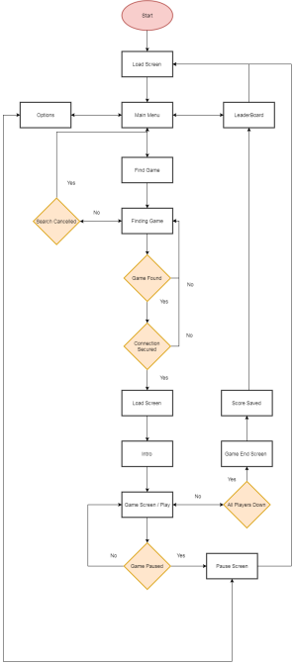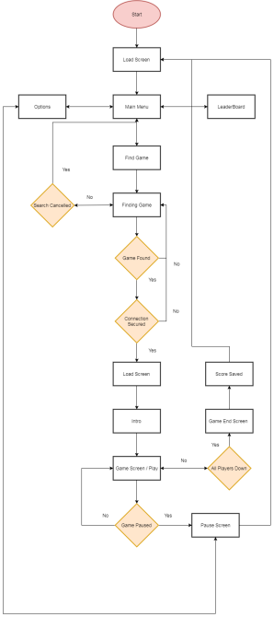

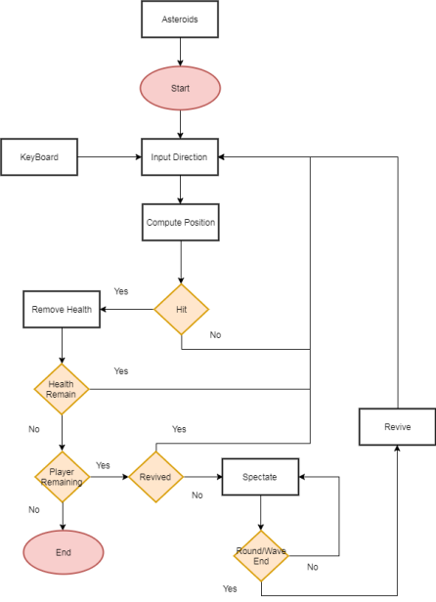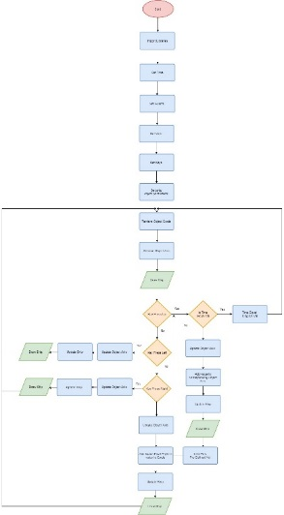

**Features** [10.7]

**User Stories (Project Backlog)** [10.8]

User Stories Revised (Epics Broken Down)-

1. Initiate a move state (Move a pre-defined model across a screen)

|  |  |  |  |
| --- | --- | --- | --- |
| Priority | Product Backlog Items | Description | Due Date |
|  |  |  |  |
|  |  |  |  |
|  |  |  |  |
|  |  |  |  |
|  |  |  |  |

**Target Burn down Chart**[10.9]

**1stWeek Sprint (Backlog)** [11]

|  |  |  |  |  |  |  |  |  |  |
| --- | --- | --- | --- | --- | --- | --- | --- | --- | --- |
| Priority | Sprint Backlog Items | Due Date | Mo | Tu | We | Th | Fr | Sa | Su |
|  |  |  |  |  |  |  |  |  |  |
|  |  |  |  |  |  |  |  |  |  |
|  |  |  |  |  |  |  |  |  |  |

**2ndWeek Sprint (Backlog)** [11.1]

|  |  |  |  |  |  |  |  |  |  |
| --- | --- | --- | --- | --- | --- | --- | --- | --- | --- |
| Priority | Sprint Backlog Items | Due Date | Mo | Tu | We | Th | Fr | Sa | Su |
|  |  |  |  |  |  |  |  |  |  |
|  |  |  |  |  |  |  |  |  |  |
|  |  |  |  |  |  |  |  |  |  |

**Coding Standards**[11.2]

Coding standards are version-independent and "always-current". All new code should follow the current standards, regardless of (core) version. Existing code in older versions may be updated, but doesn't necessarily have to be. The coding standards applied for this particular project are similar to those used by Drupal (Drupals coding standards).

1. Indenting and White Space-

Use an indent of 2 spaces, with no tabs. Lines should have no trailing whitespace at the end.

1. Operators-

All binary operators (operators that come between two values), such as +, -, =, !=, ==, >, etc.(should) have a space before and after the operator, for readability.

1. Casting-

Put a space between the (type) and the variable in a cast: (int) variable name.

1. Control Structures-

Control structures essentially relating to if, for, while, switch, etc. Control statements should always have one space between the control keyword and opening parenthesis, to distinguish them from function calls.

Moreover always use curly brackets even in situations that are technically optional, since they decrease the likeliness of logic errors, etc.

1. Line Length and Wrapping-

Conditions (conditional statements) should not be wrapped into multiple lines. Whilst Lines containing longer function names, function/class definitions, variable declarations, etc should not exceed 80 characters.

Although conditional statements may as long as its purpose is conveyed or portrayed clearly. Furthermore comments are allowed to exceed the limit, though must be moderated still to ensuring the code is not impossible to locate as it is overwritten and encased in comments.

1. Function calls-

Functions should be called with no spaces between the function name, the opening parenthesis, and the first parameter; spaces between commas and each parameter, and no space between the last parameter, the closing parenthesis, and the semicolon.

1. Quotes-

There is no pre-defined or set standard for double or single quotes other than trying to keep consistency and ensure that the quotes are closed and not left open to avoid any errors.

1. Comments-

There isn't a particular standard to commenting other than ensuring that comments are clear and concise, the amount of characters a comment may exceed is not set, though it is recommended to keep the comments to either one or two lines.

1. Naming conventions-

Functions should be named using lowercase, and words should be separated with an underscore. Functions should in addition have the grouping/module name as a prefix, to avoid name collisions between modules.

Variables should be named using lowercase, and words should be separated either with uppercase characters.

1. Arrays-

Arrays should be formatted using short array syntax with a space separating each element (after the comma), and spaces around the => key association operator, if applicable.

1. Function Declarations-

Arguments with default values go at the end of the argument list. Always attempt to return a meaningful value from a function if one is appropriate.

Anonymous functions should have a space between "function" and its parameters.

*\*Reference links-*

*\*https://www.drupal.org/docs/develop/standards/coding-standards*

**Design[2]**

**Games Mechanics**

**Player States**

**Move-**

**Intractable Entity's**

1. Big Space Ship
2. Small Space Ship
3. Big Asteroid
4. Small Asteroid

**Points system**

|  |  |  |  |
| --- | --- | --- | --- |
| ID | Value | Destroyed | Points |
| Small Asteroid | 50 | 0 |  |
| Big Asteroid | 100 | 0 |  |
| Small Saucer | 150 | 0 |  |
| Big Saucer | 200 | 0 |  |

**Health Damage system**

|  |  |  |  |
| --- | --- | --- | --- |
| ID | Damage | Hit | System Health |
| Small Asteroid | -1 | 0 | 100% |
| Big Asteroid | -5 | 0 |  |
| Small Saucer | -4 | 0 |  |
| Big Saucer | -7 | 0 |  |

**Player Camera View**

The Camera will be a fixed aerial view, tracking the 2D ship graphic model continuously (real-time), positioned in the middle of the screen. The system applied, similar to the online game Diep.io which boasts a fixed camera that disables scrolling out to view the surrounding environment (area), thereafter adding another element to the game as players are forced to be more cautious.

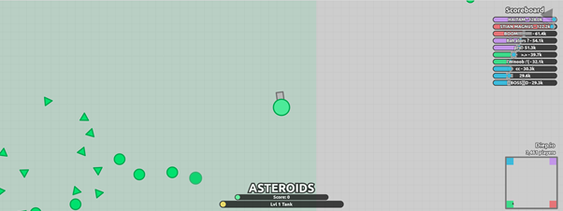

**Target Systems**

The game has ultimately been decided to be hosted on PC despite the rise in the mobile market since the majority of user's and reason for the sudden rise in mobile gaming stems from the east in particular china, whilst the game will only run (be using) on one lingistutic language English.

Therefore it would be useless to cater to a demographic whom are unlikely to buy the game due to its demeanour and exclusion of national language a barrier that though passable is still a problem in regards to the user's ease of use.

Furthermore nationals with whom speak the English language (Americans, English, Australia, etc) though have a huge following on mobile, the computing gamer market still largely outweighs the mobile market by ______, hence the reason the game will be run on PC.

With regards to download, despite the heavy critiscm steam has been garnering recently due to the scrap of steam green light and influx of shoddy and poorly made games, the game will be available and hosted (put up) via the steam store as although the massive flow traffic will make it harder for a game to be distinguishable the abolishment of steam green light does not come without any advantages, since now only a fee is required to be procured by valve or steam rather than a fee and user recognition.

Whilst the ability to stand out in a ever so saturating and cluttered market place would prove capability and thereafter boost influence and recognition (brand status).

Steam is also still a widely regarded and respected market platform and although may not herald the same status as it used to still has the ability to make or break a game.

In addition to market said applications onto the apple store place an ID is required meriting or allowing the application to be sold through the apple store. Furthermore apple also includes its own terms of service that have to be met and abided by with the application being checked based on said regulations before it is even released even after paying for the right to host on the apple store since apple have their own standards.

**Inspiration**

Following the decision to recreate the 1979 arcade game Asteroids, collective research into similar classics and there remakes has given fruit to the ideology behind this rendition, Asteroids Odyssey, using a similar aesthetic outlook to the original and updated vectors, along with tweaked game mechanics, updated game sounds and a multitude of game variations thus giving the game more flavour, tweaking any faults found in the original due to developer mistakes and allowing the user to have access to more content. Thus enhancing playability, Mimicking the original with a twist, allowing gamers to experience the journey that is asteroids with another, overall following suit to the originals legacy but altering certain aspects of the game to build upon the flaws that stemmed from the 1979 release, essentially modernising the game.

As seen below games that helped formulate this rendition-

1. Pac man Championship
2. Mario
3. Halo Anniversary (switch between graphics)
4. call of duty black ops (Zombie mode, Team work, Leader board)
5. Crash bandicoot (DDA System)
6. Diep.io (Camera view)

**Notes (Undecided Features)**

* *procedural/randomly generated environment*

*\*add adaptive music*

*\*button to switch between retro graphics and sounds to updated versions*

*\*neon updated graphics*

*\*faced paced intro before the menu*

*\*2D with 3D aspects or illusion of 3D*

*\*Single Player with different aspects and tutorial*

*\*Ranks and different ships as player rewards*

*\*References Links-*

*\*http://melodrive.com/blog/what-is-adaptive-music/*

*\*http://soundbible.com/1795-Electrical-Sweep.html*

**Test Plan**

**Evaluation [3]**