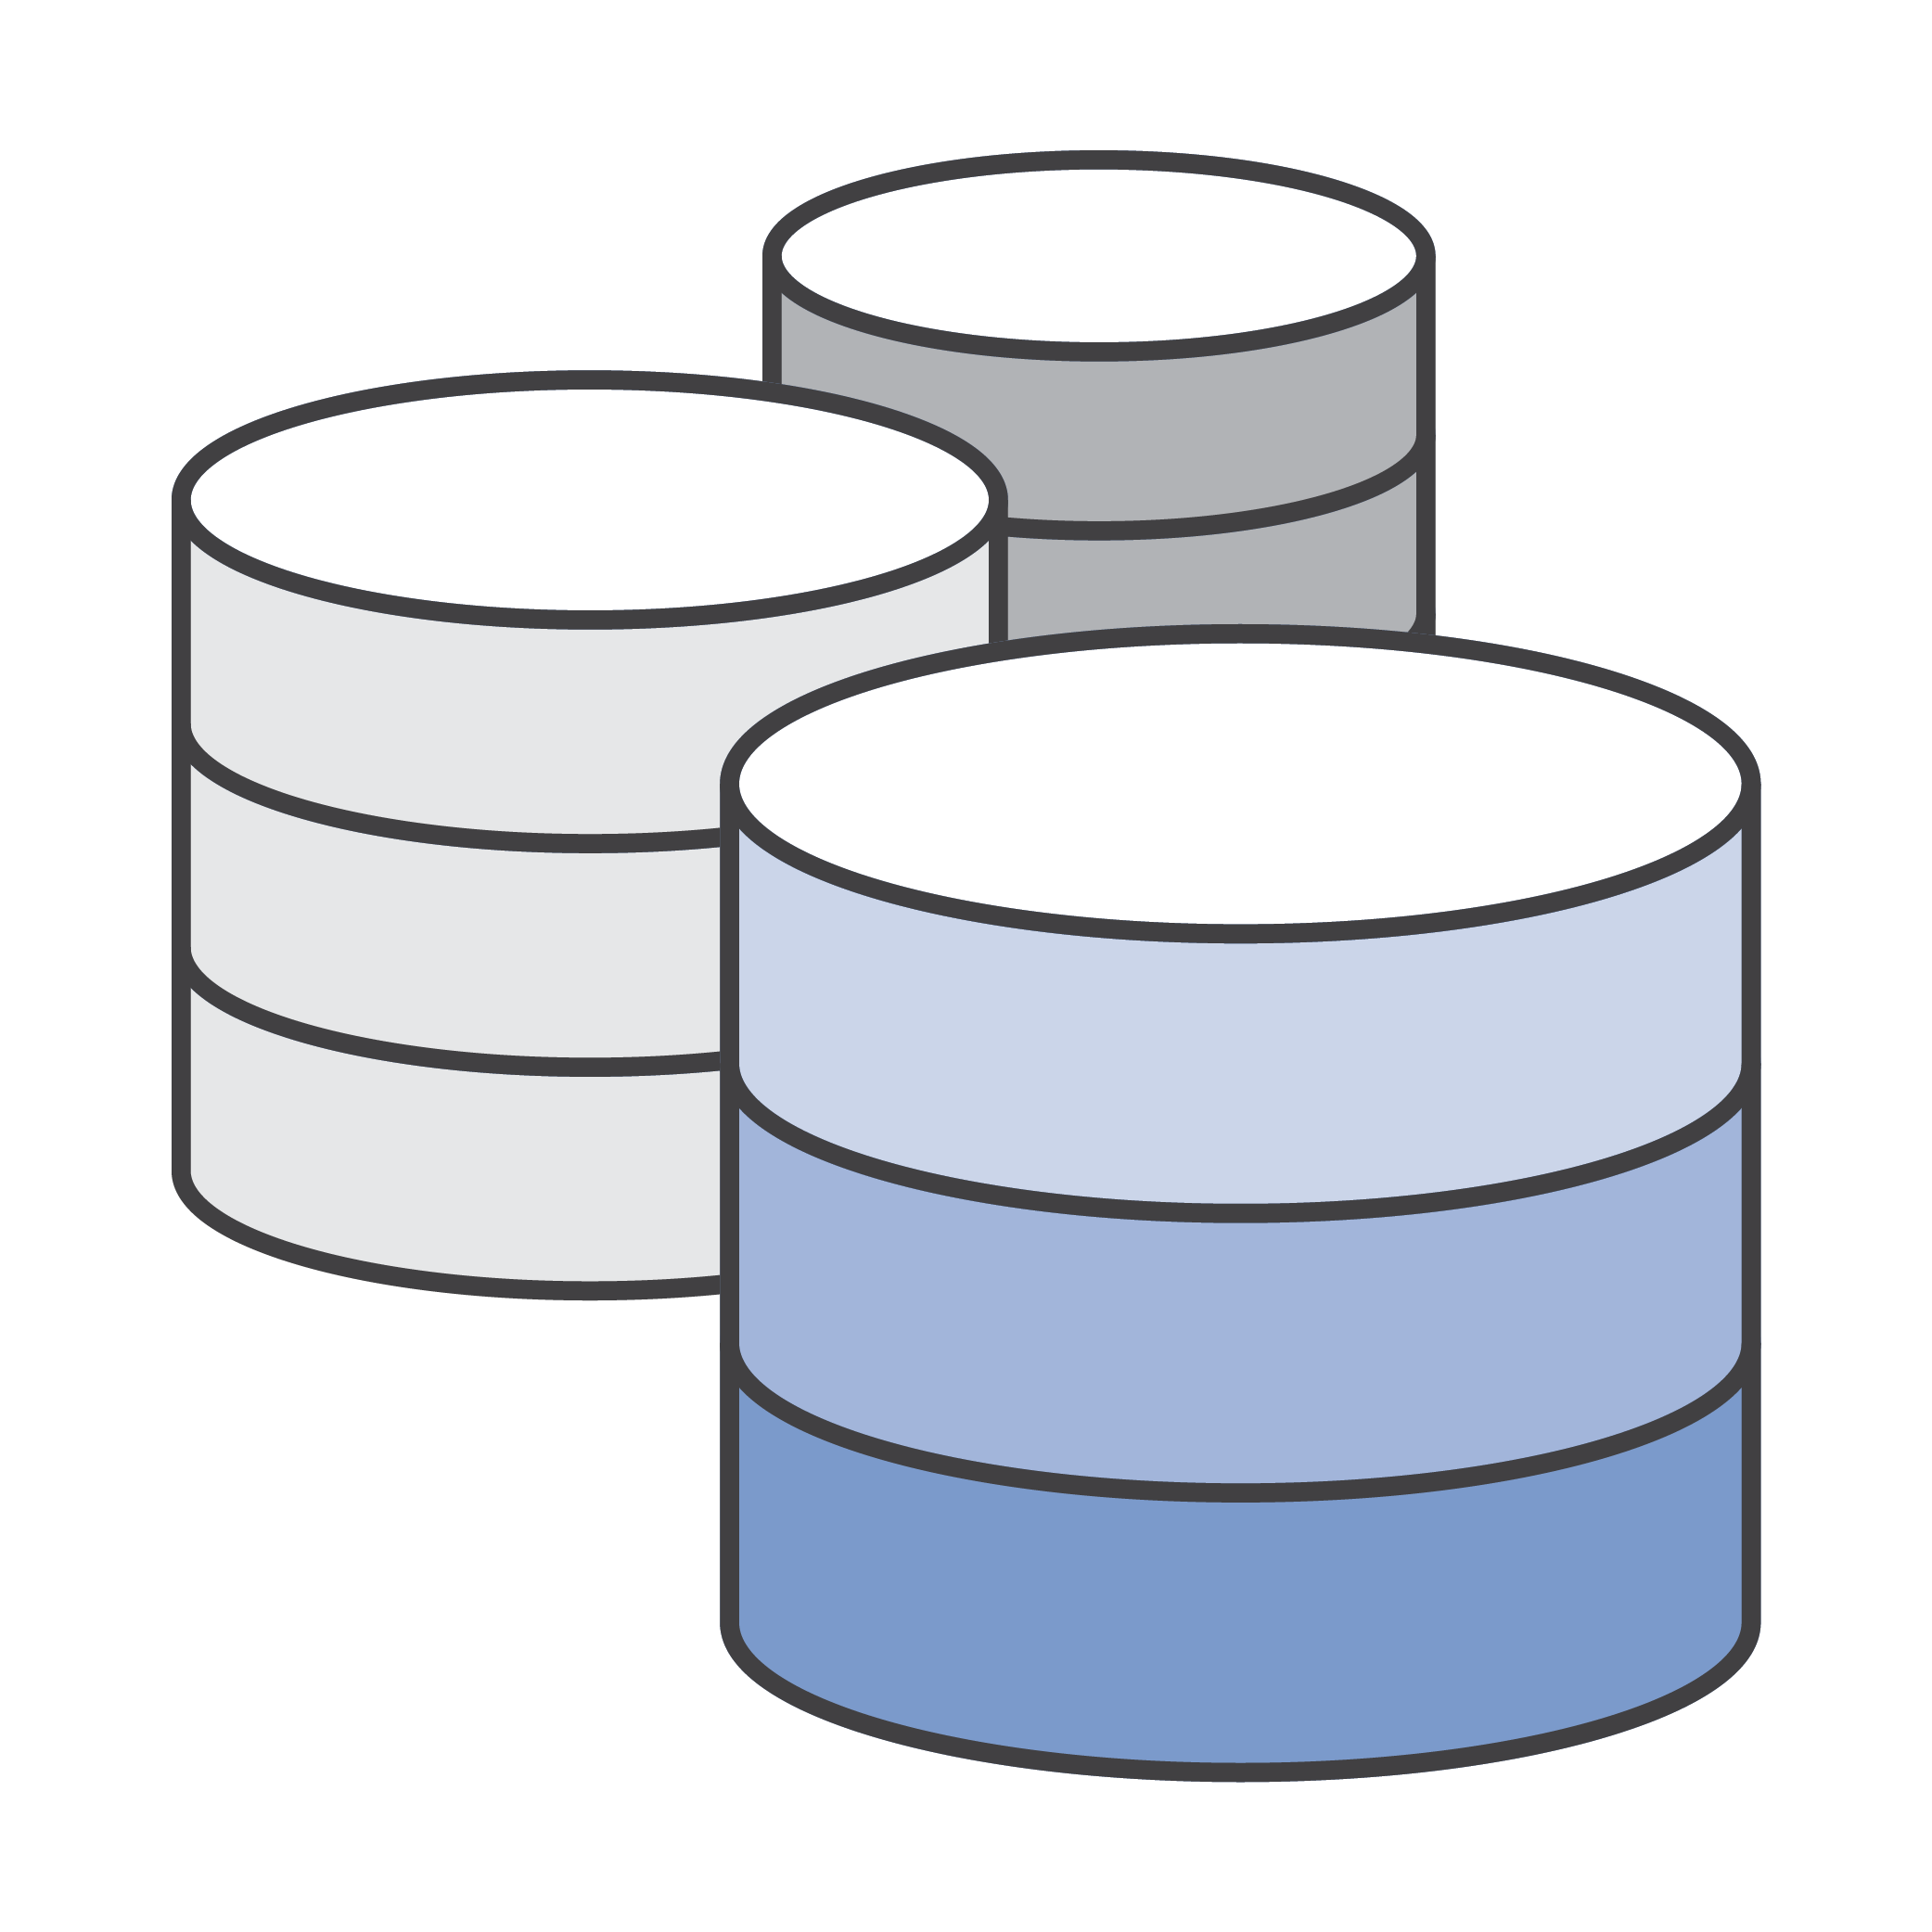

**User Manual**

Matthew Sides  
11/04/18

**USER'S MANUAL**

**TABLE OF CONTENTS**

Page #

1.0 GENERAL INFORMATION 1

1.1 System Overview 1

1.2 Project References 1

1.3 Organization of the Manual 2

1.4 Acronyms and Abbreviations 2

2.0 SYSTEM SUMMARY 3

2.1 System Configuration 3

2.2 Contingencies and Alternate Modes of Operation 3

3.1 System Menu 4

3.1.1 Main Interface 4

3.1.2 Enemies 5

3.1.3 Heroes 6

3.1.4 Skills 7

3.1.5 Heroes Skills 7

3.1.6 Enemies Skills 8

3.1.7 Delete Entry 9

3.1.8 Exporting Data to Excel 12

3.2 Exit System 12

4.0 QUERYING 13

4.1 Querying 13

4.2 Query Capabilities 13

4.3 Query Procedures 14

5.0 REPORTING 15

5.1 Reporting 15

5.2 Report Capabilities 15

5.3 Report Procedures 15

**1.0 GENERAL INFORMATION**

# GENERAL INFORMATION

## 1.1 System Overview

The system is designed to allow the user to seamlessly enter in data about a particular entity (Hero, Enemy) using pre-programmed, easy-to-use forms. The information entered into the forms is then warehoused in a database table. Users are then capable of generating a number of various reports based on the information in the database table. The system is also capable of using Microsoft Excel to efficiently import and export data.

The system is designed to be run with Microsoft Access 2007, and was developed in 2018 by Matthew sides apart of the Reboot organisation. It is classified as a simple application, with a straightforward GUI.

## 1.2 Project References

The following is a list of the references that were used during development of the system:

* Microsoft Access 2007
* Microsoft Word 2007
* Microsoft Excel 2007
* W3Schools

## 1.3 Organization of the Manual

This manual is divided into 5 major sections, listed and defined below.

1. – General Information: Contains basic information about the program, such as functions performed and a description of the program.
2. – System Summary: This section provides a general overview of the system.
3. – Getting Started: This section provides a general walk-through guide to the system, from beginning to exit.
4. – Querying: This section describes the query and retrieval capabilities of the system.
5. – Reporting: This section describes the various reports that can be generated by the system.

## 1.4 Acronyms and Abbreviations

GUI – Graphical User Interface

# SYSTEM SUMMARY

## 2.1 System Configuration

Users are provided with a GUI to interact with the database to complete tasks such as data insertion, data deletion, data modification, along with various queries and reports.

## 2.2 Contingencies and Alternate Modes of Operation

Regular backups should be performed, due to the fact that in the event of an emergency and/or accident, stored data could become lost.

Whilst Data should be purged, archived and updated regularly to ensure that the 2GB of storage is not filled, thus clearing up the traffic or flow of data.

**3.0 GETTING STARTED**

## 3.1 System Menu

### 3.1.1 Main Interface

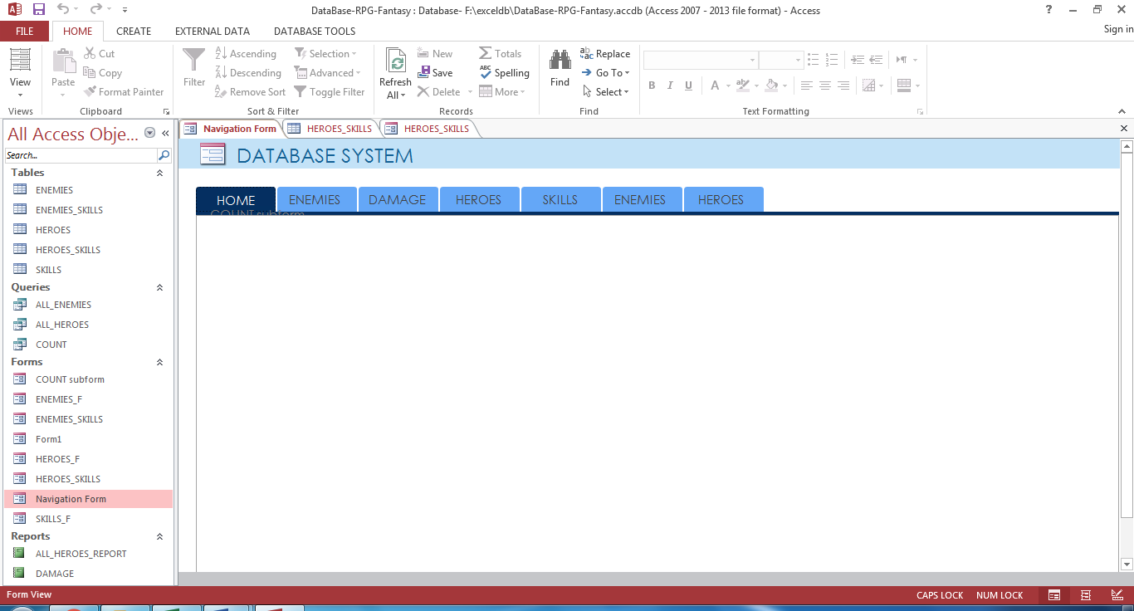

Upon launching the system, users are presented with the main interface (pictured above). By clicking the labeled tabs, users are capable of performing the following actions:

* Creating/Editing Enemies
* View a compiled Damage Report
* Creating/Editing Heroes
* Add Skills
* Alter Enemies Skills
* Alter Heroes Skills

### 3.1.2 Enemies

### 

By clicking on the Enemies tab, users are able to easily create a record of a new enemy or edit a pre-set enemy’s values. Users simply fill in the fields using a new ID for a new Enemy or an ID currently in use to edit an Enemies features/Values. Clicking Insert/Update to alter or add this new information into the database table.

### 3.1.3 Heroes

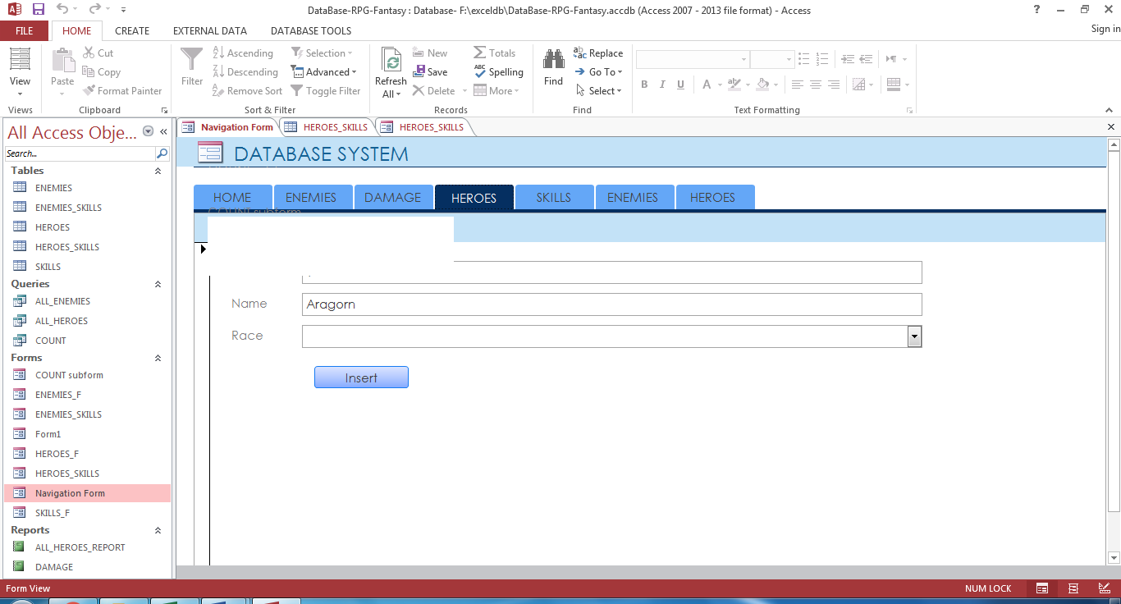

By clicking on the Heroes tab, users are able to easily create a record of a new Hero or altering an existing one. Users simply fill in the empty fields, clicking the insert/update button to make and affirm the changes/ additions. Another way to create a new record would also be to click the “New Record” icon,New Icon, located on the bottom panel, after the information has been entered.

### 3.1.4 Skills

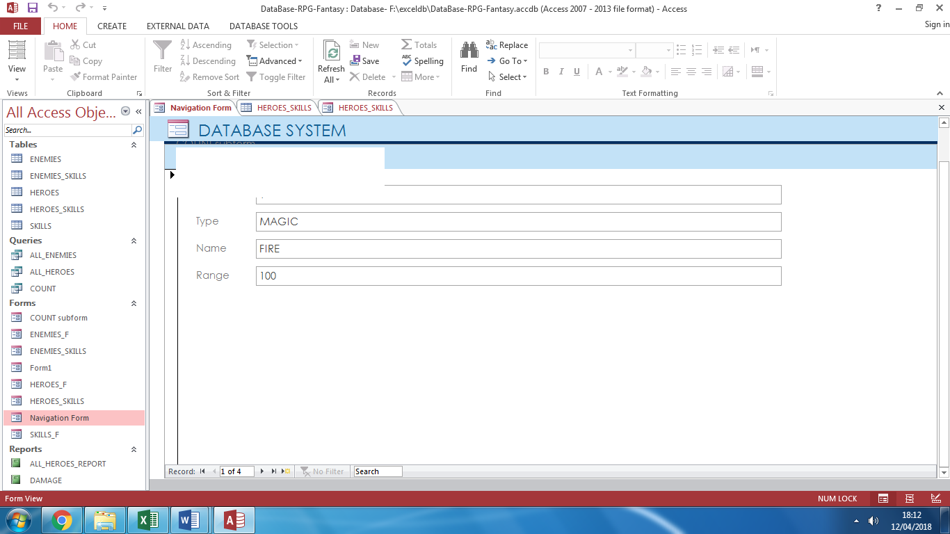

By clicking on the Skills tab, users are able to easily create a record of a new skill or edit an existing record. User’s merely need to alter the fields to their preference, thereafter clicking the insert button or new record button, located at the bottom of the screen.

### 

### 3.1.5 Heroes Skills

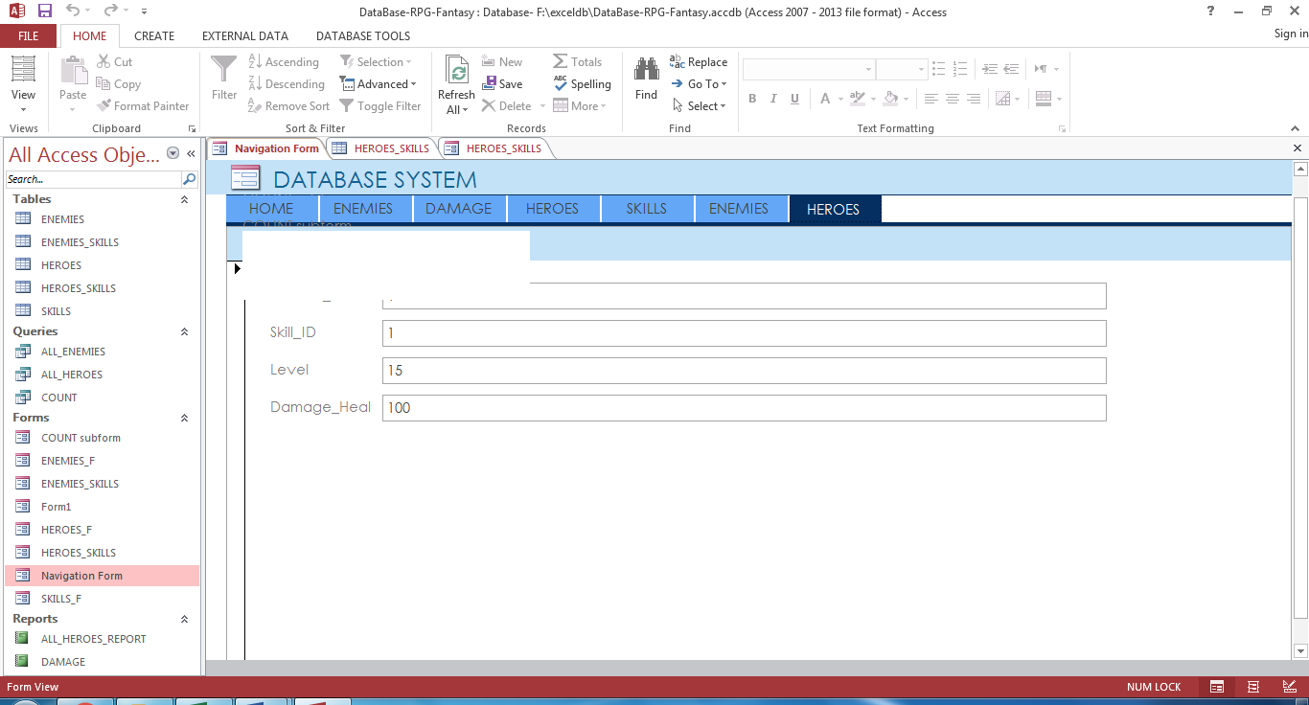

By clicking on the Heroes Skills tab, users are able to easily create or edit a record of a Heroes skill. Through utilising information already stored within the skill table, taking the ID along with the Hero ID that the User wishes to connect said skill too. User’s simply have to fill in the other fields, clicking the insert button or button found in the lower half of the screen, thus adding a skill to the Heroes skill tree or list.

### 3.1.6 Enemies Skills

### 

By clicking the Enemies Skills tab, Skills may become a branch of certain Enemies and created through a User filling in the empty fields and clicking either the insert button or new record button both listed or placed in the bottom half region of the screen.

### 3.1.7 Delete Entry

### 

### Users may purged or remove information stored within a data base table permanently, using the delete object element/button. Following said process the user is for warned of the implications using a pop up box before the data is ultimately deleted.

### 3.1.8 Exporting Data to Excel

Exporting to Microsoft Excel is achieved by first opening up the table which contains the desired information. Following this, users click the tab located at the top of the screen labeled “External Data” and are presented with the following screen:

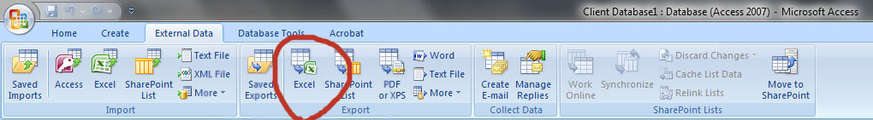

By clicking Excel in the “Export” Category, users can export their data to excel.

## 3.2 Exit System

Users should ensure that all of their changes and input have been saved in the database. Once their information has been saved, the user can either click the Microsoft ribbon, followed by Exit Access.

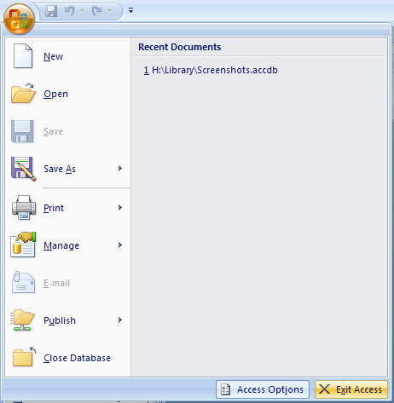

A secondary exit method available to the user is the x button located in the top right of the screen.

# 4.0 QUERYING

## 4.1 Querying

This section describes the query and retrieval capabilities of the system. The instructions necessary for recognition, preparation, and processing of a query applicable to a database shall be explained in detail.

## 4.2 Query Capabilities

There are various query capabilities pre-programmed into the system, available to the user by a variety of easy-to-use buttons on the left-hand side of the screen. These queries are accessible by clicking on sentences following the Query Icon (Query)

QueryAll Heroes: Allows the user to view the Heroes in the Enemies Table’s.

QueryAll Enemies: Allows the user to view all the Enemies and there attributes in the Enemies Table’s.

QueryCount: Allows the user to count the amount of heroes in a table with a set parameter of their choosing, such as desired level or skill.

## 4.3 Query Procedures

Users can access particular queries by clicking on the desired query, denoted by the Query Icon (Query), and then following the prompts that follow.

For example, to perform a query and view the Enemies Table: Users would click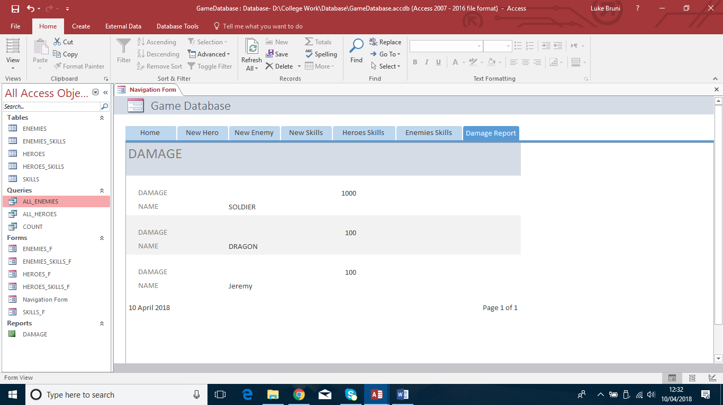, which would generate a table showing all the Enemies and there properties in the form of a table, shown below:

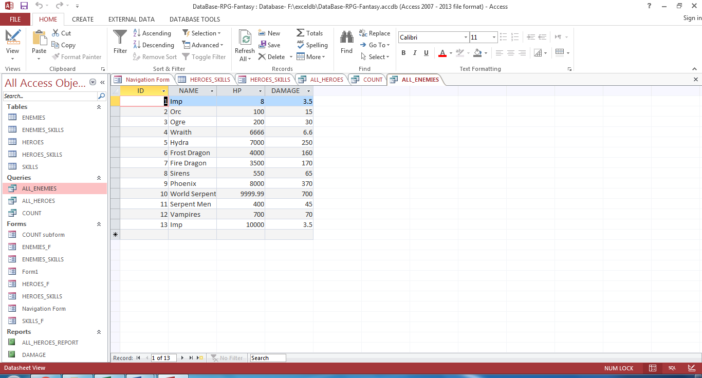

# 5.0 REPORTING

## 5.1 Reporting

This section describes and depicts all standard reports that can be generated by the system or internal to the user.

## 5.2 Report Capabilities

The user is capable of generating various reports, such as:

Report Viewing a list of all Entities in the database

Report Report of all skills regarding a particular amount of damage.

These are available on the left-hand side of the window, marked by the Report icon (Report)

## 5.3 Report Procedures

In order to access these reports, double-click on the desired report, and then follow the prompts that follow.

For instance, to run a report showing the Damage tally of each Enemy or a particular Enemy, users would first double-click on the report marked “DAMAGE”.

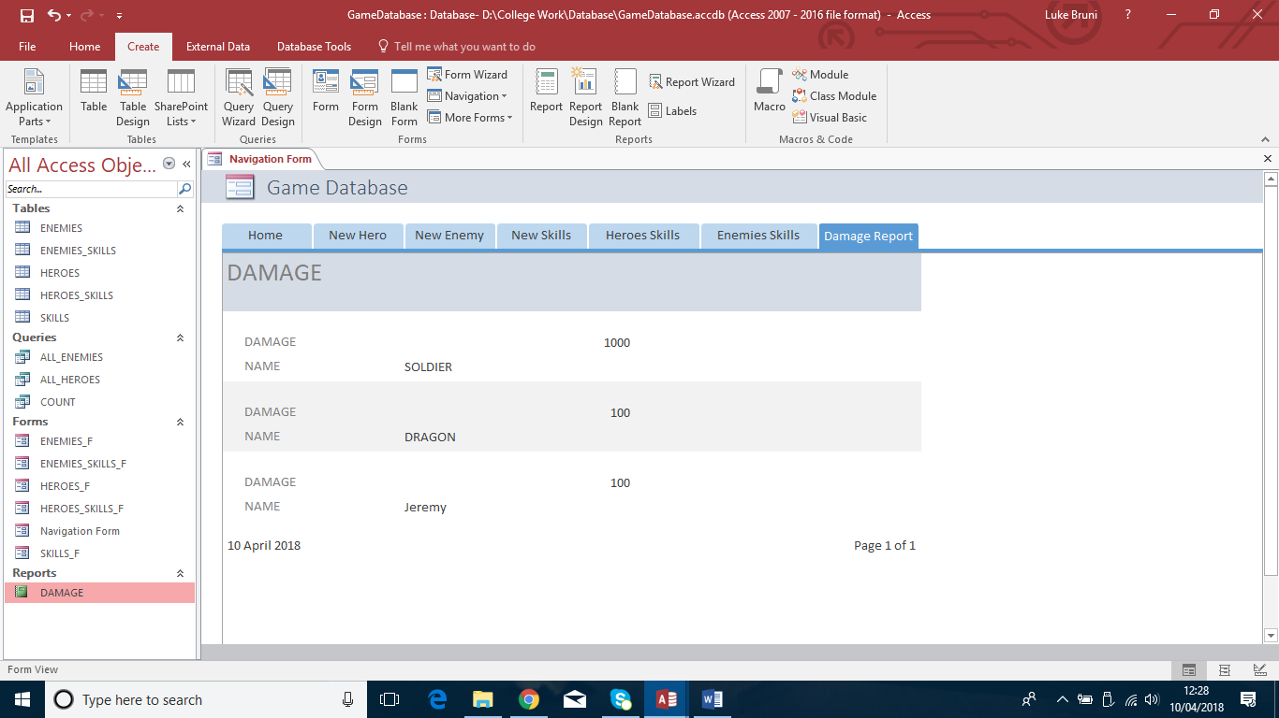.

Finally, the report is generated and displayed to the user:

