**THREE.JS Solar System Documentation**

I used Vscode to create my project and I used the live server extension to run the project in chrome.

**Camera Controls:**

Left mouse button: Rotate

Right mouse button: Pan

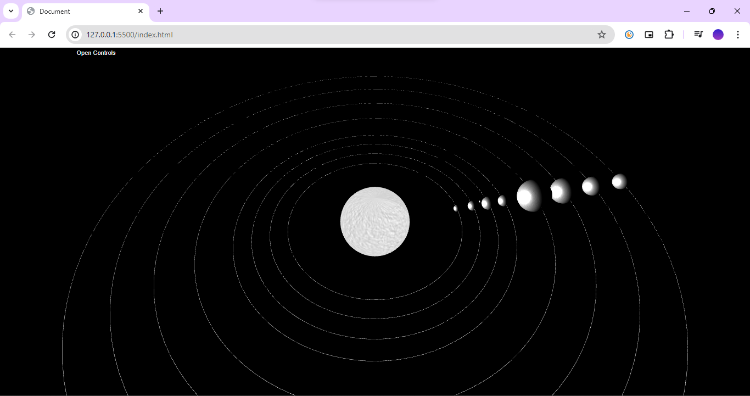Scroll wheel: Zoom in/Zoom out

Open GUI controls



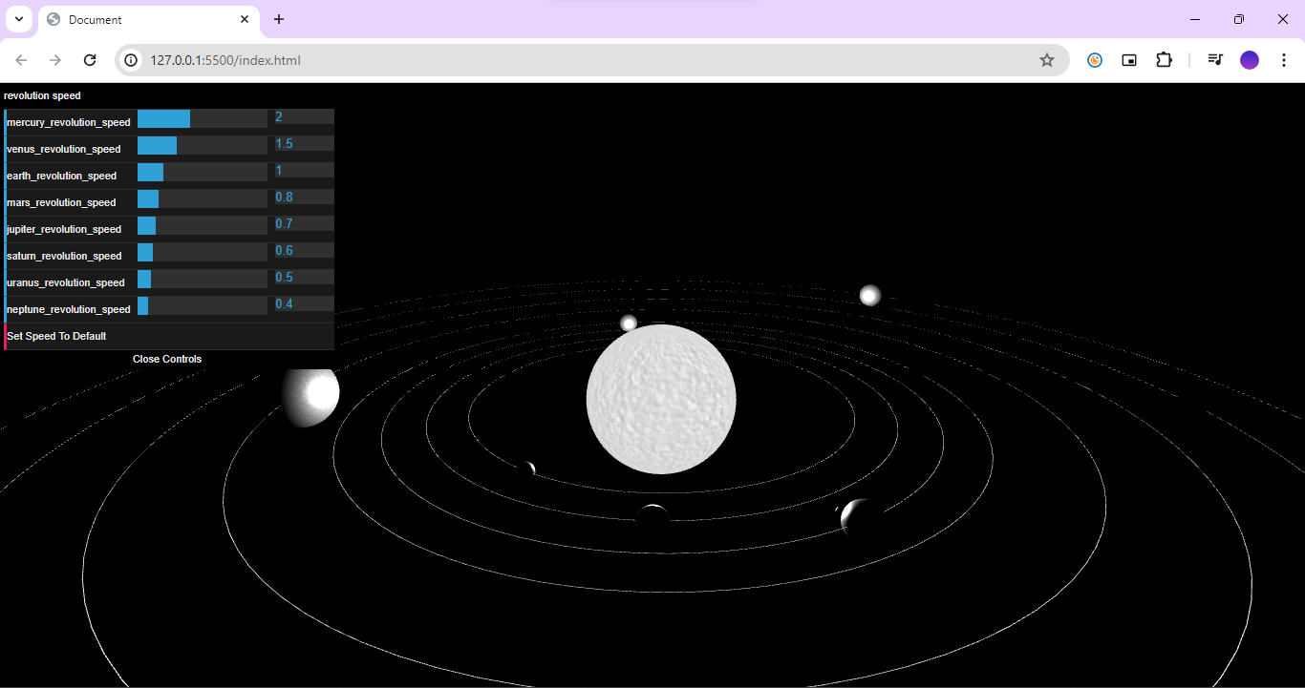

Click to set all the revolution speeds back to default

Adjust the sliders to control the revolution speeds of the planets

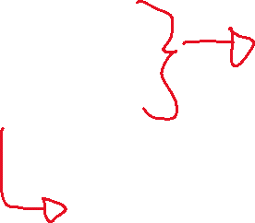

**Software:**

**1)**

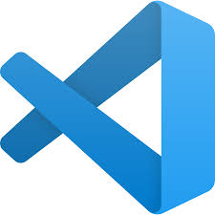

-VSCODE

AND

2)

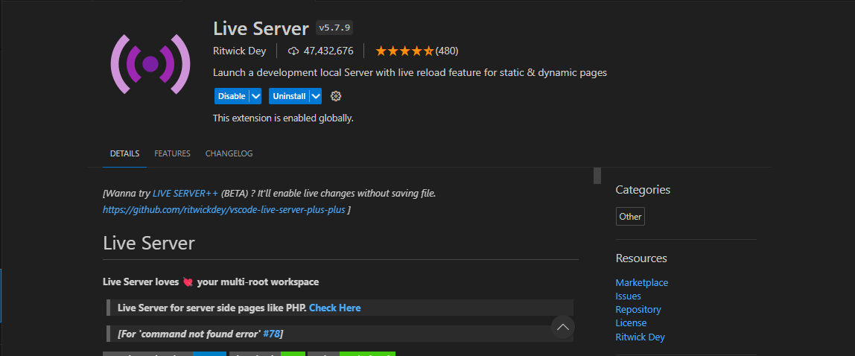

LIVE SERVER EXTENSION

-Search for the live server extension in the extension tab in vscode.

-Once installed right click on the html file and select ‘open with live server’.

