Econ 5015 – Implementing a Graph in Python
You may work by yourself or in groups of 2. If in a group, submit one script per group.
For this assignment, you will implement a weighted, undirected graph in Python. A graph consists of a set of nodes and a set of edges. The edges are connections between two nodes. A node consists of a name and a set of edges that involve that node. An edge consists of a weight and two nodes.

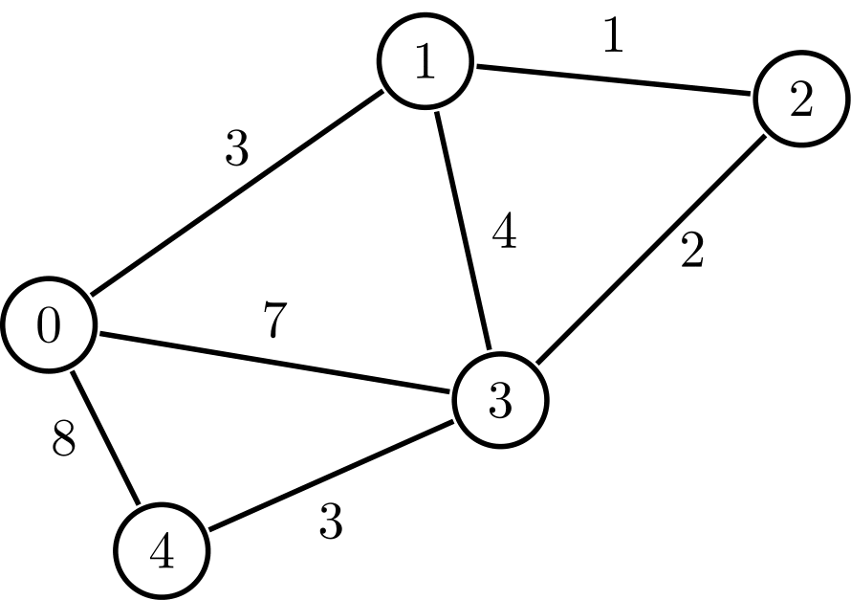

For example, in the above graph, there is a node with name “1” which has three edges. One of the edges has weight “3” and connects nodes “1” and “0”. The graph is undirected (which is what we will do in our assignment) because all edges go both directions whereas in a directed graph, an edge could possibly go from node 0 to node 1 but NOT from node 1 to node 0.
In a script called Graph.py, you should create the following two classes:
- Graph. The Graph class should have one attribute, nodes. The nodes attribute should be a dictionary that maps a node name (a string) to a Node object (see below). All nodes of the graph should be included in the nodes dictionary. The __init__ method should by default create a graph with no nodes (i.e. nodes is an empty dictionary).

The Graph class should also have the following methods:
  - size(). Returns the number of nodes in the Graph.
  - add_nodes(names). names should be a list with str elements. This method adds one node for each element of the names list. If a name already exists in the Graph, do nothing for that node. The newly created nodes should have no edges. No return value.
  - add_edge(n1,n2,w). Adds an edge with weight w between nodes with the names n1 and n2. If an edge already exists between those two nodes, overwrite the old weight with new weight w. If one or both of the names are invalid, do nothing. No return value. (Note: because we are creating an “undirected” graph, this method should add edges to both nodes n1 and n2.
  - get_names(). Returns a list with names of all nodes. Each element of list should be of type str.
  - get_node(n). Returns Node object for node with name n. Or, if there is no node with name n, then return -1.

- Node. The Node class should have two attributes, name and edges. The name attribute should be of type str and is a name for the node. The edges attribute should be a dictionary that maps node names to weights. Every node that is connected to this node by an edge should be included in the edges dictionary. Nodes that are not connected to this node by an edge should not be in the edges dictionary. For example, in the graph above, the edges dictionary for node “0” would have three entries: “1” maps to 3, “3” maps to 7, and “4” maps to 8. The edges dictionary for node “4” would have only two entries: “0” maps to 8 and “3” maps to 3.

The __init__ method for Node should require that a name is provided and should create a node with no edges (i.e. edges is an empty dictionary).

The Node class should have the following methods:
  - get_weight(n). Returns the weight for the edge between this node and the node with name n. If no such edge exists, return -1.
  - add_edge(n,w). Adds an edge with weight w between this node and node with name n.
  - num_neighbors(). Returns the number of edges that connect to this node.
  - get_neighbors(). Returns a list of names of nodes that share an edge with this node.

The class names, attribute names and method names must match exactly with how they are listed above. No imports for this assignment! (No Numpy, pandas, etc)
Example: to create the graph above, you would use the following code:
g = Graph()
g.add_nodes( [ “0”, ”1”, ”2”, ”3”, ”4” ] )
g.add_edge(“0”, ”1”, 3)
g.add_edge(“0”, ”3”, 7)
g.add_edge(“0”, ”4”, 8)
g.add_edge(“4”, ”3”, 3)
g.add_edge(“3”, ”1”, 4)
g.add_edge(“1”, ”2”, 1)
g.add_edge(“2”, ”3”, 2)

The above code should create one Graph object and 5 Node objects. The nodes attribute of the Graph object should be a dictionary with 5 key-value pairs, with the string names “0”,”1”,…”5” as keys and the 5 Node objects as corresponding values. Each Node objects should have an attribute for its name (for example, “0”, “1”, …) and another attribute for its edges. For example, the Node object for node 0 would have name “0” and edges dictionary {“1”: 3, “3”: 7, “4”: 8}. The Node object for node 1 would have name “1” and edges object {“0”: 3, “3”: 4, “2”: 1}.

g.get_names() should return [ “0”, ”1”, ”2”, ”3”, ”4” ] (possibly in different order)
g.get_node(“1”).get_neighbors() should return [“0”, “3”, “2”] (possibly in different order)
g.get_node(“1”).get_weight(“0”) should return 3.

