Daniel Saya & Matthew Demarco
Data 6560 – Checkpoint 5

Question Overview: Our project examines whether team level performance metrics can accurately predict MLB regular season win totals. We would consider our project successful if we could predict accuracy within 5 wins(RMSE < 6, R^2 > 0.85). This would create valuable insights for MLB front offices, analysts, and fans.

Our Data: https://d.docs.live.net/1ec0710fd8ff4750/Documents/Fairfield%20Univeristy/Graduate/Fall%202025/DATA6560/Master_Dataset.csv

Univariate Distribution | Key Takeaways
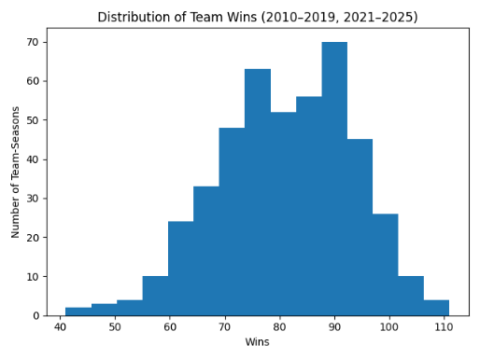 | - Teams Cluster between 70-95 wins  - Small percentage of teams with 100+ wins  - Small percentage of teams sub 60 wins  - Few outliers
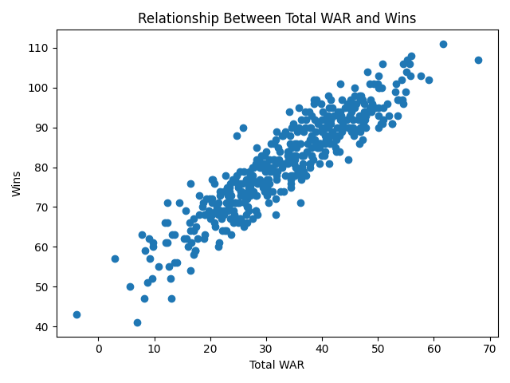 | - WAR is indicating as a strong factor of wins  - Very strong correlation between WAR and wins  - Strongest relationship in the dataset
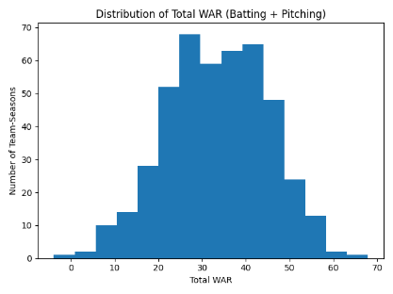 | - A high WAR correlates to both strong pitching and batting performances  - Appears to be very few outliers with most teams clustered between 20-50

