

Matthew Fripp S2223217

Wireframes 1

Landing 2

About us 2

Shops 3

Shop 4

Items 5

Edit Item 6

Users 7

Edit User 8

Login 9

# Wireframes

## Landing

## 

## About us

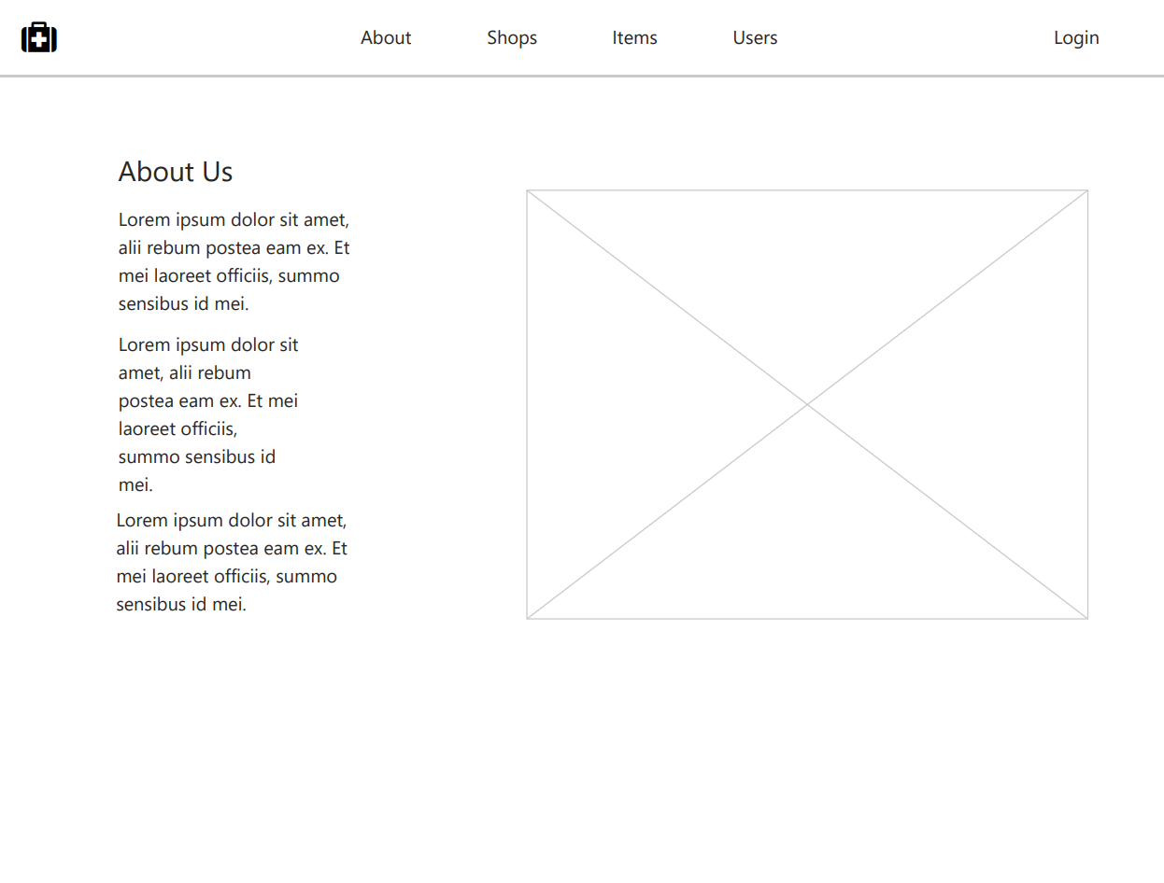

## Shops

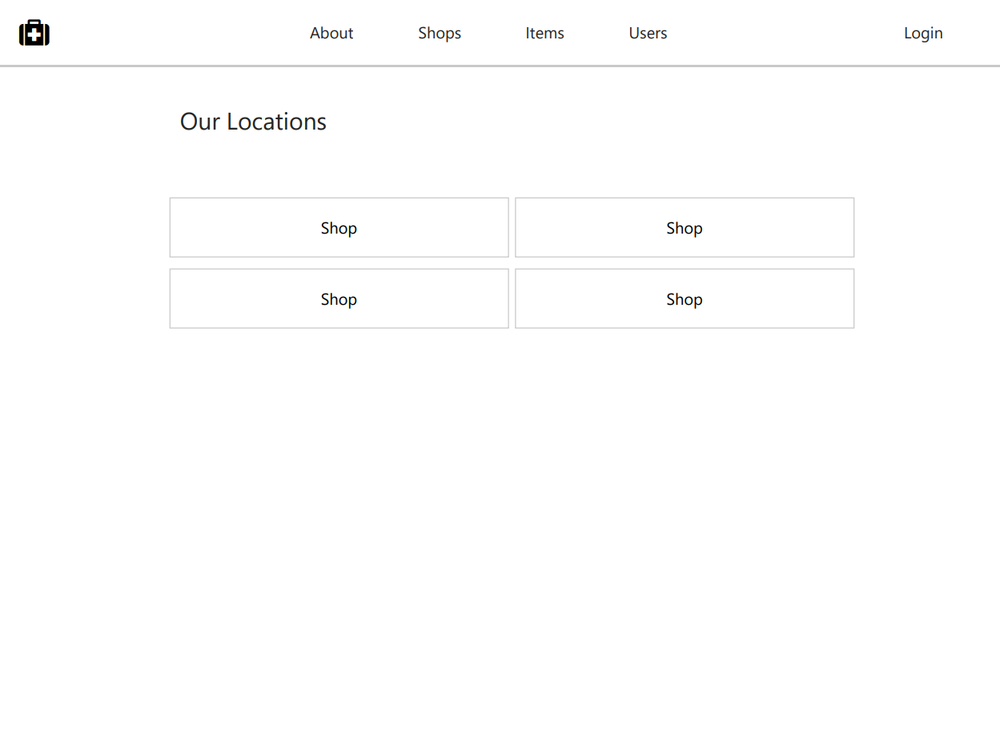

## Shop

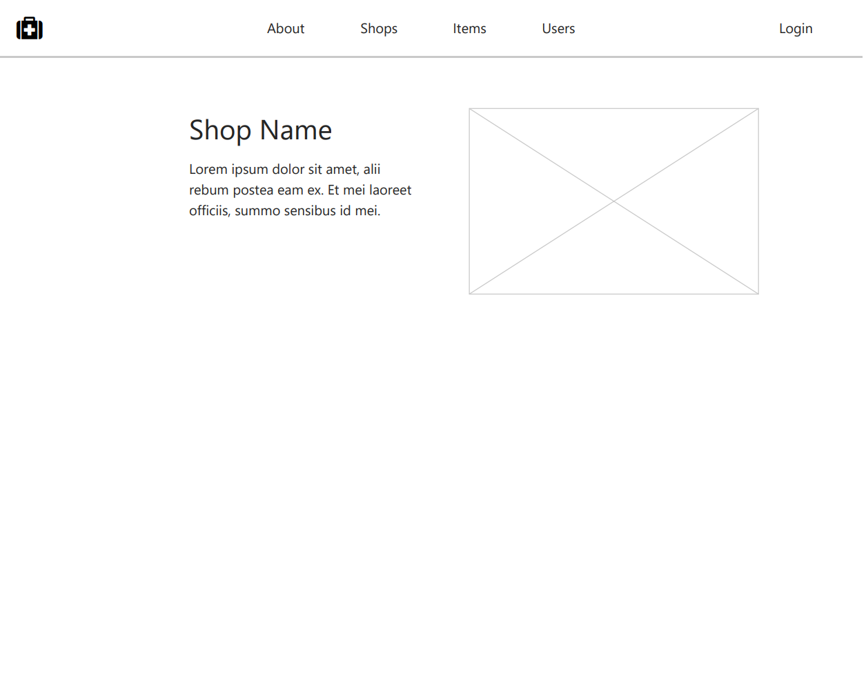

## Items

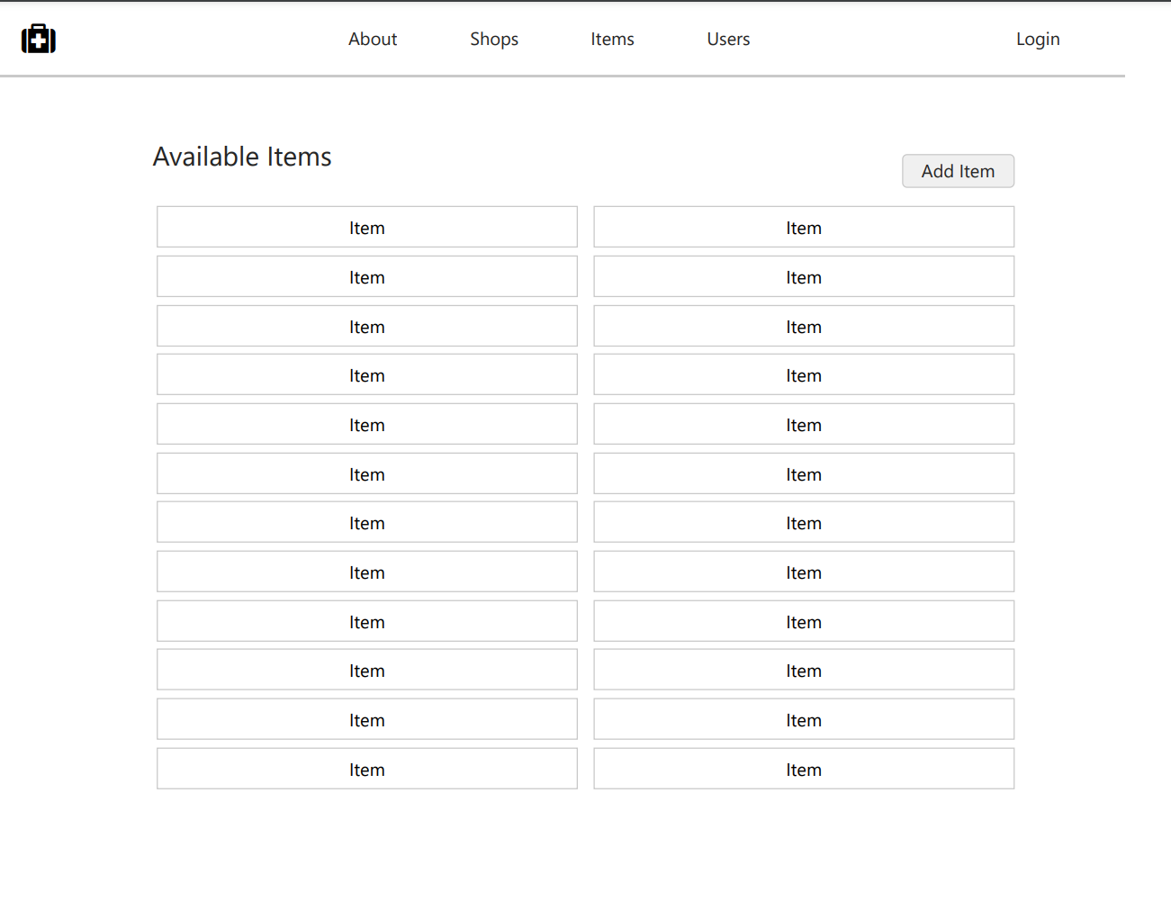

## Edit Item

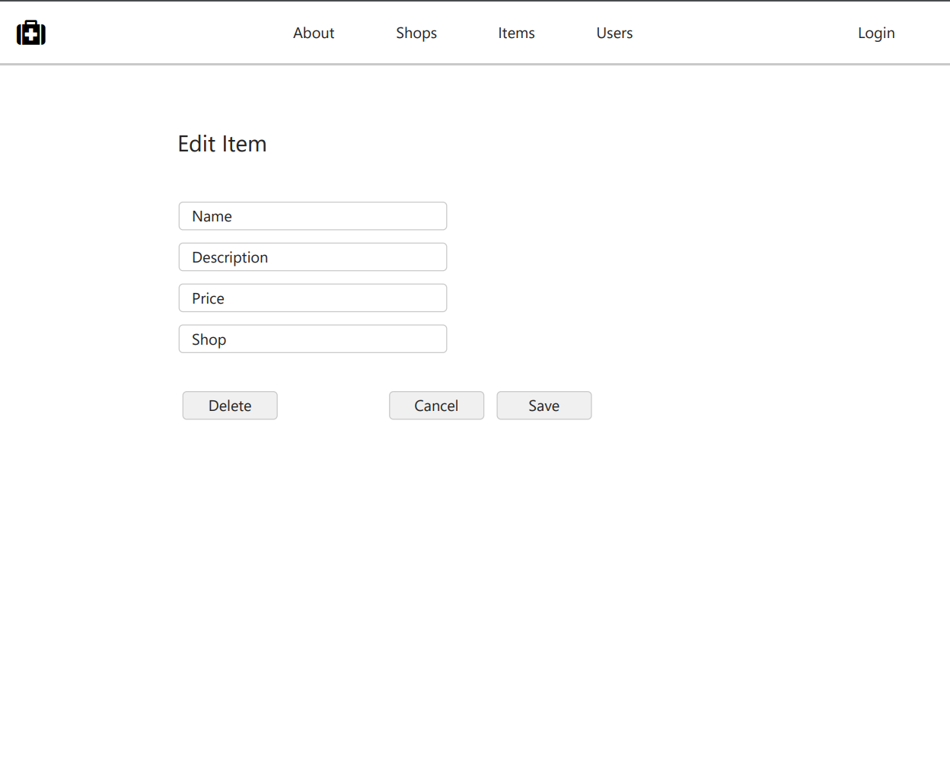

## Users

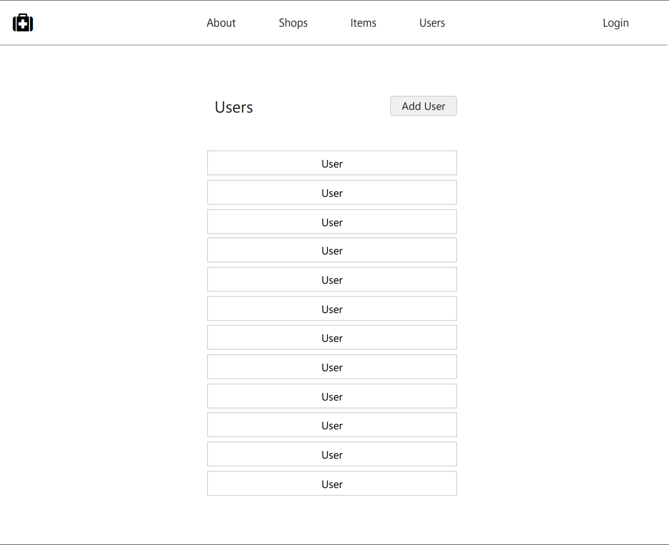

## Edit User

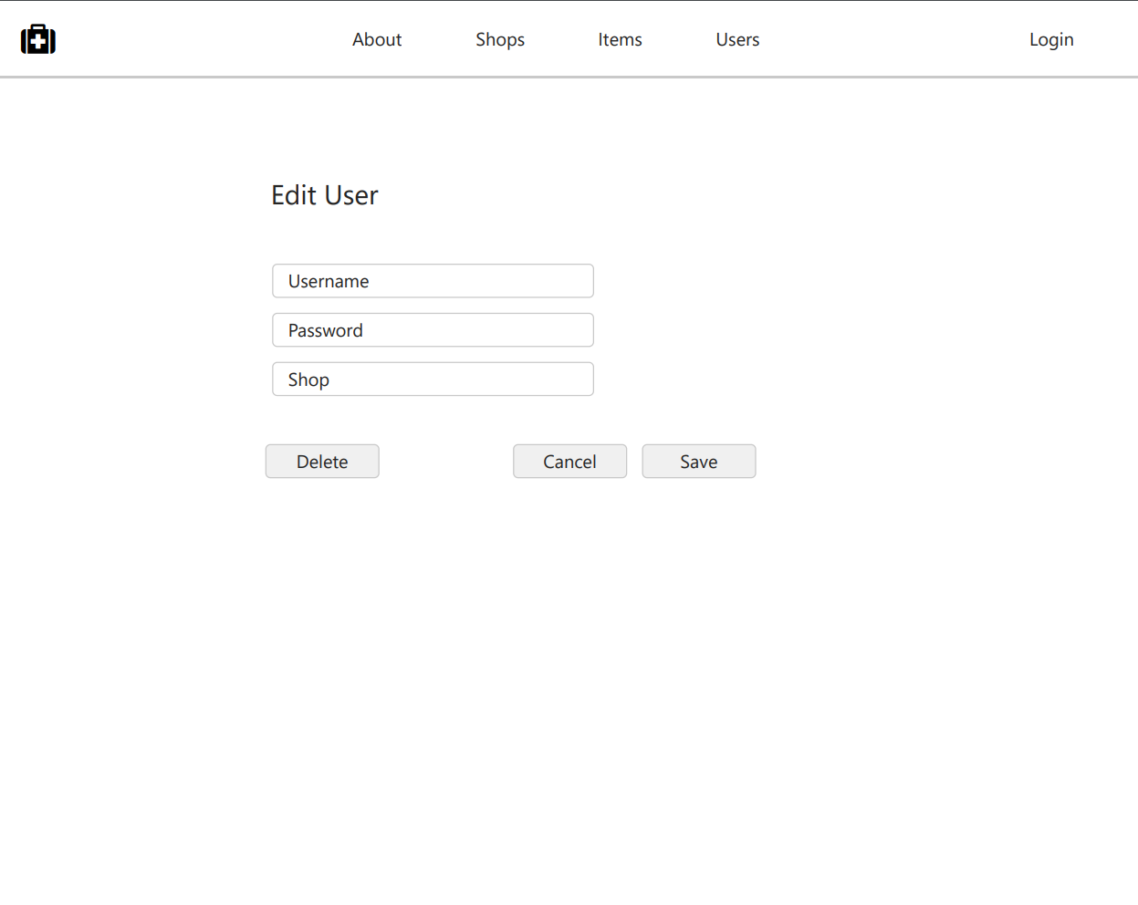

## Login

