
d o c u m e n t a t i o n

PURPOSE:
To automate TLO schedule input, assignment, and generation via MS Excel spreadsheets.

PREREQUISITES:
User must be logged into client’s site as an administrator using Internet Explorer.
Schedules file must be created and formatted as described below.
Employees file must be created and formatted as described below.

FORMAT:
The schedules & employees file MUST be created as an Excel document and named schedules.xls and employees.xls respectively.
In addition, the format must be precisely as follows:
- Place the TLO Alias in the upper left cell of each Excel document
- Name the schedules as desired.
- Input the scheduled time and employee assignments.

Follow the visual layout below:

NOTE: LEAVE EMPLOYEE LIST BLANK!

NOTE: EMPLOYEE NAME MUST MATCH TLO VERBATIM!
NOTE: ORDER OF SCHEDULES MUST MATCH SCHEDULES.XLS!
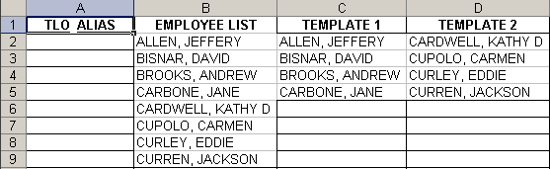

USAGE:
- Place and in the same location as

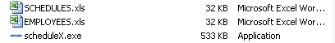

- Launch

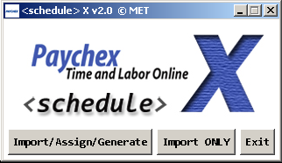

- Choose your selection, and follow the prompts.

